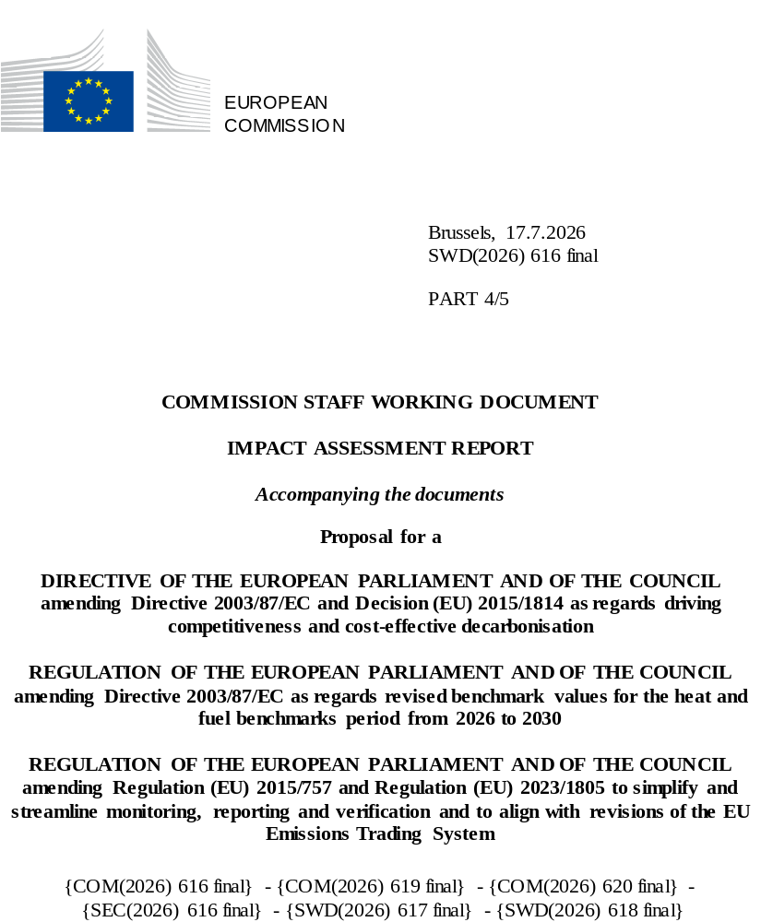

Table of Contents
Annex 12: Stationary Installations 4
List of Tables 4
List of Figures 6
1. Carbon Leakage 7
1.1. Overview 7
1.2. Scoping exercise 7
1.2.1. Carbon leakage prevention measures for direct emissions 7
1.2.2. Carbon leakage prevention measures for indirect emissions 9
1.3. Policy measures 12
1.3.1. Description 12
1.4. Assessment of the measures 15
1.4.1. Overview 15
1.4.2. Economic impacts 17
1.4.3. Social impacts 53
1.4.4. Environmental impacts 55
1.4.5. Summary 57
2. 20 MW Threshold 59
2.1. Scoping exercises 59
2.2. Policy measures 60
2.2.1. Description 60
2.3. Assessment of the measures 61
2.3.1. Economic Impacts 61
2.3.2. Social impacts 64
2.3.3. Environmental impacts 64
2.3.4. Summary 68
Annex 13: New Sectors and Technologies: Waste Management and Carbon Capture and Utilisation (CCU) 69
List of Tables 69
List of Figures 69
3. Waste 70
3.1. Overview 70
3.2. Scope of regulated activities and emissions 71
3.2.1. Municipal waste incineration (MWI) 71
3.2.2. Hazardous waste incineration (HWI) 74
3.2.3. Landfilling of non-hazardous waste 75
3.2.4. Discarded measures 77
3.3. Carbon price signal and emission abatement 79
3.3.1. Ability to pass-on the carbon cost and emissions abatement in the waste value chain 80
3.3.2. Emission abatement at installation level 83
3.3.3. Complementary measures and revenue use 87
3.4. Monitoring and Reporting 88
3.4.1. Threshold for inclusion 90
3.4.2. Simplified MRV for small and ultra-small emitters 92
3.5. Coherence with other policy frameworks 92
3.6. Policy measures 95
3.6.1. Description of the policy measures 95
3.7. Assessment of Policy measures 95
3.7.1. Environmental impacts 95
3.7.2. Economic impacts 101
3.7.3. Social impacts 105
3.7.4. Summary 107
Appendix 1: Data on emissions from waste incineration and landfilling in the EU 111
Appendix 2: Selected case studies on emissions abatement options for waste incineration and landfilling 116
Appendix 3: MRV methodologies for waste incineration and landfilling 119
4. Non-permanent Carbon Capture and Utilisation (CCU) 124
4.1. Overview 124
4.2. Scoping 126
4.2.1. Description of importance and potential for CCU market, products 127
4.2.2. Identification and description of accounting approaches 129
4.2.3. Identification of potential non-permanent CCU products and their normal use or end-of-life treatment 132
4.2.4. Identification of potential loopholes for downstream accounting 132
4.3. Policy measures 134
4.3.1. Description of the policy measures 134
4.3.2. Description of discarded measures 135
4.4. Assessment of the measures 136
4.4.1. Quantitative assessment 137
4.4.2. Environmental impacts 138
4.4.3. Economic impacts 142
4.4.4. Social impacts 153
4.4.5. Summary 153
4.5. Conclusions 155
Annex 14: Linking 156
1. Why and why not to link? 156
2. With whom to link? 156
3. Conclusion 157

Annex 12: Stationary Installations

List of Tables
Table 1: Sectors deemed to be exposed to a genuine risk of carbon leakage due to indirect emission costs (excluding sectors that have become newly eligible as of 1 January 2025) 11
Table 2: Indirect cost compensation by Member State 12
Table 3: Summary of GEM-E3 scenarios and policy options they address 15
Table 4: Overview of the 2031-40 free allocation in the baseline compared to the policy measures 18
Table 5: Estimation of the total volume of free allowances available under the baseline for 2031-40 20
Table 6: Estimation of the total volume of free allowances available under CL1 for 2031-40 21
Table 7: Estimation of the total volume of free allowances available under CL2_90 for 2031-40 23
Table 8: Estimation of the total volume of free allowances available under CL2_90 (CBAM variant) for 2031-40 24
Table 9: Estimation of the total volume of free allowances available under CL2_50 for 2031-40 25
Table 10: Estimation of the total volume of free allowances available under CL2_50 (CBAM variant) for 2031-40 27
Table 11: Estimation of the total volume of free allowances available under CL3 for 2031-40 27
Table 12: Decomposition of factors that could affect the total cost of indirect carbon cost compensation post-2030 31
Table 13: Percentage change in the unit cost of production relative to the baseline scenario (2040) 44
Table 14: Percentage change in unit cost of production levels for variants CL290_9085 and CL290C_9085 compared to scenarios CL2_90 and CL2_90C. 44
Table 15: Percentage change in production levels in 2040 relative to the baseline scenario 45
Table 16: Percentage change in production levels for variants CL290_9085 and CL290C_9085 compared to scenarios CL2_90 and CL2_90C. 45
Table 17: Percentage change in export levels in 2040 relative to the baseline scenario 46
Table 18: Percentage change in sectoral export levels for variants CL290_9085 and CL290C_9085 compared to scenarios CL2_90 and CL2_90C. 46
Table 19: Percentage change in GDP and its components in 2040 relative to baseline scenario 47
Table 20: Estimated CSCF under the different carbon leakage prevention measure of the total volume of free allowances available under the baseline and policy scenarios for 2031-40 48
Table 21: Sectoral employment change for ETS sectors in 2040 relative to the baseline 53
Table 22: Percentage change in sectoral employment levels for variants CL290_9085 and CL290C_9085 compared to scenarios CL2_90 and CL2_90C. 54
Table 23: Change in the EU 27 emissions in 2040 relative to baseline scenario (in MtCO2eq) 55
Table 24: Change in the non-EU 27 emissions in 2040 relative to the PRIMES baseline scenario (in MtCO2eq) 56
Table 25: Difference EU27 and non-EU27 emissions levels for variants CL290_9085 and CL290C_9085 compared to scenarios CL2_90 and CL2_90C. 56
Table 26: Summary of impact assessment for individual measures for carbon leakage relative to baseline 58
Table 27: Summary of impact assessment for individual measures for indirect carbon cost relative to baseline 58
Table 28: Administrative costs paid per operator in the EU 62
Table 29: Estimated emissions and installation coverage from lowering the 20 MW threshold 67

List of Figures
Figure 1: Verified emissions for CBAM and non-CBAM sectors between 2021-23 9
Figure 2: Total free allocation across the policy options 19
Figure 3: Distribution of free allocation under the baseline for 2031-40 21
Figure 4: Distribution of free allocation under CL1 for 2031-40 22
Figure 5: Distribution of free allocation under CL2_90 for 2031-40 23
Figure 6: Distribution of free allocation under CL2_90 (CBAM variant) for 2031-40 25
Figure 7: Distribution of free allocation under CL2_50 for 2031-40 26
Figure 8: Distribution of free allocation based under CL3 for 2031-40 28
Figure 9: comparison of indirect cost compensation and share of indirect emissions per Member State (2021-2023 average) 33
Figure 10: Share of sub-installations and emissions (average 2021-23) by category size in tCO2 for selected non-CBAM sectors 38
Figure 11: Share of sub-installations and emissions (average 2021-23) by category size in tCO2 for selected CBAM sectors 39
Figure 12: Share of installations and electricity consumption (average 2021-23) by category size in MWh/ year for selected sectors that are currently eligible for indirect cost compensation 41
Figure 13: Estimated electricity price for large industrial consumers 49
Figure 14: Proxy curve of emissions by capacity 60
Figure 15: Distribution of installations by capacity 62
Figure 16: Administration fees for operators and competent authorities by installation capacity 64
Figure 17: Overview sector activities that make up the EU ETS baseline 65
Figure 18: Number of installations by capacity (2019) 66
Figure 19: Annual emissions from <20 MW installations 66
Figure 20: Emissions by installation capacity 67

Carbon Leakage and 20 MW
- Carbon Leakage
  - Overview
Free allocation has been provided to ETS sectors to address the risk of carbon leakage, which occurs if industrial production relocates from the EU to jurisdictions with less stringent environmental standards. The recent introduction of the CBAM will place a carbon price equivalent to the EU ETS price on imports of certain basic products, providing and additional tool for preventing carbon leakage and, thereby, also ‘level the playing field’ in terms of the carbon costs faced by domestic production and imports entering the EU for the sectors currently covered (i.e. electricity, steel, cement, aluminium, fertilisers and hydrogen) without fully relying on free allocation for these sectors.
Considering the changes to free allocation in Phase IV, this impact assessment considers how best to revise free allocation and carbon leakage protection in Phase V of the EU ETS and whether a continuation of the current approach to free allocation remains suitable or if further reforms are appropriate.
  - Scoping exercise
    - Carbon leakage prevention measures for direct emissions
      - Background
Since the outset, the EU ETS has addressed the concern that an unequal carbon pricing in different jurisdictions may result in either an overall increase in global GHG emissions or a lower reduction in global emissions than in EU emissions. Allocation of free allowances has served as the main tool to prevent possible relocation of industrial production subject to EU carbon pricing to countries with less stringent climate policies, which is also referred to as carbon leakage.
While this approach helped ease the political and economic transition to a carbon market, it also introduced challenges. Uneven allocation methods across Member States led to distortions in intra-EU competition and, in sectors where allowances were passed through in product prices, companies could gain so-called windfall profits. Moreover, the environmental incentive to reduce emissions was weaker where free allocation was based on historic emissions and covered most or all a company's compliance needs.
From Phase III onwards, the share of free allowances declined as more allowances were auctioned. The methodology for allocating allowances for free changed from grandfathering (based on historic emissions) to benchmarking those rewards installations with lower specific emissions for their production by receiving more allowances for free.
The design of free allocation under Phase IV underwent significant reform to better align with climate ambition, economic fairness, and environmental integrity. The scope of this evaluation for carbon leakage prevention focuses on the key changes to free allocation that occurred at the start of Phase IV following the revision of the ETS Directive in 2018:
- Revised benchmark values for free allocation
- Updated carbon leakage list
- Establishment of a buffer to limit the application of the Cross-Sectoral Correction Factor (CSCF)
- Better alignment of free allocation with actual production levels
The reforms introduced indicate a strategic shift in how the system addresses carbon leakage. Rather than merely shielding the sectors indefinitely from external competition, the updated design encourages innovation while continuing to prevent relocation of emissions and production.
Because of the changes in the 2023 revision of the ETS Directive, part of the free allocation is now conditional, and this is reflected in the latest amendment of the Free Allocation Regulation (‘FAR’). The conditional aspects of free allocation are now as follows:
- Free allocation to eligible installations will be reduced by 20% if operators have not implemented energy efficiency recommendations from energy audits or energy management systems as stipulated under the EU Energy Efficiency Directive (EED).
- The free allocation to eligible installations with product benchmarks will be reduced by 20% if a sub-installation’s specific emissions are higher than the 80th percentile of emission levels for the relevant product benchmarks in their benchmark curve, unless they have a compliant Climate-neutrality plan (CNP) in place.
- District heating (DH) operators in Member States with relatively high DH emissions can obtain an additional 30% of free allowances on the condition that they have a compliant CNP in place and they make sufficient investments in the implementation of the included emission reduction measures before 2030.
Throughout the stakeholder consultation, carbon leakage was a widespread concern among stakeholders, although exposing substantial divisions between different types of stakeholders. An overall majority of respondents, mainly companies and business associations, generally advocated for maintaining and improving free allocation (with suggestions for improvements ranging from simplifications, to updating benchmarking methodologies or the carbon leakage list, or introducing conditionalities), particularly for sectors not covered by the CBAM. Conversely, NGOs generally favoured a phase-out of free allocation to fully implement the “polluter pays” principle and accelerate decarbonisation, or making free allocation conditional on taking steps towards carbon neutrality.
      - Emissions covered by non-CBAM sectors
Figure 1 provides an overview of the direct emissions covered for CBAM and non-CBAM sectors based upon provisional NIMs data, which is relied upon throughout this assessment as it provides the most comprehensive dataset on the activity level, emissions and free allocation provided to installations at the sub-installation level. This information is submitted by ETS operators as part of the process for applying for free allowances.

- Verified emissions for CBAM and non-CBAM sectors between 2021-23
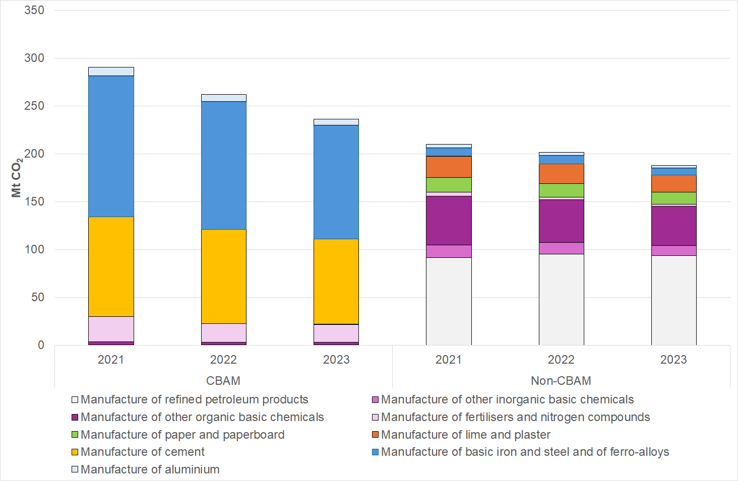
Source: NIMs dataset (2014-18, 2019-23), Own illustration
The key non-CBAM sectors in terms of absolute emissions include the manufacture of refined petroleum products, manufacture of other inorganic and organic basic chemicals, the manufacture of paper and paperboard and the manufacture of lime and plaster. Indeed, these sectors account for around 40% of the average non-CBAM emissions between 2021 and 2023.
    - Carbon leakage prevention measures for indirect emissions
The ETS Directive establishes, in Article 10a(6), the principle that Member States should adopt financial measures to compensate electro-intensive industries at genuine risk of carbon leakage due to indirect carbon costs (ICC - carbon costs that are passed on through the wholesale electricity price based on the carbon cost the marginal power producer incurs), subject to State aid rules.
ICC compensation supports the business case for electro-intensive industrial processes by reducing their carbon costs. It is particularly relevant for electrified industrial processes that face an indirect carbon cost and compete with non-electrified processes that emit CO₂ directly and benefit from free allocation. Conceptually, the environmental benefit of ICC compensation is therefore a combination of:
- Carbon leakage protection: addressing the risk of electro-intensive industries relocating, due to indirect carbon costs, to areas with less strict climate governance.
- Incentivising electrification: supporting the business case for electrification relative to direct emissions, for industries that could electrify their processes.
Article 10(6) describes some key features of Member States’ ICC compensation measures, including that the compensation should be based on ex ante benchmarks for indirect emissions per unit of production, calculated as the product of electricity consumption corresponding to the most efficient available technologies and of the CO₂ emissions from electricity production.
The Article 10(6) mandate does not contain an expiry date and is not subject to a review clause. However, Article 30(2) states that carbon leakage support measures shall be kept under review and explicitly requires the Commission to consider whether ICC measures should be further harmonised. In practice, detailed elements of Indirect Cost Compensation (ICC) governance are elaborated and amended through the relevant State aid guidelines, which are outside the scope of this review.
The guidelines are developed separately and cover the key characteristics such as sectoral eligibility, the methodology for calculating indirect carbon cost, the generosity of the aid (aid intensity) and conditions related to the expenditure of the aid (conditionality). The objective of the guidelines is to ensure that any State aid awarded is necessary to achieve the environmental objective of the EU ETS by reducing the risk of indirect carbon leakage and is limited to the minimum needed to achieve the environmental protection sought (proportionality of the aid) without creating undue distortions of competition and trade in the internal market.
Aside from State aid, some electro-intensive installations are also eligible to receive free allocation covering indirect emissions from January 2026. To incentivise the electrification of industrial processes and reduce their emissions, the 2024 amendment of the FAR removed the rules on “exchangeability” of fuel and electricity, so that highly or entirely electrified processes covered by the EU ETS benefit from the same free allocation as processes with high direct emissions. The extent to which an electrified installation benefits from this depends on the free allocation benchmarks (i.e. an installation will benefit most when it has electrified, but high direct emissions are still included in the relevant benchmark). To avoid overcompensation, Article 10a(6) of the ETS Directive states that indirect costs covered by free allocation should not also be covered by State aid. Processes not eligible to receive free allocation covering indirect emissions will remain eligible for national State aid schemes. The FAR change may affect the composition of indirect cost compensation in two ways: 1) demand for State aid may fall if a share of the indirect cost is instead compensated through free allocation; 2) the overall quantity of compensated emissions may increase, since some installations who would not have received State aid will receive free allocation.
In principle, carbon leakage risks related to ICC should dampen over time as the EU’s electricity supply decarbonises. However, ICC can still play an outsized role in the costs faced by electro-intensive industries due to the role of fossil fuels in setting marginal electricity prices. JRC analysis suggests that fossil fuelled power plants will continue to set the marginal price 86% of the time up to 2030. It is therefore relevant to consider how carbon leakage risk related to ICC should be addressed after 2030.
At present, 15 Member States grant ICC. This impact assessment considers how the ETS Directive should address ICC post-2030, including whether ICC measures should be further harmonised. It does not quantify the specific effect of the FAR change. Further details of the current ICC governance framework can be found in the annual report on the functioning of the European carbon market, and State aid guidelines.
      - Overview of sectors eligible for indirect cost compensation
The list of sectors eligible for indirect cost compensation through State aid for the period 2021-2025 was established in the ETS State aid guidelines published in 2020. This list is shown in Table 1. In early 2026, these guidelines were amended for the period 2026-2030, expanding the number of eligible sectors and changing some of the aid intensity and conditionality rules. The effect of the amendment is not considered in this assessment.
- Sectors deemed to be exposed to a genuine risk of carbon leakage due to indirect emission costs (excluding sectors that have become newly eligible as of 1 January 2025)
NACE code | Description
14.11 | Manufacture of leather clothes
24.42 | Aluminium production
20.13 | Manufacture of other inorganic basic chemicals
24.43 | Lead, zinc and tin production
17.11 | Manufacture of pulp
17.12 | Manufacture of paper and paperboard
24.10 | Manufacture of basic iron and steel and ferro-alloys
19.20 | Manufacture of refined petroleum products
24.44 | Copper production
24.45 | Other non-ferrous metal production
20.16.40.15 | Polyethylene in primary forms
23.14.12.10 | Glass fibre mats
23.14.12.30 | Glass fibre voiles
20.11.11.50 | Hydrogen
20.11.12.90 | Inorganic oxygen compounds of non-metals
      - Overview of the provision of indirect cost compensation by Member State
Table 2 provides an overview of the indirect cost compensation by Member State for the year 2023. It outlines the differentiated nature of the support for indirect carbon costs across the EU.

- Indirect cost compensation by Member State
Member State | Amount paid  for indirect costs  incurred in 2023  (million EUR) | Number  of recipients  (installations) | Auction  revenues  in 2023  (million EUR) | Relative size of indirect costs aid compared to auction revenue
Belgium | 249.9 | 56 | 739.9 | 33.8%
Czechia | 60.4 | 23 | 771.3 | 7.8%
Finland | 143.2 | 55 | 571.5 | 25.1%
France | 908.8 | 293 | 2,060.1 | 44.1%
Germany | 2,395.0 | 707 | 7,582.5 | 31.6%
Greece | 287.0 | 57 | 1,441.8 | 19.9%
Italy | 165.5 | 252 | 3,547.4 | 4.7%
Luxembourg | 37.6 | 4 | 7.6 | 492.0%
Netherlands | 147.3 | 48 | 1,261.1 | 11.7%
Poland | 614.6 | 97 | 5,406.7 | 11.4%
Portugal | 25.0 | 23 | 726.7 | 3.4%
Romania | 116.7 | 31 | 571.8 | 20.4%
Slovakia | 58.3 | 9 | 377.5 | 15.4%
Slovenia | 25.4 | 16 | 186.5 | 13.6%
Spain | 282.8 | 191 | 3,514.0 | 8.0%
Austria | N/A
Lithuania | N/A
Bulgaria | N/A
Croatia | N/A
Cyprus | N/A
Denmark | N/A
Estonia | N/A
Hungary | N/A
Ireland | N/A
Latvia | N/A
Malta | N/A
Sweden | N/A
Source: Report from the Commission to the European Parliament and the Council on the functioning of the European carbon market in 2024 pursuant to Articles 10(5) and 21(2) of Directive 2003/87/EC
  - Policy measures
    - Description
      - Carbon leakage prevention measures for direct emissions
The following three policy measures to be considered in the impact assessment include:
- CL1: Improved current approach on free allocation:
This measure represents a continuation of the current approach on free allocation but also includes several simplifications and improvements. Simplifications consist of a avoiding a general update of the carbon leakage list and streamlining of the application for free allocation and how the benchmarks are established to reduce the administrative burden. Benchmarks will continue to be set by the average performance of the 10% best performing installations, taking into account the minimum and maximum update rates and the rules for extrapolation of the trend to the mid-point of the relevant five years allocation period. However, fall back benchmarks should be differentiated to take into account the specificities of the different sectors. The rules on allocation level changes and conditionalities remain as they are currently in force.
- CL2: Conditional free allocation for investments:
This measure builds upon the improvements and simplification introduced in measure CL1 and it expands and generalises the conditionalities introduced for the period 2026-2030 (i.e. based on energy audits and climate neutrality plans for the least efficient installations and investments for district heating). A share of free allocation will be made conditional on installations developing meaningful climate neutrality plans and investing in significant emission reductions an amount equivalent to economic value of the conditional free allocation. Enforcement will take place ex-ante and ex-post. Before the allocation of (conditional) free allowances for the following period, operators will need to make binding financing decisions for the required investments. At the end of the allocation period, operators will need to demonstrate that the planned investments have been implemented leading to GHG reduction. The conditional allowances thus not allocated will be made available for free allocation to other operators. A gradual approach is necessary to enable economic actors to adjust. The share of conditional free allocation would be phased in starting with 20% in 2031, 40% in 2032, 60% in 2033, 80% in 2034 and then 100% from 2035. The impact of this measure will be assessed based on two scenarios assuming a different level of compliance with the conditionalities, namely a compliance rate of 90% (referred to as “CL2_90” in the rest of the document) and respectively 50% (“CL2_50”).
- CL3: No free allocation and partial surrender of allowances until 2034
This measure proposes an alternative to free allocation for carbon leakage protection. It replaces the current free allocation provision with a system like the approach used for phasing in the compliance obligation of maritime. Therefore, installations, instead of receiving a certain quantity of allowances for free, would be required to surrender allowances only for a part of their reported emissions. However, unlike maritime, the non-surrendered share of allowances is equivalent to allowances received for free (in the other measures) and therefore there would not be any adjustment to the cap to compensate for the partial surrender of allowances. The share of emissions that will require the surrendering of allowances will gradually increase to 100% surrender of allowances by 2034 (20% surrender in 2031, 50% in 2032, 80% in 2033, 100% from 2034). In this way, all sectors (CBAM and non-CBAM) will pay for 100% of their emissions from 2034.
- Revenue recycling variants
In the standard modelled scenarios, revenue generated by the EU ETS is recycled with 50% financing power sector investments and 50% dedicated to improving energy efficiency in covered industries. Parts of this impact assessment also consider a revised recycling structure (CL1R, CL3R) where the 50% allocation to the power sector is instead transferred as a lump sum payment to households.
- CBAM variants
All policy measures for direct emissions target carbon leakage protection for non-CBAM sectors, while free allocation for installations covered CBAM continues to be phased out as currently planned in the ETS Directive by 2034.
However, a CBAM variant is analysed for each policy measure that considers, in addition to the specific changes for that policy measure, re-allocating 15% of the free allowances that would have otherwise been phased out to installations covered by CBAM.
- Cap variants
For derriving a free allocation budget and the resulting free allocation and cross sectorial correction factor, each policy measure has been constructed based on the ambition level determined under the measure CAP2.
In addition, a variant is analysed for CL2 based on a version of the 85% reference scenario attaining in 2035 an economy-wide GHG emissions level target consistent with a pathway towards a 90% target in 2040, but thereafter consistent with an 85% target in 2040. (CL290_9085 and CL_90C_9085). This corresponds to the CAP3 measure for the trajectory of the EU ETS from 2031-2040 (see Annex 8 – part 1, section. 2.2)
      - Carbon leakage prevention measures for indirect emissions
The following two policy measures are considered in the impact assessment:
- ICC1: Continued existing State-aid encouragement:
The policy measure envisages continuing the encouragement for Member States to provide indirect carbon cost (ICC) compensation in line with State aid rules, as set out in Article 10a(6) of the ETS Directive.
As with the existing Article 10a(6), the Commission may elaborate specific rules concerning ICC compensation through State aid guidelines. The guidelines currently in force apply to Member States’ measures granted up to 2030.
- ICC2: Partly harmonised ICC:
In addition to the measures described in ICC1, this would consist of providing EU-level funding for ICC compensation by reserving 5% of auctioned allowances for this purpose. Providing harmonised ICC compensation through an EU-level instrument would reduce distortion in the single market and provide increased certainty to firms. Given budget constraints, a harmonised ICC fund may not be able to provide support at the maximum intensity currently permitted in the State aid guidelines. Therefore, each Member State would retain the right to provide additional compensation up to the level permitted under State aid rules.
  - Assessment of the measures
    - Overview
Free allocation numbers, indirect carbon costs and the impact on carbon leakage protection are affected not only by changes in the free allocation measures, but also by the broader changes to the ETS Directive, such as the level of ambition and the resulting ETS cap and linear reduction factor, the integration of removals or the inclusion of waste incineration in the scope of the EU ETS. Changes to the Market Stability Reserve may also impact liquidity. Therefore, the full impact of the measures on carbon leakage protection outlined in this chapter can only be assessed in combination with the measures on ambition, the integration of removals, MSR, cap and scope as part of the policy options, outlined in section 6 of this impact assessment .
The impact of the carbon leakage protection measures described in section 1.4 focuses on the quantitative assessments of the quantity of free allocation under the different scenarios, the sectorial distribution of the free allocation, as well as the financial value of these allowances.
In addition, GEM-E3 model runs have been completed to estimate a range of economic, social and environmental impacts resulting from different free allocation distributions across non-CBAM sectors over the 2031-40 period. The GEM-E3 model is informed by output provided by PRIMES to then assess the impact of different options for the provision of free allocation. The baseline considered under the GEM-E3 model is a free allocation budget based on the continuation of the existing legislation that assumes the ETS cap declines with an LRF of 4.4% between 2031-2040.
The modelling then compares different expectations in terms of free allocation budgets and how the allowances are distributed across industrial sectors to then provide quantitative metrics on carbon leakage rates as well as macro-economic implications. The annual share of the verified emissions that are estimated to be covered by free allocation for different industrial sectors between 2031 and 2040 is provided as a modelling input on free allocation for the GEM-E3 model runs. This modelling input has been determined based upon a comprehensive bottom-up calculation of free allocation using sub-installation data from the preliminary NIMs dataset for 2019-23 for both activity levels and emissions. The NIMs database is the outcome of the National Implementation Measure (NIM), which was specified in Article 14 of Commission Delegated Regulation (EU) 2019/331 – ‘Free Allocation Regulation’ (FAR) requiring EU Member States to inform the European Commission by providing a list of installations covered by the EU ETS and the preliminary amount of free allowances to be allocated to these installations calculated in accordance with Union-wide harmonised rules for free allocation. Table 3 provides an overview of the scenarios used for the GEM-E3 assessment, while a full explanation of the GEM-E3 model and its application in this impact assessment is outlined in Annex 4.
- Summary of GEM-E3 scenarios and policy options they address
Policy Options | Impact (Summary)
Baseline/Reference Scenario | Post-2030 greenhouse gas emissions reductions are driven by continued mitigation in both ETS and non-ETS sectors, in line with existing regulatory frameworks. Under the scenario, EU ETS emissions continue to decline annually following the linear reduction pathway as currently legislated. The revenue generated via the EU ETS is recycled, with 50% allocated to financing power-sector investments and the remaining 50% dedicated to improving energy efficiency in EU ETS industries.
PO1 (CL1 & CL1R) | CL1: EU targets 85% reduction in GHG emissions by 2040, with free allocation for non-CBAM sectors based on updated product benchmarks, which is the improved current approach. The revenue generated via the EU ETS is recycled, with 50% allocated to financing power-sector investments and the remaining 50% dedicated to improving energy efficiency in EU ETS industries.  CL1R: CL1 with revised recycling structure, where the 50% allocation to financing power-sector investments is instead transferred as a lumpsum payment to the households, while power investments are financed via domestic and foreign borrowing.
PO2 (CL2_50, CL2_90, CL2_50C & CL2_90C, CL2_90_9085 and CL2_90C_9085) | CL2_50 & CL2_90: EU targets 85% reduction in GHG emissions by 2040, along with a progressive share of free allocation for non-CBAM sectors which is conditional on investment in green energy/technology with two compliance variants, i.e. 50% and 90%. The emissions from the municipal waste are also considered under the EU ETS. The revenue generated via the EU ETS is recycled, with 50% allocated to financing power-sector investments and the remaining 50% dedicated to improving energy efficiency in EU ETS industries.  CL2_50C & CL2_90C: CL2_50 & CL2_90 with a progressive share of free allocation for both CBAM and non-CBAM sectors.  CL2_90_9085 and CL2_90C_9085 represent the same policy measures as in CL_90 and CL_90 but assessed based on the 90-85 cap pathway.
PO3 (CL3 & CL3R) | CL3: EU targets 85% reduction in GHG emissions by 2040 as it phases out the free allowance for non-CBAM sectors to ensure no further free allowances are provided to industry 2034 onwards. The emissions from the waste sector (including municipal, landfill, etc.) are also considered under the EU ETS. The revenue generated via the EU ETS is recycled, with 50% allocated to financing power-sector investments and the remaining 50% dedicated to improving energy efficiency in EU ETS industries.  CL3R: CL3 with revised recycling structure, where the 50% allocation to financing power-sector investments is instead transferred as a lumpsum payment to the households, while power investments are financed via domestic and foreign borrowing.
For indirect carbon costs, the section analyses their possible evolution out to 2040 and considers how the ETS Directive’s provisions concerning indirect cost compensation should evolve. This analysis is limited in its level of detail since indirect cost compensation is currently provided via State aid and granular assessment of indirect cost compensation is typically conducted through the elaboration and amendment of dedicated State Aid Guidelines.
The impact assessment also relies upon more qualitative inputs, especially with regards to stakeholder interviews and OPC responses to put the assumptions applied in the modelling into context of the experiences from industry and others.
    - Economic impacts
      - Conduct of business
        - Carbon leakage prevention measures for direct emissions
According to the legal default, no free allocation is provided from 2031. However, this is different to what was envisaged in other Union legislation, so it was appropriate to establish a different baseline scenario for the provision of free allocation over 2031-40. The decision was taken to assume in the baseline that there will be a continuation of the current carbon leakage rules albeit with no update of the carbon leakage list or product benchmarks. In the baseline, free allocation was therefore still determined using preliminary NIMs date and applying the existing formula for free allocation (i.e. preliminary free allocation = activity level*benchmark (BM)*Carbon Leakage Exposure Factor (CLEF)*Cross Sectoral Correction Factor (CSCF)). Key assumptions taken to determine free allocation in the baseline included:
- The free allocation budget was determined based on a share of 43% of an ETS cap resulting from the continuation of the currently legislated linear reduction factor of 4.4%. The 3% buffer for free allocation is not continued post 2030.
- The level of activity was assumed to conservatively remain constant over time.
- The existing product benchmarks were updated based upon 2021/22 data to determine the top 10% of sub-installations for the 2026-30 period and these values were then further extrapolated for the 2031-40 period.
- The CLEF was not applied in the 2031-40 period, as the carbon leakage list was not updated.
To estimate the economic impact in terms of cost of the policy measures, it was necessary to calculate free allocation for Phase V of the EU ETS for the different policy measures under consideration. Each of the policy measures apply the same assumptions as outlined above in the baseline scenario except for the following key assumptions:
- The free allocation budget is set based on the assumption that the share of the ETS cap reserved for free allocation increases to 46% of the ETS cap for distribution, following any transfers to instruments to support investments, such as the Industrial Decarbonisation Bank (IDB) or the Innovation Fund (IF). The share of 46% results from the 43% from the baseline and the 3% free allocation buffer that was foreseen but not used in Phase IV. As the CSCF is projected to be triggered in all scenarios, the 3% buffer is already integrated in the free allocation budget.
The free allocation budget is higher in all the policy measures as lower LRFs were applied to the ETS cap over the 2031-40 period than in the baseline scenario (see Annex 8 – part 1, section 2.6). Based on these assumptions a free allocation budget results under the baseline and each policy options scenarios, as outlined in Table 4
- Overview of the 2031-40 free allocation in the baseline compared to the policy measures

Scenario | 2031-40 free allocation budget (M EUAs)
Baseline | 1453
CL1/PO1 | 1,934
CL2/PO2 | 2,026
CL3/PO3 | 2,367
Source: Own calculation
The free allocation to be received by industry then varied further depending upon the implementation of each measure.
- Under the improved current approach (CL1), the methodology is the same as in the baseline. Potential simplifications or improvements under CL1 are not expected to impact overall FA values. The free allocation budget is higher in CL1 because of the different level of ambition and the different ETS cap. Also assumes existing conditionality requirements are fulfilled. The phase-out of free allocation for CBAM sectors is continued as in the baseline.
- Under the conditional free allocation for investments approach (CL2), the methodology is the same as outlined in CL1 but with expanded conditionality in 2031-40 with two variants to assume a range of compliance amongst ETS operators.
- Under the no free allocation from 2034 approach (CL3), the methodology differs from the previous policy measures as free allocation is calculated based upon a share of emissions in line with schedule phase out under this policy option.
Given that each policy measures under consideration in this impact assessment involves a different distribution of free allowances across industry compared to the baseline, the economic impact is outlined for each scenario in the following sub-sections below by firstly summarising in a table the overall volume of free allowances that industry receives, and, secondly by illustrating in a figure how the volume of allowances is distributed across industry. Figure 2 provides an overview of the free allowances to be allocated under the baseline and the different policy options.

- Total free allocation across the policy options
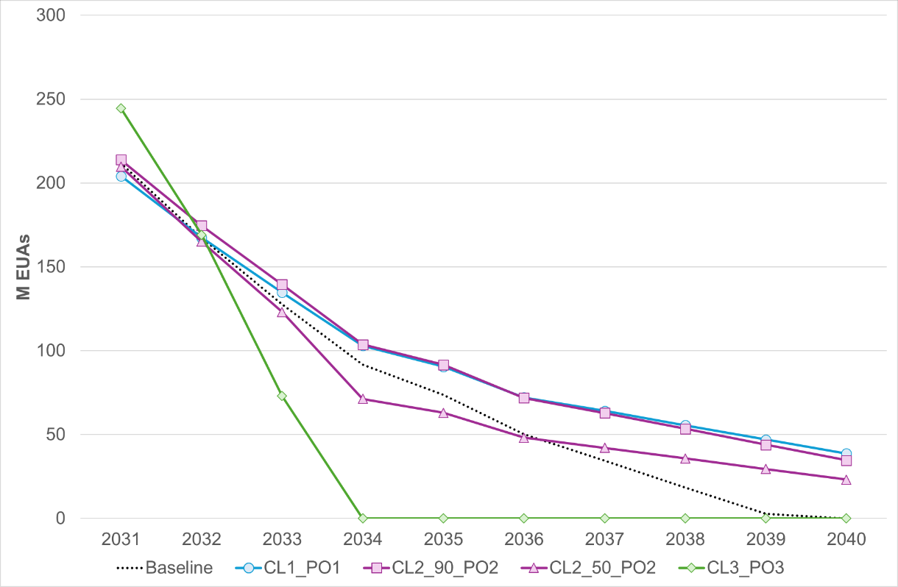
Source: Preliminary NIMs dataset (2019-23), Own calculation
While the economic impact of the policy measures on the conduct of business focuses primarily on changes in the allocation of free allowances across industry, the introduction of further conditionality under CL2 requires an assessment to quantify the potential positive impacts of requiring installations to make binding financing decisions of an equivalent value with the conditional free allocation to implement their climate neutrality plans. A share of free allocation will be made conditional on installations demonstrating that they have meaningful climate neutrality plans in place and that, by a certain deadline before the application for free allocation for the following period, have made binding financing decisions of an equivalent financial value with the conditional free allocation to implement their climate neutrality plans.
The estimation of free allocation volumes in this analysis over 2031-40 is a simplification as it relies upon the assumption that activity levels remain constant at 2023 levels for the entirety of Phase V.
The policy measures were designed to apply to sectors not currently covered by the CBAM. The rationale for this was that a phase out of free allocation for CBAM sectors was already legislated for under the CBAM regulation and the focus of the impact assessment was on how best to reform free allocation for the remaining sectors.
The analysis then concludes by summarising the relative changes in the volume of free allocation and its distribution across industry and then converted the allowances into a monetary value by applying an average EUA price projected for the 2031-40 period to quantify the potential economic impact on the conduct of business.
Baseline
Table 5 shows that the overall budget for free allocation between 2031-40 in the baseline. The starting point for the estimation is the free allocation budget, which is set based upon the ETS cap and the share of it reserved for free allocation. In the baseline, the total free allocation budget is assumed to be 1,453 M EUAs over 2031-40. The preliminary free allocation was then calculated following a bottom-up approach (see discussion above) and this resulted in a total of 3,417 M EUAs over 2031-40. As the preliminary allocation exceeded the free allocation budget, the CSCF was progressively applied over the period with the value declining rapidly from 0.55 in 2034 to 0 by 2040. The application of the CSCF allows the final free allocation budget to not exceed the free allocation budget for the 2031-40 period. In a final step, the CBAM factor was applied over Phase V for sub-installations covered by the CBAM and this reduced the total free allocation over 2031-40 to 778 M EUAs in the baseline.
- Estimation of the total volume of free allowances available under the baseline for 2031-2040

 | 2031 | 2032 | 2033 | 2034 | 2035 | 2036 | 2037 | 2038 | 2039 | 2040
FA Budget | 316 | 278 | 239 | 200 | 161 | 123 | 84 | 45 | 7 | 0
FA (Preliminary) | 366 | 366 | 366 | 365 | 365 | 318 | 318 | 318 | 318 | 317
CSCF | 0.86 | 0.76 | 0.65 | 0.55 | 0.44 | 0.39 | 0.26 | 0.14 | 0.02 | 0.00
FA (before CBAM phase out) | 316 | 278 | 239 | 200 | 161 | 123 | 84 | 45 | 7 | 0
FA (after CBAM phase out) | 212 | 167 | 128 | 92 | 74 | 50 | 34 | 19 | 3 | 0
Source: Own calculation based upon preliminary NIMs data for 2019-23
Figure 3 shows how the distribution of free allocation to sectors develops over time in Phase V of the EU ETS under the baseline. The manufacture of refined petroleum products (NACE code 19.20) would receive around 202 million EUAs for free under the baseline over 2031-40. Given that the refineries sector was identified previously in the scoping exercise as the highest emitter between 2021 and 2023 after the iron and steel and cement sectors, it is to be expected that this sector would account for the largest share of allowances over the 2031-40 period as the CBAM progressively reduces free allocation in the covered sectors. Indeed, although the manufacture of basic iron and steel and of ferro alloys (NACE code 24.10) received 76 million EUAs for free and the manufacture of cement (NACE code 23.51) received 47 million EUAs for free, the majority of these free allowances were distributed only up until 2034.

- Distribution of free allocation under the baseline for 2031-40
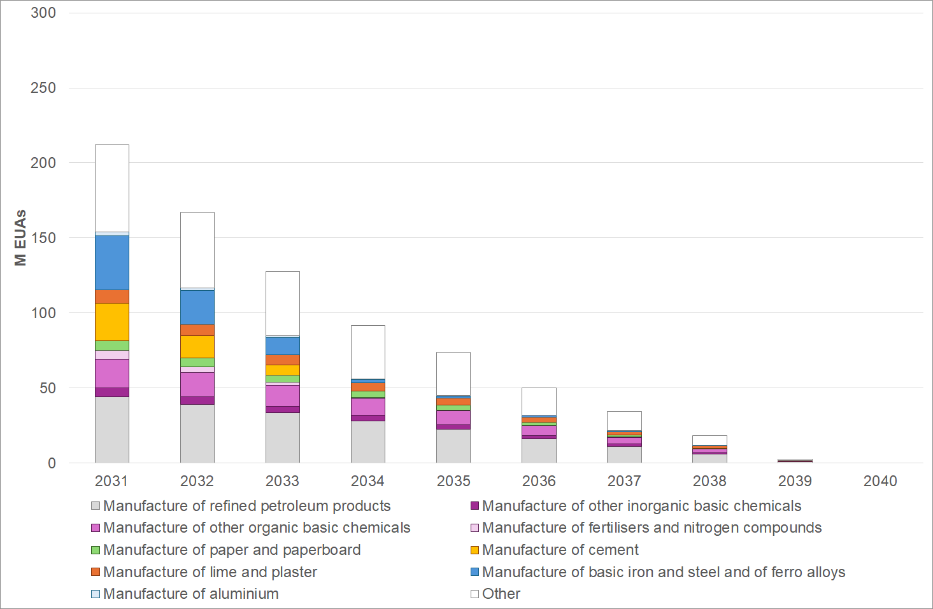
Source: Own calculation based upon preliminary NIMs data for 2019-23
Policy Measures
The policy measures are designed with a higher free allocation budget between 2031-40, compared to the baseline scenario. The higher free allocation budget reflects the fact that the overall ETS cap is assumed to be less stringent than in the baseline. How this free allocation budget is distributed across industrial sectors however varies by the different policy measures.
CL1 (PO1)
Table 6 shows that the overall budget for free allocation between 2031-40 in CL1, which is assumed to be 1,934 M EUAs over 2031-40. The preliminary free allocation was then calculated following a bottom-up approach and this resulted in a total of 3,425 M EUAs over 2031-40. As the preliminary allocation exceeded the free allocation budget, the CSCF was progressively applied over the period with the value declining from 0.83 in 2031 to 0.30 by 2040. The increased volume of free allocation in CL1 compared to the baseline results in a higher CSCF over the period. The application of the CSCF allows the final free allocation budget to not exceed the free allocation budget for the 2031-40 period. In a final step, the CBAM factor was applied over Phase V for sub-installations covered by the CBAM and this reduced the total free allocation over 2031-40 to 978 M EUAs.
- Estimation of the total volume of free allowances available under CL1 for 2031-40

 | 2031 | 2032 | 2033 | 2034 | 2035 | 2036 | 2037 | 2038 | 2039 | 2040
FA Budget | 305 | 278 | 252 | 225 | 197 | 176 | 156 | 136 | 115 | 95
FA (Preliminary) | 367 | 366 | 366 | 366 | 366 | 319 | 319 | 319 | 319 | 319
CSCF | 0.83 | 0.76 | 0.69 | 0.61 | 0.54 | 0.55 | 0.49 | 0.43 | 0.36 | 0.30
FA (before CBAM phase out) | 305 | 278 | 252 | 225 | 197 | 176 | 156 | 136 | 115 | 95
FA (after CBAM phase out) | 204 | 167 | 135 | 103 | 90 | 72 | 64 | 56 | 47 | 39
Source: Own calculation based upon preliminary NIMs data for 2019-23
Figure 4 shows how the distribution of free allocation to sectors develops over time under CL1. The manufacture of refined petroleum products (NACE code 19.20) would receive around 266 million EUAs for free over 2031-40 and this is followed by the manufacture of other organic basic chemicals (NACE code 20.14), the manufacture of basic iron and steel and of ferro alloys (NACE code 24.10) and the manufacture of lime (NACE code 23.52) that receive 108 million EUAs, 80 million EUAs and 46 million EUAs respectively over 2031-40. In contrast to the baseline, there are considerably more allowances available for free up until the end of Phase V and this reflects the less stringent cap that also reduces the need for the full application of the CSCF.
- Distribution of free allocation under CL1 for 2031-40
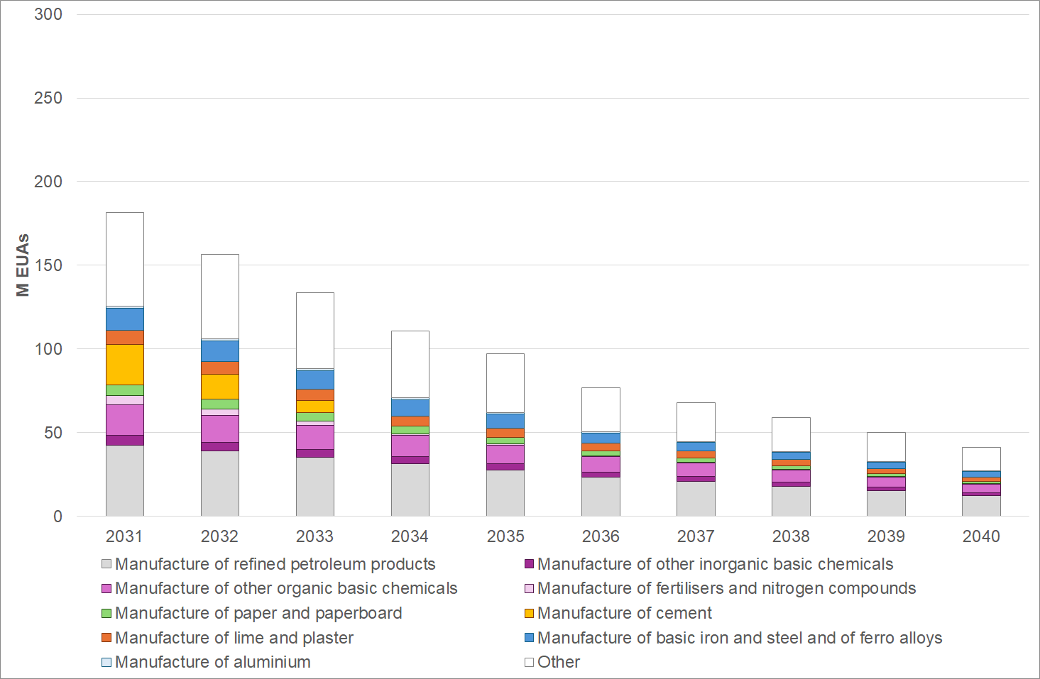
Source: Own calculation based upon preliminary NIMs data for 2019-23
CL2_90 (PO2)
Table 7 shows that the overall budget for free allocation between 2031-40 in the CL2_90 scenario, which is assumed to be 2,206 M EUAs over 2031-40. The preliminary free allocation was then calculated following a bottom-up approach and this resulted in a total of 3,306 M EUAs over 2031-40. The preliminary allocation is lower than under the CL1 scenario as the CL2_90 scenario assumes that in the 2031-40 period that an increasing share of the free allocation will be conditional. The total volume of the primary allocation is, however, like the CL1 scenario as a compliance rate of 90% is assumed in the first variant of the CL2 scenario. As the preliminary allocation exceeded the free allocation budget, the CSCF was progressively applied over the period with the value declining from 0.88 in 2031 to 0.31 by 2040. The slightly lower preliminary free allocation under the CL2_90 scenario (as well as the higher free allocation budget) compared to the CL1 scenario results in the application of a more stringent CSCF across the period. The application of the CSCF allows the final free allocation budget to not exceed the free allocation budget for the 2031-40 period. In a final step, the CBAM discount factor was applied over Phase V for sub-installations covered by the CBAM and this reduced the total free allocation over 2031-40 to 990 M EUAs.
- Estimation of the total volume of free allowances available under CL2_90 for 2031-40

 | 2031 | 2032 | 2033 | 2034 | 2035 | 2036 | 2037 | 2038 | 2039 | 2040
FA Budget | 320 | 293 | 267 | 240 | 212 | 187 | 163 | 139 | 114 | 90
FA (Preliminary) | 363 | 360 | 356 | 349 | 349 | 306 | 306 | 306 | 306 | 305
CSCF | 0.88 | 0.82 | 0.75 | 0.69 | 0.61 | 0.61 | 0.53 | 0.45 | 0.37 | 0.30
FA (before CBAM phase out) | 320 | 293 | 267 | 240 | 212 | 187 | 163 | 139 | 114 | 90
FA (after CBAM phase out) | 214 | 175 | 139 | 104 | 92 | 72 | 63 | 53 | 44 | 35
Source: Own calculation based upon preliminary NIMs data for 2019-23.
Figure 5 shows how the distribution of free allocation to sectors develops over time under the CL2_90 scenario. The manufacture of refined petroleum products (NACE code 19.20) would receive around 267 million EUAs for free over 2031-40 and this is followed by the manufacture of other organic basic chemicals (NACE code 20.14), the manufacture of basic iron and steel and of ferro alloys (NACE code 24.10) and the manufacture of lime (NACE code 23.52) that receive 109 million EUAs, 84 million EUAs and 54 million EUAs respectively over 2031-40. In contrast to the CL1 scenario, even though the preliminary free allocation is slightly lower in the CL2_90 scenario due to the implementation of conditionalities with a compliance rate of 90%, there are still more allowances available for free in the final allocation (after the application of the CSCF) up until the end of Phase V under the CL2_90 scenario and this primarily reflects the higher free allocation budget due to the higher cap as a result of including waste incineration in the ETS (in comparison to the CL1 scenario).
- Distribution of free allocation under CL2_90 for 2031-40
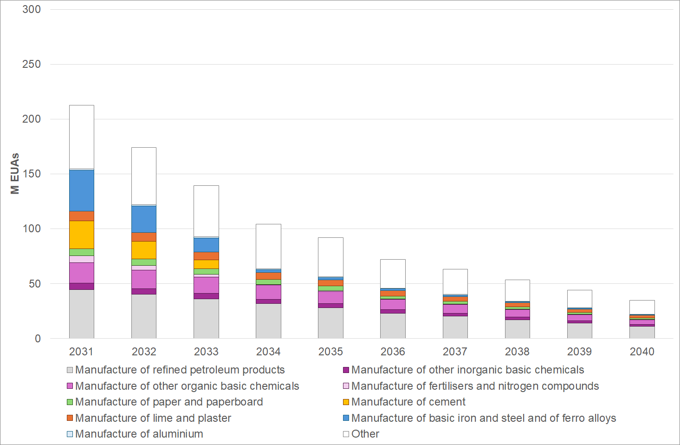
Source: Own calculation based upon preliminary NIMs data for 2019-23
The introduction of further conditionalities under CL2 are expected to impact the level of investment in abatement options to accelerate rates of decarbonisation and therefore further impact the conduct of business by insisting that installations make binding financing decisions of an equivalent value with the conditional free allocation to implement their climate neutrality plans. Under CL2, the share of free allowances that are subject to conditionality increases from 20% in 2031, 40% in 2032, 60% in 2033, 80% in 2034 and then 100% from 2035 up until 2040. The value of the free allocation that is subject to further conditionalities under CL2_90 is estimated by multiplying the volume of the preliminary free allocation that is subject to conditionality each year for non-CBAM sectors by firstly the CSCF for the CL2_90 scenario, assuming an average price of EUR 150 over the period. . The expected level of investment because of the introduction of further conditionalities under CL2_90 for non-CBAM sectors only is estimated to be around EUR 90 billion over the 2031-40 period. It is important to note that this amount is not necessarily additional, as it is not possible to estimate how much from the free allocation given without any conditions would be spent on investments regardless.
CL2_90 CBAM variant
Table 8 shows that the overall budget for free allocation between 2031-40 in the CL2_90 (CBAM variant), which returns 15% of the allowances initially taken away by the application of the CBAM factor from the sectors covered under the CBAM. The starting point for the estimation is the free allocation budget, which is set based upon the ETS cap and the share of it reserved for free allocation. In the CL2_90 (CBAM variant) scenario, the total free allocation budget is assumed to be 2,206 M EUAs over 2031-40. The preliminary free allocation was then calculated following a bottom-up approach and this resulted in a total of 3,306 M EUAs over 2031-40. As the preliminary allocation exceeded the free allocation budget, the CSCF was progressively applied over the period with the value declining rapidly from 0.69 in 2034 to 0.30 by 2040. The application of the CSCF allows the final free allocation budget to not exceed the free allocation budget for the 2031-40 period. In a final step, the CBAM discount factor was applied over Phase V for sub-installations covered by the CBAM but with 15% of the allowances initially removed each year subsequently returned to these installations under the CL2_90 (CBAM variant) scenario and this therefore increased (compared to the CL2_90 scenario) the total final free allocation over 2031-40 to 1,146 M EUAs.
- Estimation of the total volume of free allowances available under CL2_90 (CBAM variant) for 2031-40

 | 2031 | 2032 | 2033 | 2034 | 2035 | 2036 | 2037 | 2038 | 2039 | 2040
FA Budget | 320 | 293 | 267 | 240 | 212 | 187 | 163 | 139 | 114 | 90
FA (Preliminary) | 363 | 360 | 356 | 349 | 349 | 306 | 306 | 306 | 306 | 305
CSCF | 0.88 | 0.82 | 0.75 | 0.69 | 0.61 | 0.61 | 0.53 | 0.45 | 0.37 | 0.30
FA (before CBAM phase out) | 320 | 293 | 267 | 240 | 212 | 187 | 163 | 139 | 114 | 90
FA (after CBAM phase out) | 230 | 192 | 159 | 124 | 110 | 89 | 78 | 66 | 54 | 43
Source: Own calculation based upon preliminary NIMs data for 2019-23
Under the CL2_90 CBAM variant scenario, the manufacture of basic iron and steel and of ferro alloys (NACE code 24.10) receives 161 million EUAs for free and the manufacture of cement (NACE code 23.51) receives 100 million EUAs for free, most of these free allowances were distributed only up until 2034. These values are higher in the CL2_90 CBAM variant than in the CL2_90 scenario due to the return of 15% of the allowances that were initially taken away from both sectors due to the application of the CBAM factor.
- Distribution of free allocation under CL2_90 (CBAM variant) for 2031-40
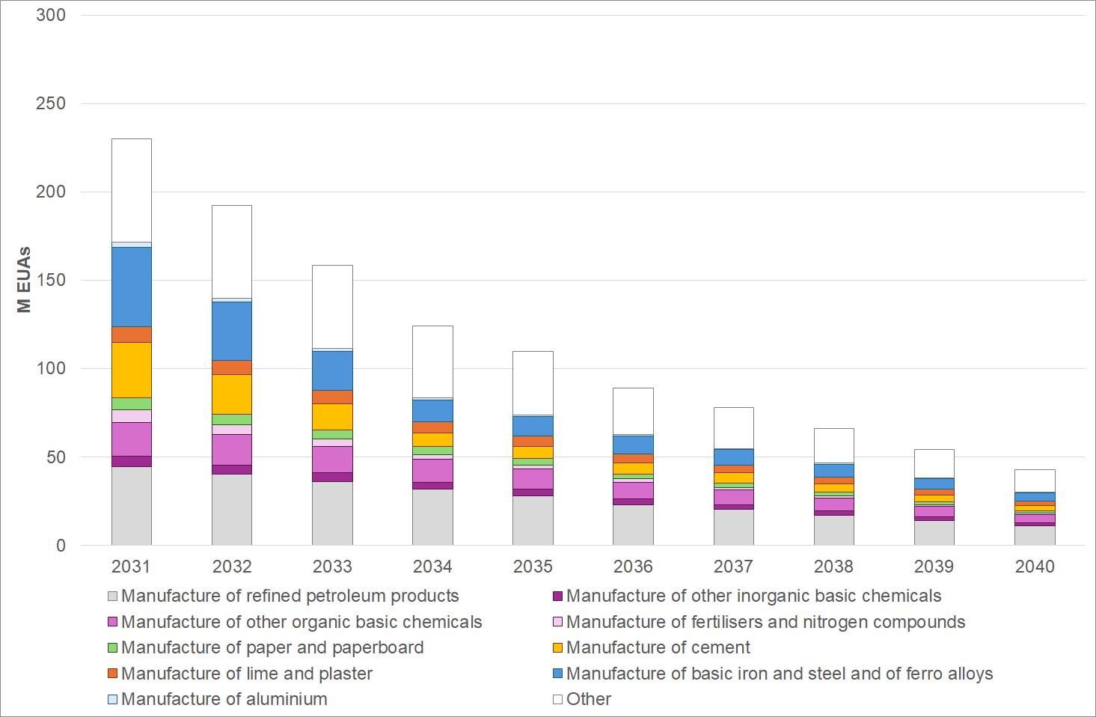
Source: Own calculation based upon preliminary NIMs data for 2019-23
CL2_50 (PO2)
Table 9 shows that the overall budget for free allocation between 2031-40 in the CL2_50 scenario, which is assumed to be 2,206 M EUAs over 2031-40. The preliminary free allocation was then calculated following a bottom-up approach and this resulted in a total of 2,829 M EUAs over 2031-40. The preliminary allocation is lower than under the CL2_90 scenario as the CL2_50 scenario assumes that in the 2031-40 period that an increasing share of the free allocation will be conditional but that the compliance rate falls of 50%. As the preliminary allocation exceeded the free allocation budget, the CSCF was progressively applied over the period with the value declining from 0.92 in 2031 to 0.36 by 2040. The lower preliminary free allocation under the CL2_50 scenario compared to the CL2_90 scenario results in the application of a higher CSCF across the period. The application of the CSCF allows the final free allocation budget to not exceed the free allocation budget for the 2031-40 period. In a final step, the CBAM discount factor was applied over Phase V for sub-installations covered by the CBAM and this reduced the total free allocation over 2031-40 to 811 M EUAs.
- Estimation of the total volume of free allowances available under CL2_50 for 2031-40

 | 2031 | 2032 | 2033 | 2034 | 2035 | 2036 | 2037 | 2038 | 2039 | 2040
FA Budget | 320 | 293 | 267 | 240 | 212 | 187 | 163 | 139 | 114 | 90
FA (Preliminary) | 350 | 333 | 316 | 282 | 282 | 254 | 254 | 254 | 253 | 253
CSCF | 0.92 | 0.88 | 0.85 | 0.85 | 0.75 | 0.74 | 0.64 | 0.55 | 0.45 | 0.36
FA (before CBAM phase out) | 320 | 293 | 267 | 240 | 212 | 187 | 163 | 139 | 114 | 90
FA (after CBAM phase out) | 210 | 165 | 123 | 71 | 63 | 48 | 42 | 36 | 29 | 23
Source: Own calculation based upon preliminary NIMs data for 2019-23
Figure 7 shows how the distribution of free allocation to sectors develops over time under the CL2_50 scenario. The manufacture of refined petroleum products (NACE code 19.20) would receive around 208 million EUAs for free over 2031-40 and this is followed by the manufacture of other organic basic chemicals (NACE code 20.14), the manufacture of basic iron and steel and of ferro alloys (NACE code 24.10) and the manufacture of cement (NACE code 23.51) that receive 85 M EUAs, 84 million EUAs and 52 million EUAs respectively over 2031-40. In contrast to the CL2_90 scenario, the preliminary free allocation is lower in the CL2_50 scenario due to the implementation of conditionalities for non-CBAM sectors with a compliance rate of only 50%. However, the preliminary allocation still exceeds the free allocation budget under CL2_50, so a CSCF remains necessary, albeit the CSCF values are higher than under the CL2_90 scenario. As the conditionalities do not apply to CBAM sectors, the preliminary allocation is higher for these sectors and with the use of a higher CSCF throughout the 2031-40 period this means that the final allocation is also higher than the CL2_90 scenario after the application of the CBAM factor to phase out their free allocation up until 2034.
- Distribution of free allocation under CL2_50 for 2031-40
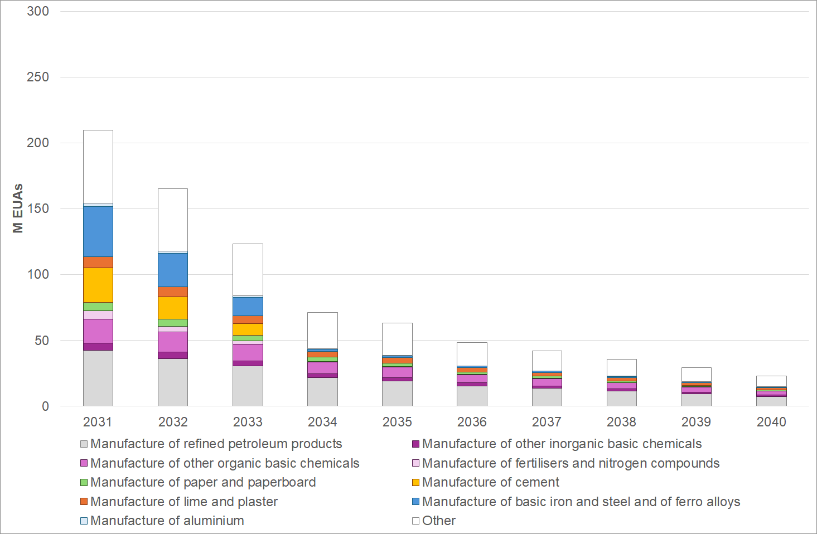
Source: Own calculation based upon preliminary NIMs data for 2019-23
The value of the free allocation that is subject to further conditionalities under CL2_50 is estimated by multiplying the volume of the preliminary free allocation that is subject to conditionality each year for non-CBAM sectors by the CSCF for the CL2_50 scenario, assuming an average price of EUR150 over the period. The expected level of investment because of the introduction of further conditionalities under CL2_50 for non-CBAM sectors only is estimated to be around EUR 50 billion over the 2031-40 period.
CBAM variant
Table 10 shows that the overall budget for free allocation between 2031-40 in the CL2_50 (CBAM variant), which returns 15% of the allowances initially taken away by the application of the CBAM factor from the sectors covered under the CBAM. The starting point for the estimation is the free allocation budget, which is set based upon the ETS cap and the share of it reserved for free allocation. In the CL2_50 (CBAM variant) scenario, the total free allocation budget is assumed to be 2,206 M EUAs over 2031-40. The preliminary free allocation was then calculated following a bottom-up approach and this resulted in a total of 2,829 M EUAs over 2031-40. As the preliminary allocation exceeded the free allocation budget, the CSCF was progressively applied over the period with the value declining rapidly from 0.85 in 2034 to 0.36 by 2040. The application of the CSCF allows the final free allocation budget to not exceed the free allocation budget for the 2031-40 period. In a final step, the CBAM discount factor was applied over Phase V for sub-installations covered by the CBAM but with 15% of the allowances initially removed each year subsequently returned to these installations under the CL2_90 (CBAM variant) scenario and this therefore increased (compared to the CL2_50 scenario) the total final free allocation over 2031-40 to 993 M EUAs.
- Estimation of the total volume of free allowances available under CL2_50 (CBAM variant) for 2031-40

 | 2031 | 2032 | 2033 | 2034 | 2035 | 2036 | 2037 | 2038 | 2039 | 2040
FA Budget | 320 | 293 | 267 | 240 | 212 | 187 | 163 | 139 | 114 | 90
FA (Preliminary) | 350 | 333 | 316 | 282 | 282 | 254 | 254 | 254 | 253 | 253
CSCF | 0.92 | 0.88 | 0.85 | 0.85 | 0.75 | 0.74 | 0.64 | 0.55 | 0.45 | 0.36
FA (before CBAM phase out) | 320 | 293 | 267 | 240 | 212 | 187 | 163 | 139 | 114 | 90
FA (after CBAM phase out) | 226 | 184 | 145 | 97 | 85 | 69 | 60 | 51 | 42 | 33
Source: Own calculation based upon preliminary NIMs data for 2019-23
Under the CL2_50 CBAM variant scenario, the manufacture of basic iron and steel and of ferro alloys (NACE code 24.10) receives 174 million EUAs for free and the manufacture of cement (NACE code 23.51) receives 121 million EUAs for free, the majority of these free allowances were distributed only up until 2034. These values are higher in the CL2_50 CBAM variant than in the CL2_50 scenario due to the return of 15% of the allowances that were initially taken away from both sectors due to the application of the CBAM factor.
CL3 (PO3)
Table 11 shows that the overall budget for free allocation between 2031-40 in CL3, which is assumed to be 2.367 M EUAs over 2031-40, which is higher than the free allocation budget under CL1 or CL2. The preliminary free allocation was then calculated following a bottom-up approach and this resulted in a total of 2,285 M EUAs over 2031-40. This preliminary allocation is considerably lower than under CL1 and CL2 as free allocation provision is discontinued from 2034 onwards for non-CBAM as well as CBAM sectors. Under CL3 the CSCF is only applied in 2031 and for the subsequent years the preliminary allocation is lower than the free allocation budget. In a final step, the CBAM discount factor was applied over Phase V for sub-installations covered by the CBAM and this reduced the total free allocation over 2031-40 to 487 M EUAs in CL3.
- Estimation of the total volume of free allowances available under CL3 for 2031-40

 | 2031 | 2032 | 2033 | 2034 | 2035 | 2036 | 2037 | 2038 | 2039 | 2040
FA Budget | 354 | 326 | 299 | 270 | 241 | 218 | 198 | 176 | 154 | 132
FA (Preliminary) | 390 | 315 | 243 | 198 | 198 | 188 | 188 | 188 | 188 | 188
CSCF | 0.91 | 1.00 | 1.00 | 1.00 | 1.00 | 1.00 | 1.00 | 1.00 | 1.00 | 1.00
FA (before CBAM phase out) | 354 | 315 | 243 | 198 | 198 | 188 | 188 | 188 | 188 | 188
FA (after CBAM phase out) | 245 | 169 | 73 | 0 | 0 | 0 | 0 | 0 | 0 | 0
Source: Own calculation based upon preliminary NIMs data for 2019-23.
Figure 8 shows the distribution of free allocation under CL3. In contrast to the baseline, no free allocation is provided to both CBAM and non-CBAM sectors from 2034 onwards. This policy measure has a significant impact on non-CBAM sectors as they receive considerably less free allocation over 2031-40 compared to the baseline. For example, under CL3 the manufacture of refined petroleum products (NACE code 19.20) and the manufacture of other organic basic chemicals (NACE code 2014) would only receive around 95 M EUAs and 56 M EUAs respectively. The impact is less for CBAM covered sectors such as the manufacture of basic iron and steel and of ferro alloys (NACE code 2410) and the manufacture of cement (NACE code 2351) as the phase out of their free allocation is already modelled in the baseline and policy scenarios. Both sectors receive 81 M EUAs and 56 M EUAs respectively.
- Distribution of free allocation based under CL3 for 2031-40
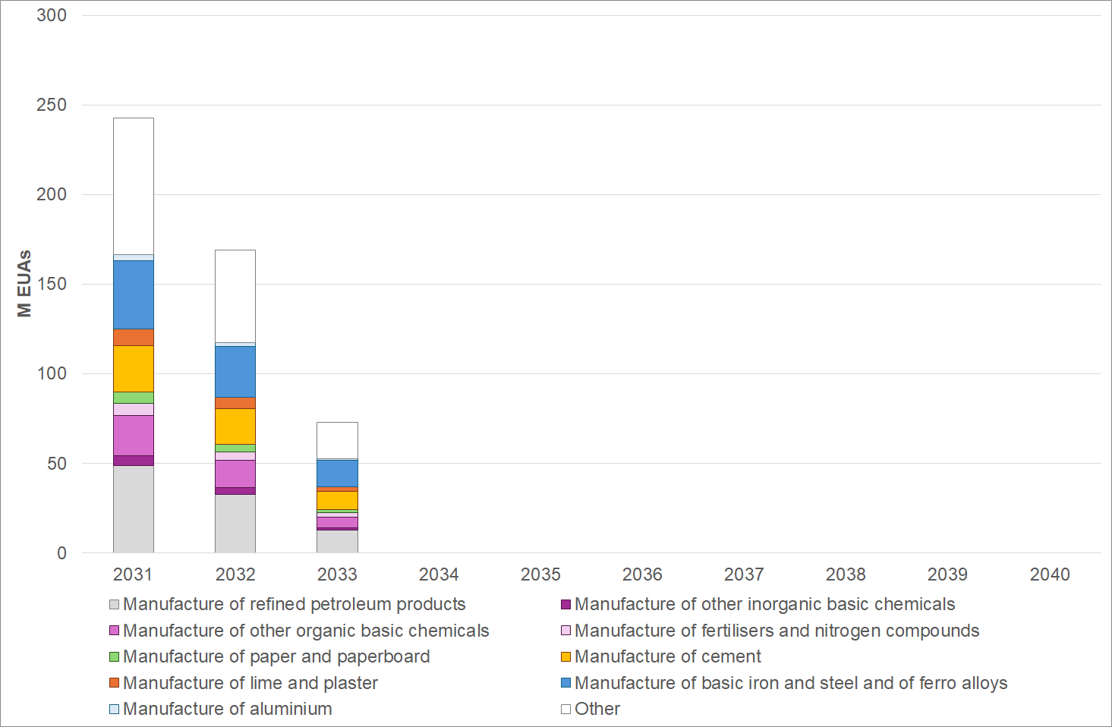
Source: Own calculation based upon preliminary NIMs data for 2019-23
Summary
The economic impact of the policy measures relates to the cost of installations paying for an increasing share of their emissions as free allocation is reduced. Given that the ETS cap will progressively decline over the 2031-40 period, the availability of free allowances will become scarce in all scenarios, however the overall budget of free allocation and the timing of the phase out vary. As the ETS cap in the policy scenarios is less stringent than the baseline, free allocation is higher except for CL3.
In terms of the economic value of the free allocation provided to these sectors it will depend upon the development of the EUA price over the 2031-40 period, which is assumed at EUR 150 over the 2031-2040. The same price assumption was used for estimating the total financial value of free allocation across all policy options – see table 12.
- Overview of the 2031-40 free allowances and their economic value in the baseline scenario and the policy measures
 | 2031-2040
EUR/tCO2 | EUR 150.0
Baseline FA (mil EUAs) | 779
Baseline FA value (bn EUR) | EUR 116.9
CL1_PO1 (mil EUAs) | 977
CL1_PO1 value (bn EUR) | EUR 146.6
CL2_90_PO2 (mil EUAs) | 991
CL2_90_PO2 value (bn EUR) | EUR 148.7
CL2_90_PO2 (CBAM Var) (mil EUAs) | 1145
CL2_90_PO2 (CBAM Var) value (bn EUR) | EUR 171.8
CL2_50_PO2 (mil EUAs) | 810
CL2_50_PO2 value (bn EUR) | EUR 121.5
CL2_50_PO2 (CBAM Var) (mil EUAs) | 992
CL2_50_PO2 (CBAM Var) value (bn EUR) | EUR 148.8
CL3_PO3 (mil EUAs) | 487
CL3_PO3 value (bn EUR) | EUR 73.1

Source: Own calculation based upon preliminary NIMs data for 2019-23
        - Carbon leakage prevention measures for indirect emissions
Currently, the provision of indirect cost compensation is fragmented across the EU. Under option ICC1, the economic impact in 2031-2040 will depend on whether there is a continuation of the existing State aid encouragement, on how this encouragement is implemented through the relevant State aid rules. Alternatively, it will be affected by the design of a harmonised system (ICC2).
To estimate the scale of the support that may be provided over Phase V of the EU ETS, a quantitative exercise was undertaken based on adjusting recent ICC compensation payments to account for possible developments post-2030. The estimates generated from this exercise must be considered tentative. They explore how today’s ICC compensation could be affected by plausible post-2030 developments, but do not model the impacts of the policy options themselves.
Observed ICC payments amounted to EUR 4.1 billion for costs incurred in 2021-2023 on average, ranging from EUR 2.2 billion in 2021 to EUR 5.5 billion in 2023, with the variation explained mainly by increases in the carbon price over this period (see Annex 15 on the ETS Evaluation for additional backward-looking analysis of ICC compensation).
A proxy for potential increased Member State participation in ICC compensation was created using Eurostat data on industrial electricity consumption in ICC-relevant sectors. This suggested that ICC compensation could increase by 18% if more Member States chose to offer compensation. It implicitly assumes that the new national schemes would adopt the average aid intensity of the existing Member State schemes. Figure 9 suggests that most of this increase would come from Sweden. However, it is important to note that the emissions factors in the current State aid guidelines are likely to overstate the extent of indirect cost in this Member State, since the guidelines assume a single emission factor per Member State, while Sweden has four electricity price zones, with a lot of electro-intensive industry located in Northern zones where electricity is cheaper and less carbon intensive.
The potential for higher aid intensity by Member States was estimated by using the ratio of ICC payments to relevant industrial electricity consumption over the period 2021-2023. Using this metric, ICC compensation would increase by a further 49% if all Member States were to provide ICC at the same intensity as Germany (the largest provider of aid in absolute terms).
Industrial electricity consumption post-2030 was estimated using a PRIMES model scenario, consistent with an 85% domestic economy-wide reduction in GHG emissions compared to 1990 levels. By this metric, average annual electricity consumption in relevant sectors is expected to remain broadly flat in the period 2030-2040, compared to 2020-2025, with a reduction of 2%. This result is driven by an increased consumption due to electrification (especially in iron & steel) combined with reductions driven by energy efficiency improvements in other sectors (e.g. pulp & paper, non-ferrous metals).
Decarbonisation of the power supply is expected to reduce indirect carbon costs post-2030.
Applying an emission factor based on the GHG intensity of electricity generated by fossil fuels (in the same PRIMES scenario) is expected to reduce ICC by 14% on average. This is due to expected coal-to-gas switching in the power sector.
Applying a marginal emissions factor could reduce ICC by 58% over the 2030-2040 period due to the expected increased contribution of non-fossil sources in setting electricity prices. This estimate is based on JRC analysis of how marginal price-setting technologies per Member State may evolve up to 2030, combined with a literature-based assumption that fossil-fuel price-setting will fall to 8% of the time by 2040.
The carbon price is assumed to reach an average level of EUR 150 in the period 2031-2040 , compared to EUR 53 used as the basis for ICC calculation in 2021-2023 on average..
Table 13 below shows the combined impact of the above estimates for the period 2030-40 on average. It suggests that greater aid provision, from higher participation and/or aid intensity, could increase ICC costs by 76%. Such an increase could result from Member States choosing to offer more State aid (ICC1) or through a harmonised ICC fund (ICC2).
Regarding post-2030 effects, the greatest impact on ICC cost is expected to be a higher carbon price. This would increase both the cost of ICC compensation and the revenues from which it would be financed, although the revenue increase will be partly offset by reduction of the overall cap. On the other hand, this effect could largely be offset by electricity market decarbonisation, provided that i) this leads to a reduction in fossil fuel technologies setting the electricity price, and ii) ICC compensation rules are adjusted to reflect this.
- Decomposition of factors that could affect the total cost of indirect carbon cost compensation post-2030
 | Default emission factor |  | Market-based emission factor
 | % impact | EUR bn | % impact | EUR bn
ICC compensation avg. 2021-2023 | - | 4.1 | - | 4.1
increased Member State participation | +18% | 4.8 | +18% | 4.8
higher aid intensity | +49% | 6.1 | +49% | 6.1
participation & aid intensity combined | +76% | 7.2 | +76% | 7.2
industrial electricity consumption 2031-40 avg. | -2% | 4.0 | -2% | 4.0
decarbonisation of power supply 2031-40 avg. | -14% | 3.5 | -58% | 3
carbon price 2031-40 avg. | +174% | 11.2 | +174% | 11.2
post-2030 effects combined | +141% | 9.9 | +18% | 4.8
all impacts combined | +310% | 16.8 | +102% | 8.3
Source: European Commission analysis combining inputs from annual reports on the functioning of the European carbon market, PRIMES, Eurostat, JRC analysis, Geis et al. (2025)
The above estimates imply a level of indirect costs equivalent to 11% to 22% of total ETS revenues in the 2031-2040 period on average, which would constrain other uses of these resources.
In option ICC1, Member States would decide how best to allocate their auction share between ICC compensation and other uses. They may also use other national revenues to fund ICC.
In option ICC2, it is suggested to limit the ICC fund to 5% of total auction revenues in order to provide resources for other uses while offering the benefits of a harmonised approach to ICC to the extent it is covered by the ICC Fund (certainty to firms and reduction in distortion of the single market). Since this level of resource may not fully compensate for the indirect carbon cost faced by industry, Member States would retain the possibility option to provide additional compensation through State aid.
The main economic impact of ICC2 compared to ICC1 would be to provide a minimum level of compensation to electro-intensive industries regardless of where they are located in the EU, thereby reducing the extent of fragmentation of the internal market. The extent to which ICC2 is preferable over ICC1 therefore depends on the extent to which fragmented provision of ICC compensation is a problem and on how this interplays with sufficient financial resources being available for ICC. Figure 9 provides insight into this issue by comparing each Member State’s share of indirect emissions (estimated using Eurostat electricity consumption data19 and emission factors from the State aid guidelines for 2021-2025) against its level of ICC compensation paid for the period 2021-2023. Share of emissions is used as a proxy for indicating the potential demand for compensation within each Member State. It suggests that, in general, the Member States who do not currently provide ICC compensation have little need to do so. Member States where indirect emissions appear high relative to the compensation paid include Spain, Austria, Italy, Romania, Slovakia and Portugal. Indirect emissions also appear high in Sweden and Finland in Figure 9, but the actual indirect emissions and associated cost may be lower in these countries due to zonal electricity pricing in the Swedish case, and industrial consumers generating their own electricity in the Finnish case (especially in the pulp and paper sector).
It is important to note that offering ICC compensation is a policy choice for each Member State regarding how to use their auction revenues. While the ETS Directive encourages Member States to limit their compensation to 25% of annual auction revenues, the actual share used varies considerably (see Figure 9). Furthermore, each Member State’s choice of whether to provide compensation and how much budget to allocate to it can vary year-on-year.

- Comparison of indirect cost compensation and share of indirect emissions per Member State (2021-2023 average)
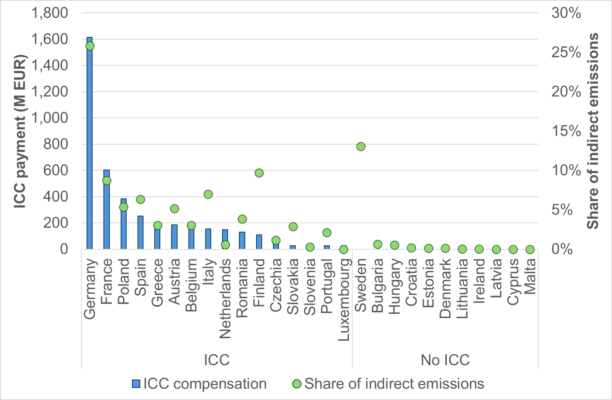
Source: European Commission annual reports on the functioning of the European carbon market (compensation), own calculation-based Eurostat electricity consumption and emission factors from State aid guidelines (indirect emissions)
In ICC1, each Member State retains the right to choose between ICC compensation and other revenue uses throughout the period to 2040. In ICC2, a share of ETS revenue (that would otherwise have gone to each Member State or to another EU-level instrument) is used to guarantee a certain level of ICC compensation to electro-intensive industries. Therefore, the question of whether to harmonise ICC compensation also represents a choice between providing discretionary resources to Member States vs. providing guaranteed EU-level carbon leakage protection to firms.
      - Administrative costs on businesses
        - Carbon leakage prevention measures for direct emissions
According to the Better Regulation Guidelines, the administrative costs consist of two different cost components:
- Business as usual costs (i.e. correspond to the costs resulting from collecting and processing information that would even be done in the absence of any legislation).
- Administrative burdens (i.e. stem from the part of the process which is done solely because of legal obligation).
The following tasks were considered as being an administrative burden on operators related to their application for free allocation:
- Learning of rules, workshops and stakeholder meetings.
- Commission Delegated Regulation (EU) 2019/3312 outlines in Article 4(2) the following particulars that accompany an application for free allocation for allocation data from 2021 onwards from the operator of an incumbent installation (requirements for new entrants are further outlined in Article 5):
- Baseline data report
- Monitoring methodology plan
- Verification report
- Commission Implementing Regulation (EU) 2019/1842 outlines in Article 3(1) that operators of installations to which free allocation has been given, in accordance with Article 10a of Directive 2003/87/EC, for the trading period from 2021 to 2030 shall report annually on the activity level of each sub-installation in the preceding calendar year
- Commission Delegated Regulation – EU – 2024/873 outlines in Article 22a conditionality of free allocation on implementation of energy efficiency improvement measures, in which the operator of an installation must demonstrate that recommendations from energy audits under Article 8 of Directive 2012/27/EU5 have been implemented
- Commission Delegated Regulation – EU – 2024/873 outlines in Article 22b conditionality of free allocation on climate neutrality plans to be submitted by the operator of an installation.
In accordance with the EU Standard Cost Model, it was necessary to identify and classify additional administrative obligations as well as any administrative obligations that may also be eliminated by the implementation of the policy measures.
All the policy measures include within their design that the carbon leakage list will not be updated for Phase V and the formula for determining free allocation will no longer include the carbon leakage exposure factor. This simplification will eliminate administrative obligations for ETS operators in all the policy measures, with considerable time spent on administration expected to be saved
Under CL1 there are no new administrative burdens added to ETS operators as the current approach is continued albeit with the modification to the formula for determining free allocation levels because of the discontinuation of the carbon leakage list. The existing obligations for ETS operators (i.e. provision of a baseline data report, monitoring methodology plan and verification plan) would be sufficient to update the existing product benchmarks as under CL1 no change to the current definition of the product benchmarks is considered (so no further inputs into an update of benchmarks would be required and therefore CL1 is not associated with additional administrative obligations).
New administrative requirements would, however, be introduced under CL2. Under this policy measure, it is expected that the conditionalities introduced for the period 2026-2030 would be expanded to include more ETS operators in Phase V of the EU ETS. The following complementary actions have been identified because of the additional administrative obligations:
- Time spent on learning rules, workshops, stakeholder meetings
- Time spent demonstrating that all recommendations from energy audits under Article 8 of Directive 2012/27/EU have been implemented
- Time spent preparing and submitting a carbon neutrality plan
Defining the target group and the frequency of the obligated actions are required as part of the assessment of additional costs using the EU Standard Cost Model.
Given that the extension of the conditionality requirement would be subject to further assessment, for the purpose of the impact assessment a range was used to identify the target group. It was assumed that the number of ETS operators that were subject to the conditionalities as applied in 2026-30 would increase by between 20% and 40% for 2031-40.
The frequency of the required action would remain unchanged and so, for example, demonstrating that recommendations from energy audits have been implemented or the submission of climate neutrality plans would be a one-off activity at the start of Phase V.
To estimate the additional administrative cost of the complementary actions outlined above for CL2, a survey was developed and circulated to industrial stakeholders to provide information on the time spent (in person hours) on average, per year in 2021-24.
Respondents indicated that they spent on average:
- 33 person/hours on learning rules, workshops, stakeholder meetings (median value: 15 person/hours) out of 83 total responses.
- 17 person/hours on demonstrating that all recommendations from energy audits under Article 8 of Directive 2012/27/EU have been implemented (median value: 6 person/hours) out of 76 total responses.
- 19 person/hours on preparing and submitting a carbon neutrality plan out of 69 total responses.
Considering an average cost of labour across Member States of EUR 40/hour (based on Eurostat data on Labour cost for LCI by country and industry for 2024), the average administrative cost per tonne of CO₂ is EUR 0.02, which represent a very small share (approximately 0.026%) of the carbon price (assumed to be EUR 64.74, which was the average price of a EUA in 2024 and is expected to be a conservative value).
To estimate the administrative cost, it is necessary to then scale the administrative cost per tonne by projected ETS industrial emissions in 2031 (i.e. around 400 Mt) and this results in an illustrative one-off administrative cost of around 8 M EURs. This is negligible compared to the estimated value of free allocation.
The stakeholder consultation revealed very strong views from industrial associations opposing the expansion of conditionality requirements for free allocation. In interviews and position papers, the argument was consistently advanced by these stakeholders that the purpose of free allocation is to protect industry from carbon costs and that it is not an instrument to directly influence other objectives such as promoting investments in low carbon technologies. Whilst this may indeed be seen as complementary and necessary to reduce industry’s exposure to the carbon price over Phase V, it was nevertheless a matter of principle for some stakeholders that the inclusion of conditionality requirements is not consistent with the original purpose of free allocation provision. However, results from the OPC also showed support for conditionality, mainly among companies and business associations from the energy sector and NGOs. Overall, making free allocation conditional on taking steps towards carbon neutrality was the fourth most frequently indicated preference (13% of all responses) to the question “on what basis should free allocation be provided beyond 2030 for sectors not covered by the CBAM” (multiple options could be selected).
Article 10a of the ETS Directive specifies that the free allocation rules shall be based on benchmarks, which account for the 10% most efficient installations, to provide incentives for reductions in greenhouse gas emissions and energy efficient techniques (by considering inter alia the most efficient techniques, substitutes and alternative production processes). It also states that free allocation shall not provide incentives to increase emissions. In this spirit, the option of placing mitigation-related conditions on free allocation is retained in this impact assessment.
In practical terms, industrial stakeholders commented frequently in both the OPC and interviews with industrial associations that any expansion of conditionality would add significant administrative burdens to ETS operators. Indeed, this view is consistent with the findings of the impact assessment that PO2 adds the highest additional administrative cost out of the policy options under consideration albeit the value is expected to be very low in comparison to the EUA price.
Given that free allocation would be phased out for non-CBAM sectors by 2034 and the time schedule for the reduction in the volume of free allowances received by ETS operators would be based on a declining share of their total verified emissions, it is to be expected that CL3 would result in a reduction in the administrative burden of businesses as they would no longer have the cost of applying for free allocation beyond 2034 and in the preceding years the input required would come from existing obligations (i.e. provision of a baseline data report, monitoring methodology plan and verification plan). It is important to add that whilst indeed the administrative costs would be lower if CL3 was adopted, this would lead to much higher carbon costs.
        - Carbon leakage prevention measures for indirect emissions
For ICC compensation, Option ICC1 would not involve significant change to the administrative cost for private sector. In this option, monitoring, reporting, verification and conditions for receiving support are elaborated in successive iterations of State aid guidelines.
Option ICC2 would create an additional administrative burden in cases where an installation receives support both from national State aid and from a harmonised EU system. ICC2 may also cover more firms than ICC1 (installations in Member States that do not offer national State aid), leading to administrative costs for these firms (but also benefits in the form of ICC compensation).
      - SMEs
        - Carbon leakage prevention measures for direct emissions
The SME test was applied to identify and assess the impact of the policy measures (related to direct emissions) on SMEs. In accordance with the better regulation guidelines, the SME test comprises the following components:
- Identification of affected businesses
- Consultation of SME stakeholders
- Assessment of the impact on SMEs
- Minimising negative impacts on SMEs
In a first step, the businesses most likely to be affected by the policy measures were identified by using the preliminary NIMs dataset to categorise sub-installation information for selected non-CBAM sectors into different tCO₂ emission ranges. However, SMEs cannot be directly identified from the ETS data available and therefore proxy measures based on low emissions or low power consumption are adopted for the SME test.
For the non-CBAM sectors selected shown in Figure 10, the lime and refined oil sectors have the lowest shares of their total sub-installations that emit under 5,000 tCO₂ (under 20% and around 20% respectively) while the ceramics and paper and paperboard sectors have the highest shares accounting for over 60% and 50% of their total sub-installations respectively. The chemical sectors both organic and inorganic are within this range with a 34% and 36% share of their total sub-installations that emit under 5,000 tCO₂ respectively.
The distribution of emissions across the different categories highlights some further key insights:
- Around 70% of the refined oil sector’s average 2021-23 emissions were generated by around 20% of their total number of sub-installations that emitted CO₂ above 1,000,000t.
- Around 77% of the lime sector’s average 2021-23 emissions were generated by around 32% of their total number of sub-installations that emitted CO₂ above 1,00,000t.
- Both inorganic and organic chemical sectors have a more even distribution of emission categories that contribute to their total emissions but still around 61% and 52% respectively of their average 2021-23 emissions were generated by around 7% and 5% respectively of their total number of sub-installations that emitted CO₂ above 250,000 t.
- Around 86% of the paper and paperboard sector’s average 2021-23 emissions were generated by around 46% of their total number of sub-installations that emitted CO₂ below 100,000t.
- Around 81% of the ceramic sector’s average 2021-23 emissions were generated by around 36% of their total number of sub-installations that emitted CO₂ below 50,000t.
The analysis of the preliminary NIMs dataset confirms that SMEs are likely to be impacted by the policy measures to phase out free allocation but that the impact on SMEs is likely to vary by non-CBAM sector.
SME stakeholders were represented by their sector associations in the stakeholder interviews as well as having the opportunity to submit their views within the OPC itself. In terms of the impact of the policy measures on SMEs within the non-CBAM sectors, the consultation exercise collected evidence that the concerns raised (i.e. increased direct carbon costs and a loss of international competitiveness) are very similar in nature to larger emitters but that the magnitude of the impact may be greater. It is to be expected that CL1 will have less of a negative impact on SMEs than CL2 or CL3 given that the non-CBAM sectors receive more free allowances under the current approach without imposing additional requirements under CL2 to comply with conditionalities or receiving less allowances under the more rapid phase out of free allocation envisaged under CL3 to align with CBAM sectors. Indeed, interviews with industrial stakeholders confirmed that the introduction of further conditionalities as envisaged in CL2 would impose some additional administrative costs on operators and that these would impact SMEs more. Given the strong insistence from industrial sectors for the continuation of free allocation their view that measures to more rapidly phase out free allocation as under CL3 would increase the risk of carbon leakage and that this risk would be greater for SMEs.
- Share of sub-installations and emissions (average 2021-23) by category size in tCO2 for selected non-CBAM sectors
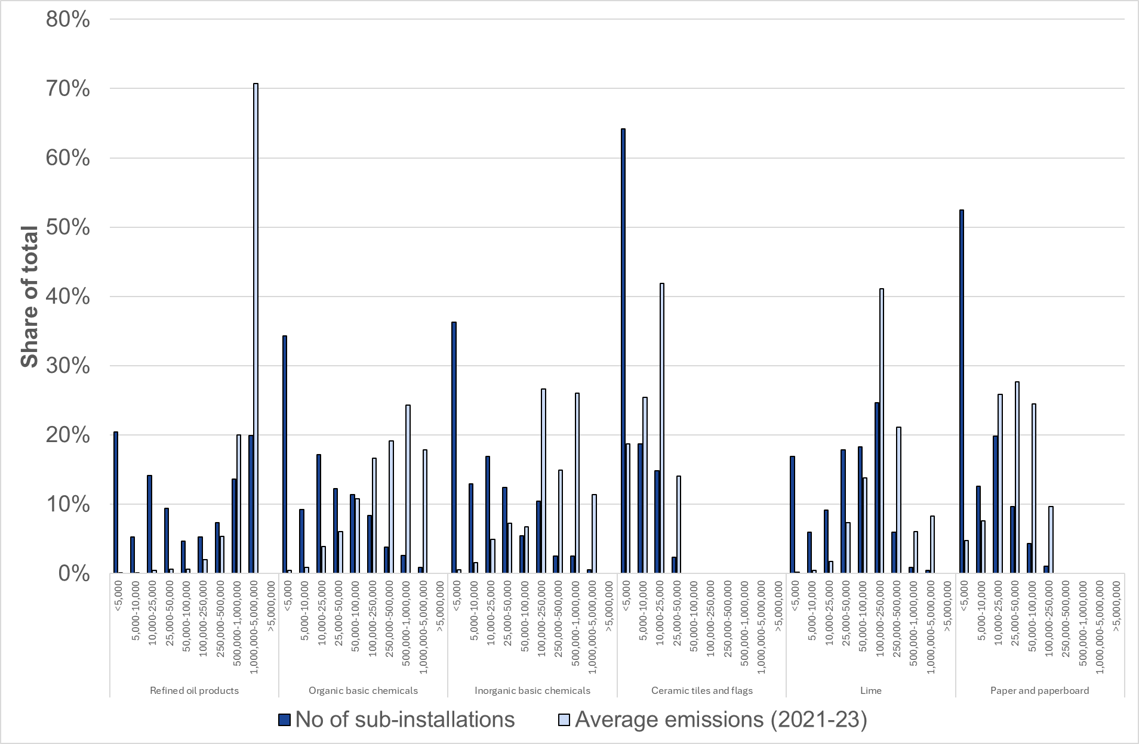
Source: Own calculation based upon preliminary NIMs data for 2019-23

- Share of sub-installations and emissions (average 2021-23) by category size in tCO2 for selected CBAM sectors
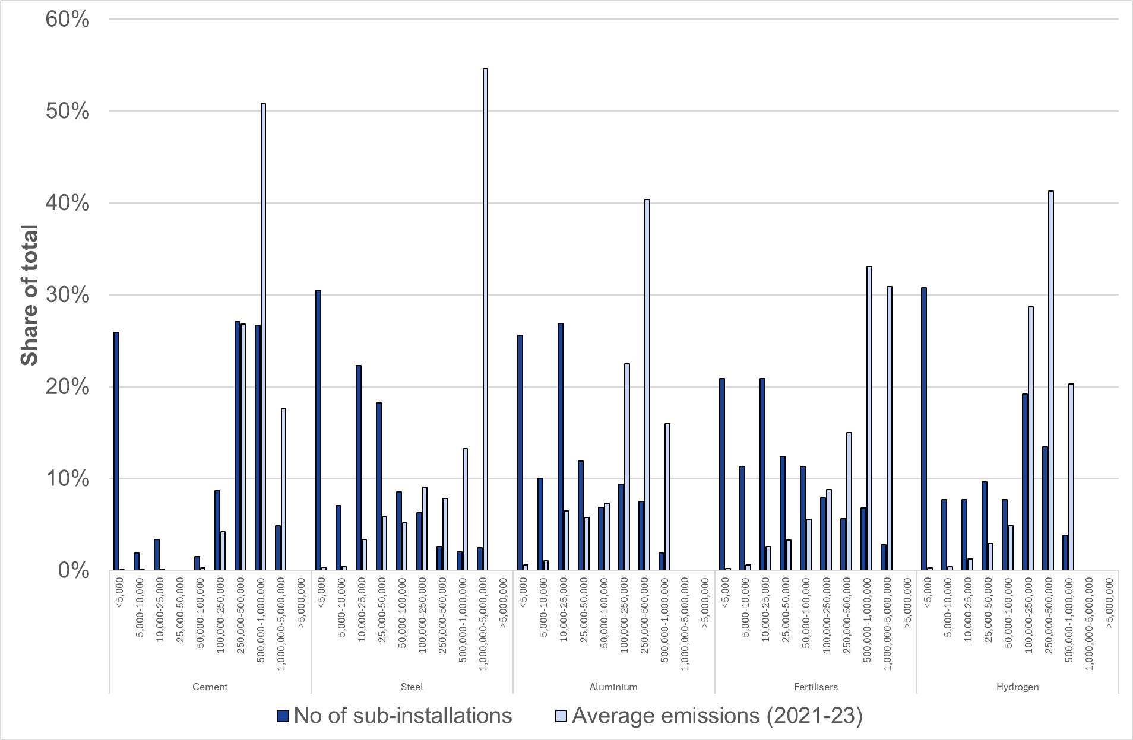
Source: Own calculation based upon preliminary NIMs data for 2019-23
To minimise the impact of the policy measures on SMEs, it was frequently advocated by industrial stakeholders to extend the opt-out eligibility for small emitters, subject to national measures that will achieve an equivalent contribution to emission reductions, under Article 27 of the ETS Directive. An increase in this threshold from 25,000 tCO₂/year to 50,000 tCO₂ per year was often referred to in the inputs provided under both the OPC and during subsequent interviews with industrial associations. This proposal would reduce the administrative burden for smaller emitters by:
- Simplifying monitoring requirements.
- Removing requirements for smaller emitters to hold an EU registry account.
- No requirements to fulfil third-party verification of emissions data.
The argument was made repeatedly by industrial stakeholders that such an extension of the opt out eligibility under Article 27 would significantly reduce reporting and compliance burdens on SMEs without jeopardising the overall environmental aims of the system.
Such an increase in the exclusion threshold would mean that for some sectors like ceramics, most of their emissions will be excluded from the scope of the ETS and covered by equivalent national measures instead. The assessment of these national measures however goes beyond the scope of this impact assessment.
        - Carbon leakage prevention measures for indirect emissions
Like the previous subsection, the SME test was applied to identify and assess the impact of the policy measures related to indirect emissions on SMEs.
In a first step, the businesses most likely to be affected by the policy measures were identified by using the preliminary NIMs dataset to categorise installation information for selected sectors into different electricity consumption ranges with a focus on the sectors selected that are currently eligible for indirect cost compensation under Annex I of the Guidance on certain state aid rules. See Figure 12 below. While it is assumed that smaller installations are more likely to be operated by SMEs, there is no specific SME threshold.
Only 3% of the refined oil sector’s total number of installations annually consumed under 5,000 MWh. In contrast, the share of the total number of installations that annually consumed under 5,000 MWh on average between 2021 and 2023 was much higher in the manufacture of other inorganic basic chemicals, aluminium production, the manufacture of basic iron and steel and ferro-alloys and copper production accounting for 35%, 32%, 24% and 20% respectively. Given the higher share of installations annually consuming electricity under 5,000 MWh it is more likely that any change to indirect cost compensation will have a greater impact on SMEs in these sectors relative to the other sectors that are also eligible for indirect cost compensation. It should also be noted that the manufacture of lead, zinc and tin production has a high share of installations consuming between 5,000 MWh and 10,000 MWh of electricity on average between 2021 and 2023 indicator that SMEs in this sector may also be impacted more by changes to indirect cost compensation.
The analysis of the preliminary NIMs dataset confirms that SMEs are likely to be impacted by the policy measures related to indirect cost compensation but that the impact on SMEs is likely to vary by sector. The impact on SMEs will also depend upon the extent to which their production process is electrified, and the level of electrification varies across and within sectors.
SME stakeholders were represented by their sector associations in the stakeholder interviews as well as having the opportunity to submit their views within the OPC itself.

- Share of installations and electricity consumption (average 2021-23) by category size in MWh/ year for selected sectors that are currently eligible for indirect cost compensation
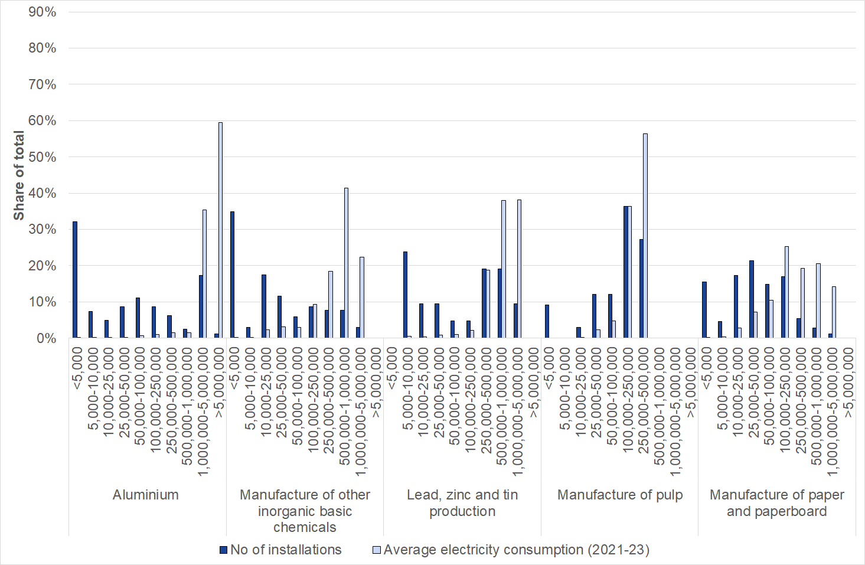
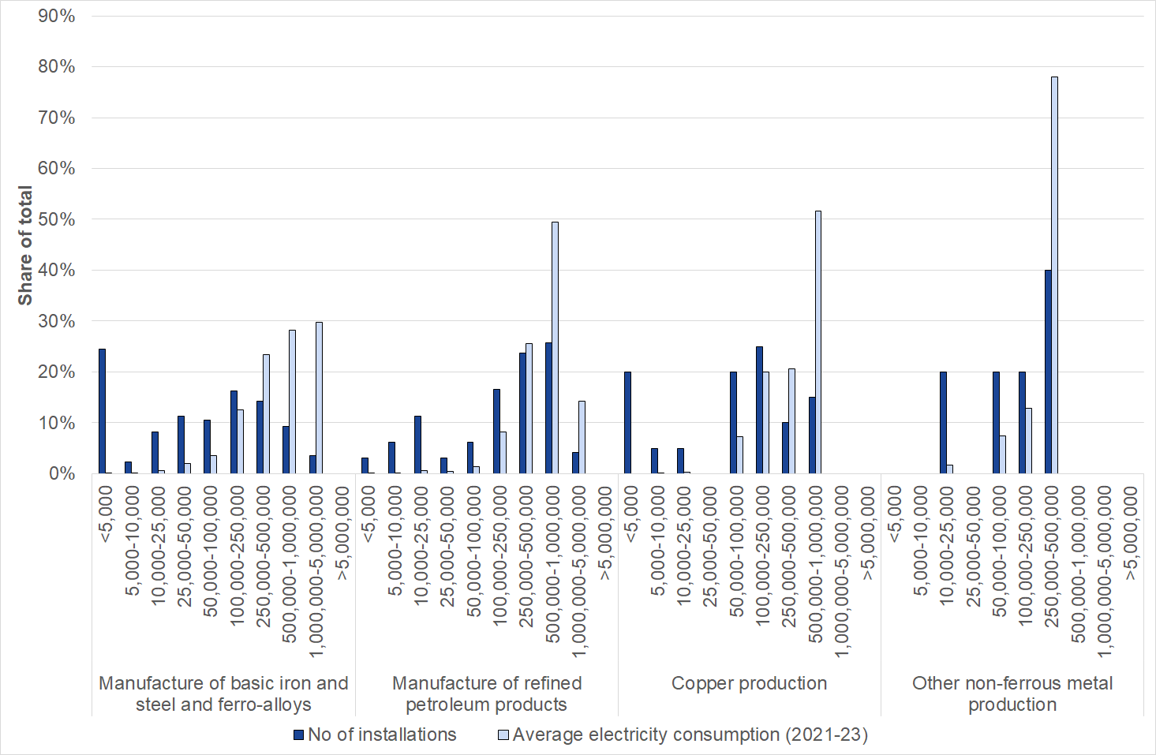
Source: Own calculation based upon preliminary NIMs data for 2019-23
      - Sectoral competitiveness, trade and investment flows
        - Carbon leakage prevention measures for direct emissions
Stakeholder consultation
During the stakeholder consultation with industry, the increase in the carbon price in recent years has been highlighted by industrial associations as a key reason for the continuation of free allocation into Phase IV of the EU ETS.
There was a strong consensus during the interviews with industrial stakeholders that phasing out free allocation between 2031 and 2040 would be very likely to have a detrimental impact on their competitiveness if enabling conditions are not available to support the shift in production processes to low carbon alternatives. Although the circumstances of industry varied, there was a commonly expressed view throughout the stakeholder consultation that the carbon cost is an additional cost that puts them at a disadvantage compared to international competitors based in jurisdictions with less stringent climate policies.
In terms of assessing the impact of the policy measures, the impact will vary depending upon the volume of EUAs distributed to each sector, the stringency of conditionality upon free allocation, or if the phase out of free allowances for non-CBAM sectors is aligned with the time schedule for CBAM sectors. More broadly the impact of these policy options will depend on the success of the EU ETS and other complementary policies in decarbonising industry and facilitating decarbonisation investments, thereby reducing industries’ direct and indirect carbon costs.
Industrial stakeholders during the consultation consistently argued that in many cases the unit cost of production is higher for products manufactured in the EU compared to international competitors. It was widely acknowledged that the key issue, driving such a differential in production cost in recent years, relates to dramatic shifts in the energy market following unexpected external events such as the global pandemic and subsequent geo-political volatility (i.e. illegal Russian invasion of Ukraine). The issue of competitiveness is further complicated by overcapacity in certain international markets and considerable changes in trading tariff regimes with certain key partners. While these developments are indeed very valid concerns that were expressed by industrial stakeholders, they are primarily addressed by other EU policies, and the scope of this assessment is limited to the impact of measures related to changes in the provision of support to protect against carbon leakage.
There was an acknowledgement by several industrial stakeholders during the interviews that the carbon price has not necessarily been the driving factor in the differential in the unit production cost between the EU and international competitors that has emerged in recent years. It was, however, consistently argued by several industrial stakeholders that the EU carbon cost exacerbates an already unfavourable situation for EU producers and that the carbon price will have a greater impact if levels of free allocation decline without alternative measures in place to support industry with the decarbonisation required to avoid carbon costs in the future.
An important topic in this regard is the use of allowance revenue to solely be used to support industry, which was a frequent position advocated by industrial stakeholders during the consultation. As highlighted previously when discussing impacts of the measures on competitiveness, ultimately it will require the state and private sector to work together to ensure the enabling conditions (i.e. availability of green hydrogen, infrastructure for CCUS, availability of low cost and low carbon electricity, market demand for low carbon products) are available so that the ambitious trajectories already outlined by industrial sectors for their decarbonisation are achieved.
Other measures and initiatives announced by the European Commission, such as the Industrial Accelerator Act, the European Grids Package, or the CO2 Infrastructure Package will further complement the EU ETS and drive the process of industrial decarbonisation.
The impact of phasing out free allocation on the competitiveness of industry is more nuanced. According to the stakeholders consulted, it will ultimately depend upon enabling conditions. For example, stakeholders across sectors pointed out that an increased exposure to a higher carbon price will not on its own be sufficient to make the deployment of necessary technologies viable. Industrial stakeholders argued strongly that without complementary policies to support the deployment of abatement potentials the concern is that there will be deindustrialisation rather than decarbonisation. The main issues raised that industry believe is beyond their direct control to influence included the following:
- Availability of financial funding to support CAPEX and OPEX
- Availability of low carbon electricity at competitive prices
- Availability of green hydrogen
- Availability of biofuels
- Availability of a support infrastructure for CCS
The ability to finance investments in these areas is partly linked to the phase-out of free allocation, since alternative uses within the EU ETS determines some of the support available for decarbonization through EU-wide instruments (such as the Innovation Fund and Industrial Decarbonisation Bank) and from Member States’ shares of auction revenues.
Beyond mechanisms linked to EU ETS, the argument was consistently advanced from a range of industrial stakeholders that the success of the transition to a net-zero economy will depend upon there being sufficient demand in the future for low carbon goods within the EU. If such a market is not supported then, in a worst-case scenario, industry fear decarbonising their production processes and then being out competed on price by international competitors on the EU market. In addition to the carbon leakage measures considered in this chapter, these risks are also being addressed by the introduction of the Carbon Border Adjustment Mechanism and ongoing efforts to develop lead markets in the context of the Clean Industrial Deal.
GEM-E3 model results provides insights into how alternative ETS design choices translate into heterogenous sectoral and macroeconomic impacts, relative to the baseline scenario by taking into consideration key drivers within scenario assumptions such as the different free allocation distributions across industry, as well as the different ETS coverage and cap stringency and alternative revenue recycling. The policy scenarios assessed by the GEM-E3 model are described in section 1.4.1.
Changes in the unit cost of production (Table 14) are driven by specific scenario assumptions namely: (i) different shares of free allocation, with highest shares in PO2_90, (ii) changes in carbon prices, notably in PO2 and PO3 where carbon prices are lower than the baseline, (iii) other scenario implications of waste inclusion in the EU ETS (iv) the impact arising from revenue recycling. The dominant driver of the sectoral effects varies between these four mechanisms across sectors.
Chemical products, which receive the largest share of additional free allocations, exhibit the steepest decline in unit production costs under the policy measures. Among the policy measures, PO3 shows the highest reduction in production costs relative to the baseline, despite the full phase-out of free allowances after 2034. This improvement in competitiveness is driven by the inclusion of waste emissions in the EU ETS, specifically the inclusion of landfills undeer PO3, relaxing the ETS constraint and thereby reducing the carbon price need to meet the EU ETS cap and hence the unit cost of production for PO3. By contrast, policy options with alternative revenue recycling (PO3R and PO1R) exhibit lower competitiveness, as redirecting revenues away from power-sector investment towards households increases domestic demand, which in turn raises both capital and labour costs. Ferrous metals and paper products publishing sectors under PO2 experiences an increase in unit production cost as higher electricity costs offsets the benefits from free allocation (which are lower compared to other sectors) and lower labour and capital costs. It is noteworthy that when free allocation is extended to both CBAM and non-CBAM sectors, ferrous metals sector becomes more competitive compared to cases when only non-CBAM sectors received free allocation. This effect is driven by near doubling of free allocations when moving from PO2_50 and PO2_90 to PO2_50C and PO2_90C, respectively. Overall, the impact on unit production costs across policy measures and sectors relative to the Reference ranges from -0.18% to 0.19%.
- Percentage change in the unit cost of production relative to the baseline scenario (2040)
 | Policy measures
 | PO1 (%) | PO1R (%) | PO2_50 (%) | PO2_50C (%) | PO2_90 (%) | PO2_90C (%) | PO3 (%) | PO3R (%)
Ferrous metals | -0.01 | 0.16 | 0.05 | 0.01 | 0.05 | 0.01 | -0.01 | 0.10
Non-ferrous metals | -0.03 | 0.12 | 0.00 | -0.02 | -0.01 | -0.02 | -0.08 | 0.04
Chemical Products | -0.17 | 0.00 | -0.07 | -0.07 | -0.12 | -0.12 | -0.18 | -0.09
Paper products, publishing | 0.04 | 0.19 | 0.03 | 0.05 | 0.05 | 0.06 | -0.02 | 0.11
Non-metallic minerals | -0.03 | 0.13 | 0.00 | -0.02 | -0.01 | -0.03 | -0.05 | 0.08
Source: GEM-E3 model (2025)
Table 15 below shows the effects on unit cost of production when using the 90-85% cap pathway (see section 1.3.1.1), compared with the reference scenario of 85% linear trajectory. This scenario shows that for most sectors, the more ambitious cap trajectory results in some decrease in EU27 emissions and increases in the non-EU27 emissions in 2035, indicating a marginally higher production costs. The differences in the results for 2040 are marginal or 0.
- Percentage change in unit cost of production levels for variants CL290_9085 and CL290C_9085 compared to scenarios CL2_90 and CL2_90C.
 | 2035 |  | 2040
 | CL2_90_9085 | CL2_90C_9085 | CL2_90_9085 | CL2_90C_9085
Ferrous metals | 0.00% | 0.07% | 0.00% | 0.00%
Non-ferrous metals | 0.02% | 0.04% | 0.00% | 0.00%
Chemical Products | 0.11% | 0.10% | 0.00% | 0.00%
Paper products, publishing | 0.03% | 0.00% | 0.00% | 0.00%
Non-metallic minerals | 0.03% | 0.05% | 0.00% | 0.00%
Source: GEM-E3 model (2025)
Production and exports respond heterogeneously across policy options relative to the baseline scenario, reflecting differences in free allocation, sectoral coverage, and revenue recycling (Tables 16 and 18). Chemical products and non-metallic minerals, which experience reductions in unit production costs relative to the baseline, face higher domestic and external demand and therefore record higher levels of both production and exports across the policy options. PO3 also exhibits higher production and export levels relative to the Reference due to lower unit cost of production. By contrast, policy options with alternative recycling (PO3R and PO1R) show lower production and export level due to reduced competitiveness. Non-ferrous metals, chemical products, and non-metallic minerals display higher production and export levels due to improved competitiveness under PO2 scenarios. On the contrary, ferrous metals become competitive leading to higher production and exports only when free allocation is extended to both CBAM and non-CBAM sectors. Overall, the impact on production and export across policy measures and sectors relative to the baseline ranges from -0.56% to 1.61% for production and -1.09% to 4.63% for exports.
- Percentage change in production levels in 2040 relative to the baseline scenario
 | Policy measures
 | PO1 (%) | PO1R (%) | PO2_50 (%) | PO2_50C (%) | PO2_90 (%) | PO2_90C (%) | PO3 (%) | PO3R (%)
Ferrous metals | -0.02 | -0.56 | -0.08 | 0.21 | -0.08 | 0.16 | 0.20 | -0.23
Non-ferrous metals | 0.26 | -0.40 | 0.12 | 0.26 | 0.20 | 0.31 | 0.60 | 0.04
Chemical Products | 1.15 | 0.74 | 0.60 | 0.69 | 0.95 | 1.03 | 0.66 | 0.44
Paper products, publishing | 0.01 | -0.05 | -0.03 | -0.04 | -0.03 | -0.03 | 0.02 | -0.01
Non-metallic minerals | 1.08 | 0.73 | 0.72 | 1.39 | 1.05 | 1.61 | 1.30 | 1.03
Source: GEM-E3 model (2025)
Table 17 below shows the effects on production levels when using the 90-85% cap pathway (see section 1.3.1.1), compared with the reference scenario of 85% linear trajectory. This scenario shows that for most sectors, the more ambitious cap trajectory results in some decrease in EU27 emissions and increases in the non-EU27 emissions in 2035, indicating a marginally lower production levels. The differences in the results for 2040 are marginal or 0 in most sectors.
- Percentage change in production levels for variants CL290_9085 and CL290C_9085 compared to scenarios CL2_90 and CL2_90C.
 | 2035 |  | 2040
 | CL2_90_9085 | CL2_90C_9085 | CL2_90_9085 | CL2_90C_9085
Ferrous metals | 0.00% | 0.07% | 0.00% | 0.00%
Non-ferrous metals | 0.02% | 0.04% | 0.01% | 0.01%
Chemical Products | 0.11% | 0.10% | 0.06% | 0.06%
Paper products, publishing | 0.03% | 0.00% | 0.00% | 0.00%
Non-metallic minerals | 0.03% | 0.05% | 0.04% | 0.04%
Source: GEM-E3 model (2025)
- Percentage change in export levels in 2040 relative to the baseline scenario
 | Policy measures
 | PO1 (%) | PO1R (%) | PO2_50 (%) | PO2_50C (%) | PO2_90 (%) | PO2_90C (%) | PO3 (%) | PO3R (%)
Ferrous metals | 0.08 | -1.09 | -0.23 | 0.81 | -0.20 | 0.6 | 0.55 | -0.23
Non-ferrous metals | 0.49 | -0.39 | 0.23 | 0.47 | 0.37 | 0.57 | 0.96 | 0.24
Chemical Products | 1.59 | 0.93 | 0.85 | 0.96 | 1.33 | 1.42 | 0.92 | 0.53
Paper products, publishing | -0.06 | -0.50 | -0.08 | -0.14 | -0.09 | -0.14 | 0.07 | -0.32
Non-metallic minerals | 2.96 | 2.04 | 2.12 | 4.02 | 3.02 | 4.63 | 3.86 | 3.06
Source: GEM-E3 model (2025)
Table 19 below shows the effects on sectoral export levels when using the 90-85% cap pathway (see section 1.3.1.1), compared with the reference scenario of 85% linear trajectory. This scenario shows that for most sectors, the more ambitious cap trajectory results in some decrease in EU27 emissions and increases in the non-EU27 emissions in 2035, indicating a marginally lower export levels, with steepest decrease for non-metallic minerals. The differences in the results for 2040 are marginal or 0 in most sectors.
- Percentage change in sectoral export levels for variants CL290_9085 and CL290C_9085 compared to scenarios CL2_90 and CL2_90C.
 | 2035 |  | 2040
 | CL2_90_9085 | CL2_90C_9085 | CL2_90_9085 | CL2_90C_9085
Ferrous metals | -0.66% | -0.64% | 0.02% | 0.02%
Non-ferrous metals | -0.47% | -0.46% | 0.03% | 0.03%
Chemical Products | -0.48% | -0.48% | 0.08% | 0.08%
Paper products, publishing | -0.03% | -0.03% | 0.00% | 0.00%
Non-metallic minerals | -1.84% | -1.79% | 0.11% | 0.12%
Source: GEM-E3 model (2025)
Table 20 shows the percentage change in GDP and the contribution of its components to this change. In all policy options, GDP in 2040 increases relative to the baseline scenario, reflecting positive macroeconomic effects driven by higher exports and/or increased private consumption, depending on the scenario. The GDP increase ranges from 0.00% under PO2_50 to 0.08% under PO3R. All scenarios with alternative recycling schemes show higher GDP growth, with PO3R in particula, with the latter achieving the highest GDP level due to the combined effect of a lower carbon price and stronger household demand stimulated by lump-sum recycling of EU ETS revenues.
In all scenarios except those with alternative recycling schemes, an improvement in EU27 competitiveness is observed, reflected in higher exports. This outcome is driven by a higher allocation of free allowances to EU ETS sectors (e.g. PO1), and/or lower carbon prices required to meet the cap because of including waste emissions in the EU ETS (e.g. PO3). In the recycling scenarios, private consumption is the main driver of GDP growth, reflecting the lump-sum transfer of EU ETS revenues to households. In these cases, exports decline due to higher labour and capital costs, which arise from increased household demand and upward pressure on factor prices. In PO2 scenarios, private consumption drops marginally.
- Percentage change in GDP and its components in 2040 relative to baseline scenario
 | PO1 (%) | PO1R (%) | PO2_50 (%) | PO2_50C (%) | PO2_90 (%) | PO2_90C (%) | PO3 (%) | PO3R (%)
GDP | 0.03 | 0.07 | 0.00 | 0.01 | 0.01 | 0.02 | 0.05 | 0.08
Investment | 0.01 | 0.01 | 0.00 | 0.00 | 0.00 | 0.00 | 0.00 | 0.01
Government consumption | 0.00 | 0.00 | 0.00 | 0.00 | 0.00 | 0.00 | 0.00 | 0.00
Private consumption | 0.03 | 0.22 | -0.03 | -0.03 | -0.03 | -0.02 | -0.03 | 0.18
Exports | 0.03 | -0.06 | 0.04 | 0.04 | 0.05 | 0.05 | 0.08 | -0.03
Imports | -0.03 | -0.10 | 0.00 | -0.01 | -0.01 | -0.01 | 0.01 | -0.07
Source: GEM-E3 model (2025)

Free allocation was always intended to be transitory in nature so its continuation into Phase V in all the policy measures under consideration shows an acknowledgement by the Commission that the non-CBAM sectors will require further support to decarbonise in what is a very challenging operating environment. However, the trajectory of the ETS cap means that the extent to which free allocation continues to be distributed based on the existing free allocation rules, will increasingly become less relevant if the annual amount of preliminary free allocation calculated exceeds the annual free allocation budget and the cross sectoral correction factor is applied in most years – see Table 21.
- Estimated CSCF under the different carbon leakage prevention measure of the total volume of free allowances available under the baseline and policy scenarios for 2031-40

 | 2031 | 2032 | 2033 | 2034 | 2035 | 2036 | 2037 | 2038 | 2039 | 2040
CSCF Baseline | 0.86 | 0.76 | 0.65 | 0.55 | 0.44 | 0.39 | 0.26 | 0.14 | 0.02 | 0.00
CSCF CL1 | 0.83 | 0.76 | 0.69 | 0.61 | 0.54 | 0.55 | 0.49 | 0.43 | 0.36 | 0.30
CSCF CL2_90 | 0.88 | 0.82 | 0.75 | 0.69 | 0.61 | 0.61 | 0.53 | 0.45 | 0.37 | 0.30
CSCF CL2_50 | 0.92 | 0.88 | 0.85 | 0.85 | 0.75 | 0.74 | 0.64 | 0.55 | 0.45 | 0.36
CSCF CL3 | 0.91 | 1.00 | 1.00 | 1.00 | 1.00 | 1.00 | 1.00 | 1.00 | 1.00 | 1.00
Source: Own calculation
        - Carbon leakage prevention measures for indirect emissions
The main effect of continuing to provide ICC compensation would be to alleviate the risk of carbon leakage and incentivise electrification by compensating for some of this cost. It is therefore an important contributor to the competitiveness of electro-intensive processes within sectors, particularly for as long as direct emitting processes continue to receive free allocation and/or fossil fuels continue to act as the marginal generator, thereby exerting a greater influence on electricity prices than their generation share would suggest.
Option ICC1 would ensure that this benefit continues, subject to each Member State’s decision regarding the granting of State aid.
Option ICC2 would bring additional competitiveness benefits to some installations (those who would not have received State aid under ICC1). However, this benefit would need to be weighed against the additional administrative burden associated with a standalone ICC fund.
During the stakeholder consultation with industry, the differential between electricity prices in the EU-27 with international competitors was often cited as having a negative impact on their levels of competitiveness. While industrial electricity prices in the EU are generally high compared to US and China, this gap has narrowed since the height of the energy crisis in 2022 and is smaller in Member States with a larger non-fossil share in electricity generation, as shown in Figure 13. European Commission analysis has indicated that carbon costs accounted for up to 11% of industrial energy prices in the EU on average in 2025, with fuel costs, network charges and taxes each accounting for a larger share.

- Estimated electricity price for large industrial consumers
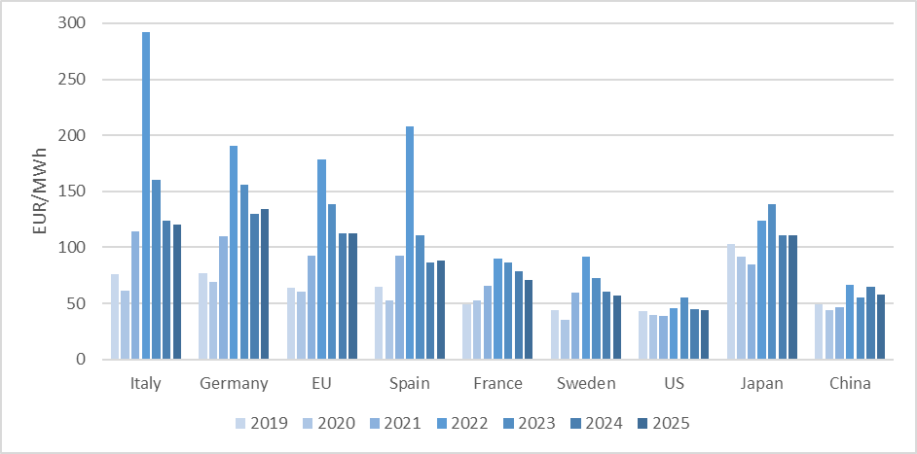
Source: European Commission: Derived from IEA Electricity 2026 for US, Japan and China, Others: EUROSTAT
The issue of indirect carbon costs wase often raised by industry as this is often a cost that they have no direct control over and this will instead depend upon efforts to decarbonise the electricity grid in a way that also ensures the price of electricity does not become excessively high in comparison to industrial competitors. The continuation of indirect cost compensation was therefore consistently supported by industrial stakeholders during the consultation, with 74% of respondents to the OPC considering that indirect cost compensation should remain after 2030 to address the risk of carbon leakage from carbon costs passed on in electricity prices (in sectors where indirect emissions are not covered by CBAM).
Stakeholders, including in sectors not currently eligible for ICC compensation, considered it necessary to offset the high electricity costs in Europe in comparison to international competitors and it was argued that without the continuation of such support the viability of current electro-intensive production processes would increasingly become at risk of closure in the future. On this point, it is important to note that ICC compensation addresses only addresses the pass through of carbon costs to electricity consumers. Other high price drivers will need to be addressed by other means such as infrastructure improvements (e.g. the European Grids Package) or other types of State aid (e.g. the Temporary Electricity Price relief available under the Clean Industrial Deal State Aid Framework).
Many industrial stakeholders expressed support for the harmonisation of indirect cost compensation in principle. Overall, 39% of respondents supported harmonising the system for compensating indirect carbon costs at EU level, in response to the OPC question if indirect cost compensation will remain necessary after 2030 to address the risk of carbon leakage from carbon costs passed on in electricity prices (in sectors not covered by the CBAM). This response was mainly from sectors and sub-sectors currently not eligible for indirect cost compensation, which could indicate that respondents believed harmonisation would involve expansion of the eligible sectors. Subsequently (and separately), additional sectors were made eligible for ICC compensation in the amendment of State aid guidelines for the period 2025-2030.
A harmonised system with a common ICC Fund would not amount to State aid. The extent to which specific firms and sectors would benefit would depend on the generosity of a harmonised system compared to the support they would otherwise receive from national State aid schemes.
      - Impact on innovation and technological development
        - Carbon leakage prevention measures for direct emissions
The provision of free allocation limits industry’s exposure to the carbon price signal. On the one hand, this may reduce the incentives within industry to abate their emissions. The historical rate of improvement in specific emissions across industry has been limited (with some notable exceptions such as the rapid reduction in emissions from nitric and adipic acid production over Phase III of the EU ETS). On the other hand, free allocation, conditioned on making investments and combined with a long-term perspective of increasing carbon prices may act as an incentive for decarbonization investments, provided a broader enabling framework is in place.
In theory, the phasing out of free allocation over 2031-40, as considered in all the policy measures, could have a positive impact on innovation and technological development by increasing the exposure of industrial producers to a rising carbon price as the ETS cap progressively declines. Given that CL3 is associated with the lowest free allocation budget and the fastest phase out, it would rationally result in the biggest impact in terms of innovation and technological development. However, the extent to which a greater exposure to the carbon price because of the implementation of the policy measures will drive the innovation required to decarbonise industry was frequently challenged by industrial stakeholders during the consultation process.
Representatives from industry were unanimous in arguing that carbon pricing alone (i.e. without revenue recycling) was insufficient to bring about the change required to decarbonise production processes unless the price was at exceedingly high levels that, very likely, would bring into question the ability of the consumer to pay for more expensive low-carbon products. It was also suggested that, in certain industries, the necessary technological innovations are not yet available commercially at scale and at a competitive price. Efforts to reduce the emission intensity could have a negative impact on the quality of their products that would not be an acceptable trade off with the standards required by their end consumers. This often leaves industrial producers with uncertainty over whether to invest in sub-optimal solutions now or to wait for technological breakthroughs later. The timing of such innovative breakthroughs will be influenced and most likely occur sooner by an accelerated phase out of free allocation, but industry also argued strongly that the levels of financial support was considerably lower than the financial support given to the power sector and that current complementary policies, such as the ETS’s Innovation Fund are not currently at the scale required to finance the investments identified by the industrial roadmaps outlining what is technologically feasible regarding decarbonisation efforts.
This is why the Clean Industrial Deal Communication announced the Industrial Decarbonisation Bank (IDB) to address the scale-up and roll-out of more mature industrial decarbonisation projects (notably in EIIs) across all MS to be funded by a dedicated part of ETS resources. With the Bank focussing on scale-up and roll-out, there is also need for continuation of the Innovation Fund (IF) (also funded by part of ETS resources) to continue supporting innovative and first of a kind technology that can address difficult to decarbonise sectors. The contribution of IDB and IF to support investments in decarbonisation and thus complementing the measures for carbon leakage protection are analysed in Annex 9.
The EU ETS will thus complement and support the objectives of the Clean Industrial Deal by providing a clear and predictable carbon price, incentivising investment in decarbonisation solutions and funding the investments which still lack the business case or where decarbonisation solutions have yet to be demonstrated, while continuing to provide carbon-leakage protection and financial support from the auction revenues with more than EUR 250 billion generated since the start of the system.
        - Carbon leakage prevention measures for indirect emissions
For several industrial sectors, electrification is crucial to decarbonise. Indirect cost compensation stimulates electrification (and hence technological development) as do the incentives to electrify from the new approach to free allocation (the removal of the exchangeability factor provides free allocation for electrified processes under 14 of the ETS benchmarks). Without ICC, companies with direct emissions may prefer to continue receiving free allocation for direct emissions rather than electrifying and having indirect carbon costs through their electricity bill (in addition to other drivers of the cost differences between electrified and non-electrified processes).
Regarding technological improvements in the electricity sector, the carbon content of electricity is often outside the control of ETS operators. However, operators can reduce it (and therefore reduce their exposure to indirect carbon costs) through investments in energy efficiency or other forms of emissions reduction, including flexibility (which may trigger additional demand for batteries and Demand-Side Response technologies) and use of renewables PPAs.
      - Public authorities
        - Carbon leakage prevention measures for direct emissions
The simplification measures included in all the policy measures on carbon leakage protection will reduce administrative burden also for public authorities, in particular for ETS Competent Authorities.
The policy measures have budgetary consequences for public authorities as the phase out of free allocation results in an increase of the share of the total allowances under the cap to be used for decarbonisation and, if auctioned, this generates revenues for national governments. At the same time, the decrease of the cap acts in a counterbalancing manner when compared to the baseline scenario.
A major benefit to public authorities is represented by the auction revenue derived from the auctioning of allowances. The auctioning volumes are derived from based on the estimates for the allowances distributed for free to industry and it does not consider any split between auction revenue that is accrued to EU level funds or to national treasures.
Table 12 shows the expected value of free and auctioned allowances across the policy options. The volume of free allocation across different policy options also has an impact on (cumulative) auction revenues. Table 22 presents the potential total value of auction revenues over the period 2031-2040, deducting from the estimated cap value the volumes to be allocated for free. This represents potential value to be used by public authorities (at Member States or EU level) for financing climate action and decarbonisation measures.
- Overview of the 2031-40 cumulative auction revenues
 | 2031-2040
Eur23/tCO2 | EUR 150.0
Baseline_Auctioned allowances (mil EUAs) | 1926
Baseline_Cumulative auction revenue | EUR 288.9
PO1_Auctioned allowances (mil EUAs) | 4043.7
PO1_Cumulative auction revenue (bn EUR) | EUR 606.6
PO2_Auctioned allowances (mil EUAs) | 4153.5
PO2_Cumulative auction revenue (bn EUR) | EUR 623.0
PO2_CL2_CBAM variant_auctioned allowances | 3987.5
PO2_CBAM variant Cumulative auction revenue | EUR 598.1
PO3_Auctioned allowances (mil EUAs) | 5546
PO3_Cumulative auction revenue (bn EUR) | EUR 831.9
Source: Own calculation
        - Carbon leakage prevention measures for indirect emissions
The policy measures also have budgetary consequences for public authorities as the continuation of the encouragement to provide indirect cost compensation enables Member States to consider offsetting higher electricity prices, due in part, to the increase in carbon prices over the 2031-40 period.
Based upon the previous calculation for adjustment costs for industry (refer to Section 1.4.2.1.2), the potential scale of the financing ranges from 9 billion to 17 billion EUR annually on average over 2031-40.
Under policy measure ICC1, it is entirely up to the Member States whether they want to pay out compensation and incur some of this cost. In practice, the funding for this compensation comes primarily from each Member State’s share of ETS auction revenues (though other national resources can be used), and each Member State will retain the flexibility to use these revenues for ICC or other purposes. In the existing Directive, Member States who provide ICC compensation are required to make information about the support publicly available. The resultant administrative burden for public authorities could be reduced by integrating this requirement into the broader reporting obligations on the use of auction revenues under Regulation (EU) 2018/1999.Under policy measure ICC2, the EU-level funding for the harmonised ICC fund would come from collection of auction revenues at EU level, implying a lower share either for Member States or other EU-level ETS-funded instruments. This funding would be distributed at EU-level according to the needs of electro-intensive industries, rather than at the discretion of each Member State. Although EU-level funding is largely expected to replace State aid that Member States would otherwise have provided, some installations will receive compensation who otherwise would not have received State aid. Therefore, we expect ICC2 to have a higher cost overall in terms of allowances distributed than ICC1.
    - Social impacts
      - Employment
The issue of employment is directly linked to the long-term viability of industrial production in Europe. During the stakeholder interviews (and further supported by OPC results), industrial associations and businesses consistently argued that the competitiveness of EU producers would be undermined without the continuation of free allocation and by ensuring that the necessary enabling conditions are in place to enable decarbonisation rather than deindustrialisation was frequently cited by stakeholders.
The GEM-E3 model was used to estimate the impact of the implementation of policy measures on employment levels. Total economy employment impacts under the policy measures shows a slight positive impact in PO1 following production trends and slight negative impact in the rest of the scenarios. The largest employment gains occur in chemicals and non-metallic minerals sector, which also records the highest production increase by 2040. Across sectors and policy measures, the overall employment impact ranges from -0.56% to 1.76. Among the scenarios, PO1R shows the highest employment increase, driven by the volume of free allowances provided along with the alternate revenue recycling option, whereas PO3 records the lowest due to the complete phase-out of free allowances after 2034 and due to the lower production in market services.
- Sectoral employment change for ETS sectors in 2040 relative to the baseline
 | Policy measures
 | PO1 (%) | PO1R (%) | PO2_50 (%) | PO2_50C (%) | PO2_90 (%) | PO2_90C (%) | PO3 (%) | PO3R (%)
Ferrous metals | 0.00 | -0.56 | -0.06 | 0.30 | -0.06 | 0.24 | 0.27 | -0.23
Non-ferrous metals | 0.27 | -0.41 | 0.12 | 0.25 | 0.20 | 0.31 | 0.60 | -0.01
Chemical Products | 1.13 | 0.75 | 0.56 | 0.65 | 0.90 | 0.97 | 0.50 | 0.25
Paper products, publishing | 0.02 | 0.00 | -0.04 | -0.05 | -0.03 | -0.05 | 0.00 | -0.01
Non-metallic minerals | 1.18 | 0.88 | 0.80 | 1.52 | 1.16 | 1.76 | 1.43 | 1.18
Source: GEM-E3 model (2025)
The table below shows the effects on sectoral employment when using the 90-85% cap pathway (see section 1.3.1.1), compared with the reference scenario of 85% linear trajectory. This scenario shows that for most sectors, the more ambitious cap trajectory results in some decrease in EU27 emissions and increases in the non-EU27 emissions in 2035, indicating a marginally lower sectoral employment rates in at that point. The differences in the results for 2040 are marginal or 0 in most sectors.
- Percentage change in sectoral employment levels for variants CL290_9085 and CL290C_9085 compared to scenarios CL2_90 and CL2_90C.
 | 2035 |  | 2040
 | CL2_90_9085 | CL2_90C_9085 | CL2_90_9085 | CL2_90C_9085
Ferrous metals | -0.25% | -0.24% | 0.01% | 0.01%
Non-ferrous metals | -0.28% | -0.27% | 0.01% | 0.02%
Chemical Products | -0.31% | -0.31% | 0.07% | 0.07%
Paper products, publishing | -0.03% | -0.03% | 0.00% | 0.00%
Non-metallic minerals | -0.76% | -0.74% | 0.05% | 0.05%
Source: GEM-E3 model (2025)
The issue of employment is directly linked to the long-term viability of industrial production in Europe. During the stakeholder engagement (and further supported by OPC inputs), industrial associations and businesses consistently argued that the competitiveness of EU producers would be undermined without the continuation of free allocation and by ensuring that the necessary enabling conditions are in place to enable decarbonisation rather than deindustrialisation was frequently cited by stakeholders.
Continuation of ICC compensation (whether State aid or harmonised) is expected to have a positive impact on employment by protecting against carbon leakage and supporting the business case for electrification of industrial processes. While ICC is not intended to support the capital cost for electrification investments, it strengthens the business case from them by ensuring beneficiaries will not be disadvantaged in the early years when indirect carbon cost may continue to be an important influence on electricity prices.
      - Fundamental rights
In accordance with the Better Regulation Guidelines, the policy measures were assessed to understand if there is impact on the fundamental rights endorsed by the EU Charter of Fundamental Rights. Following a screening of the fundamental rights, the judgement was taken that the policy measures do not have a negative impact and are likely to have a positive impact on the fundamental right with regards to environmental protection under Article 37.
    - Environmental impacts
      - Climate
        - Free allocation: carbon leakage rates
The conventional approach for carbon leakage assessment considers the emissions that increase in one (not regulated) region whilst decreasing in another regulated region and can be expressed by the following simple formula: Carbon leakage rate = increase in foreign emissions / decrease in domestic emissions. However, as described in Table 25, EU27 EU ETS GHG emissions increase from baseline levels in all scenarios. Therefore, the conventional formula for carbon leakage estimation is not relevant to this analysis.
- Change in the EU 27 emissions in 2040 relative to baseline scenario (in MtCO2eq)
 | Policy options
 | PO1 | PO1R | PO2_50 | PO2_50C | PO2_90 | PO2_90C | PO3 | PO3R
Total economy | 7.72 | 8.09 | 7.03 | 7.86 | 9.46 | 10.17 | 45.84 | 46.13
Ferrous metals | 0.06 | 0.03 | 0.37 | 0.46 | 0.39 | 0.47 | 2.51 | 2.42
Non-ferrous metals | 0.04 | -0.01 | 0.07 | 0.09 | 0.08 | 0.09 | 0.46 | 0.42
Chemical Products | 0.83 | 0.76 | 0.99 | 1.05 | 1.25 | 1.30 | 4.07 | 3.99
Paper products, publishing | 0.01 | 0.01 | 0.04 | 0.04 | 0.05 | 0.05 | 0.31 | 0.31
Non-metallic minerals | 1.00 | 0.86 | 1.82 | 2.43 | 2.13 | 2.65 | 9.99 | 9.81
Source: GEM-E3 model (2025)
Emissions are influenced both by the number of free allowances allocated and by the carbon price required to meet the ETS cap. In PO2—and especially in PO3—the inclusion of waste leads to the increase of the cap compared to the baseline, thus providing additional protection against carbon leakage. Overall, EU27 emissions increase across most scenarios, driven by three main factors: 1) the number of free allowances allocated in EU ETS sectors; 2) the carbon price required to meet the cap and 3) the increase in economic activity observed in all scenarios.
The only case in which EU27 emissions decline is observed in the non-ferrous metals sector under PO1 with recycling, where a reduction in activity leads to a corresponding decrease in emissions. In contrast, the chemicals and non-metallic minerals sectors exhibit the largest absolute increases in emissions, reflecting the higher number of free allowances allocated to these sectors relative to other EU ETS sectors and compared to the baseline scenario. The extension of free allocation to CBAM sectors also results in a slight increase in emissions in those sectors. At the level of the total economy, EU27 emissions increase because of higher overall activity across all scenarios. Moreover, the inclusion of waste emissions further raises emissions in EU ETS sectors, with the largest increase observed in PO3, where all waste emissions are fully covered under the EU ETS.
The lower non-EU emissions for the EU ETS sectors are on account of the competitiveness gains experienced by these sectors within the EU that overcome potential positive demand effects due to the small positive macroeconomic effects seen in the EU. The increase in free allowances and the reduction of the carbon prices result in a decline in unit cost of production for the EU ETS sectors. This results in competitiveness gains resulting to lower emissions outside EU27. This result in more pronounced in the chemicals and non-metallic minerals sectors as the have the largest competitiveness gains.
- Change in the non-EU 27 emissions in 2040 relative to the PRIMES baseline scenario (in MtCO2eq)
 | Policy options
 | CL1 | CL1R | CL2_50 | PO2_50C | CL2_90 | PO2_90C | CL3 | CL3R
Total economy | -8.36 | -6.37 | -4.51 | -6.88 | -6.95 | -8.93 | -4.67 | -3.97
Ferrous metals | 0.27 | 1.03 | 0.10 | -0.16 | 0.19 | -0.03 | -0.39 | 0.38
Non-ferrous metals | 0.00 | 0.28 | -0.03 | -0.07 | -0.03 | -0.06 | -0.20 | 0.09
Chemical Products | -3.42 | -1.97 | -1.86 | -2.10 | -2.88 | -3.08 | -2.15 | -1.25
Paper products, publishing | 0.02 | 0.03 | 0.02 | 0.02 | 0.02 | 0.03 | 0.01 | 0.02
Non-metallic minerals | -2.79 | -1.44 | -2.08 | -3.99 | -2.91 | -4.52 | -3.96 | -2.68
Source: GEM-E3 model (2025)
Table 27 summarises the effects regarding carbon leakage when using the 90-85% cap pathway (see section 1.3.1.1), compared with the reference 85% linear trajectory. This scenario shows that for most sectors, the more ambitious cap trajectory results in some decrease in EU27 emissions and increases in the non-EU27 emissions in 2035, indicating a marginally higher carbon leakage rates at that point. The differences in the results for 2040 are marginal or 0.
- Difference EU27 and non-EU27 emissions levels for variants CL290_9085 and CL290C_9085 compared to scenarios CL2_90 and CL2_90C.
 | 2035 |  |  |  | 2040
 | CL2_90_9085 |  | CL2_90C_9085 |  | CL2_90_9085 |  | CL2_90C_9085
 | EU27 | Non-EU27 | EU27 | Non-EU27 | EU27 |  | Non-EU27
Total economy | -29.91 | 2.54 | -30.03 | 2.50 | -0.32 | -0.44 | -0.31 | -0.44
Ferrous metals | -1.92 | 0.21 | -1.93 | 0.20 | 0.00 | -0.01 | 0.00 | -0.01
Non-ferrous metals | -0.29 | 0.07 | -0.29 | 0.07 | 0.00 | 0.00 | 0.00 | 0.00
Chemical Products | -4.38 | 1.14 | -4.39 | 1.14 | 0.03 | -0.20 | 0.03 | -0.20
Paper products, publishing | -0.33 | 0.00 | -0.33 | 0.00 | 0.00 | 0.00 | 0.00 | 0.00
Non-metallic minerals | -5.66 | 1.89 | -5.74 | 1.85 | 0.03 | -0.13 | 0.04 | -0.14
Source: GEM-E3 model (2025)
        - Indirect cost compensation
In principle, ICC compensation contributes to positive environmental outcomes by avoiding carbon leakage in electro-intensive sectors and /or incentivising electrification of industrial processes that would otherwise emit GHGs directly.
The potential benefit of industrial electrification is large. There are available technologies capable of meeting 60% of European industrial process heat demand today, and 90% by 2035. However, the net benefit in terms of emissions reduction is difficult to quantify due to the variety of industrial processes concerned and the need to consider emissions that may arise from additional electricity consumption.
Failure to compensate for ICC would nevertheless be suboptimal from an environmental point of view. Since fossil fuels often constitute the marginal electricity generation technology, a carbon cost is often passed onto electricity consumers that is more than the direct carbon cost paid by electricity generators for their embedded emissions (i.e. this carbon cost is effectively paid by all consumers on the wholesale electricity market, even if a lot of this electricity is zero carbon). This in turn has the effect of discouraging electrified industrial processes and incentivising the use of processes that emit GHGs directly, on top of the fact that free allowances are available for direct emissions.
    - Summary
The assessment in the previous sections show the relative effects of the different policy measures against the baseline. On most issues, measures CL1 and CL2 show similar effects, with small relative differences between the two sets of measures. The largest impacts, in particular on carbon leakage, are driven by the changes in the overall ambition level for the EU ETS and the resulting additional free allocation. CL2 on conditional free allocation is considered the preferred option as, in addition to CL1, increases the incentives to invest in decarbonisation and therefore better complement the measures on the Industrial Decarbonisation Bank and the Innovation Fund. CL2 also better addresses the findings in the Evaluation Report (see Annex 15) that indicate that free allocation, while effective at addressing carbon leakage, has also reduced the effective carbon price and reduced the incentives to invest in decarbonisation.
As regards indirect cost compensation, both ICC1 and ICC2 have similar effects. ICC1, continuing to provide indirect cost compensation via State aid, is the preferred option due to the disadvantages of a harmonised, one-size fits all approach of ICC2, both in terms of administrative costs and the reduced flexibility that ICC2 would imply for deciding the best use of auction revenues.
A qualitative overview of the impacts of the policy measures across the different categories are provided below in Table 28.
- Summary of impact assessment for individual measures for carbon leakage relative to baseline
 | CL1: Improved current approach | CL2_90: Conditionality (90% compliance) | CL2_50: Conditionality (50% compliance) | CL3: No free allocation after 2034
Environmental impacts
Carbon leakage rates | ++ | ++ | + | +
Economic impacts
Adjustment cost to operator | ++ | ++ | + | --
Administrative cost to operator | + | - | - | +++
Administrative cost to competent authorities | ++ | + | + | +++
Sectoral competitiveness | ++ | ++ | + | +
GDP impact | ++ | ++ | + | +
Innovation impact | + | ++ | + | +
Social impacts
Employment | ++ | ++ | + | +
Fundamental rights | 0 | 0 | 0 | 0
- Summary of impact assessment for individual measures for indirect carbon cost relative to baseline
 | ICC1: State aid encouragement | ICC2: Harmonised ICC
Environmental impacts
Address carbon leakage | + | +
Economic impacts
Adjustment cost to operator | 0 | 0
Administrative cost to operator | 0/- | 0/-
Administrative cost to competent authorities | 0/- | -
Sectoral competitiveness | 0/+ | 0/+
Reduce distortion in EU internal market | 0 | +
GDP impact | 0/+ | 0/+
Innovation impact | + | +
Social impacts
Employment | 0/+ | 0/+
Fundamental rights | 0 | 0
- 20 MW Threshold
Small installations with lower annual emissions incur a higher cost per tCO₂e emitted when participating in the EU ETS than larger installations. This is primarily attributable to the fixed costs associated with system participation. The ETS Directive therefore excludes installations, generally defined as those with total rated thermal capacity below 20MW. Articles 27 and 27a of the ETS Directive provide additional options to exclude some installations.
Since all emitters in the EU need to contribute to the EU’s climate goals and ideally face the same carbon price, it is therefore worthwhile to explore the option of expanding the system to smaller installations which are currently excluded. Furthermore, the Commission is required to consider the feasibility of lowering the 20MW thermal capacity threshold as per Article 30(5)(b) of the ETS Directive.
  - Scoping exercises
A scoping exercise was conducted to identify which emissions could in principle be added to the EU ETS if the 20MW capacity threshold were to be lowered.
This identified emissions that are:
- not currently covered by EU ETS, but arise from activities that are within its sectoral scope; and
- are outside the scope of ETS2: (the emissions trading system for buildings, road transport and additional sectors.
These emissions were estimated in a two-step process. Firstly, the relevant GHG emissions beneath the 20 MW threshold were estimated using a combination of:
- UNFCCC (CRF) inventories,
- EU ETS verified emissions,
- Article 14 (Governance Regulation) reports which map EU ETS verified emissions to Common Reporting Format (CRF) categories, and
- Data on Article 27/27a exclusions by Member States, which allow some small installations to be excluded from EU ETS, subject to certain conditions.
As a second step the feasibility of lowering the threshold was assessed using data from individual Member States’ national Medium Combustion Plant (MCP) registries to estimate the capacity distribution in installations below 20 MW. The French and Polish MCP registries were identified to be most suitable for further analysis. Data on individual capacities per installation was converted into estimated CO₂ emissions using energy input and primary fuel values, and the resulting distribution of emissions by capacity was applied as a representative curve for the entire EU (see Figure 14 below).

- Proxy curve of emissions by capacity
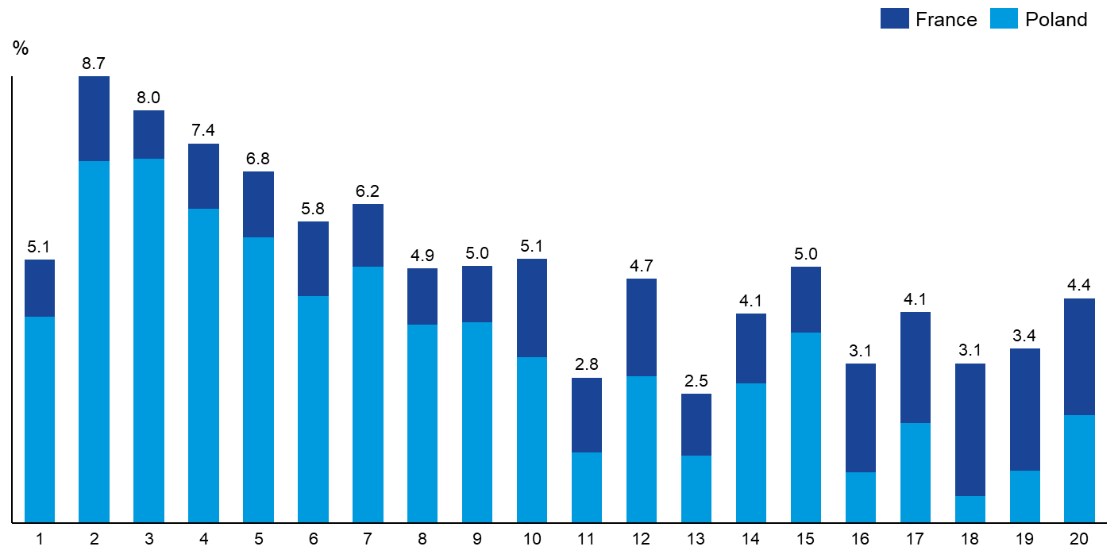
Source: Own calculation based on MCP registries for France and Poland
  - Policy measures
    - Description
The measures under consideration are the maintenance of the current 20MW threshold and the lowering of the 20MW threshold.
- T1: Maintain current 20 MW threshold (PO1, PO2, PO3)
  - In this measure, no additional installations < 20MW in capacity would be included in the ETS, avoiding any potential additional administrative and transaction fees associated with having to be in compliance with the ETS.
- T2: Lower the 20 MW threshold (e.g. 0, 5, 15, 20 MW)
  - The threshold can be reduced by 20MW, 15MW, 10MW, or 5MW. In each instance, operators of installations that are less than 20MW in capacity would need to submit registration permits to have new entrant installations incorporated into the ETS. Following the incorporation of these new installations, operators and competent authorities would incur additional administrative and transaction costs to ensure the new entrants remain in compliance with the ETS and receive free allocation.
  - Assessment of the measures
    - Economic Impacts
      - SMEs
Based on results of the open public consultation (OPC), a majority of respondents opposed lowering the installation capacity threshold to expand the pool of installations covered by the EU ETS. Those respondents were mainly companies and business associations from across different sectors. In contrast, NGOs and environmental organizations were largely supportive of a potential change. Overall, a substantial share of respondents (almost three out of ten) remained neutral or uncertain.
Some stakeholders who provided specific comments considered that the administrative burden would outweigh the potential climate benefits. Others expressed concerns regarding the ability of SMEs to maintain their competitiveness within their respective industries. Several also suggested that ETS2, which covers smaller installations with a lighter approach, is a sufficient incentive for fuel mix changes and decarbonisation efforts, but this would not cover process emissions.
      - Administrative costs on business
There are several additional requirements that operators will have to comply with when integrating additional installations into the ETS, including setting and/or expanding the scope of the monitoring plan and verification.
T1 Maintain current 20 MW threshold
Maintaining the threshold at 20MW will have no additional financial implications for operators and competent authorities. However, a considerable number of installations and their emissions will continue to operate outside the scope of the EU ETS. This impact assessment estimates that up to 28 MtCO2e of emissions could remain out of scope of the EU ETS as can be seen in Section 2.3.3.
T2 Lower the 20 MW threshold (e.g. 0, 5, 15, 20 MW)
Lowering the threshold carries various financial and environmental implications. Operators of new entrant installations will face additional administrative costs. These are estimated in Table 30 below.

- Administrative costs paid per operator in the EU
Cost | Type of cost | Used in quantification? | Amount (EUR)
Permit application fee | Non-MRV charges | No | 2,164
Annual subsistence (renewal) fee | Non-MRV charges | No | 4,130
Variation fee | Non-MRV charges | No | 684
Permit transfer | Non-MRV charges | No | 684
Revocation | Non-MRV charges | No | 1,090
Surrender | Non-MRV charges | No | 1,090
Allocation from new entrant reserve | Non-MRV charges | No | 1,815
Preparing significant modifications to your monitoring plan | Monitoring | Yes | 7,212
Monitoring in accordance with the approved monitoring plan | Monitoring | Yes | 15,671
Quality assurance and quality control procedures | Monitoring | Yes | 12,021
Preparing improvement reports | Monitoring | Yes | 4,109
Preparing an annual emissions report and submitting it to your competent authority | Reporting | Yes | 4,335
Verification | Verification | Yes | 6,789
Any other costs | Other | Yes | 9,052
Source: Based on Schleich & Betz (2004) and DAERA
According to the distribution derived from the French and Polish MCP registry datasets, more than 70% of installations are <=5 MW (see Figure 15 below). The number of installations increases as installation size reduces (see also Figure 14 above for distribution of emissions).
- Distribution of installations by capacity
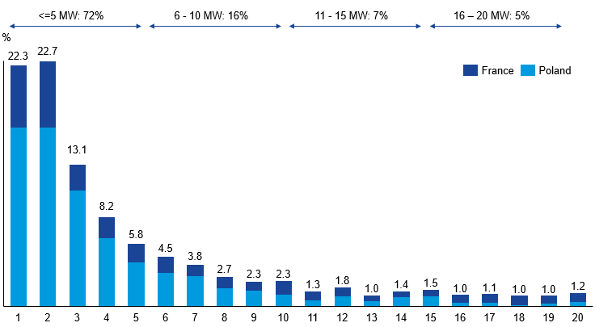
Source: Own calculation based on MCP registries for France and Poland
The estimated total number of <20MW installations EU-wide (94,428), combined with the distribution above indicates that most of the additional administration fees stem from installations that are less than or equal to 5MW, which is attributable to the greater number of smaller installations. Research by Peter Heindl also indicates that average transaction costs are elevated for smaller installations; these are calculated as total transaction costs divided by annual emissions. While this analysis centres on MRV costs, Heindl’s findings suggest that when further costs are included, smaller installations typically have higher transaction costs than larger installations.40
Lowering the 20MW threshold will also have significant financial implications on competent authorities. Like operator costs, competent authority costs will be greatest among the smaller installations (<=5MW). Among public authorities in Germany, there is an awareness around transactions costs being higher for smaller emitters and efforts have been made to reduce to these costs which may in effect increase the shift of the costs from operators to authorities. Overall, competent authorities across the EU may incur costs of around EUR 2.2 million if the threshold were to be lowered to 10 MW, and up to EUR 16.7 million if it were eliminated entirely.

- Administration fees for operators and competent authorities by installation capacity

Source: Based on Heindl (2012)
    - Social impacts
Maintaining the 20 MW threshold implies zero impact on employment, income distribution, social protection, social inclusion. Lowering the threshold may have a small negative impact on employment since participation in the EU ETS would represent an additional cost for firms. However, the overall cost would be small given the low amount of emissions that would be covered at the margin (See Section 2.3.3).
Lowering the 20 MW threshold would ensure broader participation in environmental protection and therefore contribute positively to Article 37 of the Charter on Fundamental Rights of the European Union. Apart from this, none of the options are expected to have an impact on fundamental rights.
    - Environmental impacts
      - Estimating emissions that could be affected by lowering the 20 MW threshold
Using the average of data from the period 2021-2023, the scoping exercise identified that 226.5 Mt CO₂e of emissions from activities and gases that are not currently covered by the EU ETS but would fall within its scope if the threshold were set to zero.
However, once potential ETS2 emissions are removed, the remaining emissions that could be covered by lowering the 20 MW threshold amount to 33 MtCO2e. Furthermore, 4.6 MtCO2e is subtracted to account for emissions excluded from EU ETS under Article 27, since these emissions would not be impacted by lowering the 20 MW threshold. As a result, we can estimate that relevant emissions from <20MW installations are approximately 28 MtCO₂e, consisting mostly of process emissions.
- Overview sector activities that make up the EU ETS baseline
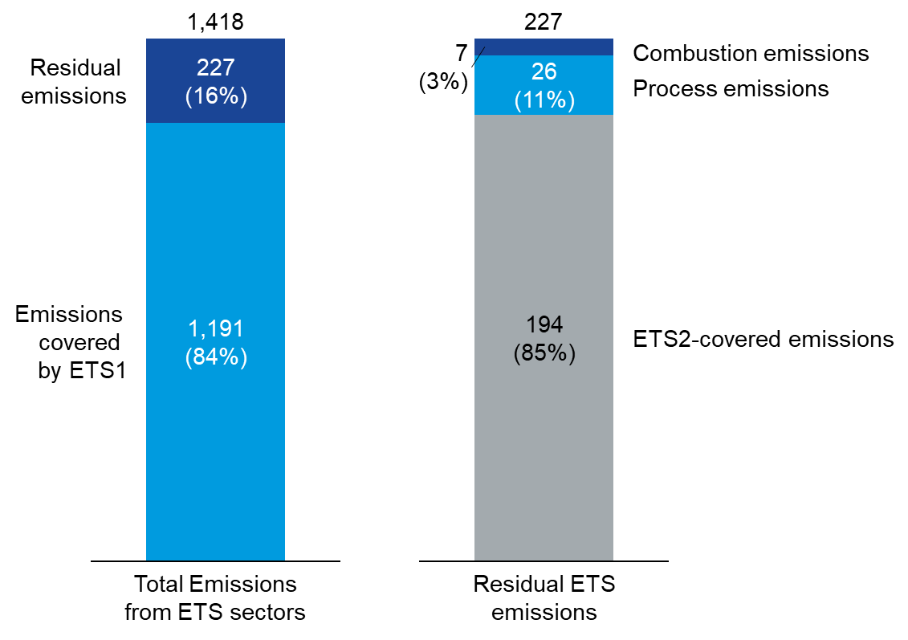
Source: Own calculation based on data sources described in this chapter
      - Estimating the distribution of emissions and installation capacities below 20 MW
Regarding the distribution of emissions, the proxy curve derived from data on Medium Combustion Plants (MCPs) demonstrates that across the two countries from which the curve is derived, the majority of emissions stem from installations that are less than 10 MW in capacity. However, this trend is drive primarily by the Polish dataset. While both countries have more installations at the lowest capacity levels, France has more emissions in the 15-20 MW bracket, indicating that installations in this capacity bracket.
Regarding the distribution of installations, Figure 19 demonstrates the number of installations below and above the 20MW threshold for each Member State.

- Number of installations by capacity (2019)
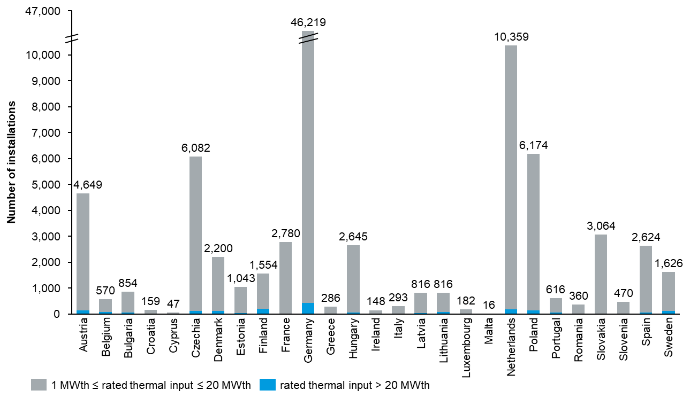
Source: European Environment Agency
      - Comparing policy options
T1: Maintain current 20 MW threshold
If the 20 MW threshold is left unchanged, the relevant emissions that are outside the scope of the EU ETS & ETS2 (which are predominantly process emissions) will need to be reduced or offset by other means.
Despite not being included in the EU ETS, emissions from <20 MW installations have been decreasing year over year as observed in Figure 19, indicating that other energy and climate policies at EU-level and in Member States may have influenced industries and businesses to reduce emissions.
- Annual emissions from <20 MW installations
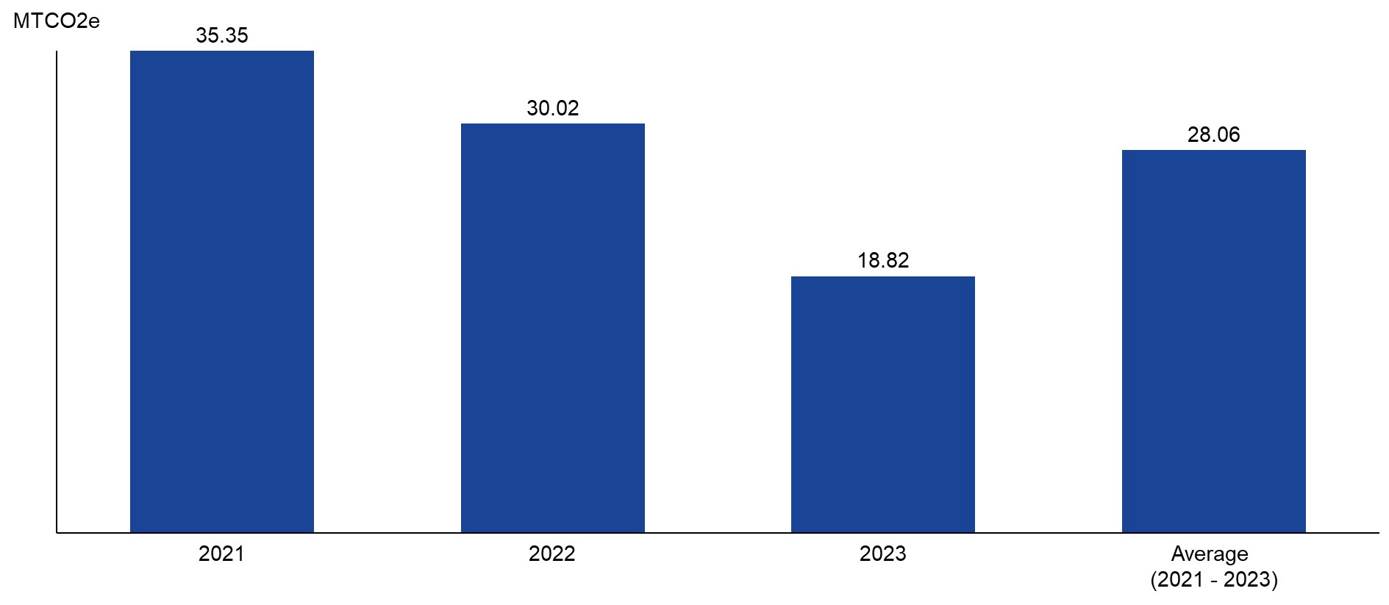
Source: Own calculation based on data sources described in this chapter
T2: Lower the 20 MW threshold (e.g. 0, 5, 15, 20 MW)
According to this analysis, up to 28 MtCO₂e of emissions could be brought into the scope of EU ETS by lowering the 20 MW threshold. As Table 31 and Figure 20 below indicate, lowering the threshold to 15 MW or 10 MW would increase coverage by 5 MtCO2e or 10 MtCO₂e respectively. This shows that the majority of emissions (the remaining 18 MtCO2e out of 28 MtCO₂e) occur in the smallest installations. At the bottom end, 72% of the <20 MW installations (68,000 installations) have a capacity of 5 MW or lower, while accounting for 36% of emissions.
At the top end, lowering the threshold to 15 MW or 10 MW would cover a modest fraction of the remaining emissions (18-37%). This would affect a relatively smaller share of the <20 MW installations (5-12% or 5,000-11,000 installations). However, this still represents a large number of installations in absolute terms. According to the latest available report, the EU ETS covered 8,640 stationary installations in 2022. Therefore, lowering the threshold to 15 MW would imply increasing the number of EU ETS stationary installations by over 50%.
- Estimated emissions and installation coverage from lowering the 20 MW threshold
 | Gain in emissions coverage |  | Gain in installation coverage
Threshold level | % of relevant uncovered emissions | MtCO2e | % of relevant  installations | Number of installations
≤15 MW | 18% | 5 MtCO2e | 5% | 5,005
≤10 MW | 37% | 10 MtCO2e | 12% | 11,615
≤5 MW | 64% | 18 MtCO2e | 28% | 26,345
No threshold | 100% | 28 MtCO2e | 100% | 94,428
- Emissions by installation capacity
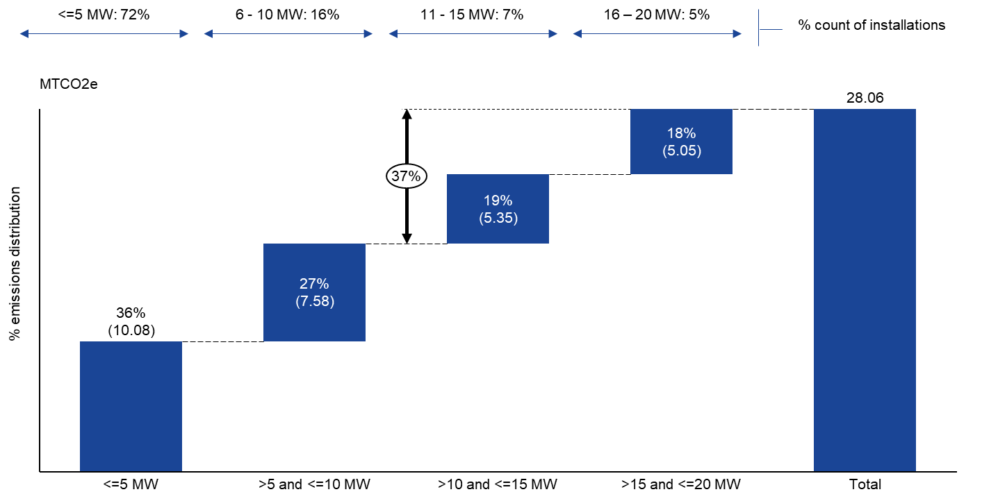
Source: Own calculation based on data sources described in this chapter
It should be noted that the distribution estimates presented in this analysis rely heavily on the distributions from only two Member States: France and Poland. A more rigorous and consistent analysis would require overcoming the difficulties encountered in obtaining data that is complete, consistent and comparable.
    - Summary
Based on the assessment presented in this section, the option of lowering the threshold is not taken further. The main reason for this is that the environmental gains from lowering the threshold would be very small compared to the substantial increase in administrative effort, in particular since most emissions from small installations will be covered under EU ETS2.

Annex 13: New Sectors and Technologies: Waste Management and Carbon Capture and Utilisation (CCU)

List of Tables
Table 1: Emissions data and estimates for MWI in the EU-27. 73
Table 2: Modelling of 2030 EU ETS cap extension for the inclusion of emissions from MWI. 74
Table 3: Emission estimates on landfilling of non-hazardous waste in the EU-27 77
Table 4: Options for threshold for inclusion of waste incineration installations in the EU ETS and estimated impact on installations covered and emissions excluded 92
Table 5: Internal Commission estimates (2022) for fossil emissions from all types of waste incineration (municipal, hazardous and industrial) in the EU27. 113
Table 6: Summary of the Tier Requirements (maximum permissible uncertainty) by category (for a measurement-based methodology). 119
Table 7: Overview of product lists by normal use or end-of-life treatment 132
Table 8: Comparison of non-permanent CCU policy measures 154

List of Figures
Figure 1: Municipal waste per capita by treatment category in the EU (1995-2023) 72
Figure 2: Number of Waste-to-Energy plants and volume treated by country. 73
Figure 3: Share of municipal waste disposed through landfill by EU Member State (2010 vs 2023) 76
Figure 4: Municipal waste recycling rates in 2010 and 2022 (EEA, 2024) 27
Figure 5: Municipal waste per capita and treatment methods (in kg, 2023) 94
Figure 6: Emissions and number of installations reported under the scope of the EU ETS MRV obligation for combustion of fuels in installations for the incineration of municipal waste (2024). 112
Figure 7: Concept of Renewable Carbon 128
Figure 8: Overview CCU technology pathways for chemicals and polymers 129
Figure 9: Simplified illustration of upstream accounting in ETS context 130
Figure 10: Simplified illustration of downstream accounting in ETS context 131
Figure 11: Simplified illustration of hybrid downstream and midstream accounting in ETS context 131
Figure 12: CO2 flows in PO2 scenario for 2040 138

- Waste
  - Overview
The EU generates around 2.5 billion tonnes of waste per year, around 5 tonnes annually per person, with emissions from waste management processes responsible for approximately 6% of the EU’s GHG emissions in 2023. While the waste sector as defined by the IPCC’s 2006 guidelines was responsible for more than 3.5% or 109 MtCO2eq of EU GHG emissions in 2023, this excludes emissions from waste incineration with energy recovery, which have been estimated to be almost similar in size.
The waste management sector includes a range of operations: material recovery (reuse and recycling – chemical and mechanical), composting and anaerobic digestion, and disposal (landfill and incineration) with or without energy recovery. GHG emissions primarily result from anaerobic degradation of biogenic waste streams (e.g. methane from landfills), incineration of fossil waste streams and energy and fuel use (e.g. mechanical and chemical recycling). Between 2010 and 2022 the share of waste landfilled in the EU decreased and other waste management methods like recycling, biological treatment of waste and waste incineration with energy recovery increased. Correspondingly, emissions from waste incineration have increased, while landfill emissions have decreased over this period but continue to be the largest source of GHG emissions from the waste management sector due to the high global warming potential of methane.
While the EU’s environment policy framework sets out targets for waste management activities to promote circularity by boosting recycling and reducing landfilling, emissions from waste management activities are currently mainly subject to national emission reduction targets under the Effort Sharing Regulation, with landfilling and waste incineration (with energy recovery) being the main sources. Member States implement a diverse range of measures to deliver on the EU waste policy targets, but few Member States apply dedicated measures to address emissions from waste management. Denmark, Sweden and Lithuania have included municipal waste incineration (MWI) installations with energy recovery in their national implementation of the EU ETS, while Germany applies a national emissions trading system and the Netherlands implemented a carbon levy for MWI emissions.
Achieving the EU’s 2050 net-zero climate target requires action across all economic sectors. These include actions related to materials and how we produce, use, re-circulate and dispose of them. Waste management and the circular economy hold considerable, mutually reinforcing potential for mitigating climate change. The introduction of additional measures linking emission reductions and circular economy policies is important to help accelerate future GHG emissions reductions while increasing circularity and improving waste management.
More than half of stakeholders in the open public consultation from different stakeholder groups, both companies and business associations as well as NGOs and environmental organisations, supported the inclusion of MWI installations in the EU ETS. Conversely, further extensions to hazardous waste incineration (HWI) installations or landfills were more divisive.
This annex considers the impacts of a potential expansion of the EU ETS to MWI and other waste management processes in contributing to the cost-effective decarbonisation of the waste management sector, while promoting a shift to a circular economy, in line with the review clause in Article 30(7) of the ETS Directive. MWI also contributes to other policy measures under consideration in the 2026 EU ETS review, notably the generation of permanent carbon removals from the capture and storage of the biogenic carbon fraction of waste, and the coverage of downstream emissions of non-permanent Carbon Capture and Use (CCU) products.
  - Scope of regulated activities and emissions
Emissions from the waste management sector are currently mainly covered under the EU’s Effort Sharing Regulation (ESR). However, industrial waste incineration and the co-incineration of waste, e.g. in a cement kiln, are already included in the scope of the EU ETS. In addition, some Member States have included waste incineration installations with energy or heat production as their main purpose in their national implementation of the EU ETS (Denmark, Sweden and Lithuania). This current framework has contributed to a heterogeneous coverage of emissions from waste management under the EU ETS and the ESR, which can lead to competitive distortions within the sector, between sectors and between Member States.
The main additional regulated activities and emissions considered for inclusion under the scope of the EU ETS are those identified under measures W1 (municipal waste incineration), W2 (municipal and hazardous waste incineration) and W3 (municipal and hazardous waste incineration and landfilling of non-hazardous waste).
    - Municipal waste incineration (MWI)
Regulated activity
Municipal waste consists of waste from households and similarly composed waste from offices, shops and other sources, collected by or on behalf of municipal authorities and disposed of through waste management systems. It accounts for 27 % of total waste generated in the EU (excluding mining and quarrying waste and construction and demolition waste). The generation of municipal waste varies considerably between Member States, from 303 kg per capita in Romania to 803 kg per capita in Austria (2022). Municipal waste incineration (MWI) entails the combustion and conversion of this residual waste into carbon dioxide (CO₂) and water, with some remaining ashes (inorganic or inert fraction). The average amount of municipal waste incinerated in the EU has almost doubled between 1995 and 2023, from 30 million tonnes or 70 kg/capita to 58 million tonnes or 129 kg/capita, representing 26% of all municipal waste treated in the EU. This increase is primarily driven by an increase in total waste generated, in combination with part of decreasing landfilled volumes going to incineration. Figure 1 shows the development of municipal waste treatment by type, showing an increase in recycling and incineration as landfilling has decreased.
- Municipal waste per capita by treatment category in the EU (1995-2023)

Source: Eurostat
Most MWI installations in the EU operate with energy recovery (also called waste-to-energy or WtE). The Industrial Emissions Directive effectively mandates energy recovery for waste incineration. A total of 411 WtE plants were reported in the EEA in 2022, excluding hazardous waste incineration (HWI) plants (see Figure 2). MWI incineration capacity is high overall in the EEA (with overcapacity by some estimates) but unevenly distributed, with several Member States having limited or no incineration capacity. The share of waste-to-energy installations in EU electricity generation was 1.4% in 2019, supplying electricity to some 20 million people (43 billion kWh). The share of municipal waste in district heating generation in the EU is more significant at 9.9% (2019), especially in the North, supplying around 17 million people (99 billion kWh). In some countries, like Germany, this can account for over 4% of the energy supply. In Denmark, heat recovered from waste incineration accounts for approx. 20% of supplied district heating.

- Number of Waste-to-Energy plants and volume treated by country.
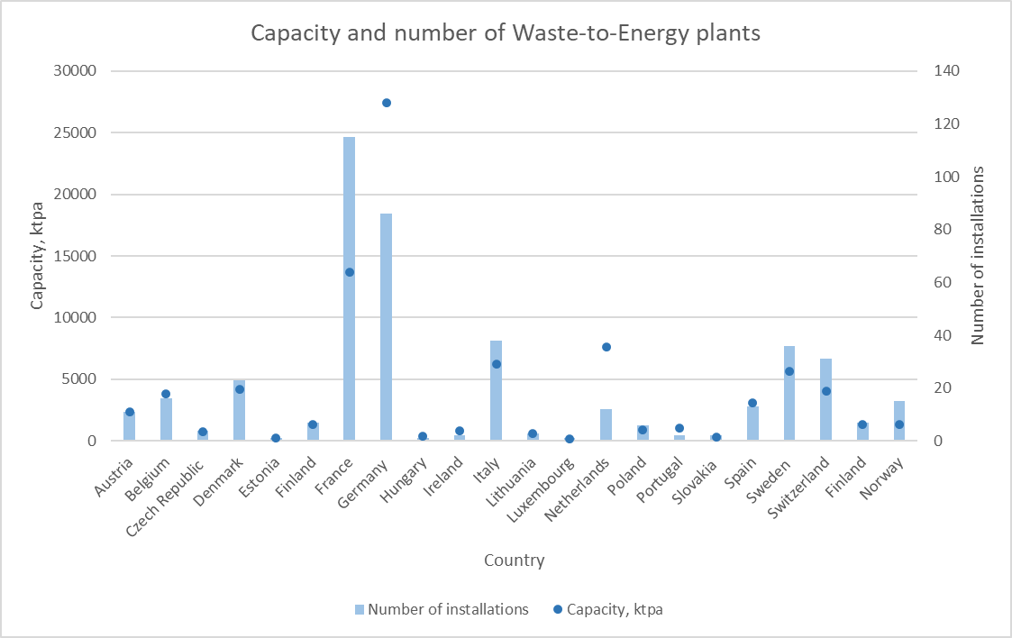
Source: European Commission, based on summary data from CEWEP (2022)
Emissions
Municipal waste is mostly composed of packaging materials and bio-waste (biodegradable garden and park waste, and food and kitchen waste). The climate change impact of MWI accounted as total CO₂e emissions largely depends on the distribution between these biogenic and fossil fractions of waste input. This varies locally, regionally and from country to country depending on collection schemes, potential pre-sorting stages and local citizen habits. A tonne of municipal waste is generally estimated to be associated with emissions between 0.7 and 1.2 tonne CO₂, of which approximately half is fossil and half biogenic. There are also other emissions associated with the plant operations, for example, the use of burners to start-up or maintain autothermal combustion, or the generation of N₂O in the deNOx system.
Emissions data and estimates for MWI in the EU are presented in Table 1 and explored and compared in detail in Appendix 1. MWI emissions have increased by almost 300% from 1990 to 2023, in parallel to the increase in volumes of waste incinerated.
- Emissions data and estimates for MWI in the EU-27.
Source | Year of reporting | Year of emissions | Fossil emissions (MtCO2e) | Biogenic emissions (MtCO2e) | Data limitations
ETS MRV data | 2025 | 2024 | 39.4 | 45.6 | Only installations above 20MW.
UNFCCC Inventory Data | 2025 | 2023 | 38.2 | / | Includes some non-disaggregated emissions from other activities.
Internal Commission estimate | 2022 | 2016-2018 | 44.3 | / | Includes emissions from HWI and co-incineration.
Cap
The cap on emissions determines the ambition level of the ETS and is the maximum absolute quantity of GHGs that can be emitted by the covered activities to ensure the emission reduction target. The cap’s annual trajectory is declining based on the linear reduction factor (LRF), which is set as a percentage applied to a reference value. The cap and LRF approach for MWI would need to be consistent with the overall EU ETS cap and LRF, implying an increase of the cap by the scope of MWI emissions. To determine the cap increase in order to base the system on recent, robust and verified data, the cap extension for MWI (measure W1) has been modelled to be in the range of 41.5 MtCO2eq (EU-27) and 42.2 MtCO2e (EEA) (see Table 2), starting from the data explored in this section and taking into account differences in scope and timeframe (see Appendix 1 for details).
- Modelling of 2030 EU ETS cap extension for the inclusion of emissions from MWI.
 | Waste scope and categories | EU27 (Mt) | EEA (Mt)
A | 2024 ETS MRV data (MWI fossil emissions) | 38.6 | 39.4
B | A plus gap filling for missing reporting data | 39.2 | 39.9
C | B plus margin for new capacity 2025-2030 | 40.5 | 41.2
D | C plus buffer for underestimation and uncertainties | 41.5 | 42.2
F | Total cap 2030 (MWI only, A-D) | 41.5 | 42.2
    - Hazardous waste incineration (HWI)
Regulated activity
Hazardous waste is waste with one or more of the hazardous properties listed in Annex III of the EU Waste Framework Directive. It covers a broad range of wastes that because of their chemical reactivity, toxic, explosive, corrosive, radioactive or other characteristics, cause danger, or are likely to cause danger, to health or the environment. In total, 10.5 million tonnes of hazardous waste were incinerated in the EU in 2022, of which 6.4 with energy recovery and 4.1 without energy recovery. This has remained broadly stable over the past decade. Hazardous waste incineration (HWI) is regulated by the Industrial Emissions Directive, which sets strict operating conditions and technical requirements to protect human health and the environment. Facilities use high temperatures and advanced flue gas cleaning to destroy hazardous substances.
Emissions
Accurate data on emissions from HWI in the EU are currently not available. Based on default emission factors and cross-analysis of aggregate waste incineration emissions data in Appendix 1, the fossil fraction of HWI emissions in the EU-27 in addition to MWI emissions have been estimated to be around 3.15 MtCO2e (See Appendix 1, Section C).
Cap
The cap-setting for HWI inclusion (measures W2 and W3) would imply an increase of the EU ETS cap by the scope of HWI emissions. In view of current limitations on HWI emissions data availability, cap-setting would ideally be based on a monitoring and reporting period to gather robust and verified emissions data with harmonised standards and rules to establish more precise data.
    - Landfilling of non-hazardous waste
Regulated activity
Landfilling entails the deposit of waste into or onto land. It includes specially engineered landfill sites and temporary storage of over one year on permanent sites. In 2022, 137 million tonnes of waste was disposed in landfills in the EU, of which 52 million tonnes was municipal waste, representing 23% of all municipal waste treated in the EU. The EU has seen a significant reduction in average municipal waste landfill disposal rates by 59% or 71 million tonnes from 1995 to 2023, in parallel to a substantial increase of biogenic waste going to composting and anaerobic digestion and of fossil waste going to recycling and incineration. Nevertheless, several Member States continue to be strongly reliant on landfilling for municipal waste, as illustrated in Figure 3. Across the EEA, 2.491 active landfill installations were registered in 2024, in addition to at least 1,995 illegal or substandard landfills (2021).

- Share of municipal waste disposed through landfill by EU Member State (2010 vs 2023)

Source: European Commission, based on Eurostat.
Emissions
One of the primary concerns with landfilling is the emission of landfill gases, particularly methane (CH₄). Landfill gas is composed of around 45%-60% CH₄ and 40%-55% CO_{2.} However, as methane is a potent GHG with a global warming potential approximately 27 to 30 times greater than carbon dioxide (CO₂) over a 100-year period and 84 to 87 times more over a 20-year period, methane represents the vast majority of GHG emissions from landfills in CO2-equivalent. Methane is generated from the anaerobic decomposition of organic waste, including food scraps, garden waste and paper. The decomposition of waste in landfills is a long-term process that continues to release methane over time, at progressively decreasing levels, for more than 50 years after disposal (so-called ‘historic emissions’). The main factors influencing the quantity of CH4 produced are the amount of waste disposed and the concentration of biodegradable carbon in that waste. In addition, CH4 emissions from landfills are influenced by the amount of CH4 recovered and utilized or flared. Fossil waste streams, such as plastics, represent only a minor fraction of GHG emissions from landfills.
Methane from landfills continues to account for the largest share of the waste sector’s emissions in the EU. At the same time, landfill emissions (for all solid waste) have decreased by 55% from 132.3 Mt CO2e since 1990 and 25% from 99.4 Mt CO2e since 2010, primarily due to a reduction in biodegradable waste being landfilled and a significant increase in landfill methane recovery and flaring. Table 3 presents the data sources and estimates for emissions from landfilling in the EU, which are explored in further detail in Appendix 1.
- Emission estimates on landfilling of non-hazardous waste in the EU-27
Source | Emission Year | Emissions (MtCO2e) | Comments
UNFCCC inventory data | 2023 | 65.3 (managed)  8.6 (unmanaged) | Scope covering emissions from historical disposal of all solid waste
Default emission factor | 2022 | 82.2 | Scope covering emissions from future disposal of all solid waste
Default emission factor | 2022 | 31.2 | Scope covering emissions from future disposal of only municipal waste
Cap
The cap-setting for the inclusion of non-hazardous landfills (measure W3) implies an increase of the existing cap by the scope of non-hazardous landfill emissions. Current EU-wide data on GHG emissions from landfills are mainly calculation-based, with constraints on accurateness in absence of comprehensive measurement-based data (see Section 1.4.3. for further discussion). The determination of the cap would therefore ideally be based on a monitoring and reporting period to gather robust and verified data based on harmonised standards and rules.
In addition, an inclusion of landfill emissions in the EU ETS would need to determine the scope of emissions under the cap, i.e. only ‘future’ emissions (resulting from waste disposed in landfills as of the date of inclusion) or also ‘historical’ emissions (resulting from the gradual decay of waste disposed in landfills prior to the date of inclusion). Based on the data explored in this section, the emissions covered would vary from 73.9 MtCO2eq in 2022 in the latter case to 82.2 MtCO2eq in the former case.
    - Discarded measures
Chemical recycling (W4): chemical recycling is a form of plastic waste treatment breaking plastic waste down into original chemical components, enabling to recover or convert plastic waste streams which are difficult or impossible to mechanically recycle and deliver higher quality and technical performance of recycled outputs. Chemical recycling is a part of the chemical sector not covered as a separate activity under the EU ETS. It covers a range of methods and technologies, including pyrolysis, gasification, depolymerization and solvolysis. It is an emerging technology with currently limited commercial operation in the EU, recycling less than 0.2% of plastic waste, but expected to scale-up in the future. Data on emissions from chemical recycling in the EU are currently not available. Some chemical recycling processes are characterised by a high energy intensity, in particular pyrolysis and gasification. Their overall contribution to EU GHG emissions would be dependent on the future scale-up and application of these technologies, as well as on the life-cycle carbon footprint of the recycled materials compared to virgin alternatives. From an environmental point of view, chemical recycling complements mechanical recycling for otherwise difficult or impossible to recycle waste streams, positively contributing to the waste hierarchy, while mechanical recycling technologies are in general preferable to chemical recycling technologies where mechanical recycling can produce recyclates with similar quality or performance characteristics.
Mechanical recycling (W5): mechanical recycling would in most cases establish an end of waste status, higher up the waste hierarchy than incineration or landfilling. Recycling activities are very variable, treating a variety of outputs and employing different technologies. Data on emissions from mechanical recycling in the EU are not available. However, mechanical recycling is primarily an energy-intensive process with the associated emissions from the power sector already covered by the EU ETS, while recycled materials generally have a better carbon footprint across the lifecycle compared to virgin products. The application of the carbon price signal to these waste management processes would not be expected to cover a substantial additional volume of emissions, while under the waste hierarchy mechanical recycling is preferable compared to incineration or landfilling, thus limiting the reach of the carbon price incentive from an overall environmental perspective.
Composting and anaerobic digestion (W6): composting and anaerobic digestion are biological processes. For composting the decomposition of organic waste takes place under aerobic conditions primarily resulting in biogenic CO₂ emissions, which would be zero-rated under the EU ETS. The remaining GHG emissions from N2O and CH4 are relatively modest, with composting being substantially less methane-intensive than landfilling and overall accounting for only 2.8 MtCO2e emissions from CH4 in 2023 (compared to 76-84 MtCO2e from landfills) and 1.7 MtCO2e from N20. Anaerobic digestion is smaller than composting both in terms of volumes and associated emissions. It is a closed process by design for the recovery of methane for renewable energy, although subject to some release of fugitive methane emissions amounting to 2.0 MtCO2e in 2023, at a more limited scale compared to composting and landfilling and with remediation possible. Under the waste hierarchy, anaerobic digestion and composting are preferable as a form of recovery and recycling contributing to the reduction of organic waste. Consequently, the application of the carbon price signal to these waste management processes would not cover substantial additional volumes of emissions, while not being coherent with the objective of the waste hierarchy incentivising these processes, limiting the reach of the carbon price incentive from an overall environmental perspective.
Carbon taxation: as an alternative to cap-and-trade systems, carbon taxation can offer predictable marginal costs and a simplified legal structure, while raising stable revenue without the complexity of allowance auctions or registries. Conversely, taxation can also be less predictable over time in view of discretionary decisions on design and levels, which undermines efficiency and investment predictability. Contrary to cap-and-trade systems taxation does not guarantee the achievement of emissions reductions in absence of a cap on total emissions, while carrying a higher aggregate cost due to the lack of market flexibility steering the most cost-efficient decarbonisation routes. Harmonised taxation at EU-level would carry an additional procedural complexity due to the unanimity requirement as a fiscal measure. On the other hand, national taxation reflects the current policy situation, characterised by a lack of harmonisation and risk of tax competition. Currently only one third of EU Member States have some form of taxation on waste incineration in place, of which only two apply a carbon tax (the Netherlands and Norway). With few exceptions, taxation levels are substantially below both current and projected future ETS prices, averaging EUR 19 to 29 across the EU. For landfilling, all but five Member States apply taxation, and levels are generally higher than for waste incineration, averaging EUR 39 to 46. For these reasons, this measure was discarded as an option to address emissions from the waste management sector, either harmonised at EU-level or for Member State implementation.
  - Carbon price signal and emission abatement
The application of the carbon price to waste incineration and landfilling can drive emissions reductions, depending on the carbon cost for operators, the carbon cost passthrough in the waste value chain and available cost-effective emissions abatement pathways at different levels of the waste value chain.
The overall carbon cost for operators depends on multiple factors including total volume of waste treated, waste composition (fossil vs biogenic fractions), the EU ETS price, the ability to pass on carbon costs to other actors, elasticities, and the availability and cost-effectiveness of decarbonisation pathways and removals generated.
The baseline assumes no EU ETS carbon cost and an average gate fee for municipal waste incinerators of EUR 100 per tonne of waste (not considering separate taxes or levies on waste incineration, which could be modulated to compensate the additional carbon cost). For the inclusion of municipal waste incineration, assuming a carbon price of EUR 110 per tonne CO2e in 2030, 1 tonne of municipal waste incinerated being associated with 0.7-1.2 tonne of CO2 of which 50% fossil CO2, and not integrating emissions abatement incentivised by the carbon price, the average effective carbon cost per tonne of municipal waste incinerated is estimated to range between EUR 38.5 and 66 (2030), at which level the carbon cost would add 38.5%-66% to the gate fee when fully passed through to waste suppliers. The cost would further increase in case the ETS price increases towards 2040.
For landfills, the baseline assumes no EU ETS carbon cost and generally lower gate fees than for municipal waste incineration, at EUR 50 per tonne of non-hazardous waste on average (separate landfill taxes not included, which could be modulated to compensate the additional carbon cost). For landfills, assuming an emissions factor of 0.6 CO2e for methane, the average carbon cost per tonne of landfilled waste is estimated to amount to EUR 66 on average, which would more than double the average gate fee when fully passed through to the waste supplier. The cost would further increase as ETS prices increase towards 2040.
The carbon price signal is expected to provide an economic incentive to reduce emissions from waste incineration and landfilling, mitigating carbon costs and buffering against future carbon price increases, provided cost-effective decarbonisation pathways are available. Action to abate emissions can be incentivised at installation level (see Section 1.3.2.) and in the waste value chain (see Section 1.3.1.).
    - Ability to pass-on the carbon cost and emissions abatement in the waste value chain
One of the most effective ways to ensure that no fossil carbon at stack (incineration) or methane (landfills) is emitted is source reduction or elimination. The carbon cost passthrough from waste disposal operators to waste collection authorities, notably local authorities, and other waste suppliers, such as commercial actors or recyclers, should incentivise action by waste collection authorities and other waste suppliers to reduce residual waste streams and the carbon/methane content in residual waste streams sent for disposal. The ability to do so is subject to the price elasticities in the sector, the contractual arrangements in place, and complementary policies and measures including targeted reinvestment of EU ETS revenues (see Section 1.3.4.).
Evidence indicates policy-relevant price elasticities for the demand for residual waste disposal ranging from -0.2 to -0.4, implying a 10-20% reduction potential in incineration in response to an average increase in disposal costs by EUR 50 (2030), and cross-price elasticities for diversion to recycling ranging from +0.32 to +0.45, implying an 16-22.5% increase potential in waste diverted from incineration to recycling. Elasticities are highest for higher price signals and for targeted weight-based or Pay-As-You-Throw waste collection systems for non-recyclable waste. Evidence on price elasticities for hazardous waste and for landfilling is more limited due to the wide variety of waste types under this category.
The carbon price incentive can improve circularity and reduce waste handling costs through improved waste prevention and separate collection. Consider a stylised example of a waste supplier (e.g. a shopping centre) with a current total waste volume of 150 tonnes per month and a waste handling ratio of 67% recycled and 33% sent to incineration as mixed municipal waste at a gate fee of EUR 100 per tonne of waste, leading to a mixed waste handling cost of EUR 4.950 per month. If the carbon price is passed through increasing the gate fee by 40% and the shopping centre improves its waste prevention and separate collection to reduce its share of mixed municipal waste sent to incineration by one third to 22%, then the mixed waste handling cost decreases by 6.5% to EUR 4.620 per month compared to the current situation.
Selected circular economy measures that can steer the collection and disposal of municipal waste in line with the higher steps of the waste hierarchy, reduce emissions at disposal stage and help manage the impact of the carbon cost include:
Improved separate waste collection to improve recycling: Recycling (both of fossil and biogenic waste streams) is key to reduce emissions from waste management, with the net climate change impacts of the waste management system the lowest in Member States recycling the most. However, separate collection of polymers and textiles (with significant impacts from incineration) that could otherwise be recycled remains overall low. Depending on national variations, approximately 70% of the waste gathered as mixed municipal waste could be collected separately and recycled in a Member State with an average EU recycling rate like Finland. The greatest share of fossil CO2 in this recyclable share comes from plastic waste, which is estimated to contain 69% of fossil carbon out of the weight of the dry material. The carbon cost passthrough from operators to waste disposal authorities is expected to incentivise action to reduce residual waste and increase recycling. Improving separate waste collection to reduce the volume of residual waste and increase the range of recyclables collected, especially those with a high fossil carbon content, can result in twofold savings by decreasing GHG emissions and by reducing disposal costs for local authorities, especially in the early years, by up to 37-56%. The potential depends on the current performance of local authorities, with lower performing systems having a higher reduction potential, while higher performing systems are expected to face a lower carbon cost due to the measures already in place. Early action is important, as improved separate waste collection can reduce the carbon cost in the shorter term and savings can be invested in future service improvements. In addition, improved upstream infrastructure to process and recycle the existing and other fossil streams will be necessary to achieve the requirements and could be supported through revenues from carbon pricing.
Improved biogenic waste collection and treatment: For landfills, reducing the amount of organic waste sent to landfills is one of the most effective ways to lower GHG emissions. Separate collection of biowaste (with significant impacts from landfilling) remains overall low. Through separate collection of food, paper, and garden waste, biodegradable waste can be diverted to alternative treatments such as composting, anaerobic digestion (AD), or biogas production. Implementing local or extended policies that ban biodegradable waste from landfills can further reinforce these efforts. In addition, Mechanical-Biological Treatment (MBT) can pre-treat waste before it reaches landfills by extracting recyclables and reducing organic content, which will lead to a reduction in associated methane emissions. Combining these policies can be particularly effective at reducing the amount of GHG emissions produced by landfills. However, this only affects emissions from future landfill disposal but does not address emissions from historic disposal in landfills, for which measures at installation-level are needed (see Section 1.3.2.).
Pay-as-you-Throw schemes (PAYT): PAYT schemes involve households or commercial actors paying corresponding to the amount of residual waste they produce. This can be enacted through residual waste bags costing more than recycling or biowaste bags, or through the cost of residual waste disposal being variable by weight. PAYT measures incentivise better sorting of waste through making recycling the cheaper option and have been widely used across Europe at different scales. For example, Parma in Emilia Romagna, Italy (population of 200,000), has achieved a waste separation rate of over 80% and a 65% decrease in residual waste generation 3 years after PAYT implementation. PAYT was enacted by equipping residual waste bins with transponders associated to each user and charging them for extra deliveries beyond the minimum included in their waste bill (to avoid littering). As well as door-to-door collection, the city set up eco-stations in park-and ride-facilities, accessible 24/7 with a badge or health insurance card, with volumetric-controlled doors for residual waste to track residual waste outside of collections and prevent littering. Further selected case studies are listed in Appendix 2.
Improved recycling efficiency: the estimated recycling efficiency (i.e. the share of plastic waste being recycled out of the total input to a recycling plant) in mechanical recycling varies for each type of waste. The average recycling efficiency in conventional mechanical recycling plants ranges between 66% and 88%,, and 71% to 93% in the 25% most advanced facilities, implying a 23% average reject rate in conventional and 15% average reject rate in modern facilities. Residues are generally sent to incineration and, to a lesser extent, landfills and other uses already covered by the EU ETS such as solid recovered fuel. To fulfil the ambitious recycling targets set at EU level, the improvement of the efficiency of the collection and recycling systems is imperative. This includes improvements in mechanical recycling and the further development and scaling of advanced and chemical recycling technologies. The carbon price on disposal of rejects can provide a complementary financial incentive and support from ETS revenues to optimise collection, sorting and recycling systems. The cost-passthrough is estimated to add around EUR 33 per tonne of plastic waste bale received and processed in recycling, or a 5-6% increase on the total cost for recyclers￼.The effectiveness of the carbon price cost passthrough in incentivising action to reduce residual waste and increase recycling depends not only on elasticities but also on the ability of operators to pass on the carbon cost in gate fees through contractual provisions. Contracts between waste incineration or landfill operators and public or private waste suppliers establish how certain cost categories are transferred from the operator to the local authority or other specific waste suppliers such as commercial or industrial actors. Contracts take varying formats (public service contracts with local authorities, or commercial contracts with other waste suppliers) and durations (e.g. generally ranging between 5 to 20 years for public service contracts). The carbon cost passthrough mechanism can be devised either as a lump sum in gate fees, fixing the carbon cost over a set period to allow for more predictable planning; through a modulated approach differentiating the gate fee depending on the emissions intensity of waste that is being disposed to encourage upstream actors to reduce the amount of specific waste streams sent to incineration or disposal; or based on performance-based contracts, rewarding improvements in efficiency and investment in lower-emission technologies. To facilitate the implementation of cost passthrough mechanisms in public service contracts, a transitional period could help to anticipate and prepare for the needed changes.
    - Emission abatement at installation level
Carbon pricing also creates economic incentives to mitigate emissions at the stage of waste disposal, with several pathways for cost and emissions abatement available to waste disposal operators:
Waste incineration
Mixed waste sorting (MWS) to reduce emissions before incineration: Sorting allows to reduce CO2 emissions and improve overall energy efficiency of waste incineration by extracting high-carbon-content and recyclable materials, preventing their incineration. It can be implemented either downstream or at installation-level. A report by Eunomia Research and Consulting (ERC) estimated that MWS could save between 10.2 and 23.3 MtCO₂e annually across the waste management sector in the EU, which would represent savings of 5-10% of total EU waste management emissions (including waste-to-energy, landfilling and other activities), while another recent study found a 20% emissions reduction potential specifically for waste incineration in Sweden from the implementation of MWS. Selected case studies are presented in Appendix 2. In terms of cost-effectiveness, cost of mixed waste sorting for MWI emissions reductions has been estimated at around 24 EUR/tonne of waste treated in the UK, with cost-effectiveness increasing as the carbon content of waste increases, while costs associated with implementing Material Recovery and Biological Treatment (MRBT) systems, which combines mechanical sorting and biological processes to manage leftover mixed waste, have been estimated to range from 2 to 13 EUR/tonne of waste treated in high-capacity (200kt) facilities, depending on regional factors such as labour and energy costs. In addition, MWS applied at installation level can also generate economic benefits for operators as the gate fee is received for the initial volume of residual waste, while recyclable fractions subsequently sorted out can be sold to the recycling industry. While these studies have different geographical and sectoral scopes, the results and the case studies in Appendix 2 indicate MWS is a cost-effective abatement option for municipal waste incineration.
Fuel switch and alternative feedstocks during incineration: Compared to other sectors, a fuel switch is not a general decarbonisation pathway for the municipal waste incineration sector. A secondary pathway to reduce incineration emissions involves replacing auxiliary fossil fuel by biofuels or other renewable alternatives. However, these emissions generally represent only a low ratio of total emissions from a waste incinerator. Fuel switching in hazardous waste incinerators could be more relevant, as auxiliary burners need to be lighted with a higher frequency to maintain the 1,100C temperature requirement in the secondary chamber. No detailed information was available on the costs associated with fuel switching and alternative feedstocks.
Process optimisation during incineration: Process optimisation enables plants to deliver a higher amount of energy, as power, heat or both, when burning the same amount of municipal solid waste. Examples include improved combustion efficiency by optimising oxygen supply and temperature, advanced monitoring and control systems to optimise combustion efficiency and minimise excess air, and upgrading boilers, heat recovery systems and turbines to maximise energy output per unit of waste. These result in a lower carbon intensity per kWh of energy produced or delivered, reducing the carbon cost.
Carbon capture, utilisation and storage (CCU/S) to sequester emissions after incineration: Carbon capture provides a twofold contribution to GHG reductions in the incineration sector by preventing the release of carbon of fossil origin and by removing carbon of biogenic origin, generating negative emissions. CCU/S can capture up to 90% of residual CO2 before emission at stack, and either permanently fixate or store it (CCS) or use it in downstream industrial applications (CCU). Experience from Member States who have already applied a carbon price on waste incineration indicates growing interest in carbon capture at incineration facilities (see Appendix 2 for selected case studies). The business case for cost-effective carbon capture implementation in MWI is driven by the investment and operational cost of carbon capture technologies, the carbon price, and additional factors:
- the cost of carbon capture in waste-to-energy installations has variously been estimated to range from EUR 40-75/tonne of CO2 (CAPEX) to EUR 76-127/tonne of CO2 (total CAPEX and OPEX), which is lower than for most other hard-to-abate industrial sectors, to EUR172/tonne of CO2 (total CAPEX and OPEX), which is comparable to other industrial sectors. These costs expected to come further down as technologies mature and become more widely adopted,, and exclude the potential to generate biogenic carbon removals and negative emissions, which is significant in the sector compared to other industrial sectors. Taken into account the potential to also generate and integrate carbon removals, a positive business case for carbon capture is expected by the mid-2030s.
- the integration of carbon removals under the EU ETS, allowing to generate revenue from removals from the biogenic fraction of MWI emissions, supporting the business case for carbon capture implementation.
- implementation of waste heat recovery to offset the loss in heat output from the operation of carbon capture technology, minimising the reduction in heat available for supply to district heating networks (where applicable). In addition, innovation in advanced solvent systems can contribute to reduce energy requirements of solvent regeneration in the future.
- a predictable timescale and financial support to plan and invest in carbon capture technology, with other abatement options offering pathways to reduce the carbon cost in the shorter-term until the implementation of carbon capture over time. Financial support and a transition period could complement the economic incentive of the carbon price. Financial support is currently already available under the Innovation Fund and the Modernisation Fund.
- waste incineration infrastructure is generally modern and technically advanced, with long operational lifespans, making it well-suited for CCUS retrofitting. In the UK – with a similar market structure as the EU27 – 60-65% of 57 installations, covering 74-78% of total emissions from the sector, have been found to be CCUS compatible. Further development of smaller modular units and the implementation of CCS-readiness mandates requiring new MWI installations to be designed for compatibility with carbon capture technology, addressing practical constraints in retrofitting smaller existing plants due to footprint restrictions.
- further development of a harmonised EU regulatory framework for industrial carbon management, including CO2 transport, access to storage locations (CCS), demand for recycled carbon (CCU), and the creation of a single European market for CO2.
Landfills
Landfills covered by the Industrial Emissions Directive must apply Best Available Techniques (BAT). In addition, a BAT Reference Document (BREF) and BAT conclusions for landfills are currently under development. Emissions abatement pathways include:
Biofilters and biocovers to reduce emissions: Biofilters and biocovers are passive techniques that can be used to mitigate landfill gas (LFG) emissions. Biofilters and biocovers can function independently of active gas collection systems and can be used for areas of landfills no longer connected to such systems. Biocovers utilising substantial amounts of aged compost have demonstrated methane oxidation rates between 30% and 40%, while methane oxidation rates in biofilters can reach up to 19%. For example, the Fakse landfill biocover project in Denmark covered over 5,000 m2 with biocovers, with field tests showing a 30% reduction in methane emissions. The cost of biofilters and biocovers is overall limited and depends on the local availability of materials. Costs include installation, as well as ongoing maintenance, such as watering oxidizing materials in dry climates and monitoring their effectiveness over time. The United States Environmental Protection Agency (EPA) estimates that, on average, the capital cost for a biocover is approximately EUR 16.7 per hectare.
Quality landfill management: Effective landfill (cover) management plays a key role in reducing methane emissions. Using impermeable covers helps prevent rainwater infiltration while enhancing methane capture. Additionally, implementing a leachate collection and management system reduces moisture levels and anaerobic conditions within the landfill, thereby limiting CH₄ production. Enhanced landfill management practices can improve waste decomposition and maximise gas collection efficiency. Key strategies include compacting waste to minimize empty spaces where methane can accumulate and using alternative daily cover materials that support gas capture. Additionally, routine monitoring and maintenance of gas collection systems are crucial to ensuring long-term effectiveness.
Landfill gas (LFG) capture and utilisation: Capturing LFG involves collecting methane produced during waste decomposition and repurposing it, for biogas production, electricity generation or heat generation in industrial processes. LFG capture not only mitigates the release of methane into the atmosphere but can also provide sustainable energy alternatives, with efficient energy recovery generating substantial savings. Alternatively flaring systems can burn excess methane if energy recovery is not feasible, converting CH₄ to CO₂ which has a lower global warming potential. LFG capture efficiency varies, with well-managed, modern sites achieving 70-90% efficiency. The abatement potential of landfill gas capture and utilisation was also explored during the stakeholder consultation, confirming these results. The overall Levelized Cost of Electricity (LCOE) for electricity production from biogas in the EU was analysed to be 80 EUR/MWh (2018) and between 40-60 EUR/MWh specifically for LFG capture and utilisation projects (2020), making it a competitive renewable energy source with an LCOE within the range of onshore wind and (substantially) below fossil power sources. Selected case studies on LFG projects are presented in Appendix 2.
    - Complementary measures and revenue use
Complementary policies and measures and the targeted reinvestment of EU ETS revenues can provide key complementary incentives for abatement, in particular by reducing the amount of non-recyclable plastics at production level and by increasing recycling of fossil-based waste streams, in particular plastics, through upstream improvements in product design, improving producer responsibility for waste treatment, and expanding recycling capacity. The EU already has several policy frameworks that promote such measures. A recent report by the Joint Research Council found that an ambitious circular economy scenario based on strengthened reduce, reuse and recover levers has a substantial potential for reducing GHG emissions across selected energy-intensive sectors, with up to 75-84 Mt CO2-eq emissions reductions in plastics by 2050 through the reduction of virgin plastics, strengthened eco-design, lifetime extension measures and improved waste management to deviate plastic towards recovery and recycling. Selected complementary measures that can support the carbon price incentive include:
Strengthened Extended Producer Responsibility (EPR): Extended Producer Responsibility (EPR) schemes shift the accountability for the environmental impacts of products across their entire lifecycle to producers, who contribute financially to waste collection, treatment, and disposal, encouraging recyclability and reparability of products. Extending and optimising EPR schemes can improve the recyclability of products, decrease the amount of non-recyclable plastics being sent to disposal, reduce the amount of carbon content in and emissions from waste, ensure that producers share the cost of managing fossil carbon emissions and generate revenue to support recycling capacity. Under the Packaging and Packaging Waste Directive, EU Member States set an EPR scheme for plastics (p-EPR) by 31st December 2024. An overview of Member States’ EPR schemes can be consulted on the sector organisation’s website. One example is Fost Plus in Belgium, an industry-funded non-profit EPR-scheme to manage packaging waste collection and recycling, including a take-back obligation for industry and eco-modulation with higher rates for difficult or non-recyclable packaging. The system achieved a 71% plastic packaging recycling rate in 2024, above the EU target, while having reduced the volume of non-recyclable packaging on the Belgian market by more than half since 2019. From 2025, textile waste (which in most cases has a fossil component) must also be separately collected and EPR schemes will be set up for textile and footwear products. Some countries have further extended EPR schemes to other fractions (such as toys, electronics, etc). Factors that can further strengthen the impact of EPR schemes are to use (part of) the revenues to support waste management service improvements, making EPR schemes sufficiently responsive to cover the ETS carbon cost, and extending and aligning EPR-schemes at EU-level to the scope of waste streams covered under the EU ETS.
Mandatory recycled content policies: Mandatory recycled content policies reduce (virgin) fossil-based waste streams and incentivise recycling. The EU has mandatory recycled content policies, primarily through the Packaging and Packaging Waste Regulation (PPWR) and the Single-Use Plastics Directive (SUPD), requiring minimum recycled content for plastics, like 25% in PET bottles by 2025 and 30% by 2030, with broader packaging rules targeting virgin material reduction and recyclability by 2030. Recent developments also set mandatory recycled content for vehicles (25% by 2036) and focus on improving end-of-life vehicle management and producer responsibility to boost circularity.
  - Monitoring and Reporting
When expanding the ETS to cover waste sector emissions, the development of an effective MRV framework, balancing the need for robustness with practical feasibility, would be an essential element of a potential inclusion of waste incineration facilities and landfills in the EU ETS. The MRV process should be in line with the rules applied in other ETS sectors. It should also build on the existing MRV obligation for installations for the incineration of municipal waste exceeding 20 MW in place since 2024. In the ETS, the monitoring and reporting of GHG emissions needs to follow the EU MRR. As a first step, operators of installations need to submit a monitoring plan to the Competent Authority for check and approval before the start of operation. Thereafter, operators carry out monitoring during the calendar year according to the approved monitoring plan. In case of significant changes to the monitoring methodology, operators submit an updated monitoring plan for approval. Operators then submit a verified annual emission report (AER) to the Competent Authority that needs to be verified by an independent accredited verifier. In case of a full integration into the EU ETS, operators then surrender allowances before 30 April and where needed, operators submit a report on improvements to the monitoring methodology before 30 June. Competent Authorities are in charge of enforcing penalties in case of non-compliance.
As of the start of 2024, installations for the incineration of municipal waste exceeding 20 MW are included in the EU ETS with an obligation for monitoring, reporting and verification only. Under the current EU ETS MRR, municipal waste incineration (MWI) installations, like any other combustion installation, can monitor emissions either by a calculation-based or a measurement-based approach, and the MRR does not contain special provisions for the monitoring of emissions from MWI. In case of an extension of the EU ETS to MWI, an update of the MRR would be needed to further define MWI-specific implementing rules (i.e. definitions, monitoring and reporting methods to be used, the detailed provisions of each method such as frequency of sampling, etc.). This was also frequently raised as an important condition for inclusion in the EU ETS by different stakeholders, both companies and business associations as well as NGOs, in the OPC.
Drawing on the feedback from the stakeholder consultation, the experience from the start of monitoring and reporting under the EU ETS as of 2024, and the UK’s approach towards voluntary MRV for waste incineration as of 2026, a tiered system that incorporates both measurement-based and calculation-based methodologies, along with simplified provisions for smaller emitters, can provide a scalable and proportionate MRV system for the inclusion of the waste incineration sector. A tiered approach allows different levels of methodological rigor depending on plant size and technical capacity, while allowing to consider the different uncertainty levels of each methodology and various technical, operational, and administrative considerations related to the variable nature of waste inputs and the need to differentiate between fossil and biogenic carbon. It will also be important to further align the MRV with existing legislative frameworks such as the Industrial Emissions Directive to avoid duplication (for example, measurement equipment such as stack flow and CO₂ volumes) and minimise administrative costs. Standard methodologies and harmonised guidance, flexible tiered methodologies and support mechanisms to ensure an accurate and manageable implementation across the sector, reducing the financial and logistical challenges for operators, for medium and small-size facilities. It must be noted that the inclusion of hazardous and clinical waste facilities may require a tailored approach, given that some measurement-based methods cannot or should not be applied (see section 1.4.1. below).
Contrary to waste incineration, there are currently no established harmonised (measurement-based) MRV protocols in place or available in literature for methane emissions from landfills, and uncertainty in the quantification of methane emissions from waste remains high. Differently to emissions from incineration, methane generation at landfills is a biological activity, with emissions being diffuse, distributed over longer timeframes and site-specific. These issues should be addressed by advancing MRV robust, harmonised MRV methodologies prior to considering carbon pricing to avoid unintended consequences. This process is expected to be complex and would need to take into account the different waste streams received across a large number of disposal sites, the decay period of biogenic waste in landfills and whether to cover only future emissions or also emissions from the decay of past disposal, and the different designs and LFG-capture possibilities of each site. While MRV approaches for landfilling could be based on calculations or measurements, the use of standardised emission factors can substantially over- or underestimate actual emissions and research gaps remain among others on the determination of national Degradable Organic Carbon values, classification of waste fractions and interactions with pre-treatment processes. A measurement-based approach would contribute to increasing the accuracy of emissions data compared to the current data reported under the ESR and UNFCCC EU national inventory reports, which in turn would be important to ensure the environmental integrity of the EU ETS, but is more complex to develop and consistently apply.
Appendix 3 discusses different measurement- and calculation-based methodologies available for waste incineration and landfill sites. The data on expected costs is sourced from the UK but is expected to be relatively transferable to the EU context.
    - Threshold for inclusion
The current thermal input threshold for inclusion in the EU ETS is 20MW. However, unlike power generation and industrial process installations, the thermal input of a waste incinerator does not consistently correspond to its emissions or its scale of operation due to the varying composition of residual waste, affecting its energy content and fossil-carbon share. Reliance on a 20MW threshold could therefore lead to inconsistencies, where some installations with low throughput but high-calorific waste would be covered, while others with high throughput but lower-calorific waste may fall out of the scope. Similar considerations would apply for landfills. An inclusion of waste sector activities into the EU ETS therefore needs to carefully consider the potential threshold for the sector, considering the nature of waste as a feedstock, environmental integrity ensuring accurate, fair and effective coverage of emissions, avoidance of disproportionate impacts on small operators and minimising threshold effects leading to diversion to installations just below the threshold. These concerns were also consistently highlighted during the stakeholder consultation by both business and NGO stakeholders from the waste sector. Three options for threshold setting for the waste incineration sector are explored below and the estimated impacts on installations and emissions covered are summarised in Table 4:
- Thermal input threshold: The EU ETS MRV obligation for MWI since 2024 as well as the German national emissions trading system covering waste incineration currently apply the general threshold of 20 MW. While no exact data is available on the share of installations and emissions falling below this threshold, an approximation can be made on the basis of the municipal waste-to-energy installations in the EEA not reported under the MRV obligation in 2024 (see Appendix 1 for details), on the basis of which 53 installations were identified with total fossil-based emissions of maximum 1.05 MtCO2e or an additional 2.7% on top of the total reported emissions under the EU ETS MRV. However, as highlighted above, any thermal threshold carries several intrinsic challenges and inconsistencies in terms of coverage in the waste sector.
- No threshold: Several stakeholders, both businesses and NGOs from across the waste management sector, proposed the 20 MW thermal input threshold to be eliminated, and all incineration and energy from waste activities included in principle. However, smaller incinerators would be expected to fall under the small or ultra small emitters provisions in Articles 27 and 27a in the EU ETS and therefore could opt-out of the inclusion of the scheme and the surrender of allowances, although still subject to a monitoring plan. Out of 411 municipal WtE installations in the EU in 2022, 58 had a nominal capacity of 50.000 tonnes of waste or less per year, which (assuming a 50% fossil-based fraction) would each be expected to produce 25.000 or less tonnes of CO2e on annual basis. If their thermal threshold is below 35 MW, these would fall under the hospital and small emitter opt-out clause under Article 27. If producing less than 2.500 tonnes of CO2e on annual basis, they would fall under the ultra-small emitter opt-out clause under Article 27a of the EU ETS Directive.
- Volume-based threshold: An alternative approach could be based on waste capacity or waste throughput (tonnes per year), more closely reflecting the specific characteristics of the sector. This approach was suggested by several stakeholders from the sector in the stakeholder consultation. The design of the UK ETS scheme expansion to waste is also proposing an alignment of entry criteria with the existing environmental permitting framework. As a result, the waste sector would be expected to use tonnage-based thresholds, specifically three tonnes per hour of non-hazardous waste or ten tonnes per day of hazardous waste. A similar approach could be followed under the EU ETS, which would result in 15 municipal WtE installations falling below this threshold, with maximum fossil-based emissions of 0.15 MtCO2e or an additional 0.5% on top of the total reported emissions under the EU ETS MRV given the limited capacity of these installations (see Appendix 1). This is expected to be a slight overestimation due to being based on nominal instead of actual incineration volumes. The disadvantage is that a volume-based threshold is not necessarily associated with the total emissions and their impact, as this will depend on the volume and composition of waste that is combusted in each facility.

- Options for threshold for inclusion of waste incineration installations in the EU ETS and estimated impact on installations covered and emissions excluded
Threshold | Examples | Estimated installations excluded (N) | Estimated emissions excluded under the threshold (N and %)
20MW (cf. EU ETS, German ETS)  (~71.500 tpa) | EU ETS for stationary installations; German ETS for MWI installations | ≤ 53 | ≤ 1.05 MtCO2e (2.7%)
No threshold |  | 0 | 0
Volume-based threshold of 3tph (~ 26.280tpa) | Industrial Emissions Directive threshold for environmental permit for MWI; UK ETS threshold for voluntary MRV for MWI | ≤ 15 | ≤ 0.15 MtCO2e (0.5%)
Source: Commission desk research.
    - Simplified MRV for small and ultra-small emitters
As indicated above, the current EU ETS Directive provides two opt-out provisions to the allowance surrendering requirements for smaller emitters:
- Article 27 EU ETS Directive allows for the exclusion of small installations subject to equivalent measures. Member States may exclude installations which have reported emissions of less than 25.000 tonnes of carbon dioxide equivalent and, where they carry out combustion activities, have a rated thermal input below 35 MW, excluding emissions from biomass. Hospitals may also be excluded if they undertake equivalent measures. These emitters are known as Hospital and Small Emitters (HSE).
- Article 27a EU ETS Directive allows for the exclusion of installations emitting less than 2.500 tonnes. Member States may exclude installations that have reported emissions of less than 2.500 tonnes of carbon dioxide equivalent, disregarding emissions from biomass. These emitters are known as Ultra Small Emitters (USEs).
  - Coherence with other policy frameworks
In line with the review clause in Article 30(7) of the EU ETS, the assessment of a potential inclusion of the waste management sector into the EU ETS should consider the alignment with the objectives of Waste Framework Directive. The long-term goal of the EU’s waste framework is to transition to a circular economy, where waste is kept to a minimum, and unavoidable waste is used as a resource as far as possible. It aims to protect the environment and human health by emphasising the importance of proper waste management, recovery and recycling techniques to reduce pressure on resources and improve their use. Effective municipal waste management requires well organised separate collections of various materials, appropriate infrastructure for sorting, treatment, incineration and/or landfill, and a viable market for the recycled output.
To this end, the EU has established a comprehensive regulatory framework to advance the transition to a more circular economy, increase recycling and reduce landfilling. It has set targets for Member States to ensure that a certain share of municipal waste, of packaging waste and of other specific waste streams is prepared for re-use and recycled. By 2025, 50% of plastic, 65% of packaging waste and 55% of municipal waste must be prepared for re-use or recycled, the latter further increasing to 65% by 2035. The EU has also set a target for Member States to reduce the share of waste sent to landfill to 10% by 2035. The current targets are set by the Waste Framework Directive, the Packaging and Packaging Waste Regulation, and the Landfill Directive. In addition, the Waste Shipment Regulation establishes strict controls over the shipping of waste within the EU and between the EU and non-EU countries, thereby preventing illegal waste trafficking and minimizing the risk of environmental harm. The Commission has announced a new Circular Economy Act to be adopted in 2026, which will accelerate the circular transition, stimulating the single market and demand for secondary materials and circular products, supporting investment in recycling capacity, reducing the landfilling and incineration of used raw materials, and rolling-out upstream producer-oriented policies such as eco-design requirements.
In addition, the Industrial and Livestock Rearing Emissions Directive (Directive 2010/75/EU or ‘IED 2.0’) regulates pollution from large industrial sites, including waste incineration plants and landfill sites, to reduce emissions to air, water, and soil. The IED 2.0 sets conditions and criteria for the granting of environmental permits to the concerned installations by national permitting authorities, including emission limits, operational standards and promoting Best Available Techniques (BATs) as the most environmentally effective and economically and technically viable way for the prevention and control of emissions, encouraging innovation.
These regulations have driven improvements in waste prevention, recycling and alternative treatment methods. The overall recycling performance for municipal waste has increased by more than 10 percentage points between 2010 and 2022, from 38% to 48.7% for the EU-27 (see figure 4). However, implementation varies significantly across Member States and national regulatory and fiscal measures differ widely in scope, enforcement and impact. Recent reports by the EEA and the European Court of Auditors (ECA) show that many EU Member States are not on track to meet the recycling targets for municipal waste and packaging waste, with 10 Member States at risk of missing both targets in 2025 nor to meet the 10% landfilling target, with 13 Member States having recorded landfilling rates of over 50% in 2021 (see figure 5). Specifically for plastic waste, a major source of incineration emissions, the EU generated 42.5 million tonnes of plastic waste in 2022, of which only around 20% was recycled while the remaining 80% was incinerated or landfilled (45% was not separately collected and 33% – three fifths of the 55% separately collected – was not sent to recycling). At the same time, separate waste collection mostly remains at a very low level, bio-waste is not yet collected separately in many Member States and fees for the Extended Producer Responsibility are often insufficient to cover the costs. Member States with the highest recycling rates and highest increases in recycling are generally those with the strongest additional regulatory policies discouraging landfilling and prioritising recycling, including (high) volume-based landfill and/or incineration taxes (e.g. DK, LV, SE, NL), bans or restrictions on biodegradable waste being landfilled (e.g. AT, BE, NL, SI), or some form of carbon pricing (DK, LT, NL, SE). Recommendations in the ECA report are to focus, among others, on making recycling practices more viable and on harmonising landfill and incineration taxes. Applying EU-wide carbon pricing to waste management activities can further support action on the EU’s waste policy framework by providing such harmonised economic incentive towards recycling and to reduce waste disposed through processes lower on the waste hierarchy.
Figure 4: Municipal waste recycling rates in  2010 and 2022 (EEA, 2024).  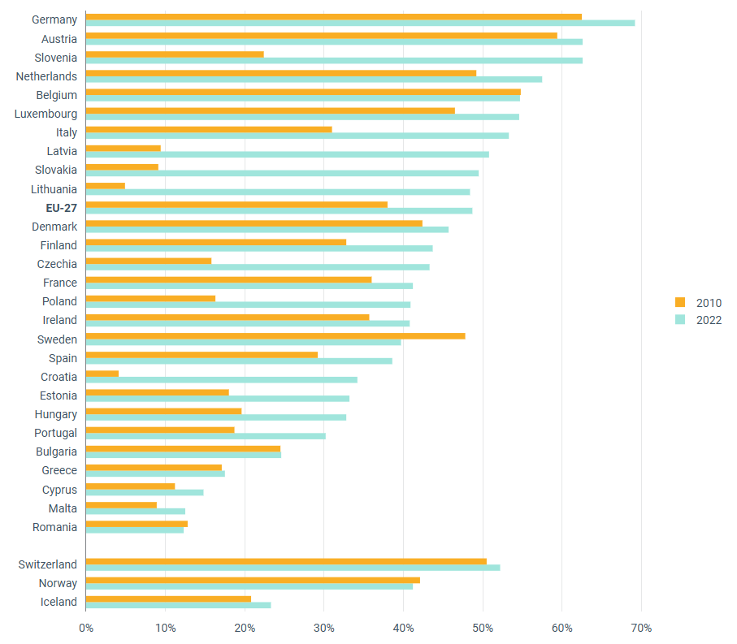  Source: EEA | Figure 5: Municipal waste per capita and treatment methods (in kg, 2023).  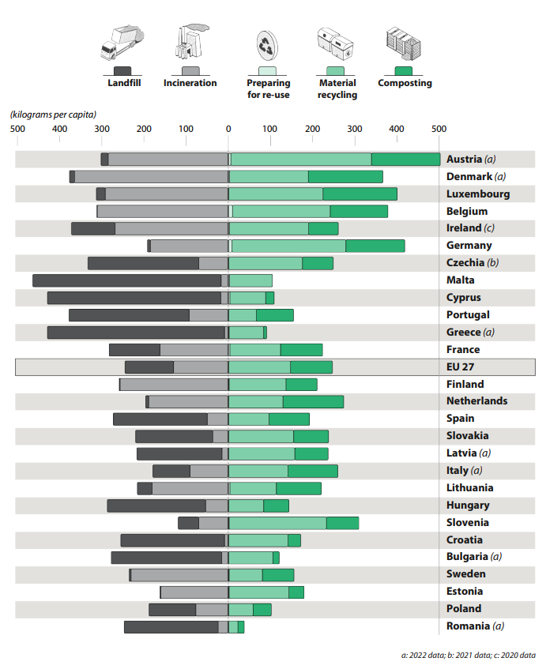  Source: ECA, based on the Eurostat dataset env_wasmun
Outside of the EU, the UK Government has established a voluntary monitoring, reporting, and verification (MRV) period for waste incinerations installations under the UK ETS as of 1 January 2026, with a decision on the full inclusion of the sector foreseen in the future. The scope of the MRV for waste incineration would apply to installations processing three tonnes or more per hour of non-hazardous waste or ten tonnes or more per day of hazardous waste, with clinical waste incinerators included and high-temperature hazardous waste incinerators exempted.
  - Policy measures
    - Description of the policy measures
Drawing from the analysis in this annex, this section assesses the concrete policy measures considered for the extension of the EU ETS to waste management activities. The measures are assessed for their environmental, economic and social impacts, specifically the environmental integrity, the alignment with waste hierarchy, the feasibility of robust monitoring and reporting of emissions as well as internal market effects and potential distortions of competition– as prescribed for the review clause. Timewise, the expansion of the EU ETS to waste management regardless of the level has been fixed at ‘from 2030 onward’ to ensure predictability and sufficient preparation time for the waste sector (considering the time for the co-decision process for the review and the time needed to implement its outcomes).
The measures under consideration are:
- W1: Inclusion of non-hazardous waste incineration installations in the EU ETS.
- W2: Inclusion of all waste incineration installations in the EU ETS.
- W3: Inclusion of all waste incineration installations and landfills of non-hazardous waste in the EU ETS.
  - Assessment of Policy measures
    - Environmental impacts
      - Climate impact
        - W1 ‘EU ETS expansion to non-hazardous waste incineration’
W1 extends the EU ETS carbon price to municipal waste incineration (MWI) compared to the baseline, which would ensure that emissions from the combustion of municipal waste, providing an economic incentive to reduce emissions cost-effectively, while also harmonising the polluter-pays-principle between Member States, between sectors and within the waste management sector.
First, the inclusion of non-hazardous waste incineration in the EU ETS would be an important step towards increasing accountability for fossil carbon emissions from municipal waste streams, notably plastics. The existing environmental policy framework on waste incineration does not specifically address GHG emissions from waste incineration, with incineration policies and taxes mainly focused on the activity and waste volumes instead of its carbon content, while few Member States have taken national measures under the Effort Sharing Regulation. Reported emissions from MWI above 20 MW under the EU ETS MRV obligation amounted to 85 Mt CO2 in 2024 for the EEA, of which 39.4 MtCO2e (47%) fossil-based emissions, and 45.6 MtCO2e (53%) biogenic-based emissions which would be considered zero-rated under the EU ETS. This is significant and equivalent to total GHG emissions from Finland or to two thirds of all ETS aviation emissions in 2024. If included as a separate sector, the fossil fraction of MWI emissions would be the 7th largest out of 27 sectors under the EU ETS.
The carbon price is projected to drive both cost-effective emissions reductions and carbon removals or negative emissions from municipal waste incineration through a combination of waste prevention and reduction at source, pre- and post-collection sorting and recycling of waste, and carbon capture and process optimisation at installation-level (see Section 1.3.). These were also the most frequently raised justifications in the stakeholder consultation by the majority of respondents supporting MWI inclusion, arguing inclusion in the EU ETS will contribute to incentivise recycling higher up the waste hierarchy (over one third of responses), as well as incentivising CCUS uptake (nearly one fifth of responses) and the potential to generate removal credits from biogenic CO2 (nearly one tenth of responses). The price signal of the cost passthrough can incentivise improved pre-collection sorting and residual waste reductions in the range of 10-20% (3.6-7.2 Mt CO2eq) and increased recycling in the range of 16-22.5% on the basis of existing price elasticities for the residual waste disposal demand. Increased recycling generates a dual benefit through the reduction of GHG emissions in the waste management sector and by providing recycled materials displacing more carbon intensive virgin materials. Combined with complementary circular economy policies and measures, an ambitious circular economy scenario has a substantial potential for up to 75-84 Mt CO2-eq emissions reductions from plastics by 2050⁴⁵. Carbon capture likewise offers a dual benefit of reducing fossil emissions and generating biogenic carbon removals and negative emissions. The risk of emissions leakage due to potential waste diversion to landfilling would be limited by the design of W1 as emissions from organic waste – the main source of methane emissions from landfills – would be zero-rated, substantially restricting incentives to divert organic waste to landfills in avoidance of the carbon cost, where they would be responsible for increased methane emissions. Conversely, the environmental risk of (fossil) waste diversion to landfills is further assessed in section 1.7.1.2.1.
Second, extending the EU ETS to non-hazardous waste incineration installations would harmonise the application of the polluter-pays principle within the waste incineration sector, addressing the current heterogeneous coverage of emissions from waste incineration depending on the waste type and Member States’ classification of installations. In addition, an extension would support a level playing field for the application of the polluter-pays between sectors, notably with the co-incineration of waste in industrial installations (e.g. cement kilns) and power generation already in EU ETS. Finally, an extension would also harmonise the application of the polluter-pays principle between Member States, addressing competitive distortions resulting from the current differentiated carbon pricing of waste-to-energy installations in selected Member States (Denmark, Sweden, Lithuania, Germany, the Netherlands). Nearly one third of respondents in the OPC who supported an inclusion of MWI into the EU ETS substantiated their support to ensure a level playing field between sectors and maximise cost-effectiveness of emission reductions, while it was also raised by multiple stakeholders in position papers and during the interviews. On the other hand, W1 carries a risk of uneven distribution of the carbon price incentive across the EU, given the diverse range of incineration shares across Member States. A ‘three-speed Europe’ can be observed in terms of incineration rates, with a share of Member States having high incineration capacity and low to zero landfilling, a share of Member States transitioning from landfilling to incineration, and another share of Member States remaining heavily reliant on landfilling and having no or almost no incineration capacity. Under W1, the carbon price would not directly affect waste management in the latter Member States.
        - W2 - EU ETS expansion to non-hazardous and hazardous waste incineration’
In addition to W1, under W2, the carbon price signal is also applied to hazardous waste incineration (HWI). A detailed analysis of cost-effective emissions reductions under W2 was not possible due to data limitations on current HWI emissions. HWI emissions were approximated in Section 1.2.2. to amount to around 3.15 MtCO2e (2022). The establishment of the cap increase and modelling of cost-effective emissions reductions under the LRF would ideally require more accurate MRV data to be collected prior to inclusion. However, the cost-effective emission reduction potential for HWI is expected to be more limited compared to W1 in view of these waste streams more regularly originating from products with limited recycling potential and a lack of viable alternatives for the hygienic and environmentally sound disposal of non-recyclable hazardous waste in view of strict regulatory requirements.
There was no majority for the inclusion of installations for the incineration of hazardous waste in the EU ETS among stakeholders in the OPC, with a relative majority of just over one third against, versus one third in favour and one third uncertain. The main arguments against inclusion of HWI were the stricter regulatory requirements and more limited alternatives in safely handling hazardous waste and potential risks to public health and safety compared to MWI, the public-service role and lack of control over upstream hazardous waste production, and limited fuel-switch options due to the need for destruction at high temperatures. One of the most frequently raised grounds in favour of including HWI installations was to uphold the polluter pays principle by enhancing coherence and a level playing field between incineration activities, and that some MWI installations hold permits also for some hazardous waste fractions (the other main argument being to incentivise cleaner technologies and cleaner consumer choices).
        - W3 ‘EU ETS expansion to non-hazardous and hazardous waste incineration as well as non-hazardous landfills’
Methane emissions from landfills are responsible for the largest share of emissions from EU waste management, with many Member States still seeing high landfill rates, despite an overall decrease over the past decades. Landfills are a persisting source of methane (CH₄), which is a more potent GHG than CO₂. Contrary to MWI, EU and national regulatory frameworks are currently in place to reduce landfills and landfill emissions (Landfill Directive and national bans on landfilling of organic and combustible waste) which, when implemented effectively, have been successful in several Member States in reducing emissions from non-hazardous landfills.
The uncertainty in the quantification of methane emissions from landfills remains high. Reported emissions based on reference values range from 74 MtCO2eq (based on ‘historical emissions’, i.e. emissions in a given year resulting from historical and current waste disposed in landfills) to 82 MtCO2eq (based on ‘future emissions’, i.e. all emissions expected over the lifetime of the waste disposed in a given year), depending on the methodology used (see Section 1.2.3.). Under both approaches, emissions exceed those from aviation currently under the EU ETS. The assessment of abatement options for landfills suggests a relatively high potential for cost-effective emissions reductions, for which the carbon price could be an important incentive (see Section 1.3.). The establishment of the cap increase and modelling of cost-effective emissions reductions under the LRF would ideally require more accurate and harmonised MRV data to be collected prior to inclusion. Emissions from non-hazardous landfilling are projected to continue to gradually decrease by 2040 if the existing regulatory framework is fully enforced and implemented, in line with the trend over the previous decades (albeit at a below-potential rate so far due to slow progress towards the landfill target in some Member States), with the benefit of ETS inclusion being to increase certainty and provide complementary incentives to achieve these reductions in view of the current slow progress towards the landfill target in some Member States.
An extension of the carbon price to emissions from landfills would have to consider whether to include only emissions from future waste disposal or also emissions from waste disposed prior to the application of the carbon price. A significant proportion of landfill emissions are expected to be a result of waste disposed of in the past as the emissions are produced by the ongoing anaerobic decay of organic material deposited years or decades earlier. The scope of coverage needs to consider not only the environmental impact of the scope, but also the feasibility of establishing a robust MRV, economic costs and abatement options. Extending the carbon price to historical emissions from landfills would provide a more extensive coverage of the polluter-pays-principle compared to applying the carbon price only to future emissions from landfills. The MRV and economic considerations are assessed in the subsequent sections.
      - Other environmental impacts
        - W1 ‘EU ETS expansion to non-hazardous waste incineration’
By incentivising waste reduction and increased recycling, the extension of the carbon price signal to MWI will contribute to the environmental policy framework objectives to reduce environmental (non-GHG) pollution (e.g. Industrial Emissions Directive, Landfill Directive) and to move waste higher up the waste hierarchy (e.g. Waste Framework Directive, Packaging and Packaging Waste Regulation).
First, action is needed at different levels to move waste up the waste hierarchy, from upstream improvements in product design to facilitate recyclability and increase recycled content, to waste prevention and effective sorting at consumption level, and separate waste collection and expanding recycling capacity. Extending carbon pricing to GHG emissions from waste incineration can provide an important complementary financial incentive supporting the circular economy by making waste prevention, recycling and reuse more financially competitive through the application of a carbon price on waste management processes further down the waste hierarchy. By internalising the carbon footprint of non-hazardous waste incineration, W1 would incentivise more efficient material flows through improved separate waste collection, sorting and material recovery. The most frequently cited argument among OPC respondents in support of MWI inclusion was to incentivise recycling higher up the waste hierarchy. On the other hand, W1 carries a risk of waste diversion to landfills, especially for fossil waste streams, which would contradict the waste hierarchy. The risk would not be uniform across the EU and is crucially dependent on the effective enforcement and implementation of the existing regulatory framework. Landfilling is currently the cheapest disposal route in Member States where bans or high taxation are not in place. Higher compliance and operational costs for municipal waste incineration may further incentivise some operators or waste producers to look for cheaper treatment or disposal routes, chiefly landfilling, where strict regulatory of fiscal policies closing the gap are not in place. This concern was also consistently raised in the public consultation by almost half of the respondents who oppose MWI inclusion, while several respondents supporting MWI inclusion also linked their support to addressing potential unintended consequences in terms of landfill diversion. Their views were divided, however, on the appropriate approach to achieve this, whether regulatory (e.g. stronger enforcement or advancing implementation of targets under the Landfill Directive), fiscal (taxation or levies) or carbon pricing (inclusion in the EU ETS). Experience of landfill development across the EU also confirms that mitigating the risk of landfill diversion is crucially dependent on effective implementation and enforcement of the waste policy framework to discourage landfilling. Member States effectively banning or (heavily) taxing landfilling of waste have generally achieved low landfilling levels, effectively deterring diversion and directing waste up the waste hierarchy. This evidence also holds for Member States currently already applying carbon pricing to municipal waste incineration, with landfill rates having continued to decrease in Denmark, Germany, Lithuania and Sweden since inclusion of the incineration sector in the ETS.
Second, by incentivising waste reduction, extending carbon pricing under W1 will further contribute to reduce non-GHG air pollutant emissions from MWI. The average net (non-GHG) environmental life cycle costs of overall waste management in the EU-27 have recently been estimated at 162 EUR/tonne of waste, with incineration and landfilling one of the main cost drivers, with Member States with high recycling rates having lower environmental life cycle costs than those with high disposal rates. MWI is a substantial source of particulate matter (PM2.5 and PM10) and polycyclic aromatic hydrocarbons (PAHs), which contribute to respiratory and heart problems, and sulphur dioxide (SO2) and nitrogen oxides (NOx), which contribute to acid rain and local smog. Typical emission factors for modern EU plants are roughly 1.07 kg NOₓ per tonne of waste, 0.087 kg SO2 per tonne, and 0.03 kg PM per tonne, alongside trace emissions of heavy metals (lead, mercury) and highly toxic persistent organic pollutants (dioxins, furans) measured in nanograms per tonne of waste. These pollutants are regulated by the IED and adopted BREF conclusions. However, pollutants can concentrate in the resulting ash and residues, and total emissions remain notable due to the scale of incineration capacity. Changes in the emission to air of different pollutants (see Figure) by EU incineration facilities varied between 2010 and 2022, showing either increasing or decreasing trends, with a more stable path since 2017. The potential for additional environmental costs reduction at EU27 level through increased recycling and reduced disposal has been estimated at EUR 8.4 billion annually.
The risk of waste diversion to HWI is limited given the technical and operational differences, smaller capacity and higher incineration cost due to higher temperatures and 2-3 times higher gate fees, and strict regulatory requirements. Still, there are MWI installations with permits to also incinerate hazardous waste fractions (generally low-hazardous fractions that can be incinerated at ‘standard’ temperature), for which a risk of waste misclassification under W1 cannot be fully ruled out but can be limited through careful boundary setting under the scope and MRR framework.
The risk of waste diversion to exports to third countries is considered to be limited. Member States exported 11.4 million tonnes of waste outside of the EU in 2024 (excluding mineral and metal waste). From November 2026 and May 2027, the EU will enforce stricter rules on plastic and hazardous waste exports under the Waste Shipment Regulation; waste export to non-OECD countries would be generally prohibited (with some exceptions) (see also Section 1.5.).
        - W2 - EU ETS expansion to non-hazardous and hazardous waste incineration’
In addition to the assessment of the impacts under measure W1, W2 addresses any residual risk of waste diversion and waste misclassification to HWI under W1. The risk of diversion to landfills is considered overall smaller than for W1, as landfilling or improper treatment of hazardous waste is either prohibited or strictly controlled under EU and national legislation. Hazardous waste export to facilities outside the EU ETS is likewise considered unlikely for the same reasons.
In terms of reducing environmental pollutant emissions and incentivising waste management higher up the waste hierarchy, the additional impact of W2 is expected to be more limited compared to the impact of W1 as there is generally lower flexibility in treatment options for materials that cannot be safely recycled, recovered, or treated by other means compared to municipal waste due to stricter regulatory requirements. However, data on treatment on hazardous waste in the EU indicates that while the amount of hazardous waste disposed through landfills and incineration (without energy recovery) has substantially increased between 2004 and 2022, the amount of hazardous waste recycled and recovered has remained constant, suggesting room for improvement.
        - W3 ‘EU ETS expansion to non-hazardous and hazardous waste incineration as well as non-hazardous landfills’
Compared to W1 and W2, the additional extension of the carbon price signal to landfilling under W3 would further contribute to incentivising waste management higher up the waste hierarchy and to reducing environmental pollutant emissions.
First, W3 would further support waste diversion up the waste hierarchy and contribute to address the risk of diversion to landfills down the waste hierarchy under W1, by providing a level playing field, but continues to carry a risk of possible waste diversion albeit more nuanced:
- to illegal landfilling, which is considered to be a significant problem in the EU.
- shifts of plastic waste away from incineration to landfilling, and of biogenic waste from landfilling to incineration, to avoid the carbon cost.
While overall relatively few stakeholders provided their view in the OPC on whether additional waste management activities should be included in the EU ETS if waste incineration is to be covered, more than one third of those called for appropriate measures to address landfill emissions, both to ensure a level playing field with incineration (if covered) and to address the climate impact of methane emissions. However, views were divided on the concrete approach, with diverse suggestions ranging from strengthening the Landfilling Directive to advance the ban on landfilling, introducing a carbon tax on landfilling, or the inclusion of landfilling in the EU ETS.
Second, W3 would support the reduction of air and groundwater contamination from landfills by disincentivising landfilling in favour of waste reduction and alternative waste management processes. Landfills that are covered by the Industrial Emissions Directive are subject to rules that aim to prevent soil pollution. Landfilling impacts local air quality through other landfill gas constituents (e.g., non-methane VOCs and ammonia) and soil/groundwater quality through leachate formation. As biodegradable waste decomposes, leachate containing nutrients, heavy metals, and organic contaminants can percolate into surrounding soil and, if not managed with engineered liners and collection systems, contaminate groundwater and local ecosystems. One study estimated that 0.2 m³ of leachate can be generated by one tonne of landfilled solid waste, depending on the type of waste and seasonal climate.
    - Economic impacts
      - Cost of compliance
        - W1 ‘ EU ETS expansion to non-hazardous waste incineration’
Under W1, the overall carbon cost to operators depends on multiple factors including total volume of waste treated, the share of fossil-based emissions, the carbon price, actions to reduce emissions at installation level and cost passthrough and actions to reduce emissions in the waste value chain. The cost is expected to vary between countries or even regions in the same country. The effective carbon cost for the fossil fraction per tonne of municipal waste has been estimated in section 1.3.1. to range from EUR 38.5 to 66 in 2030 at a carbon price of EUR 110 per tonne CO2e. The cost is expected to increase over time with the increasing ETS price until 2040. While operating costs vary considerably depending on installation type, size and location, evidence from the application of the EU ETS price to municipal waste incinerators with energy recovery in Sweden and Denmark indicates the carbon cost (in 2025) represented 10-20% of total operating costs.
One of the most effective cost abatement pathways is source reduction and diversion to recycling. The carbon cost passthrough from operators to waste suppliers and waste collection authorities can incentivise improved pre-collection sorting and residual waste reductions in the range of 10-20% and increased recycling in the range of 16-22.5% on the basis of existing price elasticities for the residual waste disposal demand (see Section 1.3.1.), supporting the circular economy. Circular economy activities already represent around 1-2% of EU GDP. In 2021, recycling, reuse and related circular economy activities accounted for 4.3 million jobs across the EU (an 11% increase since 2015) and generated approximately 299 billion EUR in gross value added, alongside the 121.6 billion EUR in private investment. Evidence shows that the higher the separate collection of recyclables and, consequently, of recycling, the higher the amounts of jobs created within the waste management system, with an overall potential for (additional) job creation in collection, transport and recycling estimated at 206.100 FTE annually in the EU27 in one study, and a potential to create up to 2.5 million additional jobs by 2030 in another study. The recycling sector delivers economic security, added value, employments, and a potential for long-term competitiveness for the EU economy by reducing reliance on imported virgin materials, reducing volatility of input costs, improving resource productivity, and strengthening innovation. At installation level, cost-effective abatement options include improved Mixed Waste Sorting in the short-term and CCUS in the medium- to longer term by the mid-2030s, with the integration of carbon removals under the EU ETS further providing the MWI sector with a potential for compensating allowance costs through removals from the biogenic fraction of waste, representing around 50% of all waste incinerated, supporting the business case for cost-effective emissions abatement (see Section 1.3.2.). Complementary policies and measures and the targeted investment of EU ETS revenues to support the rollout of CCUS and complementary measures in the waste value chain play an important role to contribute manage operational costs for operators and local authorities (see Section 1.3.3.). Annual EU ETS revenues from the inclusion of MWI are expected to be significant and average around 4.75 billion EUR over 2031-2040, assuming an average carbon price of EUR 150.
Almost a quarter of stakeholders in the OPC, from across different stakeholder groups, signalled that the EU ETS expansion to non-hazardous waste incineration can contribute to significant reductions in GHG emissions if complementary circular economy policies are effectively implemented. Some stakeholders across OPC responses, position papers and interviews also highlighted the importance of passing through the carbon costs to waste producers, following the Polluter Pays Principle (PPP), including through the extension of the EPR schemes to those producers which manufacture non-recyclable products, for example textiles.
        - W2 - EU ETS expansion to non-hazardous and hazardous waste incineration’
Under W2, the carbon price would be further extended to hazardous waste incineration (HWI) installations. Similar to W1, the overall carbon cost to the remaining installations would depend on the total volume and composition of hazardous waste incinerated, the carbon price, action taken to reduce emissions at operator level, and the cost passthrough and actions to reduce emissions throughout the waste value chain. Overall, operational cost increases due to the carbon price are expected to be comparatively higher to that of non-hazardous waste incineration installations given the higher fossil content of hazardous waste (90% compared to 50% for municipal waste) and more restricted alternatives due to regulatory constraints.
The treatment and sorting of hazardous waste are strictly regulated by health and safety regulations, implying more limited abatement options compared to W1 in terms of incentivising increased recycling, while incentives to reduce hazardous waste at source are expected to be heterogeneous depending on the specific product/waste stream and applicable regulatory requirements. Abatement options at installation-level are equally expected to be less cost-effective compared to W1, with Mixed Waste Sorting less technically, economically and regulatorily viable and CCUS application showing a more limited potential for biogenic carbon removal generation due to the higher fossil emission fraction.
A relative majority of stakeholders opposed the expansion of the EU ETS to HWI, mainly questioning the extent to which carbon pricing could be effective in reducing emissions from a process that has very few alternatives. They argued that fuel-switch options are limited due to the need for destruction at high temperatures, while applying the added cost pressure would not remove the need for the removal of hazardous waste as the production of such waste is not within their control and those installations have a public-service requirement in safely handling hazardous waste and potential risks to public health and safety.
        - W3 ‘EU ETS expansion to non-hazardous and hazardous waste incineration as well as non-hazardous landfills’
Under W3, like W1, the overall carbon cost to installations would depend on the emissions, the carbon price, action taken to reduce emissions at operator level, and the cost passthrough and actions to reduce emissions throughout the waste value chain. With total emissions from landfills being substantially larger than those from MWI, the economy-wide carbon cost will be higher, but will also be distributed among a larger number of installations compared to W1 or W2. The average carbon cost per tonne of non-hazardous waste landfilled has been estimated in Section 1.3.1. to amount to EUR 66 in 2030, assuming a carbon price of EUR 110 per tonne CO2e and 1 tonne of municipal waste being associated with 0.6 tonnes of fossil CO2 emissions. This cost is expected to increase over time with the increasing ETS price until 2040. From an economic perspective, the associated costs would also depend on whether only future emissions would be covered under the scope of extension, or also historical emissions. Overall costs would be higher over time in the latter case, as operators would also be liable for historical emissions resulting from disposal before the start of application of carbon pricing. While evidence on price elasticities for non-hazardous landfilling is limited, the combination of the existing regulatory framework with the increase in the cost of landfilling would be expected to further drive a reduction of organic residual waste streams disposed in landfills. In addition, the assessment of abatement options for landfills in Section 1.3.2. indicates a high cost-effective abatement potential compared to W1 and W2, with biogas production from landfill gas capture providing additional economic opportunities for operators.
Similarly to W1 and W2, complementary upstream measures and policies to prevent and reduce the amount of biodegradable waste that is landfilled play an important role to increase waste prevention, diversion to recycling or composting. However, upstream interventions mainly affect future emissions, while abatement at installation level is needed to address historical emissions from waste that has been landfilled in the past.
      - Administrative efforts
        - W1 ‘EU ETS expansion to non-hazardous waste incineration’
Extending the scope of the EU ETS to waste incineration relies on the existing system under the EU ETS. For both options W1 and W2, one-time administrative costs, regularly occurring administrative costs and costs for disclosure and sanctioning can be identified for competent authorities and for the operators. However, the existing system, processes and infrastructure (such as the Registry) can be used, limiting costs.
W1 builds on the already implemented MRV requirements for MWI, including the developed monitoring plans, data collection and reporting infrastructure. Additional monitoring and reporting costs under W1 may result from a review of the MRV rules to further specify the harmonised monitoring and reporting standards and protocols for the sector. As with the inclusion of any sector, being subject to the ETS entails third-party verification of emissions reports. Depending on the MRV protocol followed, other third-party cost may arise from periodic sampling if required, laboratory analysis (e.g., radiocarbon testing or waste composition studies), and the integration of IT systems for emissions tracking and record-keeping. For many facilities, particularly those without existing carbon accounting systems, these obligations necessitate specialist staff training and potentially, engagement of external consultants. The administrative burden for a specific operator will vary according to plant size, complexity and the MRV methodology adopted.
There are a range of methods available for monitoring emissions from waste incinerators, which have different associated costs. The estimated costs associated with these methods have been assessed in Section 1.4 and Appendix 3. Overall, the technical implementation and cost related to MRV, while additional, are expected to be manageable under W1 in light of the already applicable MRV obligation and other reporting obligations and experience already in place, for example under the Industrial Emissions Directive (IED), and the possibility to establish a tiered system that incorporates both measurement-based and calculation-based methodologies, along with simplified provisions for smaller emitters, providing scalable and proportionate MRV system minimising administrative costs. The threshold for inclusion may need to be modulated to alternative mechanisms based e.g. on tonnage instead of thermal capacity, to adjust to the specificities of the waste sector, as indicated by multiple sector stakeholders during the consultation.
        - W2 - EU ETS expansion to non-hazardous and hazardous waste incineration’
While largely building on W1, W2 may may require a tailored approach since some analytical methods cannot or should not be applied for hazardous waste given the regulatory and practical restrictions on the application of some measurement-based methods for these waste streams (e.g. radiocarbon and the waste analysis might not be possible due to the health and safety implications of these waste inputs). Calculation-based methodologies and simplified requirements could be developed for these installations to limit administrative efforts, especially when small.
        - W3 ‘EU ETS expansion to non-hazardous and hazardous waste incineration as well as non-hazardous landfills’
W3 would require dedicated monitoring and reporting rules to be developed in addition to W1 and W2 and tested prior to inclusion of landfilling in the EU ETS. The detailed administrative effort could not be estimated as dedicated rules would need to be developed under the ETS framework given the current absence of established MRV measurement protocols providing standardised and harmonised methodologies for methane emissions from landfills. The administrative and operational cost of MRV would be dependent on several factors, including the approach selected (calculation-, i.e. reference value, or measurement-based, i.e. ground-based and/or satellite monitoring), the scope of emissions covered (future emissions only or also historical emissions) and the characteristics of each landfill site (size, waste composition, weather conditions, gas capture efficiency, etc.) (see sections 1.4. and Appendix 3 for further details).In view of the above, the choice of monitoring methods needs to consider both the balance between accuracy, technical complexity and economic costs, as well as the suitability of each method to the different possible scope of emissions covered for landfills.
      - SMEs
        - W1 ‘ EU ETS expansion to non-hazardous waste incineration’
Stakeholder consultations and an internal study by the Commission indicate that the waste management sector has a comparatively higher share of medium-sized enterprises compared to other sectors under the EU ETS. The administrative and financial burden resulting from MRV compliance requirements for SMEs can be addressed through simplified MRV provisions for smaller installations to provide a scalable and proportionate system to keep compliance proportionate to emissions, avoiding placing an excessive burden on low-emitting sites while still ensuring a basic level of emissions accountability. In addition, W1 is modulated by the applied activity threshold. Under the EU ETS Directive, combustion installations are included in the scope of the system if they are above the threshold of 20 MW rated thermal input. Even if another threshold is set, e.g. based on waste management volume, or if no threshold would be set, smaller installations could still opt-out under the existing small- and ultra-small emitter provisions in the Directive. Several interviewed stakeholders, both business associations and NGOs, emphasised the importance of maintaining a level playing field across all MWI operators regardless of size by reducing the threshold. They argued that retaining the 20 MW threshold could create unintended incentives for operators to divert waste to smaller facilities under the threshold, thereby avoiding carbon pricing obligations.
        - W2 - EU ETS expansion to non-hazardous and hazardous waste incineration’
Due to data limitations no detailed assessment could be conducted for HWI in addition to W1.
        - W3 ‘EU ETS expansion to non-hazardous and hazardous waste incineration as well as non-hazardous landfills’
No detailed assessment on the additional impact of W3 could be conducted due to the limited information on landfill operations available. The assessment in section 1.2.2. indicates that there is a substantial share of smaller and substandard landfills in the EU, however the impact would depend on the scope of coverage and thresholds applied for inclusion of landfills under the EU ETS.
    - Social impacts
      - Employment
A quantitative assessment of the impact of employment is undertaken at the policy option level.
      - Income distribution, social protection, and social inclusion (of particular groups)
A quantitative assessment of the impact on income distribution, social protection and social inclusion is undertaken quantitatively only at the policy option level.
      - Fundamental rights
All options assessed are aligned with Article 37 of the Charter of Fundamental Rights of the European Union (the Charter) (environmental protection). They are designed to incentivise decarbonisation in the waste sector as well as encourage a transition to a circular economy model. Although the measures differ in scope (broadening progressively), they all involve the inclusion of certain Waste sector emissions in the ETS. This inclusion increases the cost of emitting these emissions, thereby strengthening the carbon price signal and encouraging emissions reductions. As a result, these measures are expected to contribute to more effective environmental protection.
The design of these measures must also ensure full compliance with Article 36 of the Charter of Fundamental Rights, which recognises access to services of general economic interest. Waste management is widely regarded as an essential public service, fundamental to safeguarding public health, environmental protection, and the functioning of the circular economy across the EU.
      - Implications for municipalities
The carbon price is expected to be (at least partially) passed through by operators to waste disposal authorities, often local authorities, through the gate fees. The subsequent cost passthrough to citizens i.e. in the form of increased taxes or levies, will crucially depend on how the initial cost passthrough incentivises municipalities, other waste generators, and third parties to reduce waste streams and/or the carbon content in waste streams, e.g. through improved separate waste collection, waste collection fees or taxation modulated for the carbon content of waste streams, or higher penalties for illegal waste disposal, as assessed in sections 1.3.1. Nearly one fifth of stakeholders opposing MWI inclusion in the OPC expressed concerns over the expected impact and perceived lack of alternatives for customers, notably local authorities. Stakeholders interviewed further specified their concerns that bringing the waste sector under the EU ETS could create operational and financial challenges for the continued delivery of these services as the additional costs associated with participation in the EU ETS (allowance purchases, MRV obligations, and administrative requirements) may place pressure on municipal budgets and waste operators. This could, in turn, affect the affordability and accessibility of waste management services for households and businesses. Evidence from Member States already applying a carbon price for municipal waste incineration (DE, SE) indicates that current pricing corresponds to limited, manageable increases in average annual household waste management fees in the order of EUR 10 (DE) to EUR 13 (SE), of which a substantial share can furthermore be avoided through improved prevention, separation and recycling of waste, alongside complementary measures and financial support through ETS revenues to support local authorities and/or households in implementing these measures and lower or avoid fees passed through to households. The extension of the EU ETS cap with the waste sector is expected to generate significant EU ETS revenues averaging EUR 4.75 billion annually for municipal waste incineration, or double to triple this amount in case of an extension to all waste incineration and non-hazardous landfills, which could be reinvested to support complementary circularity policies and measures in waste reduction and recycling.
At the same time, including the waste management sector in the EU ETS offers significant opportunities to further incentivise circularity and recycling, both minimising environmental impacts from natural resource use and financial costs for waste management for local authorities. While the waste recycling rate in Europe has steadily increased due to EU binding recycling targets, separate collection of waste was progressing slower than required and most waste was still disposed of through incineration or landfill operations in 2022, carrying substantial financial burdens on local authorities in the form of gate fees and additional taxation, and consequently on taxpayers. Including waste management into the EU ETS would contribute to incentivise ambitious waste management policies to increase recycling and discourage landfills and incineration.
Overall, an extension of the carbon price to waste management activities needs to balance the environmental integrity and the costs associated to waste management as a public service. This may warrant targeted safeguards, transitional measures, or financial support mechanisms to prevent unintended social or economic impacts while still achieving the overarching climate objectives of the EU ETS.
    - Summary
A summary comparison of the measures is provided in the table below. Measure W1 is rated as compared to the baseline of no inclusion of waste management activities, with each subsequent measure designed and rated as an extension to the preceding measure. In addition, a summary of the key costs and benefits of the measures under the preferred policy option is included in Annex 3, Section 2.

Criterion | W1: Inclusion of non-hazardous waste incineration | W2: Inclusion of all waste incineration | W3: Inclusion of all waste incineration plus non-hazardous landfill
Environmental  (Climate) | +  Substantial increase of scope of economy-wide GHG emissions accounted for and priced. Incentive and resources to support sectoral decarbonisation through improved circular economy incentives and carbon capture for residual emissions (mid-decade).  Secondary decarbonisation benefit from improved circularity reducing GHG emissions from waste disposal and generating recycled materials displacing more carbon-intensive virgin materials.  Significant potential for permanent carbon removal generation from biogenic emissions, supporting economy-wide decarbonisation (synergy with integration of removals in ETS).  Enabling condition for promoting the use of captured CO2 as feedstock for non-permanent CCU products (synergy with CCU product incentives in ETS review). | 0  Limited additional environmental benefit from further extension to HWI (small scope and limited abatement incentive). | +  Substantial increase of scope of economy-wide GHG emissions accounted for and priced, complements existing emission reduction trajectory already in place under regulatory policy framework for landfilling.  Higher overall GHG emissions reductions mainly driven by landfills, compared to lower incineration emissions reductions than W1/W2.
Environment  (Other environmental impacts) | +  Additional contribution to air pollutants reduction.  Additional incentive for circular economy for materials, supporting the business case for waste prevention, separate collection, sorting and recycling.  Risk of landfill diversion for organic waste streams limited due to zero-rating in incineration. For fossil waste streams depending on effective regulatory or fiscal policy framework in place. | 0  Limited additional benefit for waste hierarchy from further extension to HWI in view of strict regulatory requirements in place. | +  Additional contribution to ground pollution reduction.  Additional incentive supporting increased separate collection and alternative treatment of organic waste streams.  Contributes to address risk of landfill diversion for organic waste streams through carbon pricing of methane. For fossil waste streams depending on effective regulatory or fiscal policy framework in place.
Economic (Cost of compliance) | +  Effective carbon cost reduced due to biogenic share plus opportunities for permanent carbon removals from biogenic emissions.  Cost-effective abatement options available at installation level and value chain, complementary policies and targeted support mechanisms are key enabling conditions for investment and planning predictability, decarbonisation support, and reinforced circular economy policies.  Contribution to circular economy growth.  Supporting level playing field for industrial installations and power plants by harmonising carbon price signal with co-incineration and electricity and district heating production. | -  High additional carbon cost for further extension to HWI due to higher emission intensity, limited carbon removal potential and restricted alternatives. | +/-  Higher cost of compliance compared to W1 and higher cost-effective abatement potential for landfills, in particular for emissions from historical disposal.  Overall cost of compliance dependent on scope of inclusion, with higher cost and operational constraints if emissions from historical disposal also covered.
Economic  (Administrative effort) | +  Limited additional costs compared to baseline (already applicable), building on already established MRV process and infrastructure, and tiered system with simplified provisions for smaller operators balancing robustness and administrative burden and costs. | -  Possible additional HWI-specific MRV cost due to regulatory restrictions. Possibility for simplified MRV or exclusions and opt-outs of the system. | -  MRV methodology to be developed and implemented for landfills from scratch​.  No cost estimate: depending on method and scope (historical emissions). Complex and lengthy development process (especially if based on comprehensive measurement-based approach). Simplified approach based on reference values possible.  Development needs to balance robustness with administrative burden and costs.
Economic (SMEs) | 0  Comparatively high share of medium-sized enterprises.  Simplified MRV, opt-out provisions and potential exclusions under threshold for small emitters reduce impact on SMEs. | 0  Same as for W1. | Comparatively high share of medium-sized enterprises but impact dependent on scope of GHG emissions included, threshold applied and other factors.

Appendix 1: Data on emissions from waste incineration and landfilling in the EU
- Data on emissions from municipal waste incineration
Data prior to 2024 (UNFCCC GHG Inventory, internal Commission estimates) do not provide disaggregated data per type of waste (municipal, hazardous, industrial) or per type of incineration (with or without energy recovery). Since 2024, accurate MRV data have been collected specifically for municipal waste incineration (with and without energy recovery) above the EU ETS threshold.

EU ETS monitoring, reporting and verification data
From 1 January 2024, installations for the incineration of municipal waste above the EU ETS threshold are required to monitor and report emissions under the EU ETS. In 2025, emissions data from the first year (2024) of the monitoring and reporting of emissions by municipal waste incineration (MWI) installations under the EU ETS became available. The total 2024 emissions from MWI (excluding hazardous waste incineration) from the reporting data provided by 19 countries (18 Member States and Norway) for 395 installations amounted to 85.0 MtCO₂eq (Figure 6). Of this total, approximately 47% or 39.4 MtCO₂eq were fossil-based emissions and 53% or 45.6 MtCO2eq biogenic emissions. In case of an extension of the EU ETS to waste incineration, only the former would be expected to fall under the scope of the EU ETS as biogenic emissions are zero-rated under the EU ETS. The 2024 MRV data provides the most recent and accurate report of emissions from MWI in the EU.

- Emissions and number of installations reported under the scope of the EU ETS MRV obligation for combustion of fuels in installations for the incineration of municipal waste (2024).
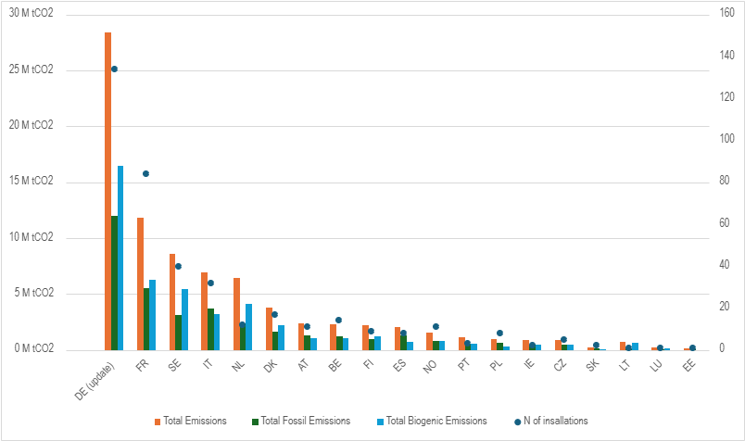
Source: European Commission
Data limitations: No data on emissions from hazardous waste incineration; no data on emissions from MWI installations below 20MW (not covered under the MRV obligation). Reported data may not be exhaustive and require further finetuning as results cover only the initial year of reporting.
UNFCCC Inventory Data
Emissions from waste incineration (all types) without energy recovery are reported separately in the UNFCCC National Inventory Report under category 5C1 and amounted to 2.07 MtCO2e in 2023. Emissions from waste incineration with energy recovery are not separately reported but are reported as part of emissions from fuel combustion. Category 1A1a (Electricity and Heat Production - Other Fuels (CO2)), which amounted to 36.1 MtCO2e in 2023, mainly covers the fossil part of municipal solid waste incineration with energy recovery whose main economic activity is power and heat production. Biogenic CO2 generated by the combustion of organic waste is not accounted for in the national total. Combined the reported fossil part of emissions from MWI in the UNFCCC inventory would amount to 38.2 MtCO2e in 2023, within the same range as the EU ETS MRV reported emissions.
Data limitations: No disaggregated data on municipal waste incineration without energy recovery; no data on emissions from hazardous waste incineration; no data on biogenic fraction of emissions.
Internal Commission Estimates
In 2022, during the legislative process on the 2023 revision of the EU ETS, the European Commission internally estimated the scope of the fossil part of emissions from all waste incineration in the EU using data reported by Member States under the Governance Regulation (2016-2018) (for overall waste combustion in the relevant sectors), EU ETS emissions reporting under Article 21 of the ETS Directive and the average share of municipal waste in the total waste combusted (67%), which were further validated through technical discussions with Member States and cross-checks with other available data sources. The data are presented in Table 5. The resulting estimates of the emissions from the combustion of the fossil fraction of municipal and hazardous waste combined are in the range of 44.2 MtCO2eq. Taking into account the difference in scope (these estimates also include installations below the 20MW threshold (see Section 2 below), hazardous waste incineration with energy recovery (see Section 3 below), and co-incineration installations already covered under the EU ETS), these estimates indicate a similar order of magnitude as the reported 2024 MRV data for MWI installations above 20MW only.
- Internal Commission estimates (2022) for fossil emissions from all types of waste incineration (municipal, hazardous and industrial) in the EU27.
CO₂ emissions (ktCO₂e) | EU ETS | Non-EU ETS | Total
Total fossil emissions from all waste incineration (municipal, industrial, hazardous) | 22,369 | 40,636 | 63,005
Fossil emissions from incineration of municipal and hazardous waste | 12,928 | 31,332 | 44,260
Fossil emissions from incineration of industrial waste | 9,441 | 9,304 | 18,746

Data limitations: No disaggregated emissions from municipal and hazardous waste incineration installations, from installations above and below the 20MW threshold, and from incineration and co-incineration installations.
- Estimates of emissions from municipal waste incineration installations below the 20MW threshold
Data on the share of installations below the 20 MW threshold are not readily available, as these were not subject to the monitoring and reporting obligation under the EU ETS as of 2024. Emissions from municipal waste installations below the 20MW threshold can be approximated based on the nominal capacity of municipal waste-to-energy installations not reported under the MRV obligation,. On this basis, 53 installations (EEA) were identified with total fossil-based emissions of maximum 1.05 MtCO2e, or an additional 2.7% on top of the total reported emissions under the EU ETS MRV, given the limited capacity of these installations. Moreover, this figure is an overestimate as approximated emissions are based on nominal instead of actual incineration volumes, which are generally lower. On the other hand, this figure does not cover any MWI installations without energy recovery, although no evidence was found on such installations and these would be expected to represent only a minor share of emissions given the limited total emissions of this subsector (2.07 MtCO2e in 2023 for all types of waste incineration without energy recovery combined).
- Estimates on emissions from hazardous waste incineration
As identified in Section A, detailed data on emissions from hazardous waste incineration in the EU are currently not available. Emissions from hazardous waste incineration can however be estimated based on the volume of hazardous waste treated and the default emission factor of hazardous waste incineration on the one hand, and by cross analysing the data sources on total waste incineration in Section A.
The volume of hazardous waste incinerated amounted to 10.5 million tonnes of waste in 2022 according to Eurostat, of which 6.3 million tonnes with energy recovery and 4.1 million tonnes without energy recovery. However, these data cover both incineration in dedicated hazardous waste incineration installations, as well as co-incineration in industrial installations (e.g. cement or lime kilns) and fractions of low-hazardous waste incinerated in municipal waste incinerators. The former is currently already covered by the EU ETS, while the latter would be covered under the inclusion of MWI under the EU ETS in line with the existing scope of the MRV obligation for MWI. Considering only hazardous waste incinerated in dedicated hazardous waste incineration installations, the volume amounted to only 3.5 million tonnes of waste (Industrial Emissions Portal).
HWI generally has a higher fossil emission intensity (90%) compared to MWI. Combining the volume of HWI with the 0.9 fossil-based emission factor results in an estimated total fossil fraction of emissions from HWI ranging from ~3.15 MtCO2e (dedicated HWI only) to ~9.5 MtCO2e (all hazardous waste incinerated through various types of incinerators) of which ~5.7 MtCO2e fossil emissions from HWI with energy recovery and ~3.8 MtCO2e fossil emissions from HWI without energy recovery, with the additional coverage in case of an extension of the EU ETS to HWI in addition to MWI expected to be closer to the first (3.15 MtCO2e).
D. Data on emissions from landfilling
UNFCCC Inventory Data
Member States collectively reported 65.3 Mt CO₂e emissions in 2023 from all solid waste disposed in ‘managed waste disposal sites’ and a further 8.6 Mt CO2e from ‘unmanaged’ waste disposal sites or illegal activities. Municipal waste represented around two fifths of all solid waste landfilled in the EU27 (52 out of 137 million tonnes of solid waste landfilled in 2023), but no detailed information is reported on the corresponding share of emissions. Landfill emissions have decreased by 55% from 132.3 Mt CO2e since 1990 and 25% from 99.4 Mt CO2e since 2010, primarily due to a reduction in biodegradable waste being landfilled and a significant increase in landfill methane recovery and flaring. A smaller number of emissions are also emitted from sectors such as ‘uncategorised waste disposal sites’ and ‘open burning of waste’. The data reported in the UNFCCC GHG inventory cover historical emissions resulting from the decay of waste disposed in the past.
Estimates using emissions factors
Emissions from landfilling can also be estimated using data on the tonnes of waste landfilled in the EU, combined with an emission intensity factor. In 2022, 137 million tonnes of solid waste was disposed in landfills in the EU. Using an indicative value of 0.6 tonne CO2eq/tonne of residual waste treated in conventional landfill with flaring, which can be considered the technological level in the middle between landfills without flaring and any type of energy recovery at all on one end and highly engineered landfills with methane capture and energy recovery on the other, the resulting estimate of landfill emissions for solid waste in 2022 would be 82.2Mt CO2 eq. 52 million tonnes of the 137 million tonnes of solid waste were municipal solid waste, which translates into an estimated 31.2Mt CO2 eq for municipal waste landfill emissions in 2022. This estimate covers a different scope of emissions compared to the UNFCCC inventory data, providing an estimate of ‘future’ emissions from the waste disposed in a landfill in a given year (assuming all incorporated emissions are released in one year) but not considering emissions resulting from past disposal in landfills.

Appendix 2: Selected case studies on emissions abatement options for waste incineration and landfilling
Mixed Waste Sorting (MWS)
- Case Study 1 – The IVAR IKS facility in Forus, Norway, has operated a fully automated sorting plant (equipped with near-infrared (NIR) and visual spectrometer (VIS) technologies, differentiating between various polymers and material types) since 2019, designed to process residual household waste of approximately 325.000 citizens. The recovery of recyclables increased from 28% to 82% following the implementation of MWS. The facility reduces annual CO2 emissions by approximately 33.000 metric tons.
- Case Study 2 – Omrin's Ecopark De Wierde in Heerenveen, the Netherlands, is a public waste management company with an advanced AI-driven separation plant processing over 311.000 tonnes of household waste annually, achieving a 78% waste separation rate, which significantly outperforms the EU average of 49%.
- Case Study 3 – The Site Zero facility in Motala, Sweden, is currently the world's largest and most advanced plastic sorting plant, using near-infrared (NIR) sensors to separate 12 different types of plastic, compared to only four types previously. In its first full year of operation (2024), the facility doubled the sorting efficiency to 95% compared to 47% previously, and approximately 42.4% of all plastic packaging received at the facility was successfully converted into recycled raw material.
Pay-As-You-Throw (PAYT) schemes
- Case Study 1 - The County of Aschaffenburg, Germany, has implemented a weight-based PAYT system, resulting in one of the highest recorded rates of recyclables collection (86%) and one of the lowest recorded rates of residual waste generation (55 kg per capita per year) in the EU. The Aschaffenburg model has been replicated in other Germany counties, in Italy and in Belgium.
- Case Study 2 – Bergen, Norway: by changing their model of waste collection from curbside collection to underground collection hatches with a PAYT element, residual waste collected reduced by 9% and plastic recycling collected increased by 28% 6 years into the scheme.
- Case Study 3 – Bassano del Grappa, Veneto, Italy: a PAYT was piloted as part of the EU-funded LIFE-REthinkWASTE project. Residents receive a personalised bill based on the amount of unsorted waste they generate and was combined with a KAYT (know-as-you-throw) information campaign to encourage proper sorting. The scheme resulted in a 27.8 % reduction in residual waste between 2018-2022.
- Case Study 4 – Chastre, Belgium: the first municipality to introduce smart bins equipped with microchips in Belgium, in 2016, whereby any household producing waste above a certain quota got a surplus tax of up to EUR 600 added to their basic local tax. This amounted to residual waste per person dropping from 135kg to 74kg.
Carbon Capture
Case Study 1 – In Norway, the world’s first commercial incineration plant equipped with full-scale CCS technology is set to become operational in 2026. The Oslo Klemetsrud plant aims to capture and store approximately 400,000 tonnes of CO₂ annually, of which around 60% is expected to be biogenic.
- Case Study 2 – In Sweden, the Filbornaverket waste-to-energy-plant aims to capture and store its emissions by 2030. The project has been awarded support from the Innovation Fund.
Case Study 3 – In the Netherlands, the Twence plant introduced a first pilot for carbon capture in 2014, with a subsequent development to upscale the solution. It targets a CCU concept, converting the captured carbon into sodium bicarbonate which could be used to abate the acid gases in the flue gas, and since 2020, the plant has been supplying some nearby greenhouse infrastructure. The AVR-Duiven plant has been successfully capturing CO2 via an MEA chemical absorption process and supplying to nearby greenhouses in the form of liquid CO2 since summer 2019 in the range of 60kton of CO2 every year .
- Case Study 4 – In the UK, waste management company Viridor has announced plans to invest up to GBP 1 billion in CCS technologies across seven sites, aiming to capture approximately 0.9 million tonnes of CO2 annually at its Runcorn WtE facility.
Landfill gas capture and utilisation (LFG)
- Case Study 1 - Granges landfill: renewable gas production from landfill biogas (France): In June 2025, Veolia and Waga Energy inaugurated a renewable natural gas facility at the Granges landfill in Burgundy, eastern France. The project’s primary objective is to capture methane generated by decomposing waste and upgrade it into quality biomethane, thus reducing GHG emissions while displacing fossil natural gas. The facility can treat up to 600 m³ of raw biogas per hour and inject the upgraded gas into the local distribution network operated by GRDF (France gas distributor) via a dedicated pipeline. Since it began operating in early 2025, the plant has produced enough renewable gas to supply more than 3000 households annually and is expected to avoid around 3.300 tonnes of CO2 equivalent emissions each year. The project has significantly improved the site’s overall energy efficiency and environmental performance by replacing a combined heat and power unit with direct biomethane injection.
- Case Study 2 – Can Mata controlled landfill: large-scale biomethane injection from landfill biogas (Spain): In June 2023, PreZero, Waga Energy, and Nedgia commissioned Spain’s largest landfill biomethane injection project at the Can Mata controlled landfill near Barcelona. The project is designed to fully upgrade landfill biogas into grid-quality renewable gas, thereby maximising methane recovery while reducing GHG emissions. The facility produces around 70 GWh of biomethane per year, sufficient to supply approximately 14000 households, or fuel around 200 municipal buses, avoiding more than 17.000 tonnes of CO2 equivalent annually. The project pioneered an innovating financing model, based on a long-term biomethane purchase agreement support by 2.4 million EUR from the EU Innovation Fund.

Appendix 3: MRV methodologies for waste incineration and landfilling
- Measurement-based methodologies
Waste incineration installations: Most (if not all) MWI installations already apply a measurement-based approach (continuous emission monitoring system (CEMS)) for the monitoring obligations under the Industrial Emissions Directive (IED) on the concentration of air pollutants (NOx, SOx, etc.), providing experience in the application of measurement-based approaches for the monitoring of GHG emissions. The specific requirements for measurement-based monitoring of GHG emissions would depend on the tier levels applicable in accordance with Annexes II and VIII of the MRR. Category A installations are expected to achieve at least Tier 2, while Categories B and C are expected to meet Tier 4. Most waste incinerators (64%), especially WtE installations, would be expected to fall within Category B, with an estimated 35% of installations falling within Category A. However, among the latter, some installations, such as hazardous waste incinerators or smaller installations, may fall below the threshold for opt-outs of small installations (see section 1.4.3. below for details). Table 6 outlines the requirements by category.
- Summary of the Tier Requirements (maximum permissible uncertainty) by category (for a measurement-based methodology).
CO₂ emission uncertainty | Tier 1 ±10% | Tier 2 ±7.5% | Tier 3 ±5% | Tier 4 ±2.5%
Category A
Category B
Category C
- Radiocarbon analysis (C14 method): For large WTE plants treating MSW, the most reliable MRV method is radiocarbon (C14) analysis. Radiocarbon analysis, also known as the C14 method, measures the ratio of carbon isotopes in flue gas to differentiate between fossil and biogenic carbon. Fossil-derived CO2 contains no C14, whereas biogenic sources do. The costs associated with C14 implementation depend on installation costs, annual operating costs and sampling and analysis costs. An analysis done in the UK for the future inclusion of waste incineration in the UK ETS estimated cost ranges at EUR 34.900 – 93.000 for installation, EUR 11.600-23.300 for annual operating costs and EUR 465-755 per sample lab analysis. However, smaller operators may find this method difficult to implement due to the infrastructure, costs and expertise required, as the method requires regular sampling of flue gases and laboratory analysis, which can be costly and technically demanding. C14 testing is generally also unsuitable for use in clinical or hazardous waste incineration facilities due to the small sample volumes and hazardous/radioactive materials handled.
- Manual sorting and sampling method: Manual sorting can serve as a supporting or indicative tool, although not typically used as a primary MRV method. Incineration facilities would likely be subject to more frequent reporting, either quarterly or annually, depending on the volume of emissions. Stakeholders in the UK preparatory report have suggested that each sample uses approximately one week’s worth of work to physically sort the waste, costing around EUR 700 - EUR 1,400 per sample. Manual sorting and sampling is labour-intensive and susceptible to subjectivity and sampling error. Due to these limitations, it is not recommended as a standalone method for regulatory MRV purposes but can serve as a supportive tool.
- Selective Dissolution Method: The selective dissolution method is a laboratory-based approach that uses chemical processes to dissolve specific components of waste, helping to distinguish between fossil and biogenic content. This technique remains largely experimental and is not yet widely adopted in operational or regulatory settings. It may apply to certain waste types where more established methods, such as radiocarbon analysis or balance calculations are unsuitable.
Landfills: Satellite-based monitoring and ground-based monitoring provide two measurement-based methods available for landfilling.
- Satellite-based monitoring: Satellite-based monitoring is an emerging monitoring approach for methane emissions from landfills. Since 2017, the TROPOMI instrument, capable to detect (among others) methane emissions, has been in orbit by the European Space Agency and the Netherlands Space Office. The data generated have been used to develop detection, identification, and monitoring systems of methane emissions from landfill sites. Recent satellite-based analyses of methane emissions from landfill sites have found little correlation with reported or modelled emission estimates at landfill sites, highlighting the potential of satellite observations to accurately detect and monitor methane emissions from the waste sector. For example, in 2022, a study published by SRON Netherlands Institute for Space Research, Harvard University, and GHGSat Inc found high emission rates in the studied landfills, with emissions above the reported in the national inventories (1.4 to 2.6 times higher). Since 2025, the European Space Agency has also been conducting a real-world case study of the Las Dehesas landfill (Spain) combining ground surveys, sensor-equipped aircraft and satellites to assess methane leaks and the impacts of repairs and changed management practices with the aim to inform satellite-guided pathways to reduce or avoid emissions, mirroring successes targeting oil and gas facilities. Satellite measurements would be accurate, could be regularly conducted to monitor trends, and would be suited to monitor historical emissions from landfills. However, while an accurate measurement method, it would in the current phase of development still be technically and economically challenging to consistently implement across the EU given the number of landfill facilities but subject to further development could be considered when establishing or updating future MRV protocols for landfill.
- Ground-based monitoring: Ground-based measurement based on a tracer gas dispersion method (TDM) can provide high accuracy and high sensitivity. It involves releasing an inert tracer gas from the landfill and measuring its concentration downwind alongside the target gas, usually methane. By comparing the ratio of methane to the tracer gas and using a dispersion model, the total emission rate of the target gas from the entire landfill can be calculated. This method is effective for quantifying whole-site emissions, including fugitive ones. However, it is very labour- and time-intensive and scaling this methodology up to an entire landfill, let alone hundreds of landfill sites across the EU, is challenging.
- Calculation-based methodologies
Waste incineration installations: A calculation-based methodology could be used as an alternative to direct measurement for monitoring emissions in some circumstances. This approach estimates emissions by combining activity data (such as the quantity and type of waste incinerated) with emission factors derived from laboratory analysis or established default values. These emission factors could also be updated with analytical methods, where possible and applicable. Whilst a measurement-based method is preferable, the calculation-based approach is acknowledged as potentially more practical for smaller or resource-limited sites, especially where direct measurement is technically challenging or prohibitively expensive. It may be relevant for hospital and small emitters (HSEs) or for waste types such as clinical and hazardous waste, where physical sampling is restricted. In the UK, a simplified MRV framework is proposed for small, known as hospital and small emitters (HSE), and ultra-small emitters (USE). These are allowed to utilise emission factors provided by the Competent Authority, with HSE sites further exempt from needing to justify why higher MRV tiers cannot be applied and automatically allowed to use Tier 1, which has a maximum uncertainty of ±10%. This tiered flexibility is intended to keep compliance proportionate to emissions. The calculation-based methodology could be implemented according to the standard methodology set out in Article 24 of the mass-balance methodology set out in Article 25 of the EU ETS MRR:
- (Mass-) Balance Method: The balance method calculates fossil CO₂ emissions by assessing the known composition of incoming waste and applying emission factors based on the types and quantities of materials incinerated. It relies on accurate input data and is often supported by operational records, sampling, or modelling. This method is particularly suitable for medium to large facilities that have access to reliable waste composition data or can estimate it with a reasonable degree of certainty. While less precise than C14 testing, it offers a more cost-effective and scalable solution. Similarly, a customised balance method based on detailed waste characterisation could serve as a tailored MRV method for clinical and hazardous waste incinerators given the variability of waste types and their higher fossil content. It works using continuous real time data from the distributed control system (DCS), emissions data from the CEMS complemented with pre-established values from literature or the software supplier. Installation of this system is estimated to cost around EUR 58,200 per line, with annual operating costs of about EUR 17,400. One example of the use of emission factors is Germany, where emissions factors are applied estimated for the biogenic content of each waste code and/or the energy content. However, this is unlikely to be consistently accurate for all waste inputs received at the different MSWI due to the heterogeneous nature of the waste processed at incinerators. Given the variable nature of MWS, an individual or country-based approach would be recommended rather than a generic EU-wide waste code value.
- Default emission factors: Using default emission factors involves applying standardised values based on typical waste compositions and combustion technologies, often aligned with international methodologies such as those from the IPCC. This tiered approach is particularly useful for smaller facilities or those with relatively low emissions, where the cost and complexity of higher-tier methods may not be justified. It offers a simplified, consistent reporting pathway with minimal administrative burden. However, its accuracy is lower than other methods, and periodic and local validation may be required to ensure continued reliability. Waste incinerators without energy recovery, often smaller in scale, could follow simplified MRV approaches such as default emissions factors or a lower-tier balance method.
Landfills: The IPCC Guidelines establish two methods to calculate methane emissions from landfills. Method A is based on theoretical gas yield and assumes that all the methane is released in the same year the solid waste is disposed of. Method B, which is the first order decay model based on kinetics, provides a more accurate estimate for the actual annual emissions. However, method B is more difficult to apply given the amount of necessary data that is required (waste disposal, rate of decay, etc). The methods provide substantially different estimates for methane emissions from landfills:
- Default emission factors: This calculation-based method deploys default emissions factors with the assumption that all methane is released within the same year of disposal of the waste, thus including expected future decay emissions into one emissions estimate. It is a simpler method which requires limited inputs with default values and country-based quantities and data (to be provided by each MS or operator). This method could be the simplest approach. However, available emission factors vary widely depending among others on the presence and type of methane capture, local conditions and waste composition, ranging from less than 0.2 (with capture, low estimates) to more than 2.6 (without capture, high estimate based on satellite-based measurements) and the methodology used.
- First-Order of Decay (FOD) method: The FOD method estimates landfill emissions by using a mathematical model that treats the decomposition of waste as a first-order reaction, based on two main parameters: the ultimate methane generation potential and the methane generation rate constant, summing the emissions from each year's waste input using a separate equation for each year's waste. Consequently, this method covers historical emissions, reflecting the gradual decay and emissions of waste in landfills. It offers a more robust emissions profile but is more complex to implement consistently, as it requires country-specific data which may not be readily or accurately available. It is a standard method for estimating LFG emissions and is used in various models, such as the IPCC Guidelines and the U.S. EPA's LandGEM model.

- Non-permanent Carbon Capture and Utilisation (CCU)
  - Overview
Carbon capture and utilisation (CCU) refers to technological processes or practices that make use of captured carbon dioxide (CO₂) as a feedstock for the manufacture of products in various applications, such as (but not limited to) organic chemicals and plastics, synthetic fuels or building materials. As part of the CCU process, the CO₂ molecule is chemically converted in complex organic (i.e. carbon based) molecules or in mineral carbonates. CO₂ may also be used as is (without chemical conversion) in the food and drinks sector (i.e. for greenhouses, beverages) or other applications, such as a refrigerant or for fire extinguishers.
In contrast, carbon capture and storage (CCS) refers to the capture of CO₂ and its transfer for permanent storage in dedicated geological storage sites, permitted under Directive 2009/31/EC (CCS Directive). Some CCU applications also have the potential to permanently store captured CO₂ in products, also known as permanent CCU. Commission Delegated Regulation 2024/2620 supplements the ETS Directive regarding the requirements necessary for considering that emissions are permanently chemically bound in products, i.e. constituting a permanent CCU. In addition, this Regulation also lists several products that are considered to meet these requirements, namely mineral carbonates in construction products, such as aggregates, cement and other binders, concrete, tiles, bricks or other masonry products. The safeguards provided by this regulatory framework regarding CCS and permanent CCU ensure that emissions that are captured and permanently stored can effectively be considered as not emitted without endangering the integrity of the EU ETS. Therefore, ETS operators receive a derogation from the obligation to surrender emission allowances for those reported emissions that are captured and permanently stored, either through CCS or permanent CCU.
As noted in recital (97) to Directive (EU) 2023/959, until all stages of the life of a product in which captured carbon is used are subject to carbon pricing, in particular at the stage of waste incineration, reliance on accounting for emissions at the point of their release from products into the atmosphere would result in emissions being undercounted. Therefore, unless permanently stored, all other captured emissions are priced in the EU ETS, which ensures the integrity of the EU ETS. However, this approach creates the potential that some emissions may be double counted in the EU ETS in case products produced with captured emissions end up being combusted in another ETS installation. The potential integration of waste incineration in ETS 1, assessed in the previous section, would increase the risk of this double counting of emissions.
The European Commission published in February 2024 a Communication on Industrial Carbon Management (ICM) in the EU. This strategy acknowledges the importance the CCU can play in the production of advanced synthetic fuels, chemicals or polymers and its contribution to the circular economy model. As the production of chemicals and materials still relies heavily on fossil-based feedstocks, CCU can contribute to emission reductions, energy security and the autonomy of the EU by replacing the fossil feedstock with captured CO₂, (and renewable or low carbon H₂). This is further emphasised in the European Chemicals Industry Action Plan, which emphasises that the use of alternative, clean carbon sources like biomass, recycled waste and CCU are essential for achieving net zero and ensuring the clean transition of the EU chemicals industry.
Non-permanent CCU is an important technology for addressing emissions from hard-to-abate sections, providing an alternative carbon feedstock for economic sectors that require CO₂. However, the current EU ETS framework, in particular EU ETS covering stationary installations, maritime and aviation, does not fully address the unique characteristics of non-permanent CCU products, such as different carbon sources and variable storage durations for the captured carbon and the captured emissions being re-emitted at various points in the value chain. Therefore, in accordance with Article 30(5)(c) of the ETS Directive, this assessment analyses how to best recognise in the EU ETS CO₂ in captured non-permanent products, ensuring that all emissions under the scope of the ETS Directive are effectively accounted for and double counting is avoided.
The potential inclusion of waste incineration as part of this review of EU ETS, assessed in section 1 of this Annex, allows re-assessing the current accounting approach, i.e. considering all captured CO₂ as emitted unless proven that it is permanently stored, and assess alternative accounting options that recognise the environmental and economic benefits of non-permanent CCU products, while maintaining the integrity of the EU ETS.
In the open public consultation, most respondents, including a majority of companies/businesses and business associations (mainly from the energy sector and manufacturing industry), agreed that surrender obligations should be adjusted where emissions are captured and used in products without permanent storage, in order to recognize the potential climate benefits of capture and use (84 respondents, i.e. 34% strongly agreed and 55 respondents, i.e. 23% somewhat agreed). However, most NGOs and environmental organizations (strongly) disagreed with this option due to the higher integrity offered by the current system, despite its potential for double counting of emissions. Nonetheless, there was broad support across all stakeholder groups (including from both companies/businesses and business associations and NGOs) for introducing restrictions or conditions when adjusting surrender obligations for the capture and use of non-permanent carbon (e.g.: minimum emission savings, displacement of fossil carbon, avoiding double counting/pricing of the same emissions), where 47 respondents (19%) and 83 (34%) somewhat agreed.
The EU ETS framework covering stationary installations, maritime and aviation, does not fully address the unique characteristics of non-permanent CCU products, such as different carbon sources and variable storage durations for the captured carbon and embedded in a production. Non-permanent CCU applications represent a form of carbon re-use, where emissions resulting from some economic activities that would have otherwise been released directly into the atmosphere are captured and permanently used or stored or captured and utilised as a useful input for the manufacturing of other products. However, the carbon embedded in non-permanent CCU products (by definition) will be released into the atmosphere either during use or at the end-of-life of the respective product. As highlighted in Article 30(5)(c) of the ETS Directive, addressing non-permanent CCU is fundamentally a carbon accounting challenge, by which it is meant measuring and reporting emissions and surrendering the corresponding quantity of ETS emission allowances. This assessment is focused on several options for accounting for non-permanent CCU in the EU ETS, assessing the most effective approach for regulating and accounting for the capture and use of carbon in a manner that maintains the integrity of the EU ETS i.e. reduces net emissions and ensures emissions are accounted for in a fair and equal manner. However, in additional to a pure accounting exercise, recognising non-permanent CCU also has economic impacts for ETS operators, providing additional pathways for abating their emissions and contributing to achieving the objectives of the ETS Directive in a more efficient and effective manner.
The measures addressing non-permanent CCU in the EU ETS are described and assessed in section 2.3. The assessment of the environmental and economic impacts has been done based on the following criteria:
Whether they provide a level playing field for non-permanent CCU. To produce CCU fuels or chemicals, the current EU ETS rules require payment for the emissions captured and embedded in any product that does not meet the permanence criteria. This situation leads to a lack of level playing field between the traditional petrochemicals, for which no payment is required in the ETS when using virgin fossil carbon, and alternatives based on CCU.
Whether they ensure accounting effectiveness and a cost-efficient reduction of emissions. With the integration of waste incineration into the ETS, virgin fossil feedstock would be subject to carbon pricing at the point where the carbon is released from the product, potentially levelling the playing field. However, without a change in the CCU rules, the emissions embedded in non-permanent products would be paid twice: once when captured (unless they meet the permanence requirement) and a second time at the end of life when incinerated. This leads to a double counting/pricing of emissions, which results an inefficient reduction of emissions.
Whether the changes of the ETS accounting of emissions in non-permanent CCU products leads to excessive administrative burden.
Ensuring a level playing field between non-permanent CCU products and CCS and permanent CCU products will be assessed in the impact section.
  - Scoping
Non-permanent CCU is a broad concept and covers a wide range of products that could be potentially manufactured via the CCU process. Assessing the impact of the different potential accounting approaches for non-permanent CCU cannot be done in abstract, and such assessment needs to consider the characteristics of the respective products, in particular their use and end-of-life treatment. This can ultimately allow to ascertain if the final release of the emissions from the non-permanent CCU products will be covered by the EU ETS and thus if accounting further downstream, instead of at point of capture, would lead to accounting loopholes. Therefore, this section focuses on identifying the potential non-permanent CCU products that need to be kept in mind when considering how CCU could be reflected in the ETS, and the associated accounting approach.
It is important to underline that the EU ETS is a system that sets an overall cap and requires the surrendering of allowances for “fossil” resulting from activities within the scope of the EU ETS Directive. “Fossil” emissions effectively means the emissions resulting from source streams that are not considered to be zero-rated under specific provisions of the ETS Directive or its secondary legislation. Zero-rated source streams include biomass that is certified as meeting the sustainability criteria or of the Renewable Energy Directive (RED) emissions, or e-fuels that are certified as meeting the 70% emissions savings. The emissions resulting from zero-rated source streams are also considered to be zero-rated, which means that they do not require the surrender of emission allowances. Emissions resulting from the combustion of non-sustainable biomass would not be zero-rated and treated the same way as fossil emissions.
For this assessment, carbon capture and utilisation and the accounting of emissions in the ETS refers exclusively to the treatment of fossil emissions that are captured and stored or utilised. Emissions that are zero-rated receive the same treatment in the ETS regardless of whether they are released directly in the atmosphere or captured, stored or utilised in non-permanent products, i.e. they do not require the surrender of emission allowances. The EU ETS does not give credits for the capture of emissions that are already zero-rated, and the certification of carbon removals (permanent or temporary) is done under a different legal framework, namely under the Carbon Removals and Carbon Farming Regulation (CRCF).The options for integration of carbon removals in the EU ETS are analysed separately in Annex 8.
    - Description of importance and potential for CCU market, products
As mentioned in the overview, CCU is recognised as a potential solution for reducing emissions for sectors where there are very few other decarbonisation options, such as the chemicals or the cement sectors, but also some transport modes such as aviation and maritime. In this context, some stakeholders argue that CCU provides the opportunity to provide a source of “renewable carbon”, which when matched with an adequate supply of renewable energy can significantly reduce the emissions of hard to abate sectors.
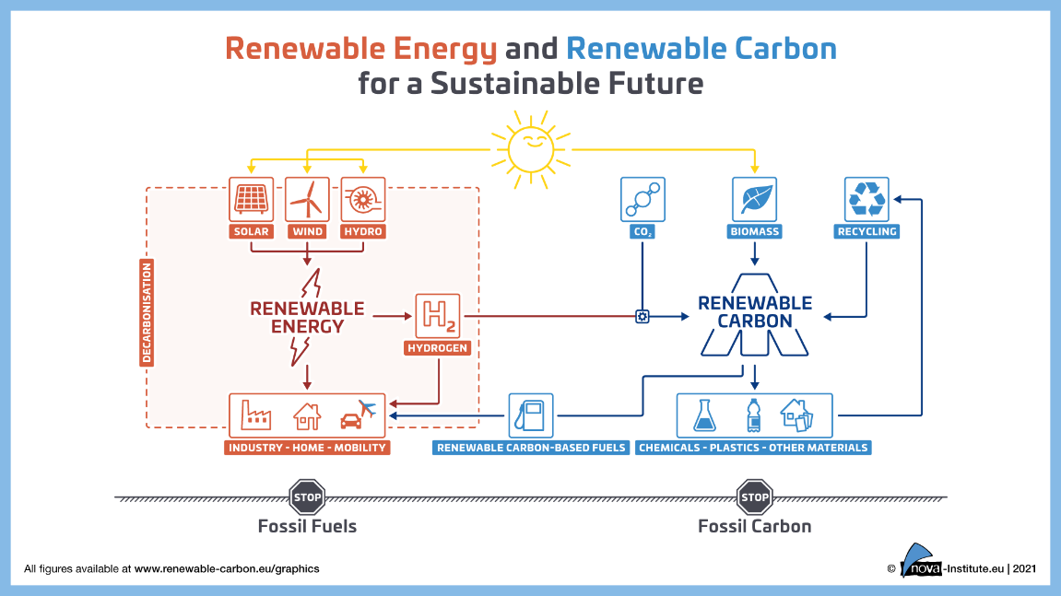
- Concept of Renewable Carbon
Source: Nova Institute
As emphasised in the European Chemicals Industry Action Plan, this is particularly important for the chemicals sectors, which requires significant amount of carbon feedstock (estimated at over 120 Mt/C/year for the EU-27) and more than 90% of it is derived from fossil sources . Therefore, the chemical conversion of CO₂ presents an important potential to produce a wide variety of chemicals without relying on fossil feedstocks. Figure xx provides an overview of the different CO₂ conversion technologies and the range of resulting CCU products, as well as their technology readiness levels.

- Overview CCU technology pathways for chemicals and polymers
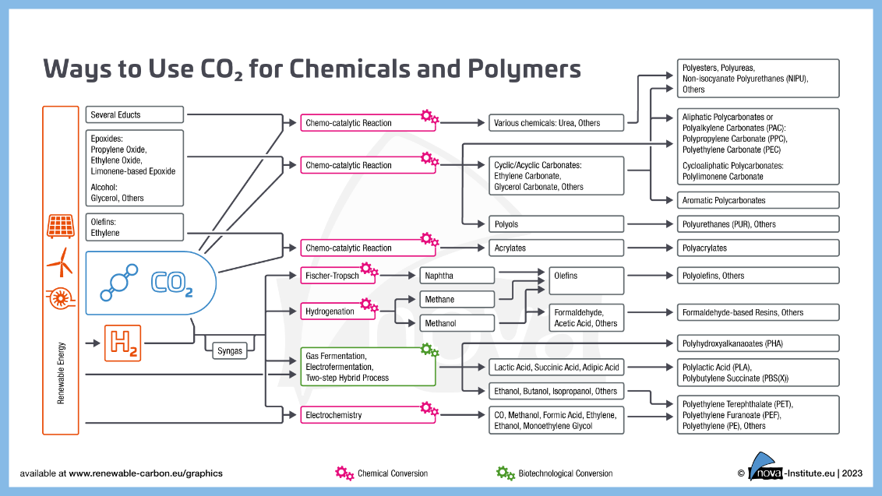
Source: Nova Institute
A 2023 report identified that in 2022, the total production capacity of novel CO₂-based products of about 1.3 Mt/a with an outlook by 2030 expected to exceed 6 Mt/a of CO₂-based products. A 2024 evaluation of a number industry studies and reports on the future of the plastics or chemicals sectors identified that the use of CO₂ as feedstock in CCU applications amounted by 2050 to an average 17% of the share of feedstock for plastics and 33% for chemicals in general (exceeding the predicated share of biomass for materials).
This makes it clear that CCU plays currently a small role as an industrial technology, but it presents an important potential for the development of new production methods that are inherently better suited to a low carbon, net-zero economy. Against this background, this assessment considers the role the EU ETS can play in providing a level playing field for CCU applications to develop and compete with traditional fossil-based production methods
    - Identification and description of accounting approaches
‘Upstream’ ‘downstream’, and ‘midstream’ in the context of this assessment refer to the different stages in the CCU value chain, i.e., ‘upstream’ representing the initial carbon capture stage and ‘downstream’ is the stage where the emission eventually occurs, such as at the point of combustion of a fuel or other end of life treatment of a product. ‘Midstream’ represents an accounting point somewhere in the middle of the value chain. In the illustrations below, a +1, 0 or -1 indicate where emissions or removals reported across the different steps of the CCUS chain. In the case of permanent storage, the sum of the emissions at each stage should add up to 0, while in the case of non-permanent CCU, the sum of the emissions at each stage should add up to +1. A lower value would represent under-counting of emissions, and a higher one would represent double counting of emissions.
‘Upstream accounting’, in the context of the EU ETS, refers to accounting for emissions at the point of capture of emissions that result from activities within the scope of the ETS Directive. Captured CO₂ that is not designated for CCS or subject to the exemption for permanent CCU products, still requires the surrender of emission allowances, i.e. it is priced at the point of capture. Captured carbon would then be utilised in the value chains of non-permanent CCU products, such as for the production and use of plastics or e-fuels. Upon combustion of e-fuels, the priced carbon is emitted into the atmosphere.
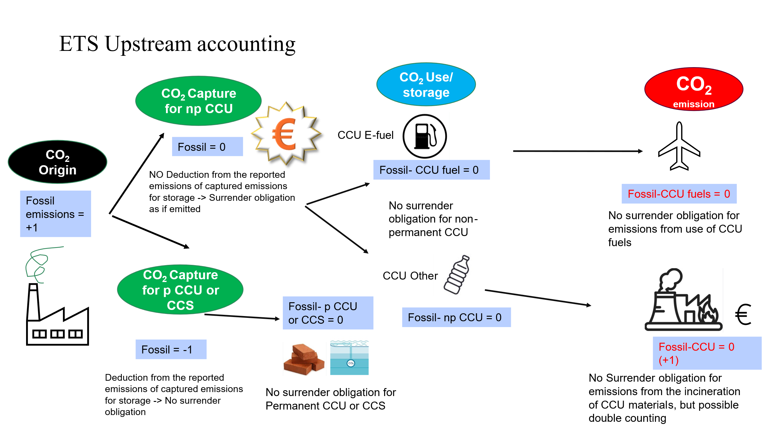
- Simplified illustration of upstream accounting in ETS context
Source: Own illustration
‘Downstream accounting’ refers to reporting of emissions at the point where the captured carbon is released back into the atmosphere, such as during product use or disposal. In this approach, the ‘final emitter’ pays, meaning the point of surrender obligation is shifted downstream in the CCU value chain. The EU ETS installation capturing its emissions and transferring the resulting CO₂ to another EU ETS installation will not be required to surrender emission allowances for that CO_{2,} regardless of if it intended for non-permanent CCU applications or permanent geological storage or any type of CCU application storage site. The emissions embedded in non-permanent CCU products are accounted and priced downstream at the end of life when combusted and the CO₂ is released.
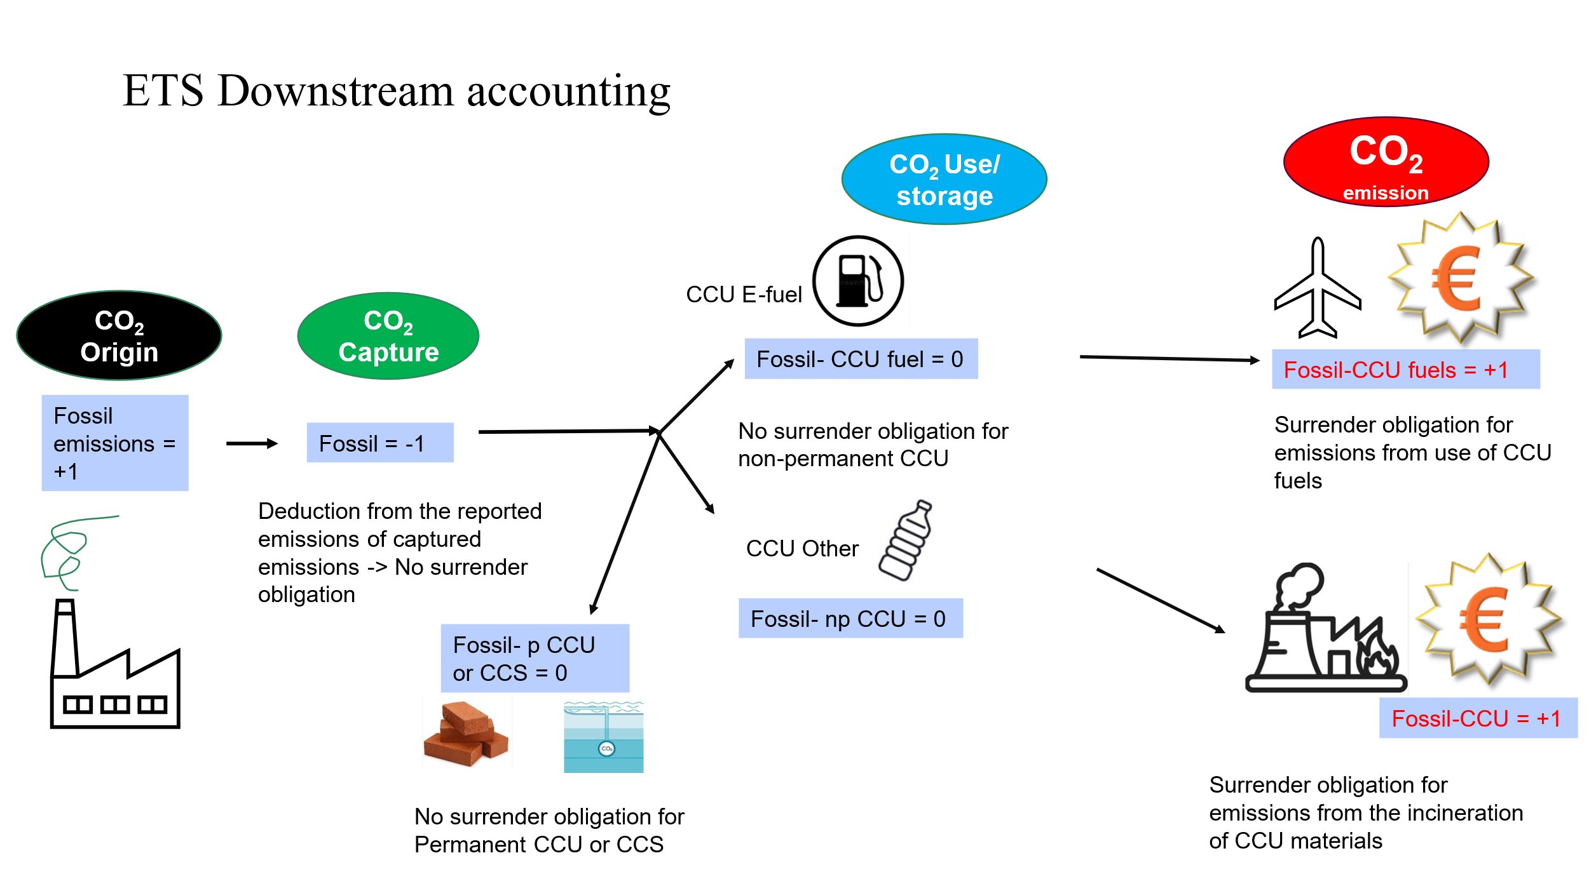
- Simplified illustration of downstream accounting in ETS context
Source: Own illustration
‘Hybrid downstream and midstream accounting’ represents a version of the downstream accounting, where the point of accounting can be enacted somewhere in the middle of the value chain for a particular CCU product. The hybrid midstream is particularly relevant for e-fuels, where the zero-rating for qualifying e-fuels can be maintained by moving the point of accounting and pricing midstream. In the case of e-fuels, the midstream accounting point as either the producer of e-fuel, similar to a refinery or organic chemicals producers, or as a distributor placing e-fuels on the EU market for final consumption. For the other CCU products, the downstream accounting is applied as described in the ‘downstream accounting’ measure, hence the ‘hybrid’ designation.
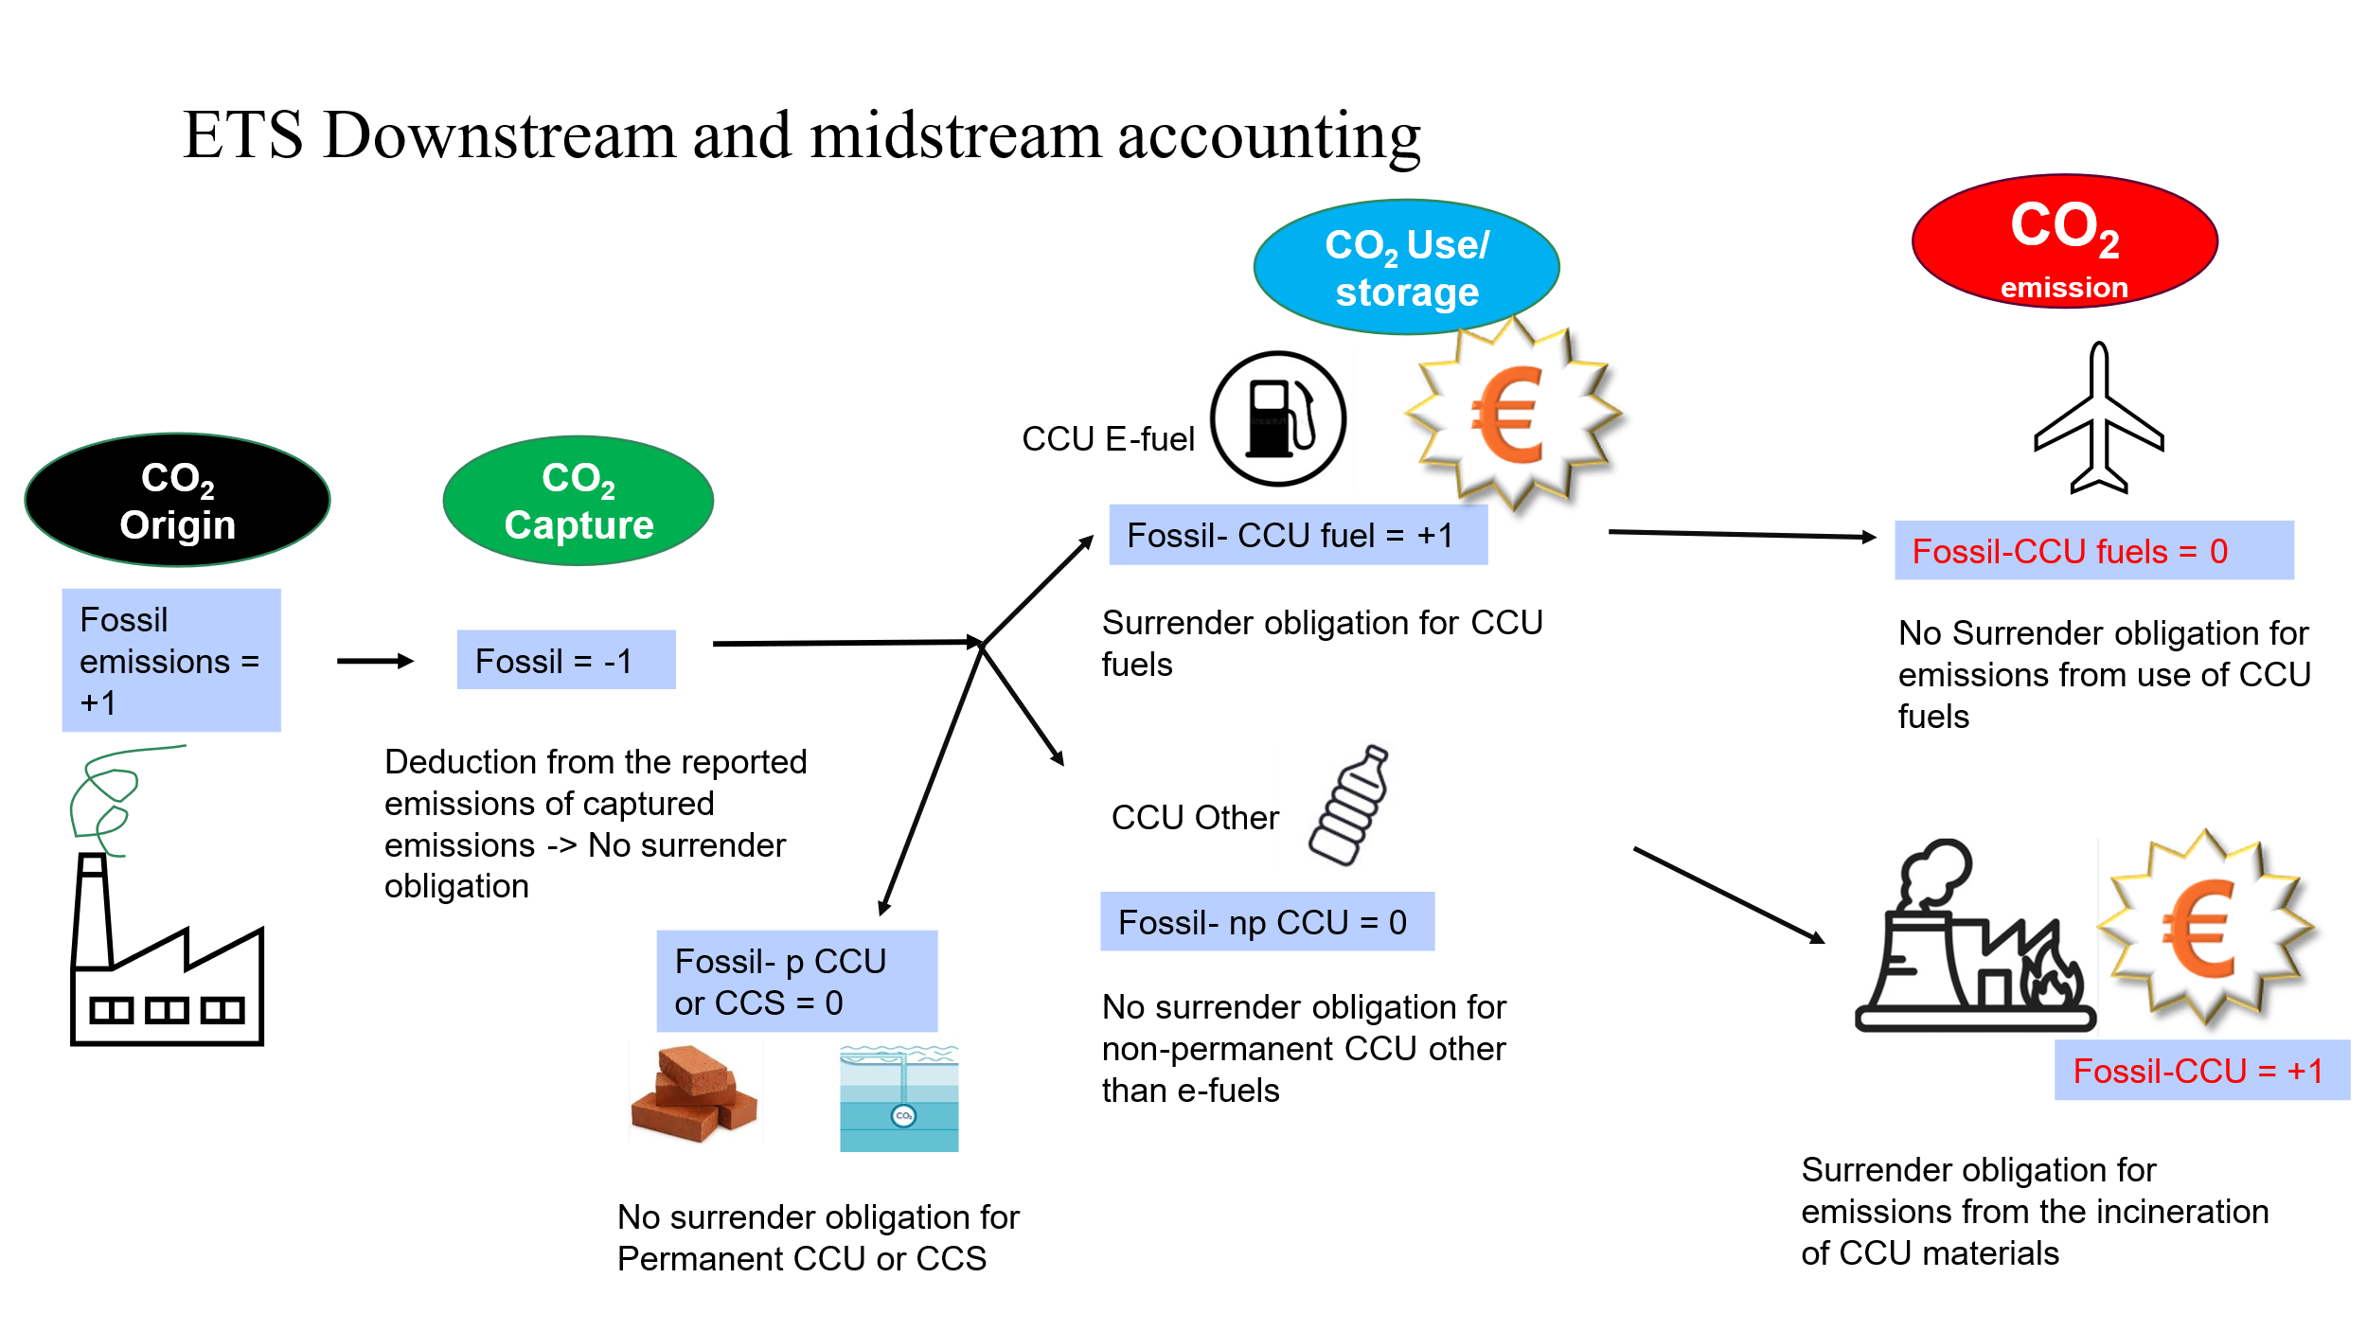
- Simplified illustration of hybrid downstream and midstream accounting in ETS context
Source: Own illustration
These concepts underpin the suggested policy measures articulated for the treatment of non-permanent CCU in the EU ETS in the below chapter.
    - Identification of potential non-permanent CCU products and their normal use or end-of-life treatment
The main CCU products or applications outlined below, as well as their normal use or end-of-life treatment.
- Overview of product lists by normal use or end-of-life treatment
Direct Utilization of CO2 | Incineration during normal use or at the end-of-life | Recycling or landfilling | Other
Dry Ice | PCC (except used as mineral fertiliser) | Plastics | Solid Carbon
Greenhouses | Plastics | Plasterboard | Other carbonates
Food & Drink | Sodium Carbonate (soda ash) | Refractory Products | PCC used as mineral fertiliser
 | E-fuels | Caustic Calcinated Magnesite | Other organic chemicals
    - Identification of potential loopholes for downstream accounting
To understand the implications of the carbon accounting policy measures to be assessed, the end-of-life pathways and emissions profile for each non-permanent CCU product was examined. The goal of this exercise was to determine which non-permanent CCU products are likely to be inert or to re-emit CO₂ at their end of life based on their typical waste management process. Should a non-permanent CCU product meet its end of life outside of the and re-emit those captured of emissions, the product is considered to evade the accounting of ETS system and undermine its environmental effectiveness. This evasion is referred to as ‘loopholes’.
An assessment of the risk loopholes was performed to determine which potential non-permanent CCU products are likely to be inert or to re-emit the embedded CO₂ at the end of life based on their typical waste management process. Furthermore, in-case of re-emission, it is important to assert whether that emission would occur within or outside the scope of the EU ETS, either currently or in the future, considering the possible extension to include waste incineration. This forms the basis of analysing the impacts of the different proposed CCU measures and whether the double- or under-counting of ETS emissions occurs.
Three waste management processes – recycling, incineration and landfill - were examined for several specific non-permanent CCU product, Direct CO₂ use applications and e-fuels were also considered. The following conclusions were determined:
- Direct utilisation of CO₂ in sectors such as horticulture, food and drinks or refrigeration, will result in direct, and in most cases immediate, emission in the atmosphere of the utilised CO₂. As these sectors fall outside the scope of the EU ETS, this re-emission of the CO₂ would not be covered by the EU ETS.
- E-fuels, which are produced from hydrogen and CO₂, will results in the CO₂ being emitted during fuel usage (combustion). The amount of CO₂ released during combustion can be considered equal to the amount of CO₂ used to create the fuel (excluding any emissions associated with the energy required for the production, which are not considered here). The use of fuels, including e-fuels, already falls largely within to scope of the EU ETS and ETS 2.
- The potential CCU products analysed that have a high incineration rate (either from the outset or at the end of several recycling cycles) are assumed to re-emit any embedded CO₂. However, some industrial wastes are co-incinerated as fuel for some ETS activities, and therefore these emissions are covered by the EU ETS. Furthermore, for the purpose of this assessment, it is assumed that the scope of the EU ETS is expanded to include waste incineration, in which case it can be assumed that most emissions from the incineration of waste will fall within the scope of the EU ETS.
- The potential CCU products that are landfilled are considered generally inert. Emissions from landfill result from the digestion (aerobic or anaerobic) of biodegradable waste. Synthetic organic materials, unless specifically designed to be bio-degradable, breakdown very slowly in landfill conditions with half-lives estimated ranging in hundreds to thousands of years. However, the current IPCC guidance on emissions from solid waste disposal sites includes only the reporting of CH₄ (methane) emissions from landfills, as the CO₂ released from landfills is considered of biogenic origin. Some emissions could occur if landfill conditions become very acidic, landfill fires or in case of illegal dumping, which may not be accounted in inventories
- For potential CCU products that have a high recycling rate, the fate of the embedded CO₂ depends on the recycling process. Mechanical recycling process do not alter the chemical composition of the material and therefore, from the CO₂ re-emission point of view, they can be considered inert. In some cases, such as plasterboard, the recycling process requires high enough temperatures that result in the release of the CO₂. In other cases, where novel recycling processes are applied, the fate of the embedded CO₂ will depend on the nature of the product and of the recycling process and it cannot be determined in advance with precision. Products that after the recycling process, due to degradation or contamination, are not recyclable anymore are assumed to be either landfilled or incinerated, and therefore the likely emission fate outlined for those two end-of-life treatments.
- There are some CCU applications that, like the direct CO₂ utilisation, will result in the re-emission of at least some the embedded CO₂ outside of the scope of the EU ETS. This category includes primarily the products such as urea or PCC used as fertilisers or soil additives, where they break down and get dissolved in the water stream or re-emitted in the atmosphere. IPCC guidance on agricultural liming considers in its the default method that all embedded CO₂ in fertilisers is released. However, it does acknowledge a high uncertainty level as high as 50% and the exact rate of re-emission is influenced by local conditions, in particular soil acidity.
This assessment shows the possible non-permanent CCU product categories that will eventually result in the release of the embedded CO₂, where that emission would occur and whether it would fall within or outside of the scope of the EU ETS, assuming also its extension to include waste incineration.
It is important to note that to date, apart from PCC, urea and some applications making direct use of CO_{2,} CCU technologies are largely at the research or piloting stage. The products researched in this section represent potential or possible products that could be produced via CCU. However, it is not possible to say which of those products will likely be produced at scale, which will depend on specific technological, financial and commercial considerations for each product. Therefore, the risks identified for the CCU products in this section are theoretical, as currently there are no or very few CCU products commercialised.
  - Policy measures
    - Description of the policy measures
The following policy measures to be considered for non-permanent CCU in the impact assessment include:
CCU0: Represents no change compared to the baseline based on upstream accounting and the current scope of the EU ETS as regards waste incineration.
CCU1: Maintain upstream accounting/pricing after integration of waste incineration
Upstream accounting is the status-quo accounting mechanism of the EU ETS premised upon the “emitter pays” principle, where carbon is accounted for at the point of the initial activity generating emissions. Upstream accounting was the most frequently identified accounting approach (44%) by respondents in the OPC when asked what accounting approach should be applied to non-permanent CCU technologies in the ETS to ensure the integrity and effectiveness of the EU ETS.
- CCU2: Downstream accounting (final emitter pays), conditional on integration of waste incineration:
Downstream accounting moves the point of accounting/pricing downstream to where the emission occurs. The capture operator (e.g. cement plant) is not required to surrender allowances for any CO₂ captured, as the final emitter, the user of synthetic fuels or the waste incinerator that incinerates non-permanent CCU products, would have to surrender allowances for these emissions. Downstream accounting, in various forms (with or without a ‘chain of custody’ approach) was the second most frequently identified approach (38%) by respondents in the OPC, mainly from companies and business associations from the manufacturing industry.
- CCU3: Hybrid downstream & midstream accounting, conditional on integration of waste incineration:
This approach is a variation to the previous downstream accounting option that seeks to offer an accounting approach that can accommodate the emissions profiles of e-fuels. In this approach, downstream accounting on waste incineration would take place to ensure that the emissions resulting from most non-permanent CCU products that meet their end-of-life downstream are accounted for. Additionally, a zero-rating for qualifying e-fuels would be maintained, and to ensure emissions from e-fuel production are accounted for, the point of accounting/pricing would move midstream and placed on either the producer or distributor of e-fuels. The difference between the two options as the midstream point of accounting is that midstream accounting at the point of production would cover only e-fuels produced in the EU, while midstream accounting at the point of distribution would cover both domestic and imported e-fuels. The producer or distributor of e-fuels would be included in the EU ETS as an operator and would be required to surrender allowances for the fossil CO₂ used in e-fuels, which would enable to continue zero-rating these fuels when used in the ETS.
    - Description of discarded measures
- Life Cycle Assessment (LCA) based partial non-surrender obligation or carbon tracking:
LCA approaches fundamentally concern the evaluation of a non-permanent CCU product’s life-cycle emissions through life-cycle analysis. LCA approaches and associated partial surrender obligations could be conceived as a sub-option for both upstream and downstream accounting, where instead of altering the point of an allowance surrender obligation, the extent of the surrender obligation is altered instead with emission factors based on life-cycle assessments that identify the climate benefit of non-permanent CCU products. In other words, partial emission factors would be applied instead of full pricing or full exemption. A life-cycle assessment approach to non-permanent CCU technologies in the ETS was supported by only a small share of OPC respondents (11%), mainly on the grounds that this would provide for the most accurate accounting method, LCA can represent an “outside of the box” solution for some, moving beyond the upstream-downstream paradigm, forgoing the need to assess as well whether a non-CCU product will be incinerated at its end of life or not. Additionally, LCA measures represent alternatives to the approach of addressing CCU through the avoidance of double counting, particularly in case of a decision not to integrate waste incineration into the EU ETS. More so, LCA approaches may provide incentive for CCU over the use of virgin fossil feedstock if the non-permanent CCU application is recognised to have, and is rewarded for, lower life-cycle emissions. LCAs in principle could be done, requiring clear and favourable rules for carbon footprint accounting to create incentives for CCU-based products.
However, there is no consensus on an appropriate methodology for conducting LCA for non-permanent CCU applications. In essence, the comparison of non-permanent CCU applications with a fossil fuel baseline may sound simple in principle, but in practice, can also involve a range of uncertainties and assumptions, being highly dependent on chosen baseline scenarios and associated assumptions. More so, it may not even be the case that a non-permanent CCU product displaces a fossil fuel baseline. A wide range of outcomes can be achieved when applying substitution with credits to deal with allocation in LCA approaches.
Fundamentally, LCA measures would require putting in place a certification infrastructure to be able to make such assessments, which would be complex and create a disproportionate administrative burden for uncertain benefits. The overall lack of consensus on methodological approach inherently raises a degree of uncertainty with regards to exactly how the associated monitoring, reporting, verification and accreditation (MRVA) would function in the first place.
Furthermore, LCA approaches are generally not compatible with the existing ETS MRVA framework, which was not designed to incorporate life-cycle assessments. Introducing LCA based approaches for CCU would introduce an unlevel playing field for CCS, which is based on incorporating the entire CCS chain in the scope of the ETS Directive (capture, transport and storage) and monitoring and reporting any emissions associated with each step.
In the context of CCU fuels, a “strict LCA approach is not seen as implementable for the ETS MRVA” according to FuelsEurope. For the chemical sector as well, there can be a wide range of LCA approaches that can lead to different results, and no clear way to harmonise LCAs for different chemicals and their products in what is inherently a complex industry. Practically, the tracking of the carbon molecules across the value may be unfeasible. Chemicals could be processed through many different stages and intermediaries and used as a feedstock for various end-use products. In practice, both upstream and downstream actors would have difficulties in compiling LCAs for their products due to uncertainties of the value chains.
Even though LCA has been standardised by the European Committee for Standardisation in ISO 14040/14044, the standard does not prescribe the exact methodological choices to be made regarding factors such as: selection of the functional unit, system boundaries (i.e., different “cradles” in a “cradle-to-gate” system), background processes, or environmental impact assessment methods. The lack of consensus on LCA for non-permanent CCU applications could also lead to sub-optimal decisions. As discussed above, with LCA approaches there is an inherent trade-off between the accuracy of an LCA approach versus the costs and administrative burdens of the associated MRV; the greater the accuracy the more costly the MRV system. Every LCA approach heavily depends on adequate data, the provision of which from stakeholders can incur additional costs.
Finally, the established approach of the EU ETS is based on Scope 1 direct emissions. Integrating an LCA approach that revolves around Scope 3 logic would increase the risk of double counting. Under the downstream accounting scenario, if again there is no comprehensive coverage of all end-of-life pathways for non-permanent CCU, then the same concerns about loopholes can arise again. More so, LCA has also been criticised for not being able to account for emission timing, i.e. the time interval between the capture of CO₂ and its subsequent emission. To this end, some stakeholders have suggested adding “timeframes”, where different blocks of time are used to denote the emissions from different components (Cembureau, stakeholder interview, July 28, 2025), although how exactly this would work was not detailed.
Given the limited feasibility and technical complexity, specifically the lack of consensus on methodological approach for applying an LCA to non-permanent CCU activities, the lack of certification structure and ease of integrating an LCA approach in the existing EU ETS MRVA framework, this measure is not assessed in detail as a policy measure in the impact assessment.
  - Assessment of the measures
This section assesses each of the three policy measures proposed for accounting non-permanent CCU in the ETS, as outlined in the previous section. These alternatives are considered regarding their economic, social and environmental impacts, drawing on the findings of the scoping exercises and stakeholder feedback.
    - Quantitative assessment
The modelling foresees that all industrial and power installations pay ETS price, disregarding whether emissions are captured and used for CCU later, that is equivalent to the upstream accounting. The options included in the assessment are:
- The current CCU (CCU0) accounting in EU ETS follows the rule: the EU ETS installation capturing the CO₂ is required to surrender an allowance if the captured carbon is subsequently used to produce RFNBOs or other CCU in non-permanent goods. This is equivalent to the upstream accounting.
- Midstream accounting (CCU3): The point of accounting/pricing is moved mid-stream. In the context production or distribution of e-fuels, this captures producers/distributors of e-fuels. They will be required to surrender allowances for the fossil CO₂ used in e-fuels.
The scope of CCU analysis in the current assessment is focused on two categories:
- on CCU in non-permanent materials + waste incineration
- on CCU for synthetic fuels production
The implementation of CCU in non-permanent materials proved challenging due to the limited availability of detailed statistics on the end-of-life treatment of products in Eurostat balances, as well as the scarcity of product-specific data on the potential share of recycled CO₂ content. Furthermore, the analysis was constrained by the lack of national-level data from ETS installations in the waste incineration sector. In agreement with the client, this route was therefore excluded from the assessment.
The EU ETS impact assessment scenarios align with the regulatory requirements for renewable fuels of non-biological origin (RFNBOs) and recycled carbon fuels, which determine the eligible sources of carbon feedstock for synthetic fuel production. In line with the Delegated Act, and Directive (EU) 2018/2001, recycled carbon fuels must achieve at least 70% greenhouse gas savings and use fully renewable electricity.
To reflect these provisions, the analysis assumes that CO₂ from electricity generation can be used only until 2035, and CO₂ from industrial processes only until 2040. Over time, the supply of capturable fossil CO₂ is expected to decline, with eligible sources increasingly limited to residual emissions from hard-to-abate sectors. Consequently, the model does not invest in infrastructure for fossil CO₂ use but instead prioritises CO₂ captured from biomass processing, particularly from biofuel production, refer to Figure 12.

- CO2 flows in PO2 scenario for 2040
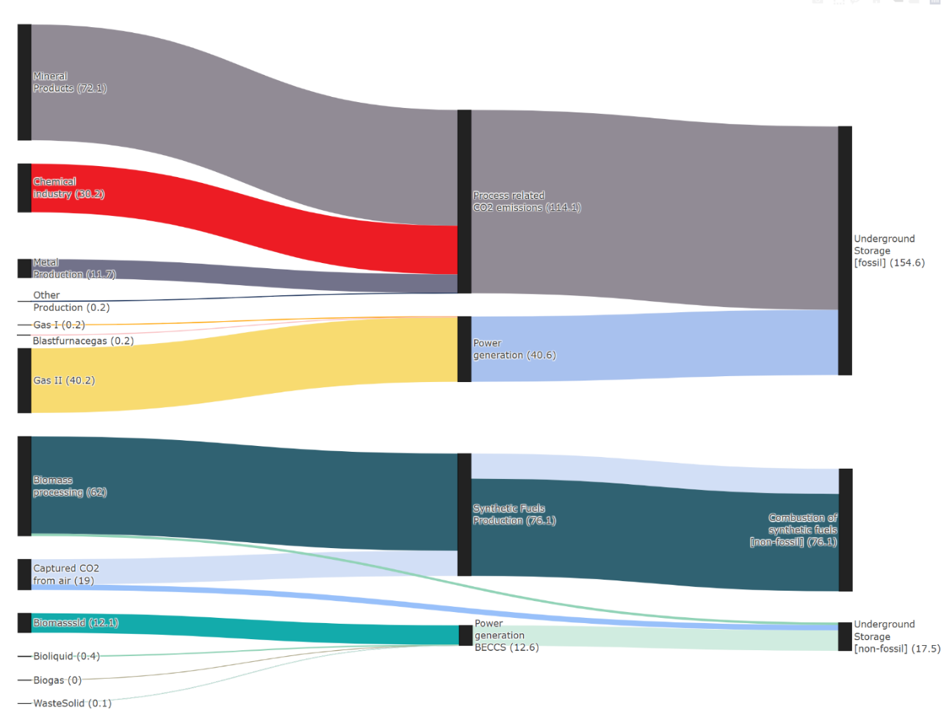
Source: PRIMES
Additionally, a recent JRC study computed the technical feasibility of capturing CO2 in the EU industrial sectors, suggesting that a total of 210-290 Mtpa are available for capture in the iron and steel, cement and petrochemicals sectors together depending on the capture technology deployed, while in waste-to-energy plants the capturable amount would lie between 60 and 120 Mtpa.
    - Environmental impacts
The creation of a non-permanent CCU product prevents the immediate release of CO₂ into the atmosphere but results only in a delay of days to years when that emission is eventually released into the atmosphere, compared to permanent storage which stores the CO₂ for hundreds to thousands of years.
The EU ETS is fundamentally an emission accounting system that monitors and reports as accurately as possible the emissions resulting from the activities within its scope, which then leads to a corresponding compliance obligation for the respective ETS regulated entities. Therefore, the accurate accounting of emissions is essential for the EU ETS meeting its objectives.
Non-permanent CCU poses an accounting challenge for the EU ETS, as captured emissions by an ETS installation and used for non-permanent CCU products will eventually be released in the atmosphere at a relatively short period of time somewhere down the value chain. As these delayed emissions are still relevant on climate change timescales, they cannot be treated the same as emissions that are permanently stored and will need to be reported as emitted sooner or later.
Therefore, the effective accounting of emissions is the principal criterion to determine the environmental impacts of recognising non-permanent CCU in the EU ETS. Effective accounting means that emissions should be counted at least once (no undercounting), but also no more than once (no double counting). Effective accounting also ensures accurate pricing of emissions, which is essential for the EU ETS achieving its objectives.
It is important to also note that non-permanent CCU products enables the substitution of fossil carbon in sectors that require a carbon feedstock, supporting the reduction of scope 3 emissions for the chemical industry. However, CCU applications are very energy intensive and they provide LCA GHG emissions reduction only if the energy used for the capture of the CO₂ comes from renewable sources and the utilisation process is done with green H₂The ETS is feedstock agnostic and does not provide any restrictions on the type of energy used for a particular process, but it requires that all emissions associated with the production process are monitored, reported and surrender the corresponding number of allowances. This ensures that although no specific renewable energy requirements are set, any development of CCU applications will be done within the constraints set by the ETS cap and the carbon price signal, prompting ETS installations to make use of CCU applications only when it results in overall emissions reductions. Some academic stakeholders emphasized the importance of ensuring permanence if surrender obligations are adjusted to accommodate for non-permanent CCU, emphasizing the risk of mitigation deterrence and noting that potential changes to the ETS accounting framework should be carefully weighed against the avoid adverse effects on the environmental integrity of the current ETS￼. Comparatively, business associations and individual businesses emphasized the importance of recognizing the role that non-permanent CCU plays in the EU’s climate-neutrality pathway, particularly to address residual emissions.
      - CCU1 – ‘Upstream accounting’:
Upstream accounting provides the highest assurance in terms of integrity of the ETS system, as all captured emissions are considered as emitted unless proven that they are stored permanently. It is virtually guaranteed that all captured emissions resulting from ETS activities would be accounted for at least once, e.g. by the operator of a cement plant with a carbon capture facility, but possibly also by the waste incinerator (if any). Therefore, under the upstream accounting there is no risk of undercounting of emissions. This was also corroborated by OPC responses, with one of the main justifications for those supporting upstream accounting being the high environmental integrity by providing for a full coverage of emissions without risk of undercounting.
The upstream accounting is the approach that is currently in force in the EU ETS. It was included to avoid emission leakage out of the ETS when carbon is transferred to non-ETS installations, as a significant share of potential downstream emissions would occur outside the scope of the EU ETS. Therefore, without an upstream accounting system, these emissions resulting from ETS activities would bypass the ETS carbon price.
      - CCU2 and CCU3 – ‘Downstream’ and ‘Hybrid downstream and midstream accounting’
The most frequently cited concern in the OPC responses in relation to moving the surrender obligation downstream, both by proponents and opponents, was the risk of emission leakage associated with this accounting approach, for example in the event that CCU products such as plastics may avoid incineration, assuming that the waste sector is included within the scope of the EU ETS.
Firstly, in order to ensure the integrity of the EU ETS, the downstream and midstream accounting options require the extension of the scope of the ETS Directive to include the CCU value chain from the point of capture to the point of utilisation.
Currently, the scope of the EU ETS includes only the activities of CO₂ capture and CO₂ transport for the purpose of geological storage. Therefore, CO₂ capture and CO₂ transport for CCU purposes would also need to be included in the scope of the ETS Directive.
Furthermore, similarly to the inclusion in the EU ETS of geological storage sites permitted under the CCS Directive, CCU installations would also need to be included in the scope of the ETS Directive. This ensure that CO₂ does not need to be transferred outside the boundaries of EU ETS to be utilised in a product, keeping therefore intact the CO₂ chain of custody from the point of capture until the CCU product is placed on the market. In addition, any emissions associated with the CCU process (energy related or process emissions) will also be covered by the EU ETS, ensuring that any CCU processes are less emission intensive than traditional manufacturing processes.
Secondly, implementing downstream accounting in a manner that provides assurance of the integrity of the EU ETS would require identifying potential gaps or loopholes, specifically cases in which the end-of-life of non-permanent CCU products is met by end-of-life treatments other than municipal waste incineration, such recycling and landfill.
To determine the extent of potential loopholes, an analysis was conducted for a set of potential non-permanent CCU products to assess whether the CO₂ is re-emitted or remains inert when that product meets its end of life via recycling, landfill or incineration and, in case of re-emission, whether that emission would occur within or outside the scope of the EU ETS – see section 2.2.4.
The results of the analysis found that most of the potential CCU products are not likely to lead to any significant loopholes as regards the integrity of the EU ETS. Non-permanent CCU products that are either incinerated via waste incinerators, and the resulting emissions fall within the scope of the EU ETS or the CO₂ embedded in the product remains inert throughout the products waste management process (recycling or landfilling). In addition, CO₂ used to produce e-fuels will also not represent a loophole risk, as their combustion will mostly occur within the scope of the EU ETS, in sectors such as maritime and aviation. Furthermore, e-fuels are subject to specific certification requirements and are easily tracked across the value chain. However, to avoid undercounting of emissions used to produce e-fuels would necessarily mean that it is not possible anymore to zero-rate the emissions from the combustion of these fuels.
However, a small number of potential CCU products present a clear potential risk of loopholes to EU ETS accounting. They include:
- The direct use of CO₂ in applications such as greenhouses, food and drinks or refrigeration.
As the CO₂ is not chemically converted it will immediately be released as a greenhouse gas without the need of special conditions such as high temperature or acidic environments. Furthermore, the use of CO₂ in such applications will happen outside of the scope of the EU ETS and will not be subject its monitoring, reporting and compliance obligations.
- CCU products used as fertilisers (PCC as mineral fertiliser or urea)
As these products are used in agricultural applications and when the embedded CO₂ will eventually be released it will happen outside of the scope of the EU ETS.
There are additional loophole risks in some cases, but they are however not well defined and influenced by many variables:
- CCU products that risk emitting during the recycling
Some products (plasterboards, used oils, some organic chemicals) there may be a risk of loopholes depending on the type of recycling process used and whether that recycling is or not part of the EU ETS. Some forms of recycling may involve sufficiently high temperatures to release the embedded CO_{2.} However, it is also possible that such processes would be covered anyway by the EU ETS.
- In addition, it is possible that some emissions from the end-of-life treatment of non-permanent that would normally fall within the scope of the EU ETS may nevertheless be emitted outside the scope of the system. This can happen in the following cases:
  - Waste incineration in installations that are excluded from the scope of the EU ETS due to small size and or the specific nature of waste they treated (hazardous, medical, etc)
  - Export of waste for treatment outside of the EEA
  - Illegal dumping of waste
  - Exports of non-permanent CCU products, which would also result in waste to be treated outside of the EEA.
While these are potentially important risks, there are already measures in place that limit the export of waste outside of the EEA or that address the problem illegal dumping. In addition, as novel non-permanent CCU products are not yet produced at any significant volumes, these risks represent only a potential for future loopholes.
Therefore, it will be necessary to provide for a regular assessment of on-going of the risks of loopholes based on the actual scale-up of non-permanent CCU products, as well as the development of environmental and waste management legislation. Based on this assessment it would be possible to exclude specific products that have a high risk of creating loopholes, introduce additional safeguards or requirements, or add correction factors to account for the risk of loopholes.
    - Economic impacts
      - Conduct of business
The CCUS sector has for the moment a small economic weight, and it is not yet possible to separately identify value chains linked only to CCU. JRC analysis identified 186 key companies worldwide with activity in CCUS, out of which 45 (24%) are European or are active in the field through their European subsidiaries and that overall revenue recorded for the CCUS value chain amounted to only 95 million EUR in 2021.
Despite the limited economic role played by the CCUS sectors, it is important to consider the potential for its development and to role it can play in a low carbon, net-zero economic. Therefore, the economic impacts of the proposed measures are relevant mostly in terms of the incentives it sets for the development of this sector.
        - CCU1 – ‘Upstream Accounting’:
As regards CCU1, accounting for emissions upstream places the ETS burden on the emitter/capture operator, meaning they would have to consider as emitted and surrender allowances for any captured emissions, unless stored permanently. As a result, this measure will have the following impact on the conduct of businesses:
- It does not incentivise ETS emitters to invest in carbon capture for CCU
Installing carbon capture capacity on existing industrial installations represents a significant investment, both in terms of capital investments and operating costs. The JRC estimates that, according to the literature review, the capture costs for hard-to-abate sectors lie between 40-90 EUR per tonne of CO_{2,} varying based on the concentration and purity of the CO₂. In addition, the JRC’s own capture cost estimate suggests that around 200 Mtpa of CO2 can be captured at a cost lower than 100 EUR per tonne mostly from cement, waste-to-energy and certain petrochemical facilities.
Under upstream accounting, ETS installations that do carbon capture will be able to reduce their compliance obligations only if the captured emissions are permanently stored (either in geological storage or permanently chemically bound in products), while any CO₂ captured for other use purposes will have to be reported as emitted and thus caused an additional cost. Capture only for geological storage may be not an economical or practical option available to all installations that might benefit from carbon capture to reduce their emissions. This can be due limited number of operational storage sites, lack of proximity to those storage sites or limited CO₂ infrastructure (pipelines or shipping terminals, as truck or rail; transport is possible but for low volumes and higher costs). In fact, a recent JRC study suggests that the chemical and waste-to-energy sectors see their capturable CO2 amounts decreased the most when considering the characteristics of each individual facility, while the iron and steel, cement and refining sectors are more likely to deploy capture. Therefore, upstream accounting limits in practice the economic options available to ETS installations to reduce their capture costs and achieve their emission reduction goals. Investments in carbon capture will be done only when and where economic conditions are in place for sending captured CO₂ to geological storage site, while carbon capture for utilisation is disincentivised.
A 2024 JRC study estimated that by 2050, the European CO₂ pipeline network necessary for CCS could reach up to 9 000 km and requires investment of between EUR 9.3 billion and EUR 23.1 billion study. This shows the costs implied by a system of transporting captured CO2 either to geological storage sites and/or CCU users for the decarbonisation of hard to abate industries requires significant investments in infrastructure to ensure the connection of emitters with relevant solutions without any direct revenues. A system allowing for more localised solutions, including CCU, would reduce these infrastructure costs.
- It increases the cost of CO₂ feedstock and reduces its availability for potential CCU producers
As shown previously, the upstream accounting may reduce the incentives to invest in carbon capture for industrial emissions, except when the captured CO₂ can be permanently stored. This in turn reduces the availability of CO₂ as alternative carbon feedstock for e-fuels or synthetic chemicals. As ETS installations have no incentives to capture CO₂ for CCU, e-fuels or synthetic chemicals producers need to source CO₂ from non-ETS emitters, which limits the available volumes. Furthermore, as any CO₂ captured for non-permanent CCU would still require the payment of the ETS price for the emitter installation, this would further increase cost of this feedstock. Under this scenario, non-permanent CCU actors may rely on cost pass-through, passing the costs of the ETS down the value chain by incorporating the price of an ETS allowance into the carbon feedstocks they would sell to non-permanent CCU application developers. However, the combination of low volumes and high price for a key feedstock for non-permanent CCU products will make them uncompetitive.
The upstream accounting is beneficial for the e-fuel market, because it enables the zero rating of the emissions from the combustion of e-fuels and considering them as sustainable fuels. For producers, this allows them to sell the e-fuels at a premium and, for consumers, it allows them to use e-fuels to reduce their emissions. One fifth of respondents in the open public consultation, who expressed support for upstream accounting did so specifically for CCU fuels as, in their view, this would help to ensure regulatory stability with the current framework that also follows an upstream approach to accounting (i.e. to align with EU ETS and RED rules and remain coherent with the RED RFNBO Delegated Act).
However, despite the advantages for the e-fuel market of the upstream accounting, due to the lack of investment in carbon capture, e-fuel producers have difficulties in sourcing sufficient CO₂ feedstock for their operations.
- It leads to reduced supply of captured CO₂ to replace virgin fossil carbon in non-permanent CCU products, if capturing for permanent geological storage (CCS) is the only option for emitters.
Under the upstream accounting, capturing emissions for non-permanent CCU applications does not change the compliance obligations of ETS installations. As in the long-term the emission space for ETS covered sectors will be limited only to the hardest to abate emissions. Therefore, installations will seek to permanently store their hard to abate emissions and, if that is not possible, will not invest in carbon capture at all and therefore discourage the development of non-permanent CCU applications., ,
This view is supported by a wide range of stakeholders in the OPC across companies and business associations and academia, who considered that CCU and CCS are treated unequally under the EU ETS as currently there is a well-developed accounting framework in place for CCS, including for its transport and for liability for the risk associated with storage.
- It leads to a lack of level playing field between non-permanent CCU products and the traditional virgin carbon equivalent products
Under the current EU ETS rules, the activities of bulk organic chemicals production or refining of fuels covers only the emissions from the combustion of fuels and the process emissions, i.e. scope 1, direct emissions. However, scope 3 emissions represent 60-80% of the overall LCA emissions of the chemical sector and the majority of which is represented by the eventual emission of the embedded carbon in their products, is not considered as an ETS emission and it is not priced. To the contrary, under the upstream accounting, the embedded carbon in a non-permanent CCU product would be priced.
As a result, the upstream accounting would make non-permanent CCU products uncompetitive with their virgin fossil carbon equivalent. Non-permanent CCU applications may still be developed with an upstream accounting approach if commodity prices are high enough to cover the ETS allowance cost for capture operators or if non-permanent CCU products are sufficiently subsidised or supported through other means.
The combination of scarce and expensive feedstock and a level playing will make very difficult to create a business case for non-permanent CCU products.
Even with high levels of public support, this may result in the needed investments in CCU applications not materialising. It enables e-fuels producers to meet the certification requirements for sustainable e-fuels and allows e-fuels user to zero-rate those emissions
It is important to note that in the case of production of e-fuels, upstream accounting is currently necessary for to be able to certify these e-fuels as meeting the 70% GHG emissions savings required under the Renewable Energy Directive (for RFNBOs) and the Gas Directive (for LCFs). Therefore, without any adjustments in the respective regulatory framework, upstream accounting provides e-fuel producers a clear way of meeting the conditions necessary for the certification of e-fuels.
However, the upstream accounting allows the users of e-fuels to consider that their generation results in no emissions (or zero-rated emissions), which enables sectors like aviation or maritime transport to rely on such e-fuels for the decarbonisation of their activities.
- Double counting of emissions downstream
Upstream accounting of emissions has the potential to double count emissions when a CCU product is combusted. Emissions that have been priced upstream can be zero rated downstream, but this is only possible when it can be proven that a particular source of emissions has already been priced. This is possible for e-fuels, which are subject to a specific certification and tracking regime. Double counting occurs for CCU products end up incinerated in the general waste stream that is subject to carbon pricing. This concerns PCC used in paper, certain plastics and soda ash. This double counting of emissions increases the overall cost for businesses and reduces economic efficiency for these non-permanent CCU products.
Considering the 14 unique Eurostat waste categories, data shows that around 5% of the overall annual waste reported in 2022 went directly to incineration and energy recovery, 9% to landfill, and the remaining 86% to recycling. However, this Eurostat data represents waste treatment in the first instance of the products end-of-life and does not consider the lifecycle and associated timeline of products that may be recycled multiple times and eventually incinerated, nor does it relate to whether non-permanent CCU products are inert or re-emit under recycling or landfill. Furthermore, if most of the non-permanent CCU products considered in this analysis are recycled, materials cannot be endlessly recycled, and they will eventually sufficiently degrade that they would have to be either incinerated or landfilled. If eventually incinerated, the materials initially sent for recycling can still pose a risk of double-counting.
By volume recycled, paper and cardboard wastes, plastic wastes, and mineral waste from construction and demolition, are the top three recycled Eurostat product groupings. For plastics, most recycled plastics are recycled once or twice before final disposal, and as noted in this assessment, the average landfill and incineration rates for plastic wastes in Europe was ~40% and ~60% respectively. For mineral waste, the largest category by volume of waste treated, most waste is landfilled, with an average landfill rate of 91%, and incineration is not generally relevant. For paper and cardboard wastes (the second-most voluminous category), Eurostat data suggests that beyond recycling, the next most popular form of waste treatment is incineration in energy recovery. Research suggests that most paper can be recycled approximately 5-7 times before final disposal. Across all non-permanent CCU products considered, an average incineration rate of only 21.4% is observed.
The theoretical magnitude of potential double counting is determined by the likelihood of CCU products replacing traditional one. PCC represents one of the few existing CCU applications and is replacing natural carbonates in applications, such as fillers for paper production. Another potential CCU product category that may lead to double counting is that of polymers or plastics, replacing fossil-based virgin plastics.
Currently, the actual risk of double counting is minimal, mostly limited to quantities of PCC used as filler in paper and other products that end up eventually incinerated. However, as carbon capture and CCU applications will play an increasingly important role in decarbonising (and de-fossilising) hard to abate sectors, this risk is expected to grow and become significant with time. The theoretical potential for double counting of emissions, even when looking only at these two CCU products, can be as much as all the emissions from the incineration of more than half of the share of plastics and from all the volume of paper being disposed.
The primary method of avoiding double counting of emissions that have already been accounted upstream is to zero-rate the emissions from CCU products. This is already the established practice for emissions from biomass (as biomass emissions are accounted in the land sector) and from e-fuels, if they are certified to meet minimum sustainability requirements. However, the zero-rating of biofuels and e-fuels is enabled by a certification system that can identify and trace along the value chain fuels with specific characteristics.
Such a system would be difficult to apply to the zero-rating of CCU products in the waste stream sent for incineration. Furthermore, it is not possible to distinguish between virgin fossil carbon and captured and recycled fossil carbon, unlike biogenic emissions that can be distinguished from fossil-based carbon via isotope analysis at the point of combustion. Thus, it is technically unfeasible to avoid double counting by measurement at the point of incineration. Therefore, avoiding the double counting of emissions under the upstream accounting, would require determining the proportion of captured carbon eventually entering an ETS-regulated MWI would require a tracking or mass balance recycling of CCU based products based on a certification process from the upstream creation of the non-permanent CCU product through its end-of-life pathway or the trading of GoOs representing quantities of CCU products. However, as shown previously, such systems would be administratively complex and costly to implement.
Furthermore, while the LCA effects of using CCU products are not assessed here, it is important to also highlight upstream accounting also disincentivizes projects that can use captured CO₂ as an alternative feedstock, perpetuating the use of virgin fossil fuels and chemicals.
As a result, in the upstream accounting a risk of double counting of emissions will negatively affect business conduct by increasing the compliance obligations of businesses.
        - CCU2 and CCU3 – ‘Downstream -’ and ‘Hybrid Downstream and midstream accounting’
As regards CCU2, the accounting of emissions moves the burden of the reporting and paying for the captured emissions downstream, at the end of life of the product. This can be either where the product is consumed (in the case of fuels) or where the product is disposed of (e.g. waste incineration). This measure assumes that this downstream activity falls within the scope of the EU ETS. This measure will have the following impact on the conduct of businesses:
- It improves the business case and incentivises ETS emitters to invest in carbon capture based on the demand for fossil-replacement carbon feedstocks for CCU
The downstream accounting provides ETS emitters with more options for reducing their compliance obligations by having the possibility of choosing between capturing emissions for storage or for utilisation (or for both), and optimising their strategy based on their individual circumstances. As the availability of and access to geological storage sites is limited, CCS may not be economically viable for some installations, or even unfeasible. As shown previously, in a CCS only scenario, the required CO₂ transport infrastructure would need investments of up to 23 billion EUR by 2050. Incentivising CCU allows to reduce these investment costs, as CCU producers can be located in the proximity of emitters and would not require the transport of CO₂ over large distances
The capture for non-permanent CCU products allows ETS emitters to both reduce their ETS costs and sell the captured CO₂ as a feedstock to other installations, therefore making a costly waste product into a business opportunity.
- It incentivises the production of non-permanent CCU products by improving the availability of CO₂ feedstock
By incentivising the capture and use of emissions, the downstream accounting increases the availability and may over time reduce the cost of CO₂ as a feedstock to be used for non-permanent CCU products. More investments in carbon capture and the capturing of higher CO₂ volumes will reduce the cost of the CO₂ feedstock due to economies of scale, better utilisation of capital and competition between the different capture installations. It therefore supports the production of synthetic fuels or chemicals, as CCU producers are able to secure sufficient CO₂ feedstock to make their business viable.
- It levels the playing field between CCU products and traditional fossil products.
The downstream accounting approach ensures that non-permanent CCU products are treated the same way as their fossil fuel equivalent in terms of emissions accounting, where loopholes are avoided. Only the combustion and process emissions from their production are reported and priced in the ETS for both type of products, while the emissions embedded in the product will be reported and paid for downstream when those emissions are realised, i.e. at the point of incineration.
It is important to note that to ensure this level playing field, the activity “production of synthetic fuels and chemicals” would need to be specifically covered by the EU ETS, which is currently not the case.
The most frequently cited reason in the OPC for supporting downstream accounting options was to provide a clear incentive for CCU based carbon over virgin fossil-based carbon. By moving the surrender obligation downstream to the final emitter rather than upstream with the capture installation, CCU use can be incentivised as there is an incentive to transfer CO2 downstream as they would no longer need to surrender allowances for such non-permanent storage and re-use.
- It avoids the double counting of emissions
Downstream accounting addresses the risk of double counting that results from the upstream accounting system if waste incineration is part of the EU ETS scope. If the capture operator is not required to surrender allowances for any CO₂ captured, the final emitter, which can be the user of synthetic fuels or the waste incinerator that incinerates non-permanent CCU products, would have to surrender allowances for these emissions.
This was also one of the most frequently cited justifications for respondents to the OPC supporting downstream accounting. However, with the downstream accounting there is the risk of loopholes in the accounting system in case the downstream emission occurs outside of the scope of the EU ETS and therefore it is not priced, undermining the integrity of the EU ETS.
Respondents provided further justification for downstream accounting contributing to the avoidance of double counting, with 34 responses highlighting that the avoidance of double-counting is a key advantage of such an accounting approach. Respondents often explained that by moving the surrender obligation downstream, double counting of CO₂ emissions from further up the value chain would be avoided. This category also captures the further benefit of the downstream approach (i.e. aligning with the principle of single carbon pricing) that was frequently expressed by the respondents regarding the provision of better incentives for the use of CCU as a result of moving the surrender obligation downstream. Given that the capture installation avoids the cost of surrendering allowances under this downstream accounting approach, it can offer captured CO₂ at lower prices to producers of carbon-based products further downstream.
- It creates potential loopholes where emissions are not accounted for and paid for
As shown in the section on the environmental impacts, downstream accounting can create loopholes resulting in emissions within the scope of the EU ETS being under-reported and therefore avoiding the associated carbon price. Although, this represents primarily a potential negative environmental impact (see section 2.3.4.2), it does reduce the compliance costs for individual operators that capture their emissions as they would have to surrender less emission allowances compared to the upstream accounting under CCU1.
- ‘Downstream accounting’ weakens the business case for e-fuels and, if no adjustments in the regulatory frameworks, creates challenges in the certification of sustainable e-fuels
Downstream accounting presents a weaker business case to produce CCU fuels, as downstream accounting means that the fuel user would be required to report and price the resulting combustion emissions. In this case, there would be no incentive for fuel user to purchase and use e-fuels, which are still significantly more expensive than fossil fuels.
Furthermore, the current regulatory framework under the RED and the Gas Directive require upstream accounting for the CO₂ used to make CCU fuels. Without any regulatory adjustments, the downstream accounting approach will make it impossible to meet the required 70% GHG emissions savings for the fuels to qualify as sustainable renewable or low carbon fuels.
Correspondingly, the need for a differentiation of accounting approaches was often advocated among respondents to the OPC, making a key distinction between CCU fuels and CCU materials. One fifth of respondents who expressed support for upstream accounting did so specifically for CCU fuels as, in their view, this would help to ensure regulatory stability with the current framework that also follows an upstream approach to accounting (i.e. to align with EU ETS and RED rules and remain coherent with the RED RFNBO Delegated Act).
- It increases the compliance obligations for downstream installations, such as waste incinerators and e-fuel users
As mentioned in the previous paragraphs, under the downstream accounting fuel users would have to report and pay for the emissions resulting from the use of e-fuels the same way they would for traditional fossil fuels. Given the cost differential between the different fuels, this would disincentivize fuel users in using e-fuels and continue the use of fossil fuels. While this will not in itself increase the compliance obligations of fuel users, it will reduce their available decarbonisation options, especially for sectors that cannot be (easily) electrified, such as aviation and maritime.
Unlike fuels users, which may have a choice between which fuel type to use, waste incinerators are required to process any unrecyclable waste that is sent to them for treatment. Therefore, the downstream accounting may increase the compliance obligation of waste incinerators if included in the EU ETS, as they would be paying for emissions that originate from other ETS installations that were then captured and embedded in CCU products. This concern was also specifically expressed by respondents from the waste sector in the OPC, outlining that as they are not responsible to produce the non-recyclable waste, they would have no control over their obligation to surrender allowances. However, this would be no different from the compliance obligation resulting from the combustion of virgin fossil waste. It can be assumed that non-permanent CCU products will replace at least to some degree virgin fossil equivalent products and therefore the net effect in terms of increased compliance obligations for waste incinerators will be limited.
However, waste incinerators are now in addition to the downstream point of accounting potentially also upstream capturers of emissions if they install carbon capture. As an ETS installation with high emissions and limited abatement possibilities, waste incinerators would benefit from the same incentives as all other ETS emitters to capture their emissions and send the CO₂ either for geological storage or for CCU. This would incentivise the closing of the emissions loop, which gradually can support the demand for carbon feedstock in the economy without the use of virgin fossil fuels.
The measure CCU3 seeks to maintain the advantages identified for the downstream approach and address the challenges it creates for the e-fuel business case. Therefore, the measure retains the downstream accounting for all non-permanent CCU products other than e-fuels, for a midstream accounting would apply. Therefore, most impacts identified previously are the same and are not repeated.
Midstream accounting for e-fuels means that the accounting and pricing of emissions that are captured for e-fuels will be done by the producer or distributor of e-fuels (instead of the capturer or the user). Midstream accounting by the producer effectively covers only domestic EU production of e-fuels and additional regulations or restrictions would be required for imported e-fuels. Midstream accounting by the distributor would cover e-fuels that are either domestically produced or imported. The obligation for accounting for fossil CO₂ embedded in e-fuels would be therefore for the entity placing the e-fuels on the market, similar to how fuels are regulated in ETS2. Therefore, the hybrid downstream and midstream accounting would have the following impact on businesses:
- It provides the most flexibility to all actors in the CCUS chain to optimise their business strategy
The hybrid downstream and midstream accounting would incentivise the capture of CO₂ and provide flexibility for operators to decide whether the CO₂ should be stored or utilised in different types of products or applications depending on their particular circumstances (location, access to CO₂ infrastructure and storage, access to green H_{2,} etc.) and the comparative costs and benefits between storing emissions, or producing different synthetic chemicals, plastics or e-fuels.
For e-fuel producers this option gives more clarity on the costs and trade-offs available for sourcing different CO₂ feedstock for their production process. Fossil CO₂ may be more available and cheaper to capture, but it requires the surrendering of emissions of allowances, while biogenic or atmospheric CO₂ may be more expensive to source, but do not require an ETS payment. If the midstream accounting obligation is set for the distributor of e-fuels, the e-fuel producer does not pay directly the ETS price, reducing their production costs. The distributor will be able to balance sourcing e-fuels with cheaper production costs, from fossil CO₂ which require the surrender of emission allowances for the embedded fossil CO₂, with sourcing e-fuels with higher production costs with CO₂ from biogenic or atmospheric sources that would not lead to an ETS compliance obligation. It enables e-fuels producers to meet the certification requirements for sustainable e-fuels and allows e-fuels user to zero-rate those emissions
The midstream approach places a compliance obligation on e-fuels producers or distributors, as they would need to pay the carbon price for any fossil CO₂ embedded in e-fuels, either at the point of product or at the point of distribution. While in theory this increases their costs, the costs would not be higher compared to the upstream accounting, under which the capturer would have passed through any compliance costs it was bearing. To the contrary, the costs for e-fuel producers could be lower in the midstream approach, as they benefit from the increased investments in capture and improved availability of CO₂ feedstock due to the incentives for capture and non-permanent use under this measure.
The midstream accounting can be considered to meet the same requirements for effective carbon pricing under the RED and Gas Directive rules and will enable e-fuel producers to meet the 70% GHG emissions savings obligation required to certify the produced e-fuels as sustainable renewable or low carbon fuels. Furthermore, as accounting of emissions is done at the level of the producer or distributor of e-fuels, the users can consider these e-fuels as generating zero emissions and are therefore incentivised to use them to reduce their emissions.
        - SMEs
While carbon capture requires expensive investments that make sense only for large installations, many technology providers in the field of CCU that look to commercialize recently developed technology are small, start-up businesses. Therefore, measures CCU2 and CCU3 seek to level the playing field for these new entrants to allow new CCU products to compete with CCS.
Furthermore, these measures have been designed to be implementable based on the established MRVA system that can ensure the accounting integrity of the EU ETS, while not imposing excessive administrative burdens on operators. For this reason, the measure based on LCA accounting has been discarded as overly complex and costly to implement.
Stakeholders consulted as a part of the OPC questionnaire emphasize the importance of ‘administrative proportionality’ for non-permanent CCU policy measures. Especially amongst business associations, emphasis was placed on implementing an accounting approach that prioritizes simplicity and continuity for SMEs to effectively implement non-permanent CCU measures.
      - Administrative costs on business
In interviews, stakeholders highlighted that there are currently no tailored MRV methodologies for non-permanent CCU, hindering project developers from demonstrating emissions reductions or accessing support mechanisms such as the Innovation Fund. This in turn creates uncertainty for developers in the long-term. To unlock CCU's potential, stakeholders identified that ETS rules must be updated to recognize non-permanent CCU applications that lead to verifiable fossil carbon replacement or climate benefits, regardless of permanent storage. Uniform EU MRV methodologies for non-permanent CCU across its lifecycle (fuels, plastics, chemicals, fertilizers, construction materials) are needed. They also identified the importance of equal access to financing instruments (Innovation Fund, CCfDs) that reflects non-permanent CCU's climate value and resource efficiency. An overview of the impact of the specific administrative obligations under each of the respective policy measures is detailed below.
        - CCU1 – ‘Upstream accounting’
From an administrative perspective, for emitters the upstream accounting approach would represent the continuation of the system currently in place. The capture of emissions for any non-permanent CCU would need to be reported as emitted. From that point onwards the captured CO₂ does not require any further monitoring or reporting obligations from the ETS point of view. In fact, CO₂ transport for CCU and CCU activities are currently outside of the scope of the EU ETS and would continue to be so under this measure. However, in case an installation will capture some CO₂ for permanent storage and some for non-permanent CCU, this will imply additional monitoring and reporting costs, as the different destinations for the CO₂ receive different regulatory treatment and therefore, they need to be reported separately. The most frequently cited reason for OPC respondents supporting upstream accounting for non-permanent CCU technologies in the ETS, was its administrative simplicity as compared to more complex tracing methodologies. However, incorporating waste incineration into the scope of the EU ETS along with upstream accounting will lead to the double counting of emission (see section 2.4.2. on environmental impacts). In order to avoid or mitigate the risk of double counting, which means also double pricing of the emissions, complex monitoring and certification solutions would be required.,
Therefore, avoiding double counting would require either a full value chain coverage by the EU ETS to enable the tracking of the ‘chain of custody’ of CCU products (in practice not feasible due to the design constraints of the ETS) or alternative systems, such as a Guarantees of Origin (GoOs) system for CCU products that could be used by waste incinerators for a share of their compliance obligations, or a conservative carbon correction factor that would downrate the emissions of waste incinerators based on the estimated non-permanent CCU products placed on the market likely to end up in waste incineration. Regardless of the tracking or certification put in place, it would create higher transaction and administrative costs across the system, as it would require detailed information on the proportion of captured carbon utilized in a product and estimates how these products are used and discarded. Several energy intensive industry stakeholders articulated that this additional administrative burden and cost would have the effect of reducing captured CO₂ use by EU ETS covered entities.
        - CCU2 and CCU3 – ‘Downstream -’ and ‘Hybrid Downstream and midstream accounting’
In terms of administrative costs, the downstream accounting will result in a simplification in the current rules applicable for the reporting of emissions in case of the capture of CO₂. Emitters that capture CO₂ will be able to report it as captured (and deduct it from their overall emissions) the amount of CO₂ that has been captured and transferred to another ETS installation, regardless of the purpose, be it for CCS, permanent CCU or non-permanent CCU. This contrasts with the current situation where CO₂ captured for different purposes has different regulatory treatments.
It is important to note that to achieve these benefits, in addition to the downstream accounting of non-permanent CCU products, it will also be necessary to extent the scope of the ETS by generalising the scope of the CO₂ capture and CO₂ transport activities, as they are currently limited only to the capture and transport of CO₂ for geological storage. The ETS MRVA system for the CCS value chain relies on the physical transfer of CO₂ from one regulated entity to another, which results also in the transfer of the liability for that CO_{2,} i.e. the requirement to monitor, report and surrender allowances for any emissions associated with that CO_{2.} To ensure the level playing field for CCU and CCS applications, it will be necessary to include in the scope of the ETS the entire CCUS value chain, including the CCU activity itself (but excluding anything from the point of putting the product on the market and up to the end-of-life treatment).
On one hand, this extension of scope will create some new administrative costs for CCU installations due to the ETS requirements (GHG permit, monitoring plan, etc). However, these costs would not be any different than the costs imposed by any certification scheme, if required to prove for their products’ particular environmental claims. On the other hand, this allows CCU installations to fully participate in the ETS CO₂ value chain, i.e. their reception of CO₂ allows the transferring ETS installations to deduct that CO₂ from their reported emissions, which would not be possible without their inclusion in the ETS. Furthermore, as regards CO₂ transport infrastructure, their monitoring and reporting obligations will be simplified, as they would not need to keep track separately of CO₂ transported for different purposes.
As noted in the previous section, the downstream accounting relies on the integration of waste incineration in the EU ETS. However, once included in the EU ETS, there is no difference between the administrative costs for waste incinerators in the upstream accounting (CCU1) or downstream accounting scenario. Waste incinerators would continue to monitor and report emissions in the same manner, and therefore administrative costs would be the same for them under downstream accounting (CCU2 or CCU3).
The hybrid midstream accounting for e-fuel producers or distributors will rely on ensuring that midstream point on the value chain is part of the EU ETS. This will require an extension of the ETS scope to include e-fuel producers or distributors, which will result in some additional administrative burden (requirement for a GHG permit and monitoring plan). However, many fuel distributers are already part of ETS 2 starting as of 2027 and e-fuel producers must comply with a demanding certification process and the RED or Gas Directive. Therefore, if ensuring that regulatory requirements resulting from the midstream accounting measure are streamlined and take due accounting of the obligations already in place for these economic operators, the resulting administrative burden will be marginal.
The administrative impact of dealing with any potential loopholes will depend on the formulation of the measures taken to mitigate the risk of loopholes. Relying on complex value chain assessment and the verification of individual claims of companies will be similar to undergoing an LCA approach and, as shown in the section on discarded measures, would impose significant administrative costs. However, if the measures to mitigate costs is done on the basis of the existent ETS MRVA systems the costs, if any, would be minimal. This can take the form of an ex-ante assessment or the determination of a positive list of products considered not to lead to loophole risks (or negative list of products considered to do so), meaning that producers only need to demonstrate that their process results in a listed product, which is easily checked by verifiers. Alternatively, correction factors in the surrender obligation could be introduced, if an assessment determines that a given percentage of emissions is not accounted in the EU ETS, but the loopholes cannot be attributed to specific products. Such a correction factor could be applied universally when determining the amount surrender obligation of companies undertaking the CCU and, while it would increase the compliance costs of companies, it would not result in any additional administrative burden.
    - Social impacts
      - Employment
Integrating non-permanent CCU into the EU ETS can influence employment through creating new incentives for more CCU companies to enter the EU market. Policy measures that provide predictable, streamlined, and equal treatment of non-permanent CCU products compared to CCS, such as downstream accounting (CCU1) are more likely to enable near-term investment and job creation in the CCU industry. Additionally, adding flexibility to compliance obligations through policy measures such as mid-stream accounting (CCU3) can support EU ETS covered entities to streamline ETS compliance costs, enabling companies to direct these revenues to maintaining employment levels. Absent such support for CCU, weaker demand for non-permanent CCU products may delay investment decisions and moderate job growth in the CCU industry.
A further quantitative assessment of the impact of employment is undertaken at the policy option level.
      - Fundamental rights
Fundamental rights afford basic legal protection for political, social, and procedural rights to individuals and legal entities. The Charter of Fundamental Rights of the European Union (the Charter) is an instrument of primary EU law that enshrines the fundamental rights people enjoy in the EU. All measures were assessed having regard to the relevant EU instrument and it was concluded that they maintain full respect for human and fundamental rights, and none will have any negative impact in this regard.
The measures will have a positive impact on Article 37, which states the following with regards to environmental protection
“A high level of environmental protection and the improvement of the quality of the environment must be integrated into the policies of the Union and ensured in accordance with the principle of sustainable development”.
All the measures assessed under the non-permanent CCU thematic area adhere to Article 37 as they aim to enhance the carbon price signal by considering how to fully address the unique characteristics of non-permanent CCU products, such as carbon sources and storage durations. Adjustments to the EU ETS directive are needed to ensure the level playing field for CCU technologies while ensuring that emissions are effectively accounted for and priced. The policy measures outlined in section 2.3. will consider how to incorporate non-permanent CCU into the EU ETS, resulting in a stronger price signal and more effective environmental protection.
    - Summary
A summary comparison of the measures is provided in the table below. Measures are rated as compared to the baseline of no non-permanent CCU accounting mechanism.
- Comparison of non-permanent CCU policy measures
Criterion | CCU1 (‘Upstream accounting) | CCU2 (‘Downstream accounting) | CCU3 (‘Midstream accounting)
Economic / Conduct of business | -/+  Places non-permanent CCU applications that use recycled CO₂ at a competitive disadvantage with the traditional fossil based equivalent products. | -/+  Incentivises capture of CO₂ and provides the flexibility for operators to decide whether CO₂ should be stored or utilised in different applications.  Shifts the burden of accounting and pricing to the final emitter, disincentivized production of producing CO₂ feedstocks for e-fuels fuels, a key non-permanent CCU application. | +/++  Incentivises capture and use of CO₂ and provides the flexibility for operators to decide whether CO₂ should be stored or utilised in different applications, including both e-fuels and chemicals.
Economic / Conduct of business  Double counting | -  With integration of MWI emissions can be double counted, accounted for and priced both upstream at capture and downstream at MWI. | +  Lowers risk of double counting, as emissions accounted for at final emitter stage  Does not offer an accounting approach that aligns with e-fuels produced from CO₂ | +  Lowers risk of double counting, as emissions accounted for at final emitter stage  Combination of zero rating of e-fuels and downstream accounting allows for accounting approach conducive with all non-permanent CCU products
Economic /  Administrative costs on business | -/+  Most straight forward accounting approach.  Requires additional mechanisms to account for double pricing and leakage from the EU ETS system. | -/+  If waste incineration is integrated into the EU ETS, downstream accounting has limited additional administrative burdens.  Requires additional mechanism to identify and providing systems to avoid loopholes. | -/+  Maintains limited additional administrative burden of downstream accounting.  Fuel supplier or distributor may face increased costs to meet compliance demands but could be offset by discounted CO₂ purchase costs.
Environmental / Climate  Undercounting | ++  Creates certainty that all non-permanent CCU emissions would effectively be accounted for by the EU ETS. | +  Some risk for non-permanent CCU products whose end-of-life treatment is not met by waste incineration to create loopholes. | +  Some risk for non-permanent CCU products whose end-of-life treatment is not met by waste incineration to create loopholes.
  - Conclusions
The three measures outlined in Section 2.3 represent different accounting options that seek to adapt the ETS framework to the specificities of non-permanent CCU products. They all present advantages and disadvantages and choosing a preferred accounting model represents a balancing act between the different trade-offs.
As shown previously, upstream accounting (CCU1) provides the highest integrity and assurance that all emissions resulting from ETS activities are accounted and priced.
However, in the case of integration of waste incineration in the EU ETS, upstream leads to double counted emissions, in particular for CCU plastics. Furthermore, upstream accounting rewards only the capture of emissions for geological storage. As the capturing of CO₂ by ETS emitters for CCU application is currently much less likely than from zero-rated emitters, upstream accounting effectively restricts the development of alternative technologies that make use of the capture carbon instead of virgin fossil carbon. Both factors restrict the efficiency and effectiveness of the EU ETS in achieving its objectives.
The hybrid downstream and midstream accounting (CCU3) effectively addresses the issues outlined in the previous paragraphs and it enables investments in carbon capture and non-permanent use. This in turn contributes to reduction in costs of CO₂ feedstock and helps the business case for CCU products. It is important to recall that numerous sectors and services rely on carbon, so they cannot be “decarbonised”. The use of captured CO2 as a feedstock can provide a source of carbon for producing fuels, chemical and materials and ensure that these sectors can eventually be de-fossilised. As noted previously, the transition to alternative source of carbon is therefore, an important part of reaching the EU’s climate targets.
The combination of the downstream and midstream accounting encompassed in measure CCU3 also best addresses the specificities of e-fuels, as one particular type of CCU products with an existing regulatory framework already in place, and of other potential CCU products, such as synthetic chemicals or plastics.
The measures CCU2 and CCU3 provide important benefits, in particular as regards the incentivisation of carbon capture, ensuring the level playing field for novel and traditional products and providing flexibility to operators on what to do with captured CO_{2.} However, the trade-off of moving away from the upstream accounting of emissions is that it creates the risk for undercounting of emissions in cases when emissions captured and embedded in CCU products are released in activities outside the scope of the EU ETS.
In case of such loopholes associated with clearly identifiable CCU products or applications, the risk can be best addressed by applying the upstream accounting as a derogation to a general rule or setting additional requirements or limitations to the use of such products in order to minimise the risks. Nevertheless, addressing all possible loopholes risks is not feasible in practice without severely restricting the use of non-permanent CCU applications, limiting therefore their development. Given the low volumes of CCU products currently being produced, these risks are only hypothetical at this stage. Therefore, it is preferable to adopt an approach that regularly assesses the effective risk posed by non-permanent CCU to the integrity of the ETS and introduces corrective mechanisms if and when such risks start having a material impact.

Annex 14: Linking
Article 25 ETS Directive encourages the conclusion of linking agreements with third countries, in particular those with compatible mandatory greenhouse gas emissions trading systems and with absolute emission caps.
Article 30 (6) tasks the European Commission to analyse how linking the EU ETS to other systems can be established “without impeding the achievement of the climate-neutrality objective and the Union climate targets.” To carry out this analysis, the Commission has commissioned an analysis and will publish a report. This annex summarises the findings of the forthcoming report and draws conclusions relevant for the present review of the ETS.
- Why and why not to link?
Economic theory dictates there are gains to be made from linking ETSs, primarily as a result of the increased market size. These include increased cost effectiveness, market liquidity and stability, as well as a reduction of carbon leakage. These benefits become increasingly valuable in the European context of a carbon market with a declining cap, headed for significant emission reductions in the next decade and alignment with climate neutrality thereafter.
The benefits of linking can only be realised fully in case of a so-called ‘full, bi-directional link’ whereby allowances from one jurisdiction can be used to meet compliance obligation in the other, and vice versa. Opening one’s market to the allowances of another requires trust, legal clarity, as well as a deep degree of harmonisation in order to ensure a level playing field between compliance entities in the two jurisdictions. Stakeholder responses to the Open Public Consultation conducted under the ongoing Review also emphasised the importance of linking. Most respondents supported pursuing further linking between the EU ETS and other ETSs and emphasised economic benefits, with top motivations being reducing carbon-leakage risk, improving cost-effectiveness via price convergence, and supporting market liquidity.
This risk of a distorted level playing field impacting competitiveness is a key risk associated with linking, but there are others. For instance, harmonisation to the lower of the two sets of rules risks compromising the environmental and economic integrity of the linked system. Furthermore, without constant management and close oversight, diverging policies in the linking parties can further distort the level playing field. Linking with multiple systems increases complexity and the need for coordination.
Where jurisdictions are too dissimilar in their journey to climate neutrality, one of the two systems ends up being a permanent net buyer, de facto outsourcing its emission reductions to the other system, who sees their most cost-effective abatement options being counted towards the former’s target. Recalling the need to assess linking “without impeding the achievement of the climate-neutrality objective and the Union climate targets”, this is particularly important. Finally, diverging price levels may also discourage potential linking partners as the fungibility of allowances implies price alignment.
- With whom to link?
It follows that linking partners need to be chosen with care and that, in reality, only few jurisdictions can be regarded as realistic candidates for the EU ETS, given its advanced state and elaborate acquis. At present, the EU ETS is linked to the Swiss ETS and negotiations with the UK ETS have recently been launched. The EEA EFTA States are integrated in the EU ETS, and in the future a possible enlargement of the European Union may lead to the integration of further countries.
Other ETSs currently in operation around the world are less similar in design as well as price level and stage of decarbonisation, such that considerable obstacles would need to be overcome in order to agree on a Linking Agreement and establish a successful link. For instance, examples of design elements that are assessed in the report include the absence of an absolute cap (explicitly mentioned in Article 25, albeit not a binding prerequisite), the process of cap setting, and the global trend towards more intensity-based systems, the impacts of diverging MRV and enforcement regimes, the distinction between volume-based and price-based approaches to market stability, carbon leakage frameworks and, finally, approaches to revenue use.
The EU ETS itself is also subject to reform, which is relevant for linking because the changes reflect not only the sectoral scope, but also key building blocks related to carbon leakage (free allocation, CBAM), market stability, and the integration of domestic removals (and non-integration of international credits). Moreover, ETS2 will start in 2028, which has implications even if a linking partner is primarily interested in linking with the EU ETS. Where a prospective linking partner is unwilling or unable to implement similar rules, the level playing field is once more at risk of distortion to the detriment of the covered industries. In such instances, it is important to agree on strong rules for enforcement, dispute settlement mechanism as well as for how the linking can be suspended and terminated.
- Conclusion
The answer to the question in Article 30(6) ETS Directive how linking the EU ETS to other systems can be established without impeding the achievement of the climate-neutrality objective and the Union climate targets crucially depends on the climate ambition and the ETS-design of the other jurisdiction. Only where ambition and design are relatively aligned can linking be considered as a serious option. Given the substantial resources needed to negotiate, establish and maintain a link over time, such considerations need to be weighed before embarking on linking talks.
Finally, it is important to recall that there are other, less far-reaching forms of carbon market cooperation that can deliver important benefits. Recognition of prices paid under other schemes for instance can help facilitate trade and reduce payments under a carbon border measure. This requires understanding and trust of underlying rules, in particular those related to MRV and carbon leakage, that can only be established through close cooperation. Several multilateral fora exist to foster such cooperation and the EU, as well as several of its Member States, play a constructive role.

The Cross Sectoral Correction Factor (CSCF) is used to prevent free allocation exceeding the free allocation budget and is applied to preliminary allocation to determine the final allocation.
Commission Delegated Regulation (EU) 2024/873 of 30 January 2024 amending Delegated Regulation (EU) 2019/331 as regards transitional Union-wide rules for harmonised free allocation of emission allowances
Guidelines on certain State aid measures in the context of the system for greenhouse gas emission allowance trading post-2021 (2020/C 317/04) supplemented by Communication 2021/C 528/01, amended by C/2026/196.
The 2021 -2025 guidelines also allow aid to exceed 75% intensity under specific circumstances. The amendment for 2026-2030 allows aid intensity of 75% or 80%, depending on the sector.
Commission Delegated Regulation (EU) 2024/873 amending Delegated Regulation (EU) 2019/331
Gasparella et al. (2023) The merit order and price-setting dynamics in European electricity markets. Report JRC134300
Report from the Commission to the European Parliament and the Council on the functioning of the European carbon market in 2024. SWD (2025) 388 final.
Communication from the Commission, Guidelines on certain State aid measures in the context of the system for greenhouse gas emission allowance trading post-2021 (2020/C 317/04) and Communication from the Commission amending the Guidelines on certain State aid measures in the context of the system for greenhouse gas emission allowance trading post-2021. C/2026/196
Commission Delegated Regulation (EU) 2019/331 of 19 December 2018 determining transitional Union-wide rules for harmonised free allocation of emission allowances pursuant to Article 10a of Directive 2003/87/EC of the European Parliament and of the Council, http://data.europa.eu/eli/reg_del/2019/331/oj
Regulation (EU) 2023/956 envisages free allocations after 2030.
The proposed approach for updating benchmark values for Phase V for the purpose of the modelling exercise was to continue the update rate applied for the calculation of the 2026-30 benchmarks up until 2040. The BM value for 2031-35 will be based on the 2033 value and the BM value for 2036-40 will be based on the 2038 value.
However, it is important to acknowledge that this is under the assumption that refinery output remains constant overtime. This simplification in the methodology was necessary for consistency but in reality, it is expected that the output from the refinery sector will decline over the 2031-40 period as the use of fossil fuels are expected to be progressively phased out.
The iron and steel sector continued to receive some allocation for goods that are not currently covered under the CBAM after 2034.
The preliminary allocation calculated under CL1 differs slightly from the baseline. The minor difference occurs due to the fact that process emissions are different in the baseline and policy scenarios due to the assumption of different caps. This results in minor differences in free allocation as allocation to process emission fall-back benchmarks are based on a share of verified emissions.
The Eurostat series nrg_d_indq_n was used for this purpose. However, this only provides consumption at 2-digit NACE level. Electricity consumption at the appropriate 4-digit and 6-digit level was estimated using production value data from the PRODCOM database as a weighting factor.
In some cases, the same emission factor covers more than one Member State based on price convergence.
For this purpose, electricity consumption by PRIMES for the following sectors was used: iron & steel, pulp & paper, non-ferrous metals, chemicals, other industrial sectors. The influence of each sectoral projection was weighted according to Eurostat electricity consumption in the period 2021-2023.
JRC analysis is taken from Gasparella et al. (2023). The Merit Order and Price-setting Dynamics in European Electricity Markets. Science for Policy Brief JRC134300. 8% assumption for 2040 is based on analysis of price-setting in Germany in Geis et al. (2025). Price Formation in a Highly-Renewable, Sector-Coupled Energy System. https://doi.org/10.48550/arXiv.2509.10092
Wang M (2024) Does compensating firms for indirect carbon costs work? Evidence from Finnish manufacturing
Refer to the synopsis report documenting the stakeholder engagement strategy for the evaluation and impact assessment.
Refer to https://eur-lex.europa.eu/legal-content/EN/TXT/PDF/?uri=CELEX:E2021X0415(01))
The 5,000 MWh threshold does not refer to any specific legislation but is how the data is presented. So it is more likely that sub-installations below this threshold are SMEs.
Note from IEA Electricity 2026: “Values for 2025 are preliminary. The final electricity price for US is based off the final electricity for industry in Texas. The final electricity price for China is based off the final electricity for industry in Inner Mongolia. The prices for the United States and China are indicative of the average reported prices, individual industries depend on their energy consumption levels and where they are located.”
ESTAT NRG_PC_205, band IG (150 000 MWh or over), 2025 is based only on the first semester
Communication from the Commission to the European Parliament, the Council, the European Economic and Social Committee and the Committee of the Regions, 'European Grids Package’, COM (2025)1005 final;
Communication from the Commission, Framework for State aid measures to support the Clean Industrial Deal. C/2025/3602
Representing more than half of the 74% of respondents who supported the continuation of indirect cost compensation beyond 2030.
Annex 9 of SWD (2021) 601 final. Part 4/4
Fraunhofer ISI (2024): Direct electrification of industrial process heat. An assessment of technologies, potentials and future prospects for the EU. Study on behalf of Agora Industry.
European Environment Agency. Greenhouse Gas Data Viewer. European Union, https://www.eea.europa.eu/data-and-maps/data/data-viewers/greenhouse-gases. Accessed 21 August 2025.
Ibid
Department of Agriculture, Environment and Rural Affairs. Emissions Trading Schemes: Fees, Charges and Civil Penalties. Northern Ireland Executive. https://www.daera-ni.gov.uk/articles/emissions-trading-schemes-fees-charges-and-civil-penalties. Accessed 21 August 2025.
European Parliament and Council. Directive 2003/87/EC of 13 October 2003 Establishing a System for Greenhouse Gas Emission Allowance Trading within the Union and Amending Council Directive 96/61/EC (Consolidated Version as of 1 March 2024). Official Journal of the European Union. https://eur-lex.europa.eu/legal-content/EN/TXT/PDF/?uri=CELEX:02003L0087-20240301
Schleich, Joachim, and Regina Betz. "EU Emissions Trading and Transaction Costs for Small and Medium Sized Companies." Intereconomics 39, no. 3 (2004): 121–123. Heidelberg: Springer. https://www.econstor.eu/bitstream/10419/41807/1/388948892.pdf
Department of Agriculture, Environment and Rural Affairs (DAERA). Emissions Trading Schemes: Fees, Charges and Civil Penalties. Northern Ireland Executive. https://www.daera-ni.gov.uk/articles/emissions-trading-schemes-fees-charges-and-civil-penalties. Accessed 21 August 2025.
European Environment Agency. Monitoring Mechanism Regulation (MMR) Reporting Tools. Eionet Central Data Repository. https://cdr.eionet.europa.eu/at/eu/mcp/. Accessed 21 August 2025.
Heindl, Peter. The Impact of Administrative Transaction Costs in the EU Emissions Trading System. ZEW Discussion Paper No. 15-076. Mannheim: Zentrum für Europäische Wirtschaftsforschung (ZEW), 2015. https://www.econstor.eu/bitstream/10419/41807/1/388948892.pdf.
Heindl, Peter. Transaction Costs and Tradable Permits: Empirical Evidence from the EU Emissions Trading Scheme. ZEW Discussion Paper No. 12-021. Mannheim: Zentrum für Europäische Wirtschaftsforschung (ZEW), 2012. https://nbn-resolving.de/urn:nbn:de:bsz:180-madoc-322019
European Parliament. Charter of Fundamental Rights of the European Union, 2000/C 364/01, proclaimed in Nice on December 7, 2000, https://www.europarl.europa.eu/charter/pdf/text_en.pdf.
These are emissions that Member States can exclude from EU ETS subject to equivalent national measures being in place
European Environment Agency. Monitoring Mechanism Regulation (MMR) Reporting Tools. Eionet Central Data Repository. https://cdr.eionet.europa.eu/at/eu/mcp/. Accessed 21 August 2025.
European Commission: Directorate-General for Climate Action, Oudenes, M., Iersel, S. v., Bystricky, E. and Gardiner, A., Application of the European Union Emissions Trading Directive – Analysis of national responses under Article 21 of the EU ETS Directive (reported data in 2023), Publications Office of the European Union, 2024, https://data.europa.eu/doi/10.2834/662983
European Commission (2025). Waste Framework Directive. Available at: https://environment.ec.europa.eu/topics/waste-and-recycling/waste-framework-directive_en (Accessed: 7 November 2025).
CRT source category 5A to 5D. UNFCCC EU National Inventory Document (NID) (2025). Available at: https://www.eea.europa.eu/en/analysis/publications/annual-european-union-greenhouse-gas-inventory-2025/eu-nid-2025-1.pdf/@@download/file
Counting fossil and biogenic emissions of waste incineration with energy recovery of all waste types (municipal, industrial and hazardous). See section 1.2.1.2. for more details.
Eurostat (2025). Municipal waste statistics. Available at: link
The combined volume of municipal waste recycled (+44 million tonnes of waste), composted (+31 million tonnes of waste) and incinerated (+31 million tonnes of waste) increased by two thirds more than the decrease in volume of municipal waste landfilled (-71 million tonnes of waste) over 1995-2024 (Eurostat), reflecting both a significant increase in overall municipal waste generated and a diversion of waste streams from landfilling to both composting, recycling and incineration.
Article 50(5) Industrial Emissions Directive: “Any heat generated by waste incineration plants or waste co-incineration plants shall be recovered as far as practicable.”
CEWEP (2022). Waste-to-Energy Plants in Europe in 2022. Available at: https://www.cewep.eu/waste-to-energy-plants-in-europe-in-2022/
ZeroWasteEurope (2023). Enough is enough: the case for a moratorium on incineration. Available on : https://zerowasteeurope.eu/wp-content/uploads/2023/09/zwe_sep23_report_enoughisenoughwtemoratorium-1.pdf
8 Member States had no MWI incineration capacity in 2024 (CY, BG, EL, HR, LV, MT, RO, SI).
P. Hockenos (2021). ‘Waste to Energy – Controversial power generation by incineration’, Clean Energy Wire, 26 May 2021. Available at: https://www.cleanenergywire.org/factsheets/waste-energy-controversial-power-generation-incineration
IPCC (2000). Emissions from waste incineration, in IPCC Good Practice Guidance and Uncertainty Management in National Greenhouse Gas Inventories. Published for the IPCC by the Institute for Global Environmental Strategies, Japan. Available at: https://www.ipcc-nggip.iges.or.jp/public/gp/bgp/5_3_Waste_Incineration.pdf
Based on UNFCCC Inventory Data for categories 5C and 1A1a.
The increase in incineration emissions is primarily driven by the increase in total municipal waste generated. The volume of plastics incinerated and the volume of plastics recycled have increased more than the volume of plastics landfilled have decreased. The EU generated 42.5 million tonnes of plastic waste in 2022, of which roughly 80% was incinerated or landfilled (JRC, 2025. Plastic materials flows in the EU-27 and their environmental impacts).
This estimate uses the PRIMES model, calibrated to Eurostat energy balances and the reporting by EU Member States under the EU Governance Regulation and reflected in GHG inventory data under UNFCCC, and compared to the emissions reported under the ETS MRV obligation in 2024, to draw an average.
Total missing reporting data identified from 4 installations in 3 Member States (BE, DE, HU) estimated at ~0.40 MtCO2e in total based on combined nominal capacity and standardised fossil-based emission factor of 0.5/tonne of waste, in addition to 0.20 MtCO2e emissions reported under the fuel combustion activity by 2 installations in LT.
Estimated at 4% (EU27 only) based on extrapolation of capacity increase over the previous ten-year period (2012-2022) and desk research on planned projects by 2030.
Eurostat (2024). Waste Statistics. Available at: Waste statistics - Statistics Explained - Eurostat
In the European Pollutant Release and Transfer Register (E-PRTR), which covers specific landfills defined as receiving 10 tonnes per day or with a total capacity of 25,000 tonnes or more, excluding inert waste landfills and those closed before July 16, 2001. Facilities only report if they exceed specific thresholds for pollutant releases or waste transfers.
Commission report (COM(2023)304final) on identifying Member States at risk of not meeting the 2025 preparing for re-use and recycling target for municipal waste, the 2025 recycling target for packaging waste and the 2035 municipal waste landfilling reduction target.
Alongside small amounts of nitrogen, oxygen, ammonia, sulphides, hydrogen, carbon monoxide, and non-methane organic compounds (NMOCs) such as trichloroethylene, benzene, and vinyl chloride.
European Commission (2025). Methane Emissions. Available at : https://energy.ec.europa.eu/topics/carbon-management-and-fossil-fuels/methane-emissions_en#:~:text=On%20a%20100%2Dyear%20timescale,on%20a%2020%2Dyear%20timescale
EEA (2024). Annual European Union greenhouse gas inventory 1990–2022 and inventory document 2024. Available at: https://www.eea.europa.eu/en/analysis/publications/annual-european-union-greenhouse-gas-inventory.
EEA (2024). Capturing the climate change mitigation benefits of circular economy and waste sector policies and measures. Available at: Capturing the climate change mitigation benefits of circular economy and waste sector policies and measures | Publications | European Environment Agency (EEA)
It is important to note the differences in scope when comparing emissions data between landfills and municipal waste incineration. Whereas landfill emissions data generally cover emissions from all solid waste, municipal waste incineration emissions cover emissions only from municipal waste.
For example, a recent study comparing different waste treatment options found that chemical recycling through solvolysis of wind blades would be the most circular solution – up to 83% more resource-efficient than the other alternatives: Diez-Canamero, B. and Mendoza, J. M. F. (2023) Circular economy performance and carbon footprint of wind turbine blade waste management alternatives. Waste Management 164: 94–105.
The bulk organic chemicals activity under the EU ETS is process specific.
For example, whether its application remains limited to recycling waste streams that can otherwise not be mechanically recycled or is expanded to cover waste streams that could also be mechanically recycled.
Such as paper and cardboard, flexible plastics, different dense plastics, wood materials, glass, ferrous metals, non-ferrous metals, etc.
This is, for example, applicable to the recycling of glass and metals, and for many plastics (depending on the process).
UNFCCC EU National Inventory Document (NID) (2024). Available at: https://unfccc.int/documents/644896
EEA (2023). Overview of taxes on the incineration of municipal waste used in EU Member States, 2023.
EEA (2023). Overview of landfill taxes on municipal waste used in EU Member States, 2023.
Gate fees vary significantly between Member States and regions, ranging between 80 and 120 EUR per tonne of waste.
While gate fees for landfills are generally lower in the EU than for municipal waste incineration, taxation and levies on landfills are considerably higher and more prevalent than on incineration; EEA (2013). Typical charge (gate fee and landfill tax) for legal landfilling of non-hazardous municipal waste in EU Member States and regions. Last updated on 11 September 2024. Available at: https://www.eea.europa.eu/en/analysis/maps-and-charts/typical-charge-gate-fee-and
Conventional landfill with flaring. See Appendix 1 for further details.
See among others: Nordic Council of Ministers (2025). Can Economic Instruments Transform Behaviour? Available at: https://pub.norden.org/temanord2025-523/index.html; CE Delft (2025) for ZeroWasteEurope. Waste Incineration under the EU ETS. Delft, CE Delft. Available at : https://cedelft.eu/publications/waste-incineration-under-the-eu-ets/; Meens-Eriksson, S. (2024). Does costlier waste treatment lead to less residual waste? Evidence from Swedish municipalities. In the Economics of Residual Waste. Umea University. Available at: https://umu.diva-portal.org/smash/search.jsf?dswid=-8748; Gautier, A and Salem, I (2023). The impact of prices and pricing units on residual and organic waste: evidence from Wallonia, Belgium. Waste Management, Volume 155, pages 99-106. https://doi.org/10.1016/j.wasman.2022.10.027; Finnish Environment Institute (SYKE) (2026). Selvitys kierrätyksen edistämisen ja jätteenpolton hillinnän ohjauskeinoista. Available at: https://julkaisut.valtioneuvosto.fi/server/api/core/bitstreams/58c2facb-a2f2-4028-9bec-4e6f146ce9b9/content; OECD (2019), Waste management and the circular economy in selected OECD countries: evidence from environmental performance reviews, OECD Environmental Performance Reviews, OECD Publishing, Paris (https://doi.org/10.1787/9789264309395-en; Sasao T. et al. (2021). Does Weight-based pricing for municipal waste collection contribute to waste reduction? A dynamic panel analysis in Flanders. Waste Management, Volume 128, pages 132-141. Available at: https://doi.org/10.1016/j.wasman.2021.04.056; Bel G., Gradus R. (2016). Effects of unit-based pricing on household waste collection demand: A meta-regression analysis. Resource and Energy Economics, Volume 44, 2016, Pages 169-182. https://doi.org/10.1016/j.reseneeco.2016.03.003.
While the waste additionally sent for recycling may also carry an offtake cost, waste customer costs for recycling are generally substantially lower than for disposal and part of the mixed waste reduction is also assumed to result from waste prevention.
Albizzati, P.F. (2024). A model to assess the environmental and economic impacts of municipal waste management in Europe. Waste Management 174, p. 605-617.
Sund, J.H. et al. (2025). Comprehensive assessment of environmental and economic impacts of the entire EU waste management system. Waste Management 204, 114910.
Helsinki Region Environmental Services Authority (HSY) (2024). Composition of mixed household waste in the Helsinki Metropolitan Area in 2024.
SUEZ (2025). Strategic approaches to minimising ETS costs for waste producers. Available at: https://www.suez.co.uk/en-gb/news/list-of-publications
Antonopoulos, I., Faraca, G. and Tonini, D., Recycling of post-consumer plastic packaging waste in the EU: Recovery rates, material flows, and barriers, WASTE MANAGEMENT, ISSN 0956-053X, 126, 2021, p. 694–705, JRC121522.
For example 81.1% for PET (polyethylene terephthalate) packaging and 88% for HDPE (high-density polyethylene) packaging.
Residues or rejects from recycling activities are generally attributable to contamination or the higher complexity in the materials of products hindering recyclability, infrastructure limitations or economic viability
Gate fees are the charges levied on waste producers for disposing of waste, which can be modified to account for the carbon cost.
Mechanical-biological treatment (MBT) and advanced sorting technologies, such as mechanical separation, near-infrared (NIR) sensors, and AI-powered classification, can identify plastics for recycling or chemical recovery, reducing fossil CO2 emissions. and advanced sorting systems can extract. Additionally, pre-drying and shredding waste enhances combustion efficiency by removing excess moisture, decreasing the need for auxiliary fuel, and further cutting emissions.
Eunomia (2023). Mixed Waste Sorting to meet the EU’s Circular Economy Objectives. Available at: https://eunomia.eco/reports/mixed-waste-sorting-to-meet-the-eus-circular-economy-objectives/
IVL Swedish Environoment Research Institute (2025). Comparing high-quality recycling and downcycling of plastics. Available at: https://ivl.diva-portal.org/smash/get/diva2:1936329/FULLTEXT01.pdf
SUEZ (2025). Strategic approaches to minimising ETS costs for waste producers. Available at: https://www.suez.co.uk/en-gb/news/list-of-publications. Exchange rate used: 1 GBP = 1.15 EUR.
ZeroWasteEurope (2023). Nothing left behind: modelling Material Recovery and Biological Treatment’s contribution to resource recovery and fighting climate change. Available at: https://zerowasteeurope.eu/wp-content/uploads/2023/04/ZWE_Apr23_Study_MRBT_costs_study.pdf.pdf
These could be for example hydrogen, hydrogenated vegetable oil (HVO) or biomass co-firing.
There are several carbon capture methods suitable for incineration plants. Post-combustion capture is the most practical for existing facilities, using chemical solvents, adsorbents, or membranes to extract CO2 from exhaust gases. Oxy-fuel combustion involves burning waste in an oxygen-rich environment instead of air, producing a high-purity CO2 stream that is easier to capture. While pre-combustion capture is less common in incineration, it can be applied in waste gasification processes.
JRC (2024). Carbon capture, utilisation and storage in the European Union.
Eunomia Research & Consulting for Viridor (2021). CCUS Development Pathway for the EfW Sector. Exchange rate applied: 1 GBP = 1.15 EUR. The lower costs in this range relate to WtE facilities that are in closer proximity to CCUS clusters as they can benefit from shared infrastructure.
Capture costs are primarily determined by the characteristics of the CO2-rich stream. The high concentration of CO₂ in flue gases enhances the efficiency and cost-effectiveness of capture compared to other industrial sources.
Oxford Institute for Energy Studies (2024). Carbon capture from energy-from-waste (EfW): A low-hanging fruit for CCS deployment in the UK? Exchange rate applied: 1 GBP = 1.15 EUR.
Global CCS Institute (2021). Technology Readiness and Costs of CCS. Available at : https://scienceforsustainability.org/w/images/b/bc/Technology-Readiness-and-Costs-for-CCS-2021-1.pdf
Carbon Clean (2021). https://www.carbonclean.com/en/press-releases/breakthrough-industrial-carbon-capture-solution#:~:text=CycloneCC%20has%20a%20footprint%20that,and%20storage%20(CCUS)%20undeniable
JRC (2024). Carbon capture, utilisation and storage in the European Union.
The operation of carbon capture technology is energy intensive. An estimate of the energy demand required, depending on the size and configuration of the installation, is around 3.6-3.9 GJ/tCO2 or 1MWh/tCO2 (thermal input, usually from medium pressure steam to run the stripper) and in the range of 100-250kWe/tCO2 (electrical or power input, to run all equipment such as pumps, fans, etc). This can reduce the heat and/or power output available for supply by a waste-to-energy installation to a district heating or energy network. The loss in heat output can be fully recovered by means of carbon capture technology selection and waste heat recovery through heat integration and installation of heat pumps. Conversely, full recovery of heat output results in a significant (up to 50%) reduction in power output, as alternative capture technologies and heat pumps consume power.
Oxford Institute for Energy Studies (2024). Carbon capture from energy-from-waste (EfW): A low-hanging fruit for CCS deployment in the UK?
For example, the UK has implemented the CCS Readiness Requirement that mandates that all new combustion power stations with a capacity of 300 MW or more must be designed to allow future retrofitting of CCS technology, to make new infrastructure compatible with future decarbonisation technologies.
According to literature sources, the footprint for a carbon capture plant could range between 270-1,600 m²/tCO₂. See for example: Realmonte, G., Drouet, L., Gambhir, A. et al. An inter-model assessment of the role of direct air capture in deep mitigation pathways. Nat Commun 10, 3277 (2019). https://doi.org/10.1038/s41467-019-10842-5
A biofilter comprises a porous material layer topped with organic matter, such as compost, designed to oxidise methane present in LFG. LFG is directed from gas vents through flexible tubing into the biofilter, where methanotrophic bacteria convert methane into carbon dioxide which is a significantly less potent GHG. Alternatively, a biocover involves placing a porous material layer directly on top the landfill, covered by an oxidising layer of mature compost. As fugitive LFG permeates this cover, methane oxidation occurs.
EPA (2025). Apply Biofilters or Biocovers. Available at : https://www.epa.gov/lmop/apply-biofilters-or-biocovers
Kurniawan T. A. et al. (2024). ‘Landfill mining: A step forward to reducing CH4 emissions and enhancing CO2 sequestration from landfill’. Journal of Hazardous Materials Advances. Available at: https://doi.org/10.1016/j.hazadv.2024.100512
See footnote 65
Integrity Council for the Voluntary Carbon Market (2025). Landfill Gas Capturing. Available at: https://icvcm.org/landfill-gas-capture/
See for example Giordano, R. (2024). Landfill gas collection efficiency: Categorization of data from existing in-situ measurements. Waste management, volume 175, pages 83-91. Available at: https://doi.org/10.1016/j.wasman.2023.12.042; and Oonk, H (2012). Efficiency of landfill gas collection for methane emission reduction. Greenhouse gas measurement and management. Volume 2, 2012 - Issue 2-3. Available at: https://doi.org/10.1080/20430779.2012.730798
Motola V., et al. (2022). Clean Energy Technology Observatory: Bioenergy in the European Union – 2022 Status Report on Technology Development, Trends, Value Chains and Markets, Publications Office of the European Union, Luxembourg, 2022, doi:10.2760/577104, JRC130730
Unece KIT DFIU-TFTEI Technical Secretariat (2020). Background informal technical document on techniques to reduce methane emissions in Europe from landfill gases, the natural gas supply system and biogas facilities. Available at: https://unece.org/sites/default/files/2022-07/TFTEI_methane_background_document-december_2020.pdf?utm_source=chatgpt.com
WALKER, A., ALBIZZATI, P.F., MILIOS, L., PINERO MIRA, P., BESLER, M. et al., Capturing the Potential of the Circular Economy Transition in Energy-Intensive Industries - Summary Report, Publications Office of the European Union, Luxembourg, 2025, https://data.europa.eu/doi/10.2760/4604362, JRC142938
EPR-schemes can be applied through compensation models, where producers are made financially and/or operationally responsible for the management of their products' waste after consumer use, e.g. through a Producer Responsibility Organization (PRO), or cost application models, where the net carbon cost of waste management is (partially) transferred to producers through fees based on the carbon intensity of their products, potentially linked to the ETS-price.
European (2025). Overview of Member States’ EPR Schemes: https://www.europen-packaging.eu/publication/overview-of-member-states-epr-schemes/
Under the UK ETS consultation on incineration (closed in August 2024), it has been estimated that around 20-30% of the fossil waste (wt/wt) is under this plastics-EPR scope, and therefore, Local Authorities could recover those payments. See: Joint consultation (2024). ‘UK Emissions Trading Scheme Scope Expansion: Waste.’ Available at : https://assets.publishing.service.gov.uk/media/6669a60c9d27ae501186db79/ukets-scope-expansion-consultation-waste.pdf
Department for Energy Security & Net Zero (2024). MRV Options for Inclusion of Energy from Waste Plants and Waste Incinerators within the UK ETS. Available at: https://assets.publishing.service.gov.uk/media/66a24709a3c2a28abb50d725/uk-ets-waste-MRV-report.pdf
Estimate based on the combined nominal capacity of these installations (CEWEP data) and a standardised 0.5 fossil emission factor. The result is likely an overestimate as the figure is based on nominal capacity instead of actual volumes incinerated, which is generally lower.
CEWEP (2022).
The Industrial Emissions Directive applies the same thresholds, see Annex I, point 5.2.: “Disposal or recovery of waste in waste incineration plants or in waste co-incineration plants: (a) for non-hazardous waste with a capacity exceeding 3 tonnes per hour;”. This equates to a capacity of 26.280 tonnes per year. In terms of thermal input, assuming a calorific value of respectively 10 GJ/tonne of (unprepared) or 7.5 GJ/tonne of (prepared) leftover MSW, 3 tonnes per hour would imply respectively 30.000 or 22.5000 MJ/hour, or 8.33 or 6.25 MW (MJ/sec).
Estimate based on the combined nominal capacity of these installations (CEWEP data) and a standardised 0.5 fossil emission factor. The result is likely an overestimate as the figure is based on nominal capacity instead of actual volumes incinerated, which is generally lower.
All exports of plastic waste from the EU to non-OECD countries will be prohibited and subject to strict notification and consent procedures to OECD countries as of November 2026, exports of hazardous and other specific wastes to non-OECD countries will be prohibited as of May 2027, and exports of other non-hazardous waste for recovery to non-OECD countries generally restricted unless explicitly requested by the country and it shows ability to treat it sustainably, and passes audits.
ECA (2025). Special Report 23/2025. Municipal Waste Management. Available at : https://www.eca.europa.eu/ECAPublications/SR-2025-23/SR-2025-23_EN.pdf; EEA (2023). Briefing no. 28/2022. Many EU Member States not on track to meet recycling targets for municipal waste and packaging waste. Available at:
JRC (2025). Plastics materials flows in the EU-27 and their environmental impacts.
Volume-based landfill taxes (present in 22 Member States) ranged from 5 to 110 EUR/tonne of waste landfilled in 2023, while volume-based incineration taxes (present in only 10 Member States) ranged from 5-80 EUR/tonne of municipal waste incinerated. See EEA (2023). Technical note accompanying the EEA briefing ‘Economic instruments and separate collection – key instruments to increase recycling’. https://www.eea.europa.eu/en/analysis/publications/economic-instruments-and-separate-collection/technical-note-accompanying-the-eea-briefing-economic-instruments-and-separate-collection-key-instruments-to-increase-recycling
Only few Member States apply some form of emissions-based pricing on incineration. Denmark and Sweden have included municipal waste incineration (MWI) installations in their national implementation of the EU ETS, while Germany included waste incineration installations in its national emissions trading system and the Netherlands implemented a carbon levy for emissions from MWI.
EEA (2024). Waste Recycling in Europe. https://www.eea.europa.eu/en/analysis/indicators/waste-recycling-in-europe
ECA (2025). Special Report 23/2025. Municipal Waste Management. Available at : https://www.eca.europa.eu/ECAPublications/SR-2025-23/SR-2025-23_EN.pdf;
European Commission (2025). Methane emissions. Available at: https://energy.ec.europa.eu/topics/carbon-management-and-fossil-fuels/methane-emissions_en#:~:text=On%20a%20100%2Dyear%20timescale,on%20a%2020%2Dyear%20timescale.
Albizzati, P.F. (2024). A model to assess the environmental and economic impacts of municipal waste management in Europe. Waste Management 174, p. 605-617.
EEA (2025). Pollutant emissions from waste incineration (Indicator). Available at: https://www.eea.europa.eu/en/european-zero-pollution-dashboards/indicators/pollutant-emissions-from-waste-incineration-indicator
Albizzati, P.F. (2024). A model to assess the environmental and economic impacts of municipal waste management in Europe. Waste Management 174, p. 605-617.
Eurostat (2025). Trade in waste by type of material and partner. Available at: https://ec.europa.eu/eurostat/databrowser/view/env_wastrdmp__custom_19587397/default/table
Eurostat (2025). Treatment of waste by waste category, hazardousness and waste management operations. Available at: https://ec.europa.eu/eurostat/databrowser/view/env_wastrt__custom_18786621/default/table
EEA (2024). Leachate pollution from landfills (Signal). Available at: https://www.eea.europa.eu/en/european-zero-pollution-dashboards/indicators/emission-from-waste-management-facilities#:~:text=Key%20messages:%20EU%20legislation%20has,of%20waste%20generation%20is%20essential.
CleanLeachate (2010). Combined anode and cathode process to treat landfill leachate. Available at: https://cordis.europa.eu/project/id/262335
OECD (2025). The Circular Economy in Cities and Regions of the European Union. Available at: https://www.oecd.org/en/publications/the-circular-economy-in-cities-and-regions-of-the-european-union_e09c21e2-en.html
European Commission (2023) 306 final. Communication on a revised monitoring framework for the circular economy. Available at: https://www.europarl.europa.eu/RegData/docs_autres_institutions/commission_europeenne/com/2023/0306/COM_COM%282023%290306_EN.pdf
Albizzati, P.F., et al. (2024). A model to assess the environmental and economic impacts of municipal waste management in Europe. Waste Management 174, p. 605-617.
OECD (2025), “The Circular Economy in Cities and Regions of the European Union”, https://doi.org/10.1787/e09c21e2-en
CHARTER OF FUNDAMENTAL RIGHTS OF THE EUROPEAN UNION (2000/C 364/01)
“A high level of environmental protection and the improvement of the quality of the environment must be integrated into the policies of the Union and ensured in accordance with the principle of sustainable development”.
At EU ETS carbon price of EUR 75/tonne of CO2 (Sweden, 2025) and national ETS carbon price of 62/tonne of CO2 (Germany, 2026).
Installations carrying out combustion activities and having a total rated thermal input exceeding 20MW (as well as incinerating predominantly municipal waste).
AT, BE, CZ, DE, DK, EE, ES, FI, FR, IE, IT, NL, LT, LU, PL, PT, SE and SK.
Reporting data from 4 installations in 3 Member States (BE, DE, HU) was missing at the time of writing, Based on desk research, this are projected to add approximately a further 0.40 MtCO2e, based on nominal capacity and assuming a standardised 50% fossil emissions factor and bring the total number of MWI installations above the 20MW threshold in the EU to 400. In addition, 2 installations in LT were reported under the fuel combustion activity, representing 0.20 MtCO2e fossil emissions. The remaining 8 Member States had no significant MWI incineration capacity in 2024 (CY, BG, EL, HR, LV, MT, RO, SI).
38.6 MtCO2eq and 44.8 MtCO2eq for the EU-27.
Installations for the incineration of municipal waste already covered by the EU ETS (waste-to-energy installations included as part of national implementation of the EU ETS in certain Member States (DK, SE) reported at 4.8 MtCO2e in 2024 MRV data and co-incineration in industrial installation such as cement kilns)
Source: desk research based on the EU E-PRTR database and installations listed by the sector organisation CEWEP (2017, Interactive Map of Waste-to-Energy Plants. Available at: https://www.cewep.eu/interactive-map/).
The thermal input is determined by the calorific value of the waste and the mass throughput being fed into the furnace at any given moment. Approximating a throughput (capacity) value for waste incineration installations equivalent to the 20 MW thermal input threshold, assuming a net calorific value of 7.5 MJ/kg and 85% annual availability, results in a 20 MW thermal input corresponding to approximately a throughout of 71.500 tonnes per year (upper threshold).
Based on the combined nominal capacity of these installations (CEWEP data) and a standardised 0.5 fossil emission factor.
No data are available on the number and capacity of hazardous waste incineration installations below 20 MW.
Eurostat
Guidance on interpretation of Annex I of the EU ETS Directive from December 2024: https://climate.ec.europa.eu/document/download/edc93136-82a0-482c-bf47-39ecaf13b318_en?filename=policy_ets_gd0_annex_i_euets_directive_en.pdf
The First Order of Decay method used by Member States to calculate the emissions in the national inventory reports in accordance with the 2006 IPCC Guidelines is considered to account relatively accurately for the fact that the degradable organic components decay slowly over decades (see section 1.4.3 on methodologies). While the methodology can be considered to be relatively accurate, the calculation relies on the quality of activity data, emission factors and other parameters used by each Member State for their inventories, which results in inconsistencies and carries a risk of imprecise estimation.
Based on a study by Prognos and CE Delft which was assessed against a range of emissions factors for the flaring technique. Prognos and CE Delft (2022). CO2 reduction potential in European waste management. Emission factors used in national inventory reports and assessed in literature display a wide range of variation. For example, emission factors used in national inventory reports vary widely between countries, ranging from 0.8 to 2.0 tonne CO2/tonne of mixed solid waste landfilled depending on the presence and type of methane capture, local conditions and waste composition, among others, while emission factors in literature display an even wider range from less than 0.2 to more than 2.6 depending on the methodology used.
Circular Economy Knowledge Hub (2022). Waste sorting plant to advance mixed municipal waste management. Available at: https://knowledge-hub.circle-economy.com/article/12719?n=Waste-sorting-plant-to-advance-mixed-municipal-waste-management
Grayparrot AI (2025). How Omrin uses Greyparrot Analyzer to maximise yield. Available at: https://www.greyparrot.ai/resources/case-studies/omrin-greyparrot-analyzer-
SLB Capturi (2025). Oslo CCS. Available at: https://capturi.slb.com/projects/oslo-ccs
SLB Capturi (2025). Twence CCU. Available at : https://capturi.slb.com/projects/twence-ccu
AVR (2025). CO2 – capture plant. Available at: https://www.avr.nl/en/optimal-process/co2-capture-plant/
However, if an operator can demonstrate to the competent authority that meeting the required tier is technically infeasible or would result in unreasonable costs, they may apply a lower tier, specifically, one tier lower for Category C installations and up to two tiers lower for Categories A and B if Tier 1 is the minimum applied.
Article 19 of the EU ETS MRR establishes the categories of installations. Category A installations have annual emissions ≤ 50,000 tonnes of CO2e, Category B installations have annual emissions between 50,000 and ≤ 500,000 tonnes of CO2e, and Category C installations have annual emissions > 500,000 tonnes of CO2e. Based on publicly available data by sector organisation CEWEP on the number and capacity of WtE installations in the EU and assuming that 1 tonne of waste would produce around 1 tonne of CO2 of which 50% fossil-based, 270 out of 423 (64%) installations have a capacity between 100.000 and 1.000.000 tpa, i.e. between 50.000 and 500.000 tonnes of CO2 (Category B); 150 (35%) have a capacity below 100.000 tpa, i.e. below 50.000 tonnes of CO2 (Category A); and 3 (1%) have a capacity above 1.000.000 tpa, i.e. above 500.000 tonnes of CO2 (Category C).
Exchange rate used: GBP 1 = EUR 1.16
The manual sorting and sampling method approach involves physically sampling the incoming waste stream and manually separating it into fossil and biogenic fractions based on visual or material characteristics.
Schuit, B. J., et al. (2023) Automated detection and monitoring of methane super-emitters using satellite data, Atmos. Chem. Phys., 23, 9071–9098, https://doi.org/10.5194/acp-23-9071-2023, 2023.
Dogniaux, M., Maasakkers, J.D., Girard, M. et al. Global satellite survey reveals uncertainty in landfill methane emissions. Nature 647, 397–402 (2025). https://doi.org/10.1038/s41586-025-09683-8
Maasakkers J. et al. (2022). ‘Using satellites to uncover large methane emissions from landfills’, ScienceAdvances (8; 32). Available at: https://doi.org/10.1126/sciadv.abn9683
IPCC (2000). ‘CH4 emissions from solid waste disposal’, in IPCC Good Practice Guidance and Uncertainty Management in National Greenhouse Gas Inventories. Published for the IPCC by the Institute for Global Environmental Strategies, Japan. Available at: https://www.ipcc-nggip.iges.or.jp/public/gp/bgp/5_1_CH4_Solid_Waste.pdf
See for example the factors provided in Department for Energy Security and Net Zero (2023). Greenhouse gas reporting: conversion factors 2023. Available at : https://www.gov.uk/government/publications/greenhouse-gas-reporting-conversion-factors-2023 or CEWEP (2022). Waste-to-Energy Climate Roadmap. Available at : https://www.cewep.eu/wp-content/uploads/2022/06/CEWEP-WtE-Climate-Roadmap-2022.pdf.pdf
Directive 2009/31/EC of the European Parliament and of the Council of 23 April 2009 on the geological storage of carbon dioxide, http://data.europa.eu/eli/dir/2009/31/oj
Commission Delegated Regulation (EU) 2024/2620 of 30 July 2024 supplementing Directive 2003/87/EC of the European Parliament and of the Council as regards the requirements for considering that greenhouse gases have become permanently chemically bound in a product. Official Journal of the European Union, L 2620, 4 October 2024. Retrieved from https://eur-lex.europa.eu/eli/reg_del/2024/2620/oj/eng
Directive (EU) 2023/959 of the European Parliament and of the Council of 10 May 2023 amending Directive 2003/87/EC establishing a system for greenhouse gas emission allowance trading within the Union and Decision (EU) 2015/1814 concerning the establishment and operation of a market stability reserve for the Union greenhouse gas emission trading system (Text with EEA relevance), http://data.europa.eu/eli/dir/2023/959/oj
Communication from the Commission to the European Parliament, the Council, the European Economic and Social Committee snd the Committee of the Regions Towards an ambitious Industrial Carbon Management for the EU
Communication from the Commission to the European Parliament, the Council, the European Economic and Social Committee and the Committee of the Regions - A European Chemicals Industry Action Plan, Eur-Lex - 52025dc0530 - En - Eur-Lex
Directive (EU) 2018/2001 of the European Parliament and of the Council of 11 December 2018 on the promotion of the use of energy from renewable sources (recast), http://data.europa.eu/eli/dir/2018/2001/oj
Regulation (EU) 2024/3012 of the European Parliament and of the Council of 27 November 2024 establishing a Union certification framework for permanent carbon removals, carbon farming and carbon storage in products, http://data.europa.eu/eli/reg/2024/3012/oj
Nova Institute, The fossil fuel trap: Why defossilising chemistry is essential – and feasible!, https://renewable-carbon.eu/news/the-fossil-fuel-trap-why-defossilising-chemistry-is-essential-and-feasible/
Pauline Ruiz, Pia Skoczinski, Achim Raschka, Nicolas Hark, Michael Carus, Carbon Dioxide (CO₂) as Feedstock for Chemicals, Advanced Fuels, Polymers, Proteins and Minerals
Harrandt, J., Carus, M., vom Berg, C., 2024: Evaluation of Recent Reports on the Future of a Net-Zero Chemical Industry in 2050
Degradation Rates of Plastics in the Environment, Ali Chamas, Hyunjin Moon, Jiajia Zheng, Yang Qiu, Tarnuma Tabassum, Jun Hee Jang, Mahdi Abu-Omar, Susannah L. Scott, and Sangwon Suh, ACS Sustainable Chemistry & Engineering 2020 8 (9), 3494-3511, DOI: 10.1021/acssuschemeng.9b06635
IPCC 2006 Guidance, Volume 4, Chapter 11, Section 11.4.1 CHAPTER 11
Technopolis (2024, July). Issues and Options for EU Emissions Trading after 2030, Final Task 2 Report – Analysis of issues, policy topics and policy options for the 2030-2040 timeframe (Report No. CLIMA/2022/OP/0012). European Commission, Directorate-General for Climate Action. https://www.technopolis-group.com/report/issues-and-options-for-eu-emissions-trading-after-2030/
Technopolis (2024, July). Issues and Options for EU Emissions Trading after 2030, Final Task 2 Report – Analysis of issues, policy topics and policy options for the 2030-2040 timeframe (Report No. CLIMA/2022/OP/0012). European Commission, Directorate-General for Climate Action. https://www.technopolis-group.com/report/issues-and-options-for-eu-emissions-trading-after-2030/
Vermeulen, H., Lockwood, T., & Lawaetz, R. (2025, June). Pricing it right: Accounting for non-permanent CCU while safeguarding the EU ETS. CONCITO & Clean Air Task Force. https://concito.dk/files/media/document/Pricing%20it%20right.pdf
Müller, L. J., Kätelhön, A., Bachmann, M., Zimmermann, A., Sternberg, A., & Bardow, A. (2020). A guideline for life cycle assessment of carbon capture and utilization. Frontiers in Energy Research, 8, 15. https://doi.org/10.3389/fenrg.2020.00015
Cabrera, G., Dickson, A., Nimubona, A.-D., & Quigley, J. (2022). Carbon capture, utilisation and storage: Incentives, effects and policy. International Journal of Greenhouse Gas Control, 117, 103756. https://doi.org/10.1016/j.ijggc.2022.103756
The term is used in the Commission Delegated Regulation (EU) 2023/1185 to describe synthetic fuels produced with the fossil captured carbon feedstock.
Commission Delegated Regulation (EU) 2023/1185
In RED III Directive (EU) 2023/2413, the Article 27 is revised and requirement to the electricity used production of renewable fuels of non-biological origin are provided in the paragraph 6.
Bottom-up modelling of CO2 availability and capture feasibility in EU industrial facilities – JRC145042
Vermeulen, H., Lockwood, T., & Lawaetz, R. (2025, June). Pricing it right: Accounting for non-permanent CCU while safeguarding the EU ETS. CONCITO & Clean Air Task Force. https://concito.dk/files/media/document/Pricing%20it%20right.pdf
Clean Energy Technology Observatory, Carbon capture utilisation and storage in the European Union – Status report on technology development, trends, value chains and markets – 2023, Publications Office of the European Union, 2023, https://data.europa.eu/doi/10.2760/882666
Verbist, F., Meus, J., Moncada, J. A., Valkering, P., Delarue, E., & others. (2024). Implications of the EU ETS on the level-playing field between carbon capture storage & utilisation. International Journal of Greenhouse Gas Control, 136, Article 104165. https://doi.org/10.1016/j.ijggc.2024.104165
Clean Energy Technology Observatory, Carbon capture utilisation and storage in the European Union – Status report on technology development, trends, value chains and markets – 2024, Publications Office of the European Union, 2024, https://data.europa.eu/doi/10.2760/0287566
Bottom-up modelling of CO2 availability and capture feasibility in EU industrial facilities – JRC145042
Bottom-up modelling of CO2 availability and capture feasibility in EU industrial facilities – JRC145042
JRC, Shaping the future CO2 transport network for Europe, Shaping the future CO2 transport network for Europe
CO₂ Value Europe. (2025, June). CO₂ Value Europe position: The 2026 ETS revision must advantage CCU over fossil feedstocks. https://co2value.eu/wp-content/uploads/2025/06/CO2-Value-Europe-position-on-EU-2026-ETS-revision_June-2025.pdf
Vermeulen, H., Lockwood, T., & Lawaetz, R. (2025, June). Pricing it right: Accounting for non-permanent CCU while safeguarding the EU ETS. CONCITO & Clean Air Task Force. https://concito.dk/files/media/document/Pricing%20it%20right.pdf
Verbist, F., Meus, J., Moncada, J. A., Valkerig, P., & Delarue, E. (2024). Implications of the EU ETS1 on the level-playing field between carbon capture storage & utilisation. International Journal of Greenhouse Gas Control, 136, Article 104165. https://doi.org/10.1016/j.ijggc.2024.104165
Christopher vom Berg, Michael Carus, Making a case for Carbon Capture and Utilisation (CCU), https://doi.org/10.52548/VYKR3129
Ritchie, H. (2018, September). FAQs on plastics. Our World in Data. https://ourworldindata.org/faq-on-plastics
Obradovic, D., & Mishra, L. N. (2020). Mechanical properties of recycled paper and cardboard. Journal of Engineering and Exact Sciences (jCEC), 6(3), 429–434. https://www.researchgate.net/publication/346288278_Mechanical_Properties_Of_Recycled_Paper_And_Cardboard/fulltext/63cad96b6fe15d6a57343d2d/Mechanical-Properties-Of-Recycled-Paper-And-Cardboard.pdf
Eurostat. (2025). Treatment of waste by waste category, hazardousness and waste management operations (ENV_WASTRT) Data set. European Commission. https://ec.europa.eu/eurostat/web/products-datasets/-/env_wastrt
Technopolis (2024, July). Issues and Options for EU Emissions Trading after 2030, Final Task 2 Report – Analysis of issues, policy topics and policy options for the 2030-2040 timeframe (Report No. CLIMA/2022/OP/0012). European Commission, Directorate-General for Climate Action. https://www.technopolis-group.com/report/issues-and-options-for-eu-emissions-trading-after-2030/
Vermeulen, H., Lockwood, T., & Lawaetz, R. (2025, June). Pricing it right: Accounting for non-permanent CCU while safeguarding the EU ETS. CONCITO & Clean Air Task Force. https://concito.dk/files/media/document/Pricing%20it%20right.pdf
European Parliament, Council of the European Union, & European Commission. (2000). Charter of Fundamental Rights of the European Union. https://www.europarl.europa.eu/charter/pdf/text_en.pdf

